* Design TM using simulator to accept the input string Palindrome bbabb

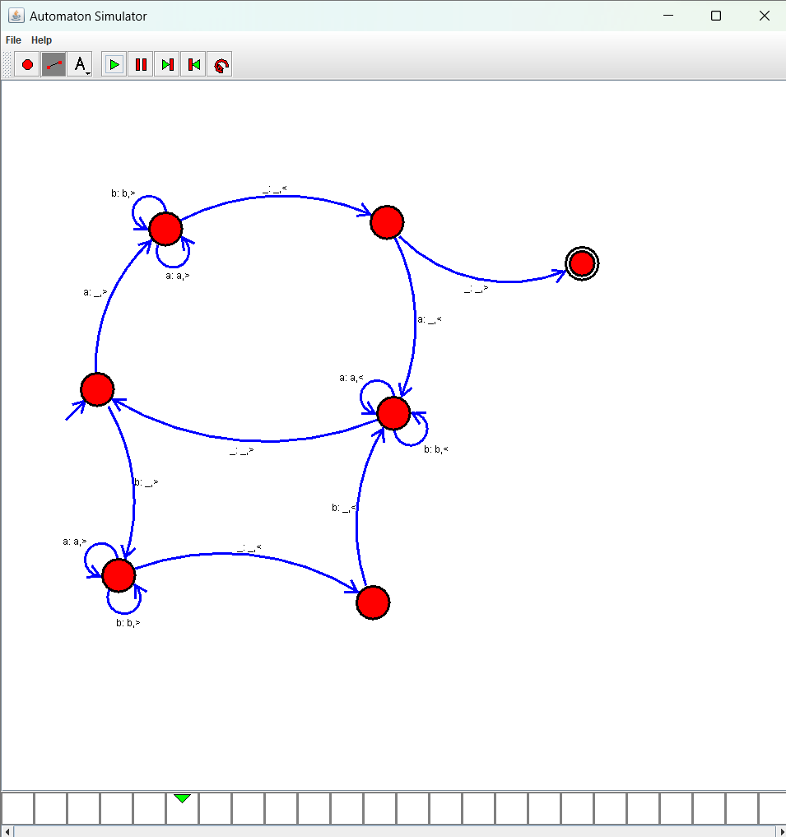

Result:

Accepted the string palindrome using the Turing machine simulator