* Design TM using simulator to accept the input string wcw

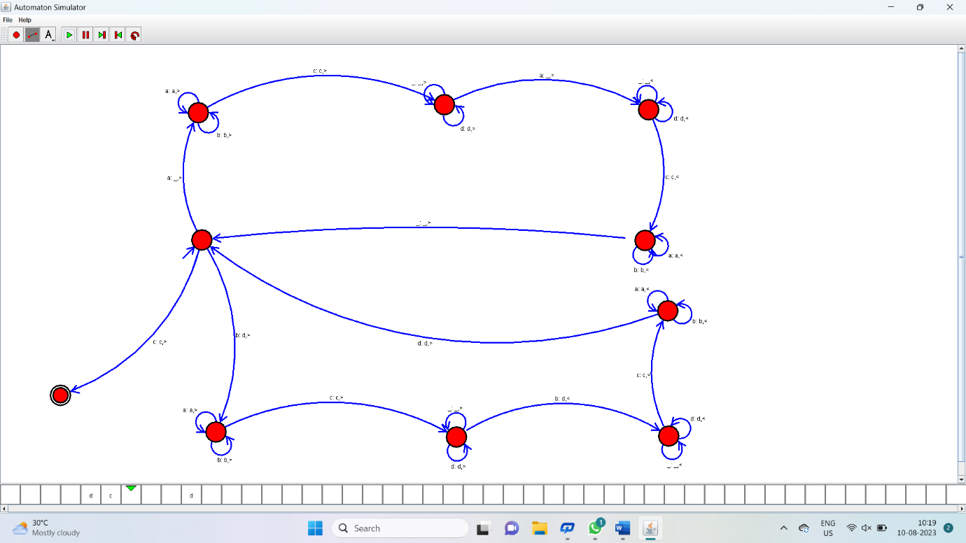

Result:

Hence it has accepted the input string wcw by using Turing machine simulator