Q1 Movie Rental Model

Class

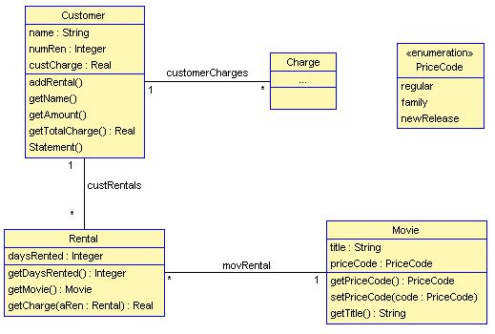

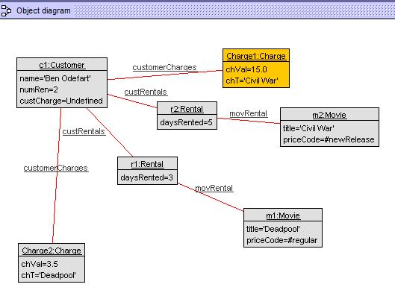

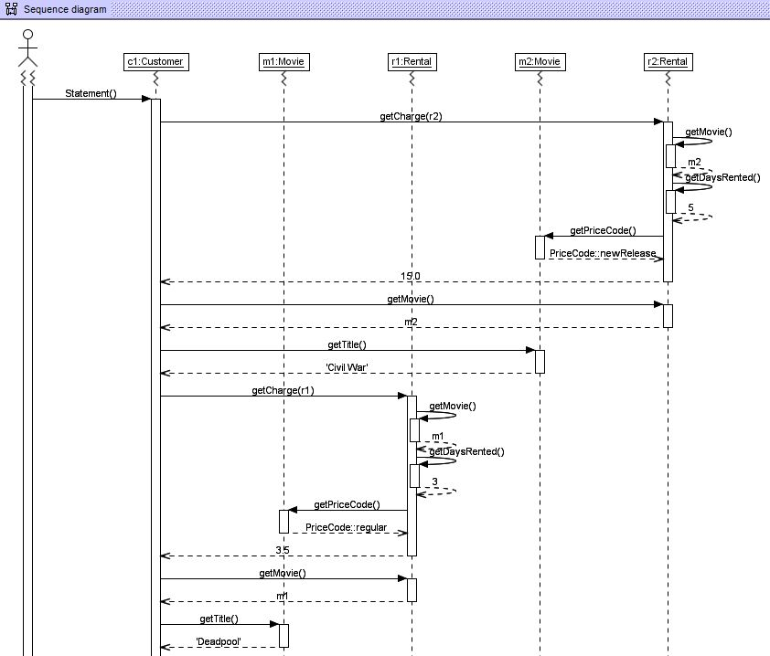

movierental.use (modified)

--This is a USE model that has embedded SOIL operations in it

--

model MovieRental

enum PriceCode {regular, family, newRelease}

--classes

class Customer

attributes

name:String

numRen:Integer

custCharge:Real

operations

addRental()

begin

end

getName()

getAmount()

begin

end

getTotalCharge():Real

begin

declare ren:Rental;

self.custCharge:=ren.getCharge(ren);

result:=self.custCharge;

end

Statement()

begin

declare aCharge:Charge, sm:Movie, ch:Real, t:String;

self.numRen:=self.rentals->size();

for ren in self.rentals do

ch:=ren.getCharge(ren);

sm:=ren.getMovie();

t:=sm.getTitle();

aCharge:= new Charge;

aCharge.chVal:=ch;

aCharge.chT:=t;

insert(self,aCharge)into customerCharges

end

end

end

class Rental

attributes

daysRented:Integer

operations

getDaysRented():Integer

begin

result := self.daysRented;

end

getMovie(): Movie

begin

result := self.movie;

end

getCharge(aRen:Rental):Real

begin

declare wrkCh:Real, m:Movie, pc:PriceCode,dy:Integer;

m:=aRen.getMovie();

dy:=aRen.getDaysRented();

pc:=m.getPriceCode();

wrkCh:=0;

if pc=PriceCode::regular then

wrkCh:=2.0;

if dy > 2 then

wrkCh:=wrkCh + (dy -2) \* 1.5;

end;

end;

if pc=PriceCode::family then

wrkCh:=1.5;

if dy > 3 then

wrkCh:=wrkCh + (dy -3) \* 1.5;

end;

end;

if pc=PriceCode::newRelease then

wrkCh:=dy \* 3.0;

end;

result:=wrkCh;

end

end

class Movie

attributes

title:String

priceCode:PriceCode

operations

getPriceCode():PriceCode

begin

result := self.priceCode;

end

setPriceCode(code:PriceCode)

begin

self.priceCode := code;

end

getTitle():String

begin

result := self.title;

end

end

class Charge

attributes

chVal:Real

chT: String

operations

end

--associations

association custRentals between

Customer [1] role renter

Rental [0..\*] role rentals

end

association movRental between

Rental [0..\*] role movRentals

Movie [1] role movie

end

association customerCharges between

Customer [1] role cust

Charge [0..\*] role charges

end

--constraints

--Added for class exercises

constraints

--Example constraints

--You may remove these constraints in your design. They are here

--just as examples.

context Customer

inv maxRental:numRen <= 10

inv agreement:rentals->size = numRen

inv rentals:rentals->notEmpty

inv daysRented:rentals->select(daysRented > 3)->notEmpty

movierental.txt (commands used)

use> check

checking structure...

checked structure in 2ms.

checking invariants...

checking invariant (1) `Customer::agreement': OK.

checking invariant (2) `Customer::daysRented': OK.

checking invariant (3) `Customer::maxRental': OK.

checking invariant (4) `Customer::rentals': OK.

checked 4 invariants in 0.006s, 0 failures.

use> !create c1:Customer

use> !create m1:Movie

use> !create r1:Rental

use> !insert (c1,r1) into custRentals

use> !insert(r1,m1) into moveRental

<input>:1:0: Association `moveRental' does not exist.

use> !insert(r1,m1) into movRental

use> !create m2:Movie

use> !create r2:Rental

use> !insert (c1, r2) into custRentals

use> !insert (r2, m2) into movRental

use> !set m1.priceCode := PriceCode::regular

use> !setm1.title := 'Deadpool;

<input>:line 1:25 mismatched character '<EOF>' expecting '''

<input>:line 1:0 no viable alternative at input 'setm1'

use> !setm1.title := 'Deadpool'

<input>:1:0: Variable `setm1' in expression `setm1' is undefined.

use> !set m1.title := 'Deadpool'

use> !set r1.daysRented := 3

use> !set m2.priceCode := 2

<input>:1:0: Type mismatch in assignment expression. Expected type `PriceCode', found `Integer'.

use> !set m2.priceCode := PriceCode::newRelease

use> !set r2.daysRented := 5

use> !set m2.title := 'Civil War'

use> !set c1.name := 'Ben Odefart'

use> !set c1.numRen := 2

use> check

checking structure...

checked structure in 1ms.

checking invariants...

checking invariant (1) `Customer::agreement': OK.

checking invariant (2) `Customer::daysRented': OK.

checking invariant (3) `Customer::maxRental': OK.

checking invariant (4) `Customer::rentals': OK.

checked 4 invariants in 0.004s, 0 failures.

use> !c1.Statement()

use>

Question 2 (Observer Pattern)

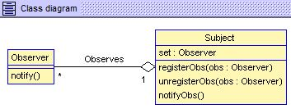

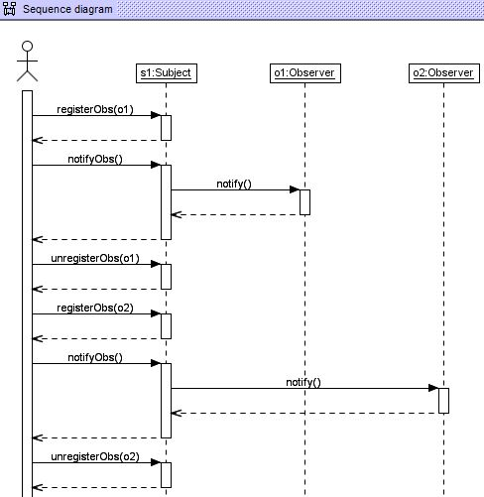

Observer.use

model Observer

class Observer

attributes

operations

notify()

begin

declare awake:Boolean;

awake:=true;

end

end

class Subject

attributes

set:Observer

operations

registerObs(obs:Observer)

begin

self.set:=obs;

end

unregisterObs(obs:Observer)

begin

declare tempObs:Observer;

self.set:=tempObs;

end

notifyObs()

begin

self.set.notify();

end

end

aggregation Observes between

Subject [1] role Subject

Observer [0..\*] role Observee

end

ObserverCMD.x

!create s1:Subject

!create o1:Observer

!create o2:Observer

!insert (s1,o1) into Observes

!insert (s1,o2) into Observes

check

!s1.registerObs(o1)

!s1.notifyObs()

!s1.unregisterObs(o1)

!s1.registerObs(o2)

!s1.notifyObs()

!s1.unregisterObs(o2)