D1–D4 Walkthrough — Transcript
PostaraTrend AI — Focused walk-through of the four R&D decision loci
Document type | Focused technical narration transcript (short version)
Companion to | PostaraTrend D1–D4 Walkthrough (HTML, browser-rendered)
Total sections | 6
Total beats | 21
Approximate runtime | 9–10 minutes at 1.0× speed (adjustable 0.5× to 1.5×)
Audience | Industry Technology Advisor (ITA) pre-call orientation
Prepared by | Celestine Oamen, Founder & CEO
Issued | May 7, 2026

How to use this transcript
This document is the verbatim narration script for the PostaraTrend D1–D4 Walkthrough — a focused, ten-minute companion to the longer technical voiceover. It is intended specifically as a pre-call orientation asset for an Industry Technology Advisor preparing to meet with the PostaraTrend team. Where the longer voiceover walks through the entire pipeline phase by phase, this short version goes directly to the four research-and-development decision loci, states each uncertainty, explains why it cannot be resolved through engineering judgment alone, and identifies the project phase that addresses it.
The transcript is structured the same way the walkthrough itself is structured. Each numbered section corresponds to one screen, with its diagram embedded at the start. Each section contains a sequence of “beats” — individual paragraphs of narration spoken in order, each accompanied by a spotlight on a specific element of the visible diagram. The beat label before each paragraph indicates which element of the diagram is highlighted while that beat is being spoken.
Note on numerals. The transcript reads exactly as the voiceover speaks the words. Numerical and alphanumerical identifiers are spelled out phonetically (“P-zero-five”, “D-one”, “S-O-P-zero-zero-four”) so that the audio version pronounces them correctly. When reading the transcript silently, this convention may feel verbose; the corresponding compact forms (P-05, D1, SOP-004) are visible in the diagrams and in the IRAP Statement of R&D Uncertainty.

1. The Four Decision Loci
Section 1 of 6 · Diagram: figure2
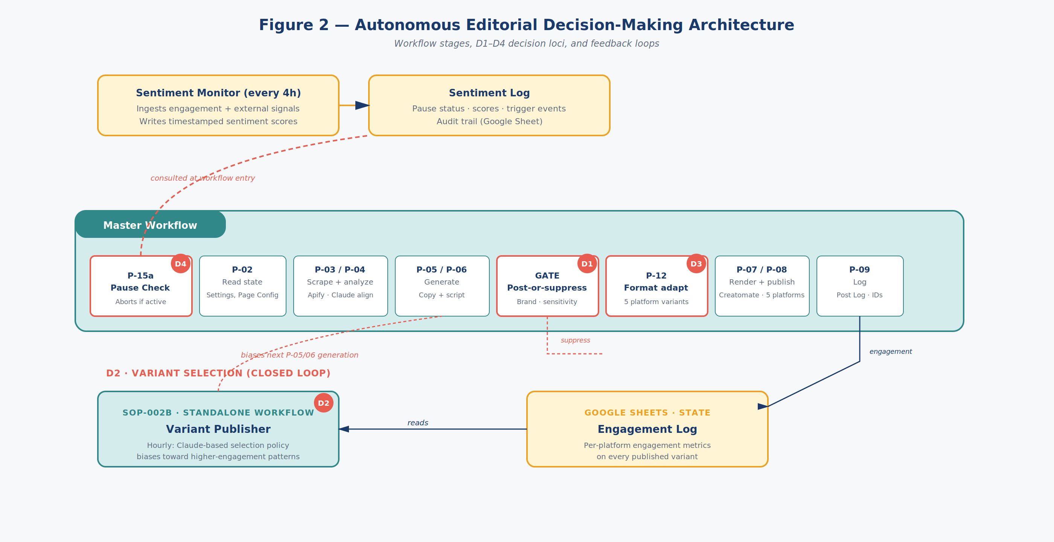
Figure 2 — Autonomous Editorial Decision-Making Architecture
Beat 1 · No spotlight (overview)
Welcome. This is a focused, ten-minute technical walkthrough of the four research-and-development uncertainties at the heart of the PostaraTrend IRAP application. It is intended for an Industry Technology Advisor preparing for our pre-call. We will cover the four decision loci — labelled D-one through D-four in Figure two — and for each one we will state the uncertainty, explain why it cannot be resolved through engineering judgment alone, and identify the project phase that addresses it.
Beat 2 · Spotlight on: Master Workflow phases (P-15a through P-09)
What you are looking at is the autonomous editorial decision-making layer of the PostaraTrend platform. The Master Workflow runs daily and executes a sequence of phases that ingest signals, generate content, decide whether to publish, adapt for each platform, render, publish, and log. The integration of the underlying services — n8n, Anthropic Claude, Apify, and Creatomate — is engineering work and is not part of the IRAP scope. The R-and-D scope is the decision-making logic that orchestrates these components into a fully autonomous publishing system.
Beat 3 · No spotlight (overview)
The system contains four architectural decision loci. D-one and D-three are stateless per-execution decisions — they are made independently each time content flows through them. D-two and D-four are closed-loop control systems — their state evolves over time through feedback. This combination of stateless decisions and feedback loops is the source of the technical uncertainty: emergent system behaviour at production volume cannot be predicted from low-volume testing. We will now examine each locus in turn.
2. D1 — Post-or-Suppress Gate
Section 2 of 6 · Diagram: figure2
(Diagram unchanged from previous section — see Figure 2 — Autonomous Editorial Decision-Making Architecture above.)
Beat 4 · Spotlight on: D1 — Post-or-Suppress Gate
Decision locus one — D-one — is the post-or-suppress gate. It sits between content generation and platform adaptation. Every piece of content that the system generates passes through D-one, and D-one classifies it as publish, suppress, or escalate. There is no human reviewer between D-one and the audience. D-one is implemented as a Claude API call with a specialized prompt that receives the generated content, the brand voice descriptors, the current sensitivity rules, and the current sentiment context.
Beat 5 · Spotlight on: D1 — Post-or-Suppress Gate
The technical question is the empirical failure rate of D-one at production volume — target of one hundred or more posts per day across multiple accounts. Failure has two forms. A false negative is inappropriate or off-brand content that warranted suppression but was published — this creates brand and reputation risk. A false positive is appropriate content that was inappropriately suppressed — this reduces commercial value. Both must be measured.
Beat 6 · Spotlight on: D1 — Post-or-Suppress Gate
What makes this genuinely uncertain is that no published industry benchmark exists for acceptable LLM-driven publication failure rates in fully autonomous systems. Engineering judgment cannot answer the question because failure modes at production volume are not necessarily extrapolations of failure modes observed at low volume. Distributional shifts in content categories, edge-case accumulation, and prompt-context interactions can produce failure dynamics that only emerge above a certain throughput threshold. Phase one of the IRAP project will produce a documented baseline measurement, and Phase two will measure improvement against that baseline through deployed guardrail systems.
3. D2 — Variant Selection Loop
Section 3 of 6 · Diagram: figure2
(Diagram unchanged from previous section — see Figure 2 — Autonomous Editorial Decision-Making Architecture above.)
Beat 7 · Spotlight on: D2 — Variant Selection closed loop
Decision locus two — D-two — is the variant selection closed loop. Unlike D-one, D-two is a feedback system. Published content produces engagement data in the Engagement Log. The Variant Publisher, a standalone workflow running hourly, reads the Engagement Log and computes a Claude-based selection policy. This policy is written to a Bias sheet that the next Master Workflow execution incorporates into its content generation prompts. Future content is therefore biased toward patterns that recently performed well.
Beat 8 · Spotlight on: Engagement Log (Google Sheet)
The technical question is whether this loop actually converges to identifiable performance-improving patterns over time, or whether noise dominates signal at the volumes a small or medium-sized business generates. Variant selection effectiveness depends on the signal-to-noise ratio of engagement metrics at a given content cadence and audience size.
Beat 9 · Spotlight on: D2 — Variant Selection closed loop
What makes this genuinely uncertain is that at low signal-to-noise ratios — which can occur at modest publishing volumes, in narrow content categories, or on platforms with high engagement variance — a variant selection policy that appears to be improving performance may in fact be tracking random fluctuations. This effect is well-known in adjacent fields such as advertising and recommender systems, but the parameter regime relevant to PostaraTrend’s target customer profile has not been independently characterized in the public literature. Phase three of the IRAP project will produce a documented characterization of D-two’s convergence behaviour across categories and platforms.
4. D3 — Format Adaptation Stage
Section 4 of 6 · Diagram: figure2
(Diagram unchanged from previous section — see Figure 2 — Autonomous Editorial Decision-Making Architecture above.)
Beat 10 · Spotlight on: D3 — Format Adaptation Stage
Decision locus three — D-three — is the format adaptation stage. Once content has been approved by D-one, D-three transforms it into platform-specific variants in parallel. Facebook receives long-form text plus video. TikTok receives short vertical video. Instagram receives square format. LinkedIn receives professional framing. Like D-one, D-three is stateless — the same input always produces the same family of platform variants, with no feedback loop.
Beat 11 · Spotlight on: D3 — Format Adaptation Stage
The technical question is whether automated adaptation actually improves engagement compared to mechanical re-publishing of identical content. Platform-specific format expectations are well known, but whether automated content adaptation by a language model produces variants that genuinely match those expectations — versus surface-level transformations that miss underlying audience-engagement dynamics — has not been empirically characterized in the public literature for this use case.
Beat 12 · Spotlight on: D3 — Format Adaptation Stage
What makes this genuinely uncertain is that some adapted variants may underperform their unadapted counterparts. Either because the adaptation degrades content quality, or because cross-platform audiences interpret inconsistency as inauthenticity. There is no a-priori basis for predicting whether adaptation effectiveness varies systematically across platforms, content categories, or audience segments. Phase three of the IRAP project will produce a documented per-platform comparison of adapted versus unadapted engagement, sufficient to support a per-platform decision about whether to deploy adaptation in commercial operation.
5. D4 — Sentiment-Gated Pause Loop
Section 5 of 6 · Diagram: figure2
(Diagram unchanged from previous section — see Figure 2 — Autonomous Editorial Decision-Making Architecture above.)
Beat 13 · Spotlight on: Sentiment Monitor (every 4h)
Decision locus four — D-four — is the sentiment-gated pause loop. D-four is the system’s safety brake. It governs not what the system publishes, but whether it runs at all. Every four hours, the Sentiment Monitor ingests engagement metrics and external sentiment signals, evaluates them against operator-configured threshold rules, and writes the result to the Sentiment Log. At the start of every Master Workflow execution, phase fifteen-A reads the Sentiment Log and aborts the workflow if a pause is currently active.
Beat 14 · Spotlight on: Sentiment Monitor (every 4h)
The technical question is the empirically validated false-positive and false-negative rate of this monitor. A false positive is a pause triggered when publishing would have been appropriate — this produces unnecessary operational disruption. A false negative is the absence of a pause when publishing was inappropriate — this produces reputational or brand damage.
Beat 15 · Spotlight on: Sentiment Monitor (every 4h)
What makes this genuinely uncertain is that current sentiment-monitor thresholds are based on operator judgment and reasonable defaults, not on measured outcomes. There is no published baseline for sentiment-monitor accuracy in this use case. Threshold sensitivity is likely to vary across content categories and account profiles. The correct threshold for any given account profile cannot be derived from first principles — it must be tuned empirically against measured outcomes. Phase three of the IRAP project will produce a documented sentiment-monitor accuracy characterization with thresholds tuned against measured false-positive and false-negative outcomes.
6. R&D Mapping Summary
Section 6 of 6 · Diagram: summary
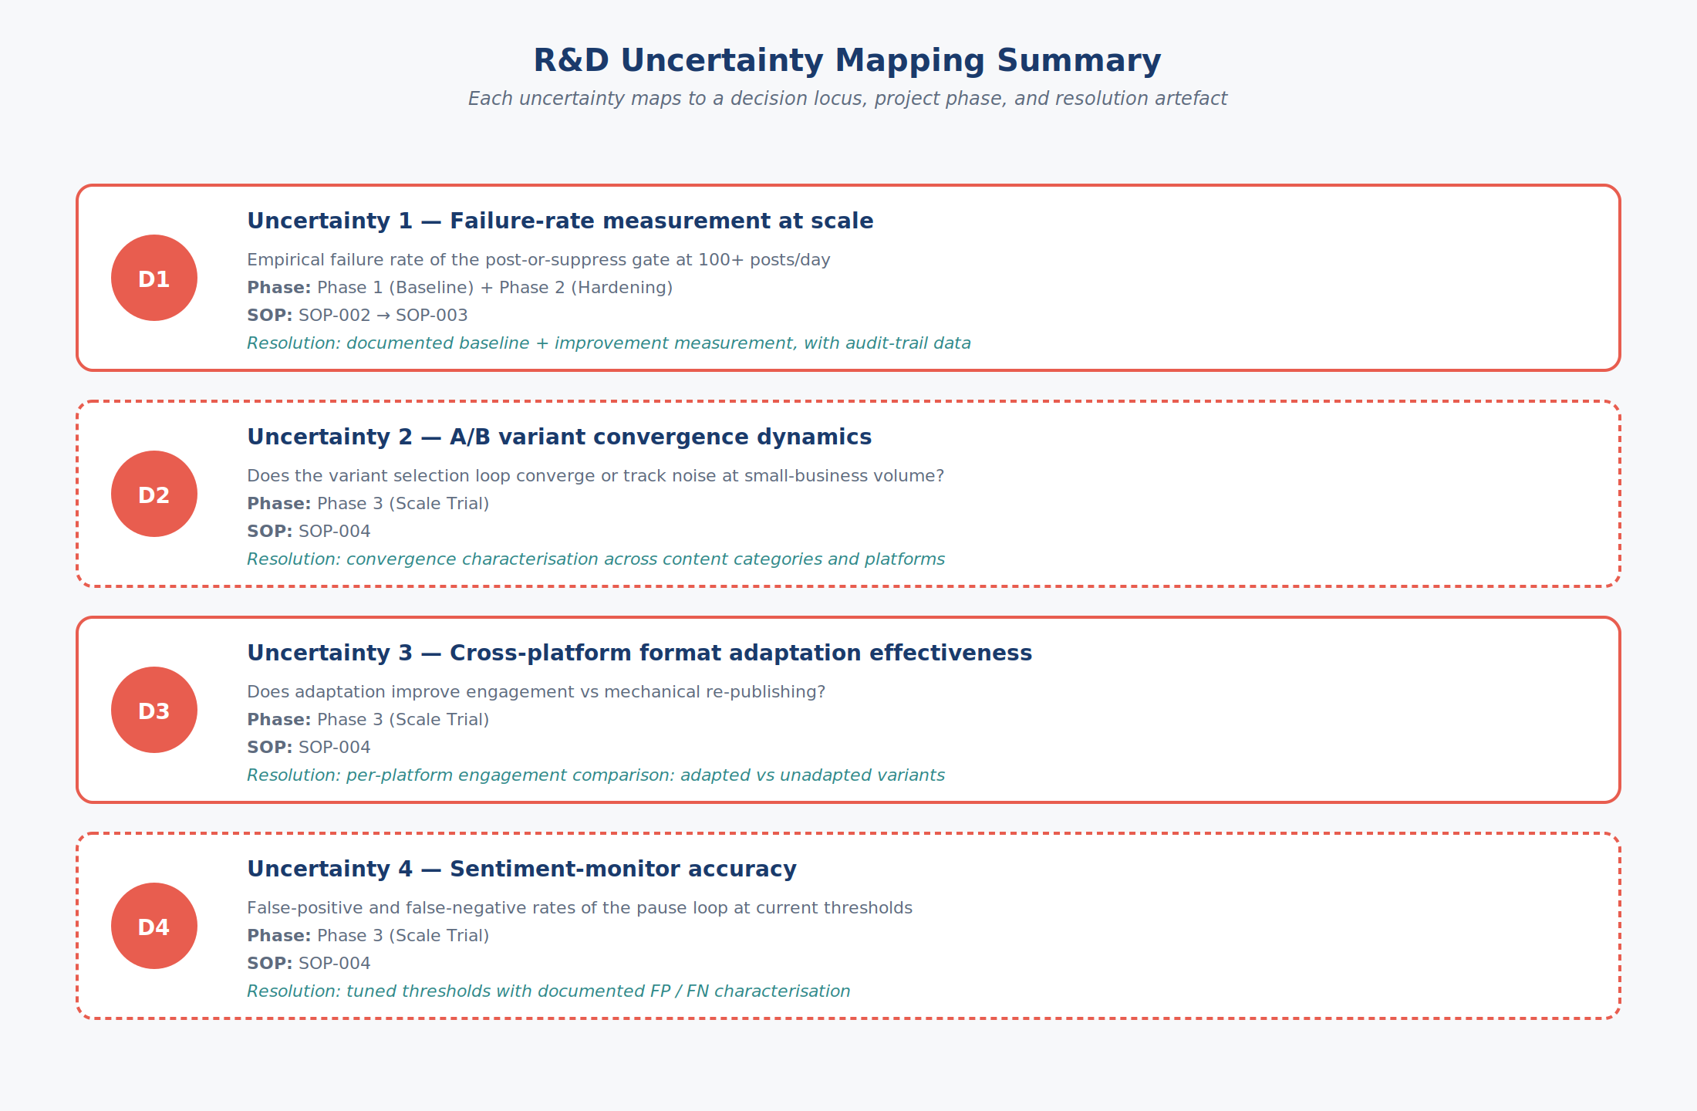
R&D Uncertainty Mapping Summary
Beat 16 · No spotlight (overview)
We have now covered all four research-and-development uncertainties. Let us close by summarizing how each maps to a specific architectural decision locus, a project phase, and a measurable resolution outcome.
Beat 17 · Spotlight on: Summary row — Uncertainty 1 (D1)
Uncertainty one — failure-rate measurement at scale — is anchored at decision locus D-one. It is addressed in Phase one and Phase two of the IRAP project, corresponding to S-O-P-zero-zero-two and S-O-P-zero-zero-three. Resolution produces a documented baseline failure rate and a documented improvement measurement, with the underlying audit-trail data available for inspection.
Beat 18 · Spotlight on: Summary row — Uncertainty 2 (D2)
Uncertainty two — A-B variant convergence dynamics — is anchored at decision locus D-two. It is addressed in Phase three of the IRAP project, corresponding to S-O-P-zero-zero-four. Resolution produces a documented characterization of the variant selection loop’s convergence behaviour.
Beat 19 · Spotlight on: Summary row — Uncertainty 3 (D3)
Uncertainty three — cross-platform format adaptation effectiveness — is anchored at decision locus D-three. It is addressed in Phase three, S-O-P-zero-zero-four. Resolution produces a per-platform engagement comparison of adapted versus unadapted variants.
Beat 20 · Spotlight on: Summary row — Uncertainty 4 (D4)
Uncertainty four — sentiment-monitor accuracy — is anchored at decision locus D-four. It is addressed in Phase three, S-O-P-zero-zero-four. Resolution produces a documented sentiment-monitor accuracy characterization with thresholds tuned against measured false-positive and false-negative outcomes.
Beat 21 · No spotlight (overview)
Each of the four uncertainties shares a common feature: the answer cannot be obtained by more careful design or longer engineering effort applied to existing code. Each requires a system that is built, deployed, instrumented, and operated at sufficient volume to gather statistically meaningful measurements. This is the structure of technical uncertainty that warrants research-and-development investment, and it is the basis for the IRAP funding application. Thank you for your time. The accompanying Statement of R-and-D Uncertainty contains the formal written version of this material.
End of transcript
This concludes the D1–D4 Walkthrough transcript. Total: 6 sections, 21 beats, approximately 1,406 words. For the formal R&D-eligibility argument in document form, see the companion Statement of R&D Uncertainty submitted with the IRAP application. For the full pipeline-by-pipeline technical walkthrough (~25 minutes), see the longer Technical Voiceover and its accompanying transcript.

