Statement of R&D Uncertainty
Autonomous Editorial Decision-Making at Scale
Document type | Statement of Technical Uncertainty (IRAP support)
Audience | Industry Technology Advisor (ITA) / technical reviewers
Prepared by | Celestine Oamen, Founder & CEO
Version | Final — harmonized, architecture-integrated
Issued | May 2026

1. Purpose of this Statement
This document provides a structured articulation of the technical uncertainties associated with the PostaraTrend AI platform, specifically within the Autonomous Editorial Decision-Making Layer (Figure 2).
Its purpose is to enable an Industry Technology Advisor (ITA) to assess whether the proposed work constitutes experimental research and development, as distinct from engineering integration.
The corporation’s position is that the work qualifies as R&D because it targets system-level uncertainties that emerge directly from the architecture, and which:
- depend on non-deterministic large language model (LLM) outputs
- involve feedback-driven system behaviour
- cannot be resolved without measured, production-scale experimentation
2. R&D Scope Defined by Architecture
2.1 Integration Layer (excluded from R&D scope)
The platform integrates commercially available services (workflow orchestration, LLM APIs, scraping, and rendering).
This layer:
- behaves deterministically
- has been proven at small scale
- does not introduce unknown system dynamics
Accordingly, it is classified as engineering work, not R&D.
2.2 Autonomous Editorial Layer (R&D scope)
The R&D focus is the Autonomous Editorial Decision-Making Layer, represented in Figure 2.
This layer introduces decision-making points that directly influence:
- whether content is published
- how content evolves over time
- how content is adapted across platforms
- whether publishing is halted for safety reasons
These behaviours are governed by four architectural decision loci:
- D1 — Post-or-Suppress Gate
- D2 — Variant Selection Loop
- D3 — Format Adaptation Stage
- D4 — Sentiment-Gated Pause Loop
Architectural note. D1 and D3 are per-execution decisions (stateless). D2 and D4 are closed-loop control systems (state evolves via feedback). This combination introduces emergent system behaviour, which is the source of the technical uncertainty.

The diagram on the following page (Figure 2) shows these four loci in their architectural context, with D2 and D4’s closed loops drawn explicitly.

Figure 2 — Autonomous Editorial Decision-Making Architecture
Workflow stages, D1–D4 decision loci, and feedback loops.
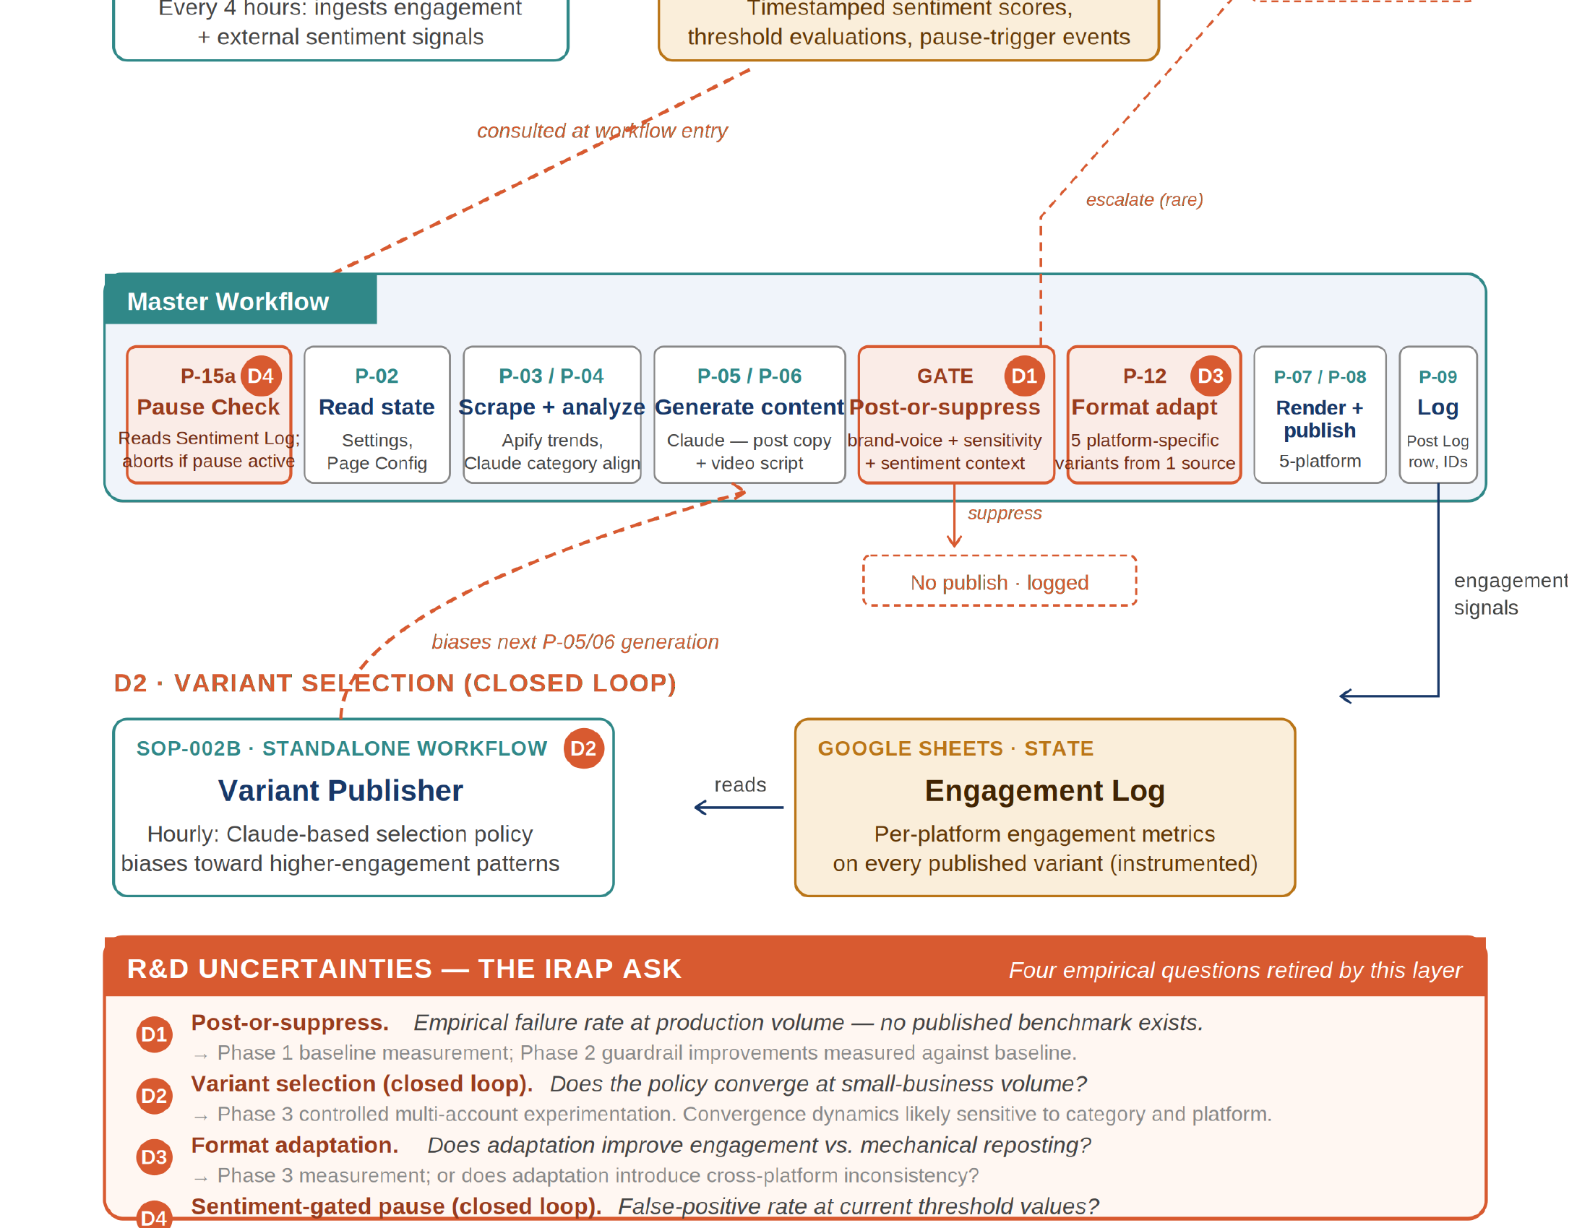

3. Technical Uncertainties (architecture-linked)
3.1 Uncertainty 1 — Failure rate at D1 (Post-or-Suppress Gate)
Architecture context. D1 is the decision gate located immediately before publishing. Each content item is evaluated independently and classified as:
- publish
- suppress
- escalate
Technical question. At production scale, what is the empirical failure rate of this decision point?
Failure definition.
- False negative — inappropriate content is published
- False positive — appropriate content is suppressed
Why this is architecturally uncertain. D1:
- operates without feedback correction
- relies on non-deterministic model outputs
- directly determines final system output
At scale, this creates unbounded exposure to edge-case failures, which cannot be predicted from low-volume testing.
Resolution approach.
- instrument decision outcomes
- measure baseline failure rates
- implement guardrails and quantify improvement against the baseline
3.2 Uncertainty 2 — Convergence of the D2 Variant Selection Loop
Architecture context. D2 is a closed-loop feedback system linking published content → engagement data → future content decisions.
Technical question. Does this loop converge toward higher-performing outputs at small-business volume, or does it respond to noise?
Why this is architecturally uncertain. The loop depends on:
- sparse, noisy engagement signals
- limited data volume at small-business scale
- recursive feedback into future decisions
This creates a control-system uncertainty in which the system may amplify noise rather than learn from signal.
Resolution approach.
- run longitudinal experiments across multiple accounts
- track engagement trends across cycles
- determine the conditions under which convergence occurs or fails
3.3 Uncertainty 3 — Effectiveness of the D3 Format Adaptation Layer
Architecture context. D3 transforms a single content source into multiple platform-specific outputs. It is a parallel, stateless process, with no feedback loop.
Technical question. Does automated adaptation improve engagement compared to non-adapted reposting?
Why this is architecturally uncertain. The architecture creates:
- multiple outputs from a single source
- independent audience responses per platform
This introduces a causality problem, in which engagement differences must be attributed solely to adaptation rather than to platform variability or randomness. In addition, inconsistent adaptation may reduce perceived authenticity.
Resolution approach.
- controlled comparison: adapted vs identical content
- platform-specific performance analysis
- category-level evaluation
3.4 Uncertainty 4 — Accuracy of the D4 Sentiment-Gated Pause Loop
Architecture context. D4 is a closed-loop safety system consisting of:
- Sentiment Monitor
- Sentiment Log
- Workflow-entry pause check
It governs whether the system executes at all.
Technical question. What are the false-positive and false-negative rates of this system?
Why this is architecturally uncertain. D4:
- applies static thresholds to dynamic real-world conditions
- influences the entire workflow at entry
- relies on judgment-based tuning rather than empirical validation
This creates a risk trade-off:
- False positives — unnecessary operational disruption
- False negatives — reputational or brand damage
Resolution approach.
- measure pause-trigger events
- compare against real-world outcomes
- tune thresholds empirically
- validate using audit logs
4. Why These Are Valid R&D Uncertainties
All four uncertainties arise from architectural behaviour, not component design:
- D1 — execution-level uncertainty
- D2 — feedback-loop convergence
- D3 — transformation effectiveness
- D4 — safety system accuracy
These uncertainties:
- emerge only under production conditions
- cannot be predicted through design or documentation
- require empirical measurement and iteration
This aligns directly with IRAP’s definition of experimental development.
5. Expected Outcomes
Resolution of these uncertainties will produce:
- measured failure-rate benchmarks (D1)
- validated or refuted convergence behaviour (D2)
- quantified adaptation effectiveness (D3)
- empirically tuned safety thresholds (D4)
Importantly: negative or limiting results still constitute valid R&D outputs by resolving uncertainty.
6. One-Line ITA Summary
“Each uncertainty maps directly to a defined architectural decision point — either a per-execution gate or a closed-loop control system — and can only be resolved through production-scale measurement of system behaviour.”

