SE101 Introduction to Software Engineering
Lab 4B - Selection & Flowchart Design
Week 4 | Topic: if-else Statements & Algorithm Design with AI

Name | Student ID | Section | Date

Learning Objectives
1. Analyze existing code and draw correct flowcharts using draw.io
2. Apply if-else logic to design new programs
3. Use GitHub Copilot to generate code from your own prompts
4. Run and verify generated code; document your AI workflow
5. Draw flowcharts for your own code

PART 1 - Flowchart Design (from Lab 4A)

Draw the flowchart for each program from Lab 4A using draw.io (https://app.diagrams.net).
Export as PNG and paste into the area below each exercise. Use the correct shapes:
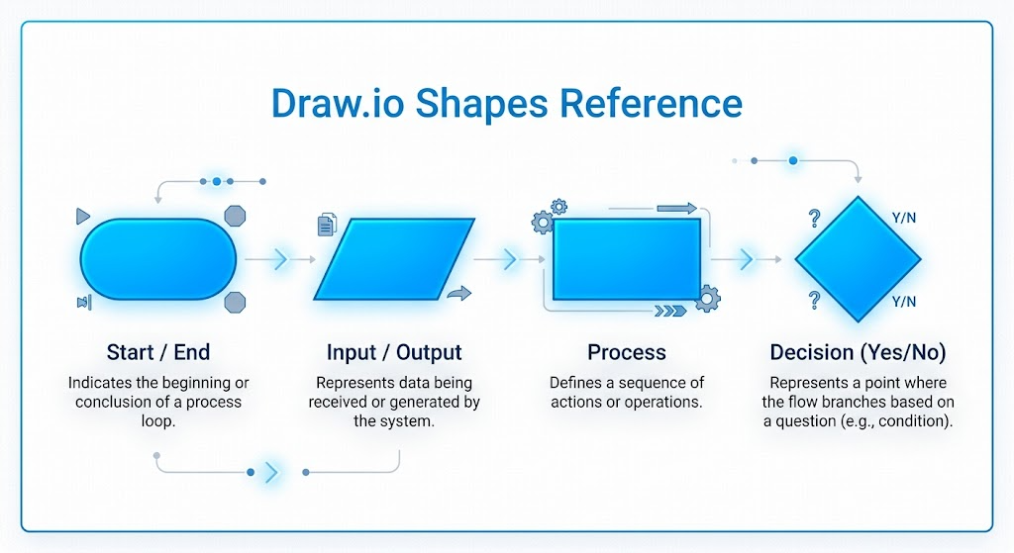

Exercise 1 : NumberChecker.java
The program reads an integer from the user and prints whether it is positive, negative, or zero.

//your code

Your Flowchart (paste draw.io screenshot):
[ Paste your draw.io flowchart screenshot here ]

Exercise 2 : SignChecker.java
The program reads two integers and prints which is larger, or "Equal" if they match.

//your code

Your Flowchart:
[ Paste your draw.io flowchart screenshot here ]

Exercise 3 : GradeClassifier.java
The program reads a score (0-100) and prints the grade letter: A (>=80), B (>=70), C (>=60), D (>=50), F (<50).

//your code

Your Flowchart:
[ Paste your draw.io flowchart screenshot here ]

Exercise 4 : BMICalc.java
The program reads weight (kg) and height (m), computes BMI = weight/(height*height), then classifies: Underweight (<18.5), Normal (18.5-24.9), Overweight (25-29.9), Obese (>=30).

//your code

Your Flowchart:
[ Paste your draw.io flowchart screenshot here ]

CHECKPOINT 1 - Part 1 Complete - Show Flowcharts 1-4
Show your instructor before continuing.

PART 2 - AI-Assisted Coding + Flowchart

Exercise 5 : SeasonFinder.java
Write a program that reads a month number (1-12) and prints the season:
Month 12, 1, 2 -> "Winter"
Month 3, 4, 5 -> "Spring"
Month 6, 7, 8 -> "Summer"
Month 9, 10, 11 -> "Autumn"
Other -> "Invalid month! (must be 1-12)"

Step 1 - Write your GitHub Copilot prompt:
GitHub Copilot Prompt
My Prompt:
What Copilot did:

Step 2 - Run the code. Show sample output:
Program Output (paste screenshot or type result)

Step 3 - Draw the flowchart:
[ Paste your draw.io flowchart screenshot here ]

CHECKPOINT 2 - Part 2 Complete - Show Exercises 5

