Pot Tracker

**Process Book: CS -5630 / CS – 6630 Data Visualization**

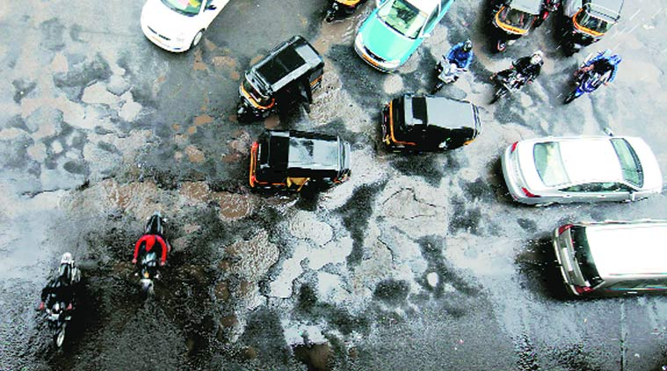http://www.indianexpress.com

Contents

1. Project Information
2. Overview and Motivation
3. Questions
4. Data
5. Design Evolution
6. Implementation
7. Exploratory Data Analysis
8. Evaluation
9. Related Work

Project Information

# Title:

PotTracker

# Project Description:

An application that gives ward wise analysis of potholes in Mumbai, India.

# Project Members:

* 1. Sunny Hardasani - u1000118, sunny.hardasani@gmail.com
  2. Mohan Krishna Manchala – u0942454, manchalamohan@gmail.com
  3. Yogesh Mishra – u1010866, yogeshmishra.india@gmail.com

Repository:

https://github.com/PotTracker/web-application

Overview and Motivation

Accidents due to potholes are one of the major problem in developing countries like India. Poor construction quality leads to a large number of potholes which cause accidents and traffic issues. According to the Road Accident Report (2014) published by the road transport and highways ministry of India, 6,672 people died in accidents caused due to potholes and speed breakers. In this project, we try to present a visualization of the potholes in a city and help the government in taking corrective measures.

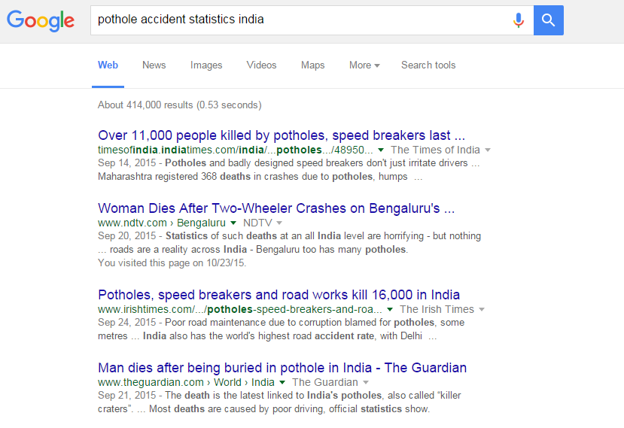

*Fig 1: Google search snapshot of accident due to potholes in India*

Basically, our visualization aims to keep track of the ward wise data of open potholes, closed potholes and the fresh potholes in Mumbai city. Both the government and people of the city are our audience. Government can use our visualization to effectively track potholes and create a plan to take appropriate measures. People can use it to compare the ward-wise increase and decrease in number of potholes and gauge the efficiency of the local leaders in the respective wards.

Our project is a part of a major project that has two components, Mobile application and Visualization application. We are assuming that there is a mobile application which will run as a background service on the mobile phones and tracks the location of the potholes whenever a vehicle running the mobile application crosses it. This application will sense the twitch and send the latitude and longitude of that (pothole) location to the cloud server. Our project focuses on the visualization application. This application will read the data from the server and show the stats of the potholes on page. Visualization will change in real time as the new data gets added on the server by the vehicles.



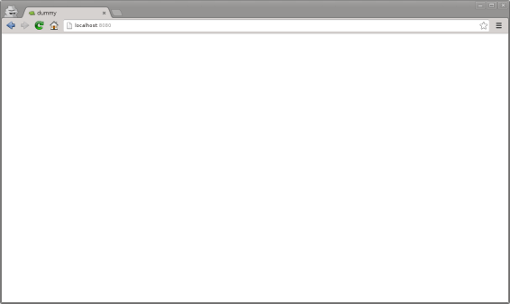

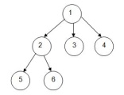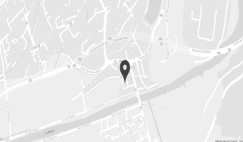

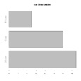

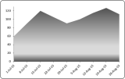

*Fig 2: Schematic of PotTracker*

In this application we are focusing on five major points

1. Ward color density will change with the count of the open potholes on the map.
2. Tree Diagram of Mumbai city with branches as wards and leaves as active potholes.
3. Number of open potholes in particular ward with respect to time will be shown in area chart
4. Top 10 potholes based on the calculations of vehicle hit in selected ward.
5. Location of the open potholes in selected ward.

Question

This visualization project tries to analyze certain statistics of the potholes in a city and help give live details to the public and government. In particular, we would like to answer the following Questions.

1. Which roads in Mumbai have been affected by potholes?
2. What is the frequency of occurrence and closure of potholes on Mumbai roads on yearly and monthly basis?
3. Number of open potholes in a particular month and its variation over a period of time?
4. What are the Top 10 potholes that have been causing problems to the public and their number of hits (Vehicle encounters)? These potholes would need immediate attention of the government.
5. Which area in Mumbai has been most effected by potholes?
6. How the potholes are varying according to the climatic seasons? How are the roads being affected in rainy season, etc?

Apart from the above questions, over the course of working on this project, we thought we should give some sort of performance assessment of road contractors through our statistics and visualization. This would help the public and government to decide the efficiency of the contractors work. Therefore, if we are successful in answering the above mentioned question we would also provide information about the area wise quality of construction of the roads and the corresponding road contractors. In future, we would also like to forecast the per month increase in the potholes for the next year.

Data

Two types of data are required to build this application:

# Administrative boundaries (Ward) shape files.

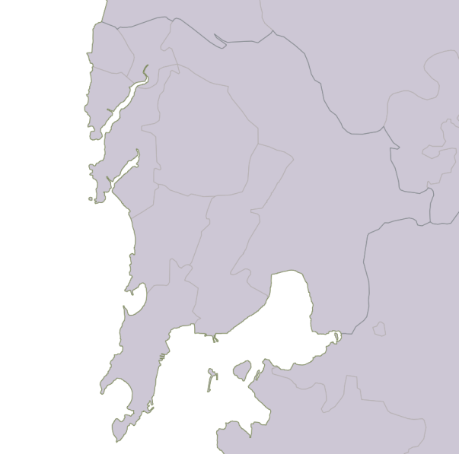The Shapefile format is a common standard for representing geospatial vector data. It is in fact a grouping of several files formatted to represent different aspects of geodata:

*Fig3: Ward wise shape file visualization for mumbai city*

* .shp — shape format; the feature geometry itself.
* .shx — shape index format; a positional index of the feature geometry to allow seeking forwards and backwards quickly.
* .dbf — attribute format; columnar attributes for each shape, in dBase IV format.

We downloaded the shapefile of India from the following source:

Link: <http://www.diva-gis.org/gdata>

**Processing:** The shape file of Mumbai city was manually extracted from the India shapefile.

We have used this shapefile to display the boundaries of wards of Mumbai city in the Google maps. To overlay the shapefile on google map, we had to convert the shapefile into GeoJSON format. We have used the Qgis software for the conversion.

# Location data read from the private database

Currently, we have manually generated our live feed of data for the locating the potholes. Our data primarily has following fields:

* Address
* Latitude, Longitude of the pothole
* Start and End timestamp
* Count of vehicle hits.
* Status(active/close)

We will create a simulation to automatically generate this data by adding new potholes and deleting some of the existing ones. In the future, we can get this data from our mobile application.

Design Evolution

The following is the diagram of our final design.

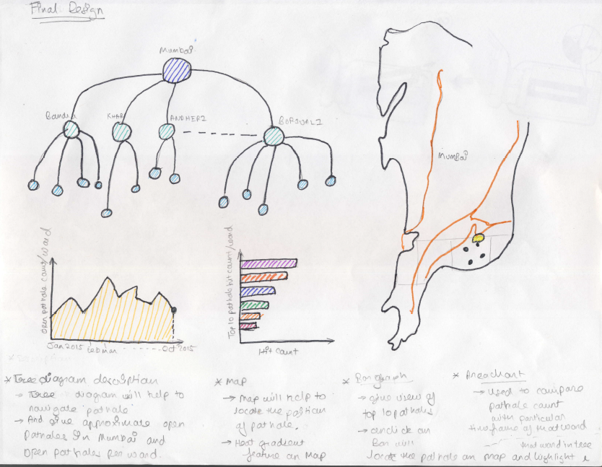**Final Design**

*Figure 4 – Final design of the complete web application with all the relevant views*

## **Description of final design:**

The final design has the tree node link diagram, the map, the Area chart and bar chart.

## **Tree diagram**

**Function**: It is used to navigate into the map using the ward and pothole nodes. It will show all the open potholes in Mumbai city and also ward wise. On clicking the ward, we will zoom into the ward in the map. On clicking the pothole, the pothole and its corresponding road gets highlighted. On hovering the ward node will give the number of potholes in that ward. In hovering the pothole node will give the number of hits (vehicle encounters) and address of the pothole.

**Decision**: We cannot see the potholes directly in the maps/google maps. We would have to zoom to the level of roads to see the potholes in the map. Hence to navigate to the potholes ­and roads without zooming the map, we have decided to use the tree diagram for easy navigation. This tree diagram will have all the potholes as nodes. So, when the user clicks the pothole, the map would zoom in to the corresponding road showing the pothole.

## **Map diagram**

**Function**: It will show the location of the wards, roads and potholes. Each ward has a heat gradient coloring based on the number of potholes. On clicking a ward, show the area chart corresponding to that ward.

**Decision**: We have decided to use google maps for the visualization of the roads and the potholes.

## **Area chart**

**Function:** It will show the year wise, month wise count of the potholes in a specific ward. On clicking the year wise chart, it will zoom into a month wise chart.

## **Bar chart**

**Function:** It will give the top ten potholes with maximum count of hits (vehicle encounters). On clicking the pothole bar, the corresponding pothole in the map will get highlighted. This chart will show the most dangerous potholes which need immediate attention.

**Decision**: Bar and Area charts are simple and best designs that are used for task similar to ours. Hence, we have decided to use them.

Implementation

## **Map**

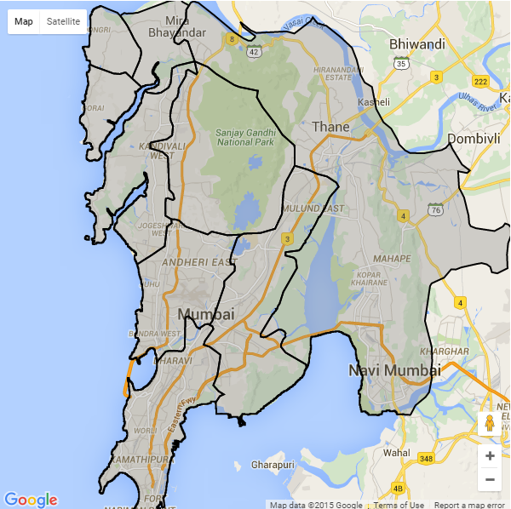 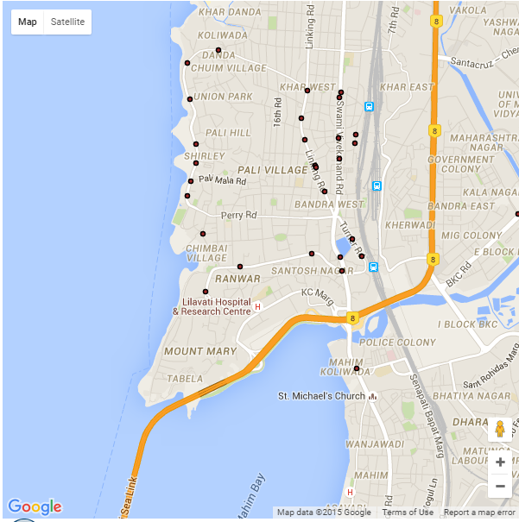

*Figure 5 - Shape file of administrative areas* *Figure 6 – pothole in the bandra area*

We have used Google maps to display the potholes in Mumbai city. Initially the map is centered at centre of Mumbai city at a zoom level of 11. We are doing our pothole analysis per each administrative area of Mumbai city. Hence, we have overlaid the shape files of administrative areas of Mumbai using D3 overlay. These administrative areas can be seen in the figure - 5.

For the milestone 1, we have implemented the following.

Currently, we are only doing for Bandra area (figure - 6), but the final design would be for all areas.

* On clicking any of the administrative area, the map would zoom in to centre of that administrative block.
* The potholes currently open in that administrative area will be displayed.

For the final design implementation, we will implement few more features like setting the chloropeth (opacity and color) of the administrative area on based on the number of open potholes and establishing the linking with other plots.

## **Tilford Tree**

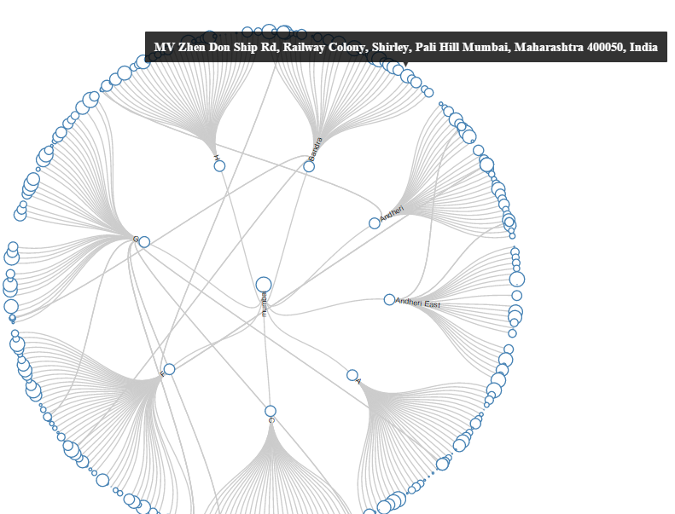 *Figure 7 – Tilford Tree*

In this intermediate version, we are using Tilford tree to map the potholes from Mumbai to Area (Bandra, Andheri, etc.) and Area to Potholes. In this pothole size (circle at depth-2) changes according to the hit count. It helps the government to identify the priority to fix the potholes. In this we are reading data from the csv file.

In final delivery, this tree contains different color for city, area and potholes and all the potholes circle comes in the sorted order and on clicking on any pothole will raise the event which is read by the other visualization to change their fields.

## **Area Chart**

In the Area Chart, we plot the months in x-axis and number of potholes in the y-axis. As of now, we have just plotted the area chart of only one administrative boundary. In this chart, we can know the number of open potholes in an area at a particular time of year. As the final work, we would plot a different area chart of different administrative boundary and invoke the corresponding plot by clicking on the administrative boundary in the map.

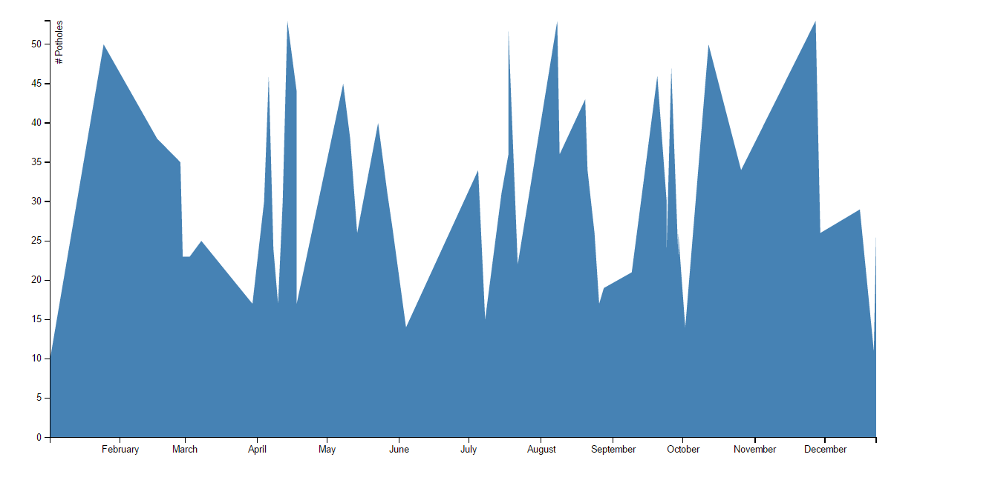

*Figure 8 - Area chart of Bandra*

## **Bar Graph**

This bar graph show the top 10 potholes of the selected region with their hit count, this will help government to take action for the most serious pothole.

In final delivery, links will get implemented which will point to that particular pothole in the map and tree.

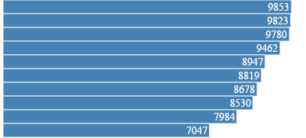

*Figure 9 - Bar graph*

Exploratory Data Analysis

To be done

Evaluation

To be done

Related Work