**LAB-9**

**PROGRAM TO SHOW DELAY IN DISPLAYING MESSAGES USING 2 THREADS**

* HANDWRITTEN PROGRAM

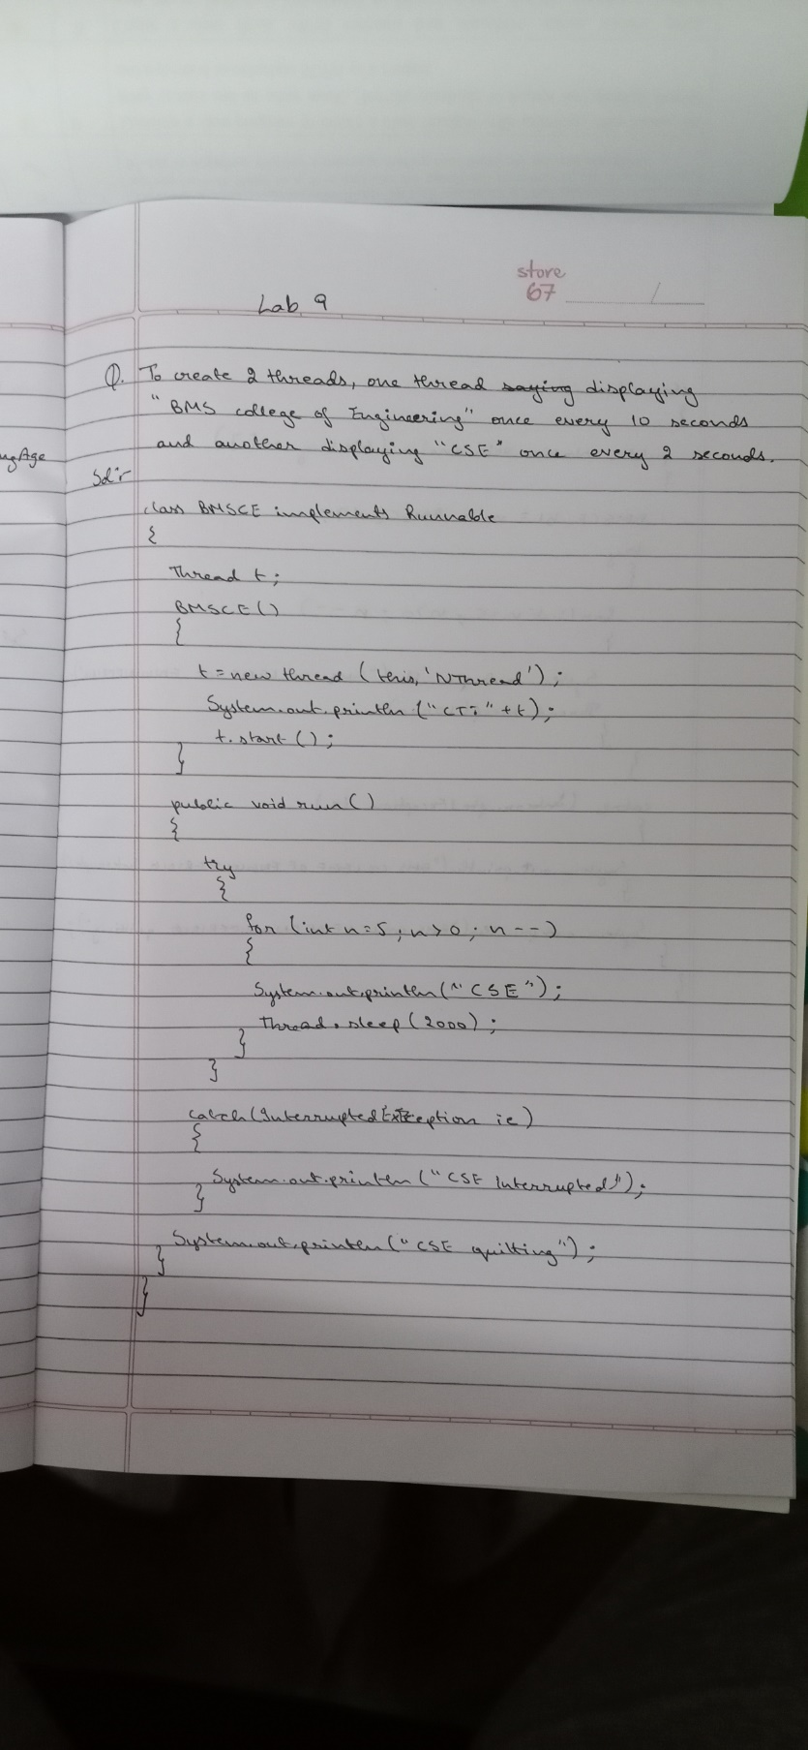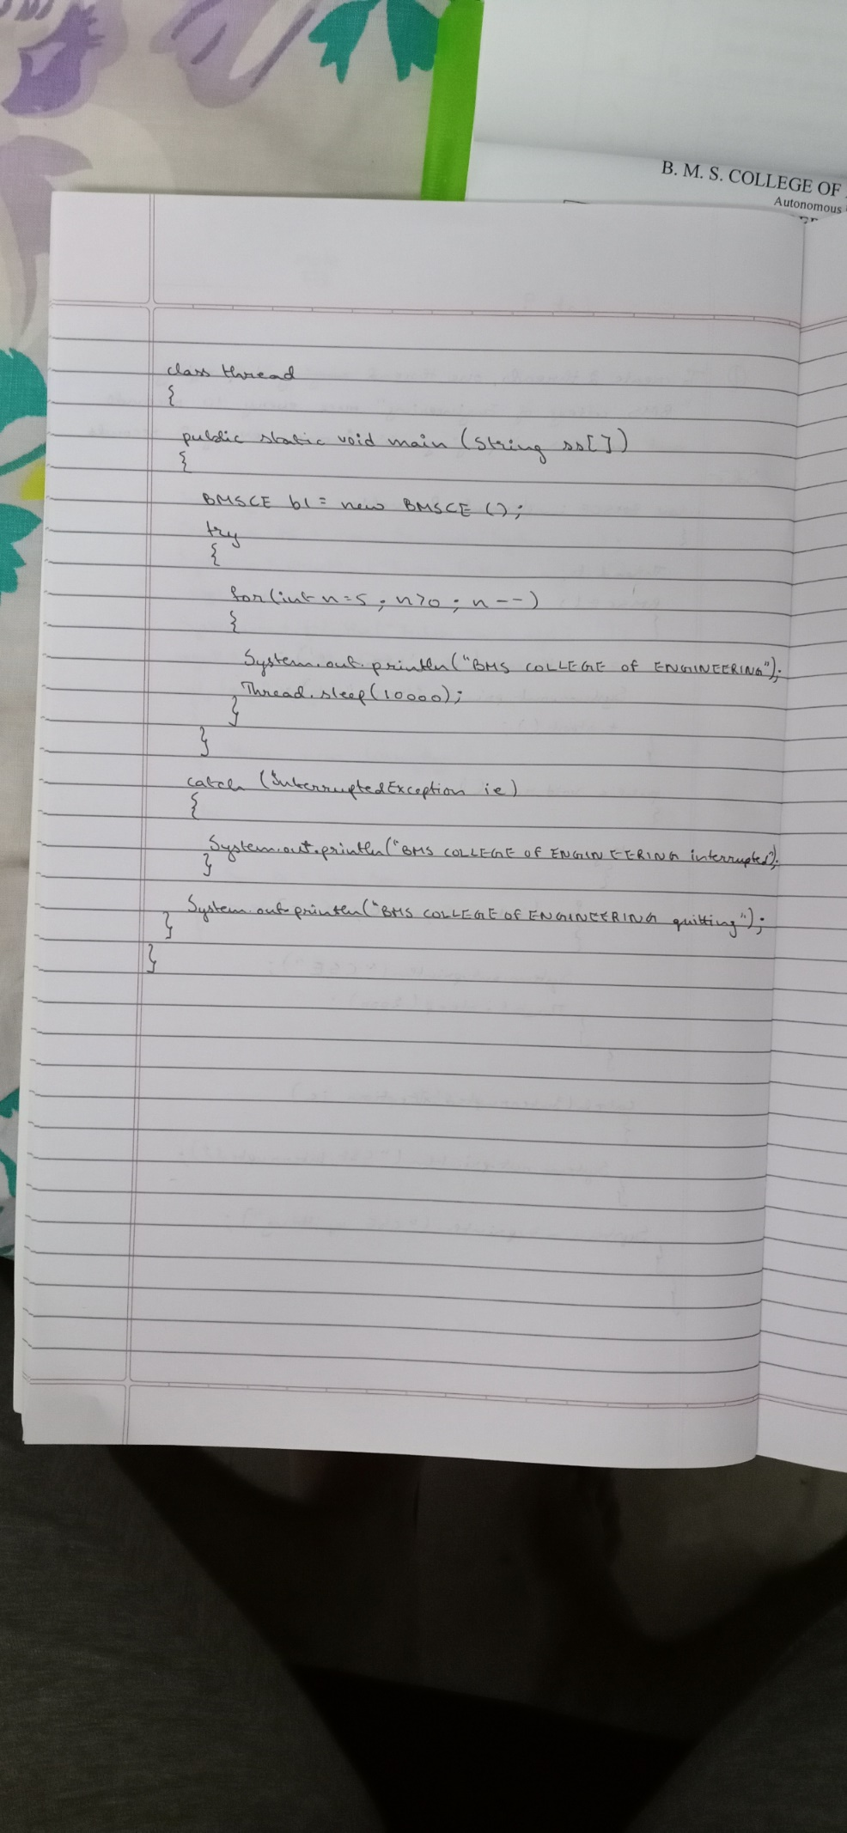

* PROGRAM

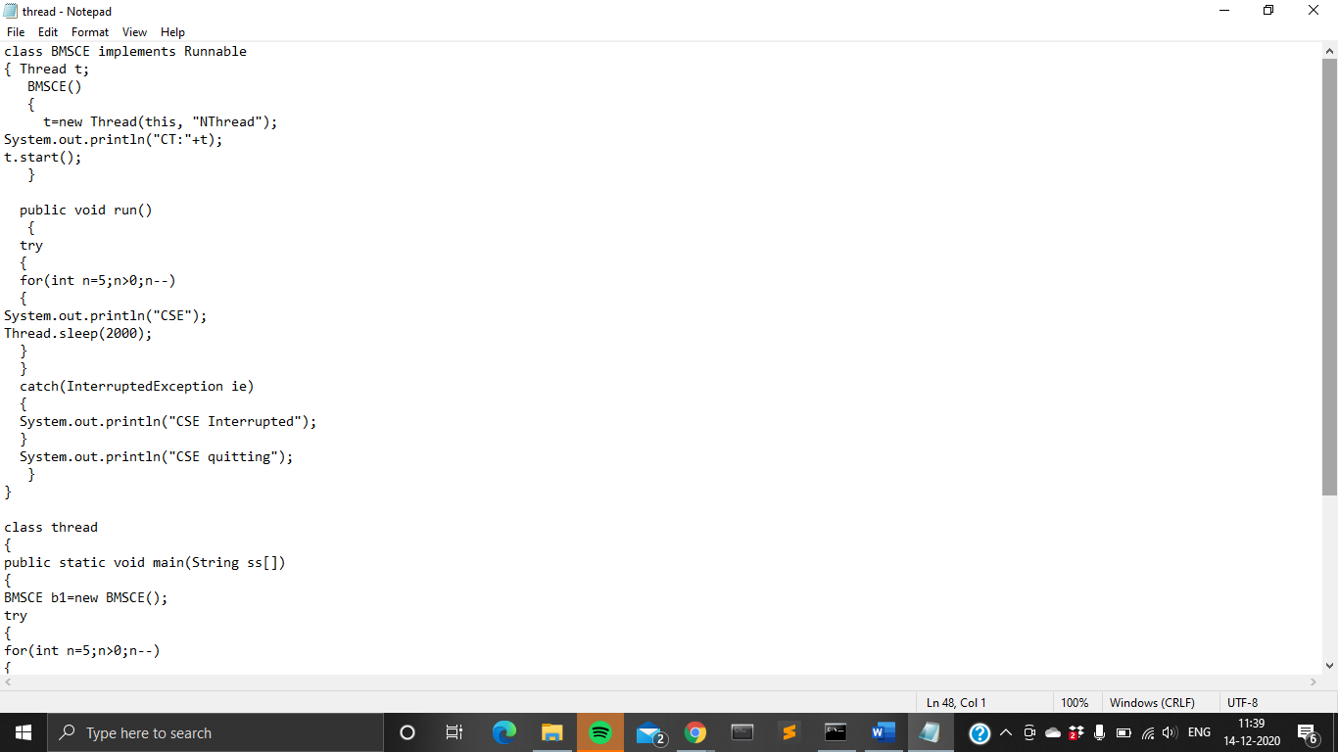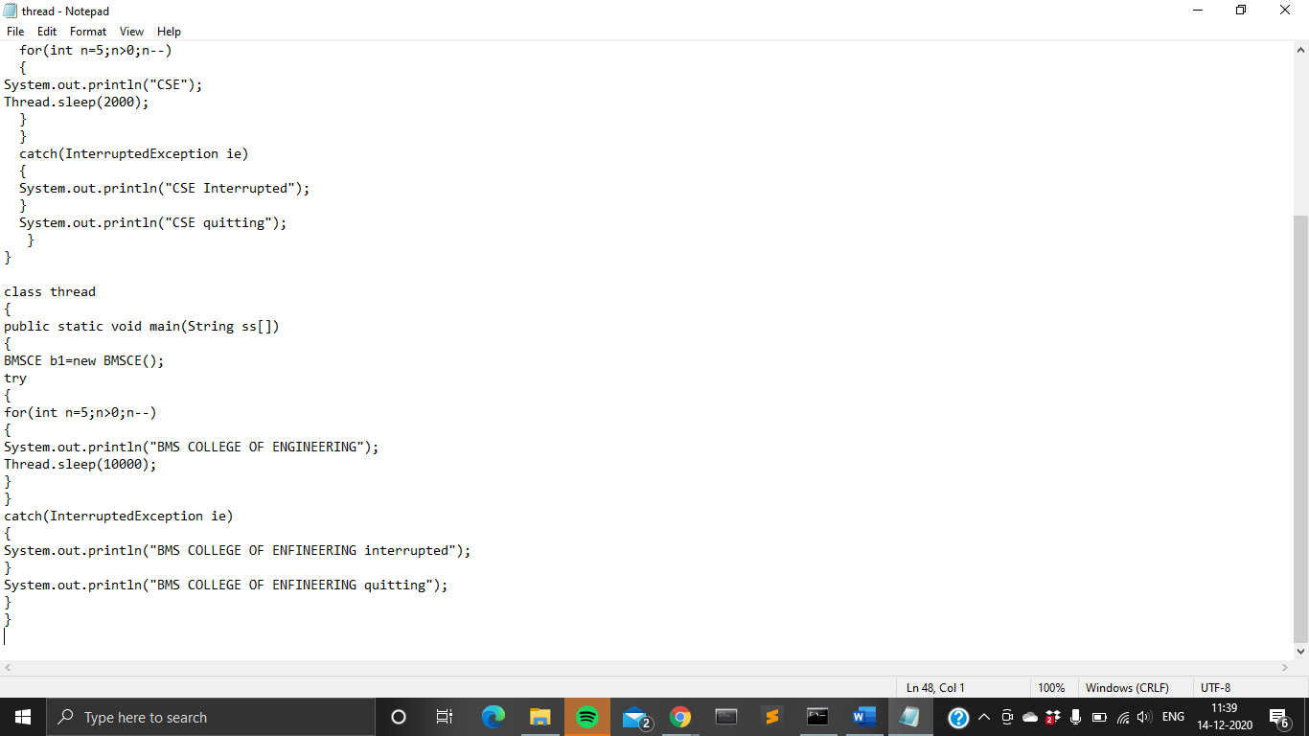

* OUTPUT

