**LAB-4**

**PROGRAM TO PRINT AREA OF A GIVEN SHAPE**

* HANDWRITTEN PROGRAM

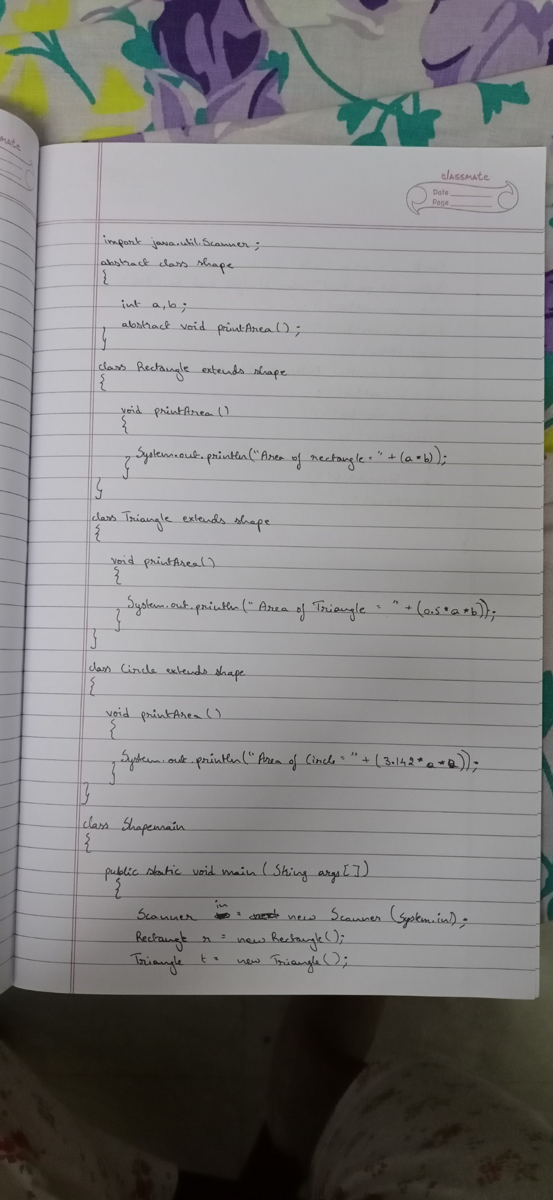

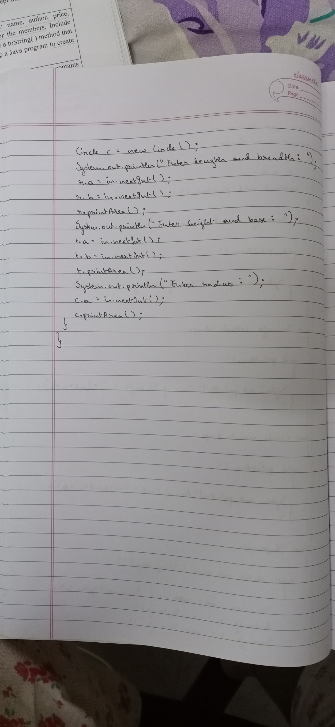

* PROGRAM

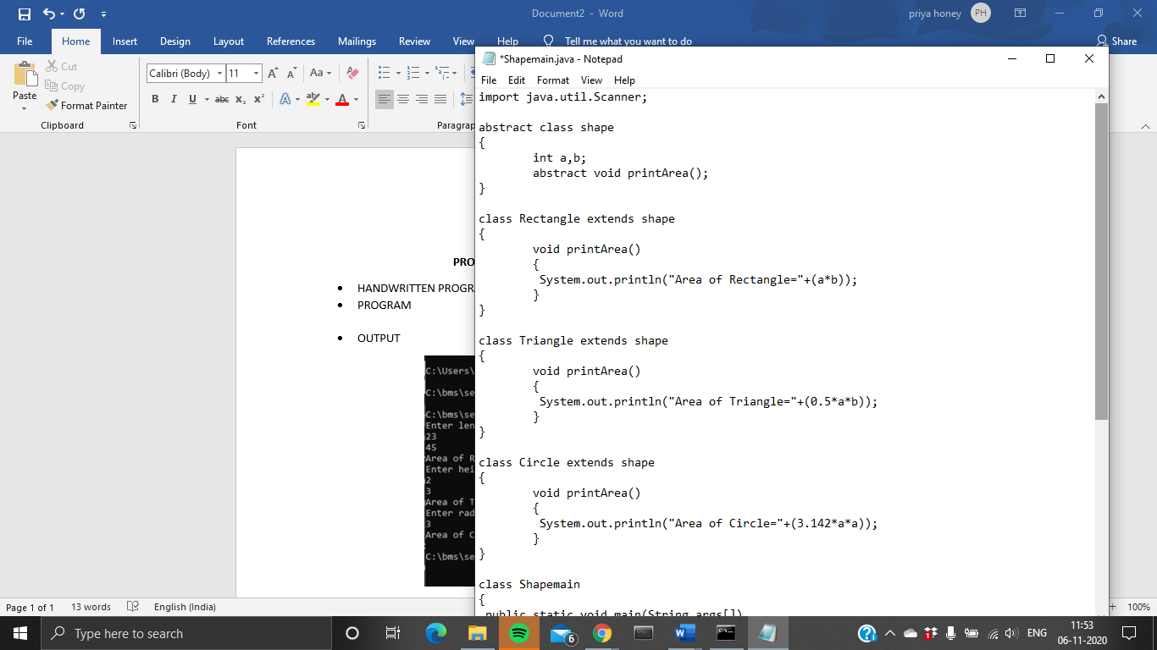

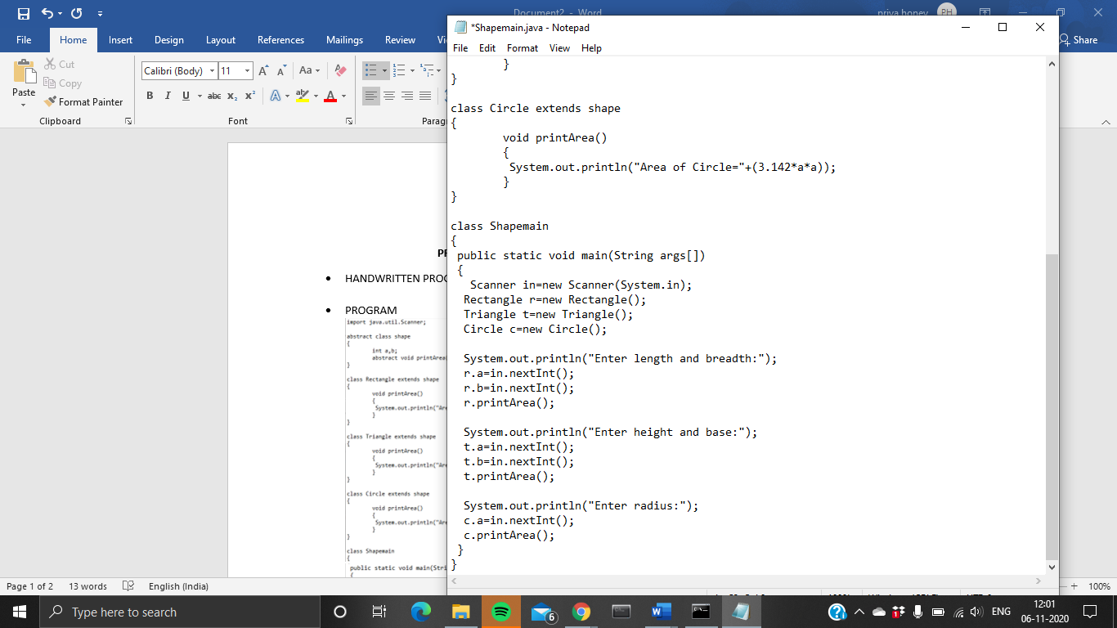

* OUTPUT

