**LAB-7**

**PROGRAM TO DEMONSTRATE GENERICS WITH MULTIPLE OBJECT PARAMETERS**

* HANDWRITTEN PROGRAM

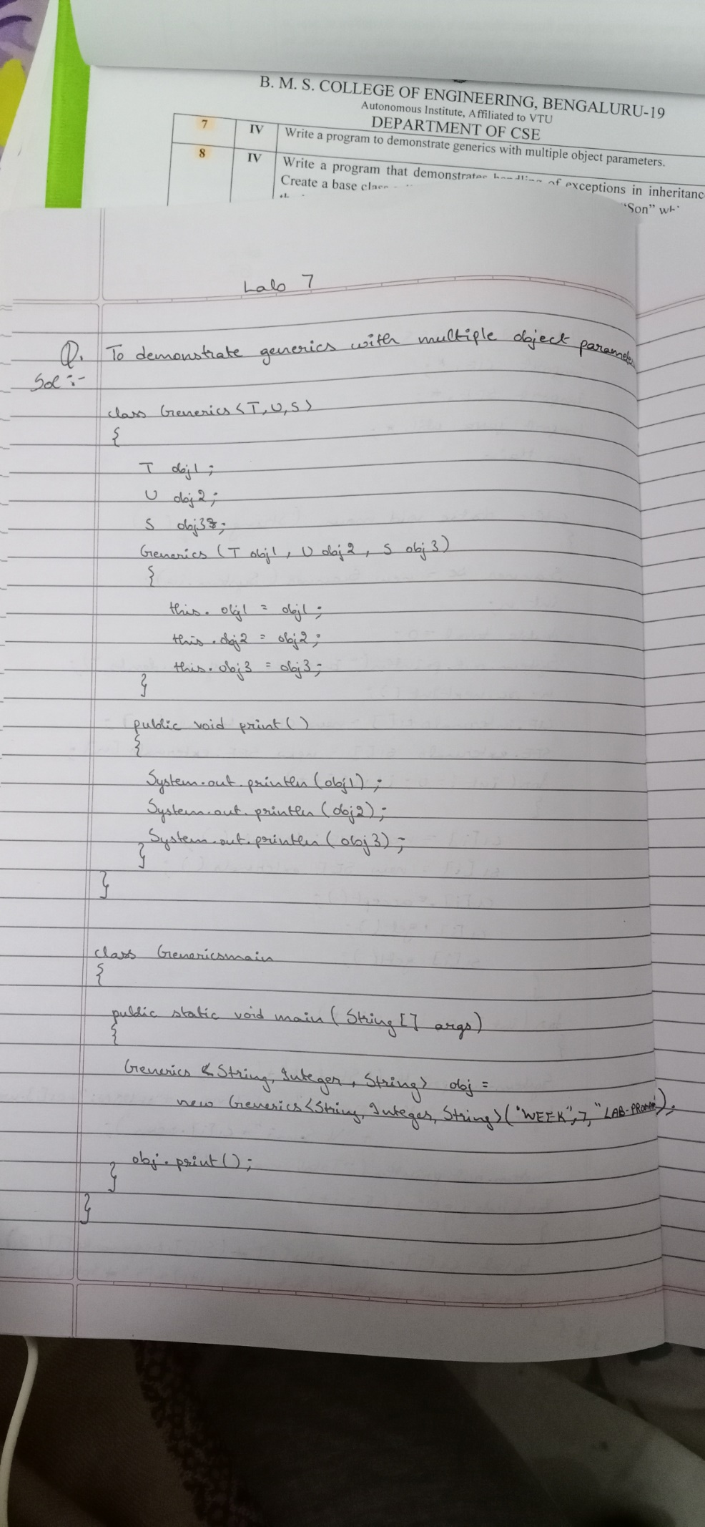

* PROGRAM

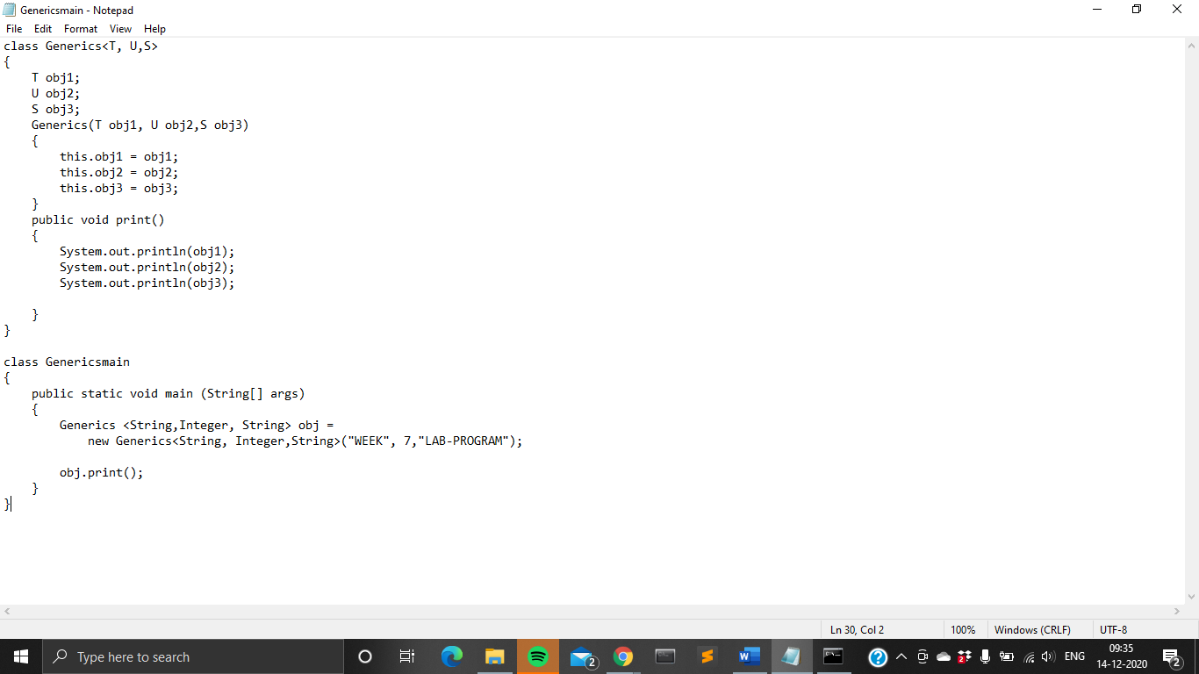

* OUTPUT

