**LAB-8**

**PROGRAM TO DEMONSTRATE THE HANDLING OF EXCEPTIONS IN INHERITANCE TREE**

* HANDWRITTEN PROGRAM

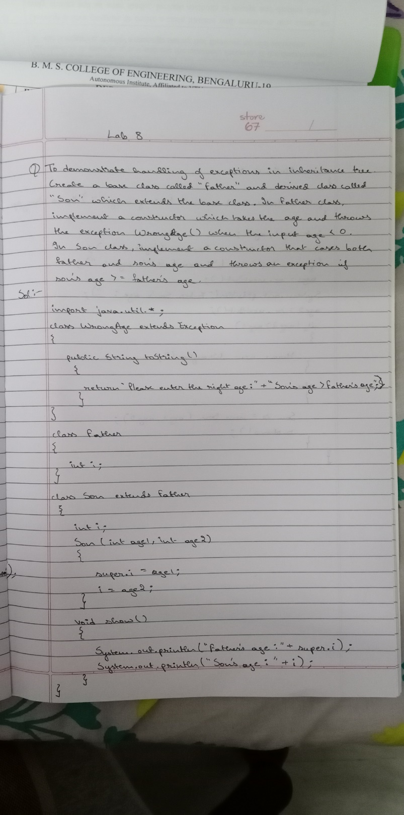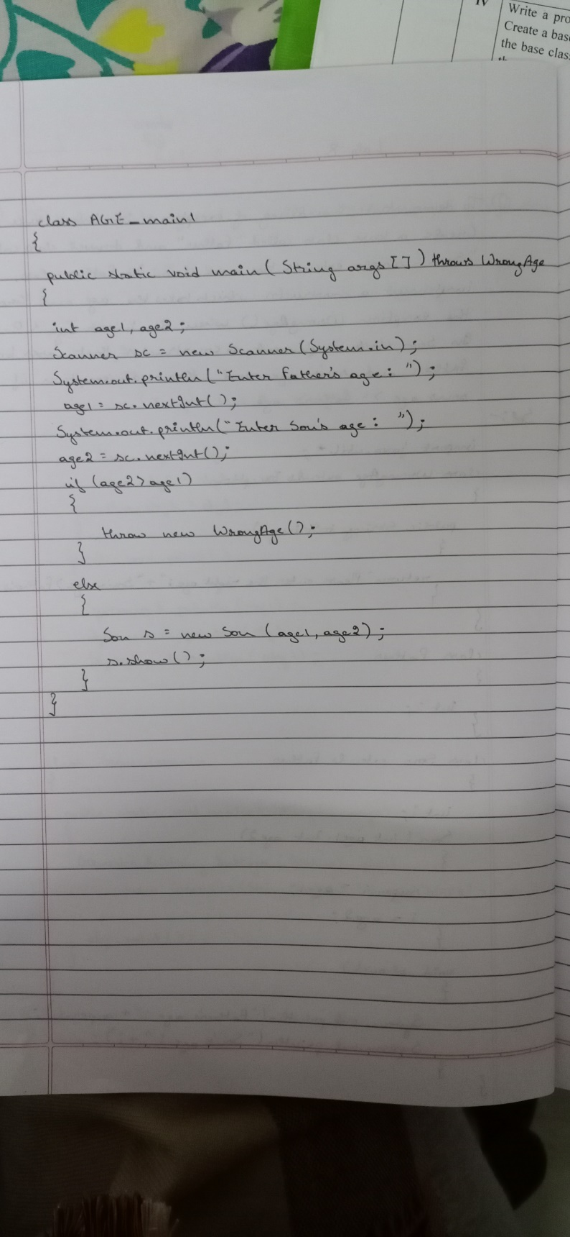

* PROGRAM

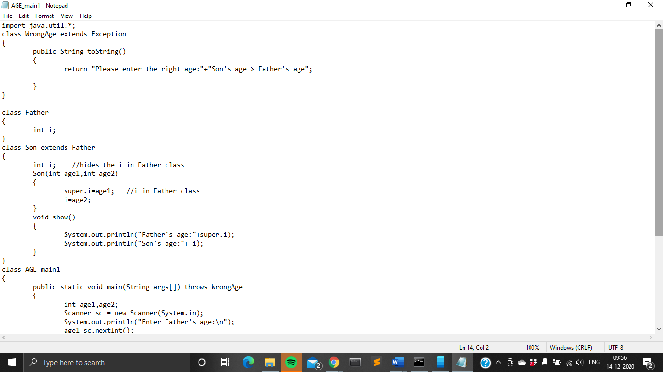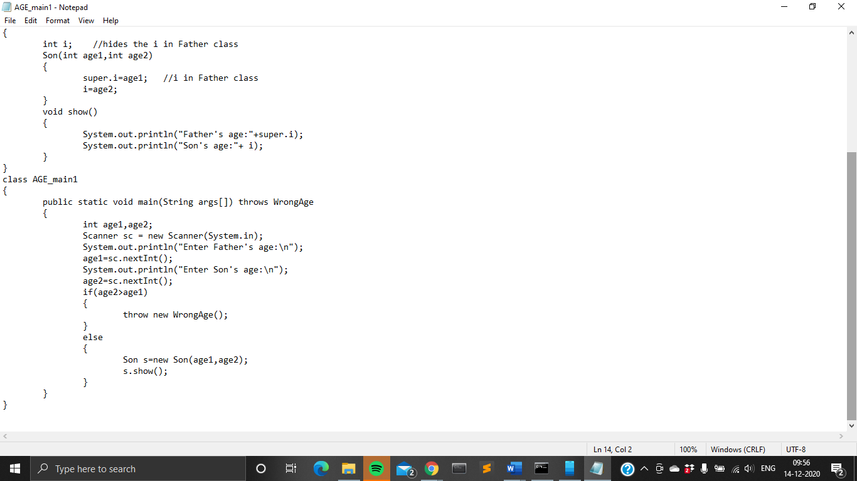

* OUTPUT

