**WEEK 2 PROGRAMS**

1. Hello world program

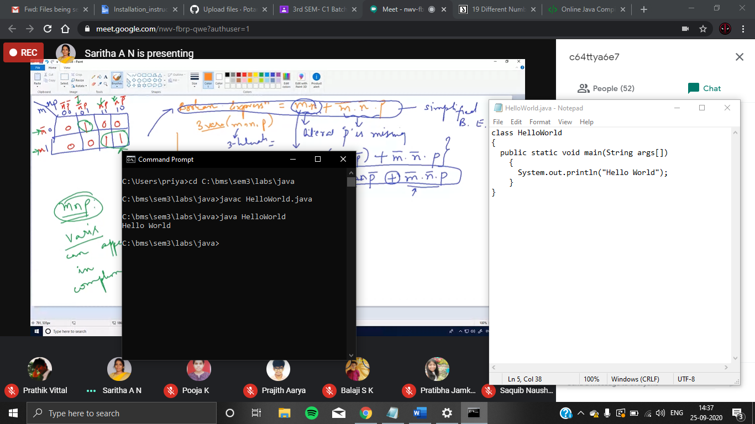



1. Largest of 3 numbers

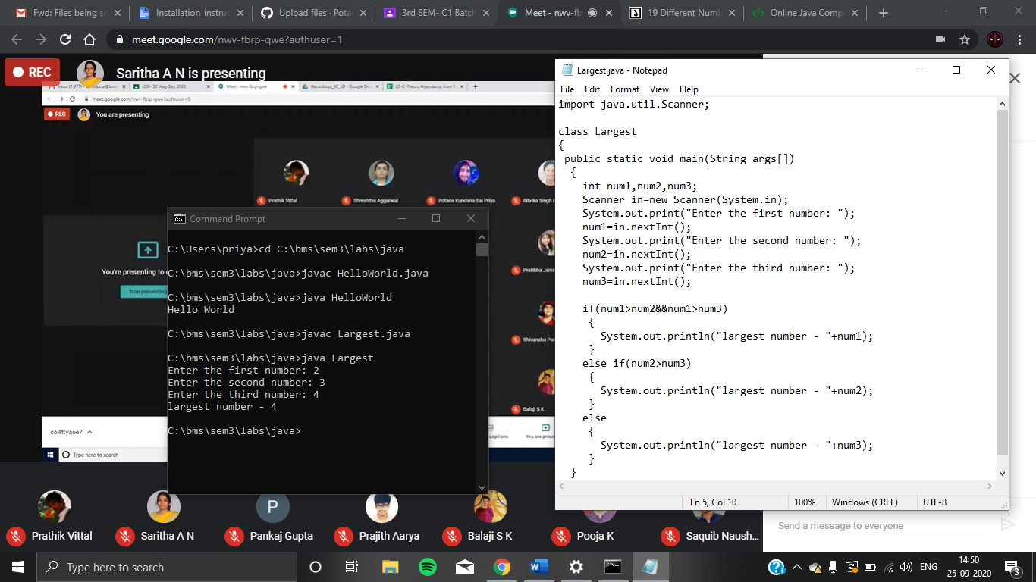



1. Printing numbers from 1 to n

