GeoSpatial Visualizations of USA Religion Distribution

Taten H. Knight  
TatenHKnight@lewisu.edu  
DATA-53000, Summer 2022

Data VisualizationLewis University

# Introduction

The goal of this project is to explore a topic via the use of geospatial visualizations, while keeping in mind the principles of data visualization we have explored to this point. The United States has many different religious groups within its borders, and there are some interesting observations that we can make about the USA’s religious makeup through geospatial visualizations. The following report explores this topic through visual comparison and short related explanations.

# Data Description

The data used for this report is available via the Data.world [1] site, and was originally sourced from Homeland Infrastructure Foundation-Level Data (HIFLD). It contains geographic information about individual religious gathering sites (mosques, temples, churches…), and has supplementary data including membership data, denomination, and subtype. Please see Table 1 for the details of the dataset –*note some irrelevant fields were omitted*.

1. Data Attributes

| Field Name | Example Value | Description |
| --- | --- | --- |
| Objectid | ﻿10438385 | Unique Identifier |
| ID | 1001 | Secondary Identifier |
| Name | FREMONT PRESBYTERIAN CHURCH | Official Name |
| Telephone | 916-452-7132 | Telephone |
| Address | 15333 WOODARD ROAD | Primary Address |
| Address2 | SAINT FRANCIS CABRINI PARISH | Alternate Address |
| City | SAN JOSE | City |
| State | CA | State |
| ZIP | 95124 | ZIP |
| Zipp4 | 2,746 | Zipp4 |
| County | SANTA CLARA | County |
| Fips | 6,085 | FIPS Code |
| Contdate | 10/10/2007 | Currentness date |
| Geodate | GEODATE | Geodate |

# Methodology and results

After inputting the data to Tableau, it was explored by creating various symbol maps and regular maps, and looking for prominent trends or other interesting data characteristics. Fig. 1 shows the first exploratory map that was used. From this first map, we get a sense of which religions are the most obviously prominent, based on the number of gathering places present in certain regions of the US.

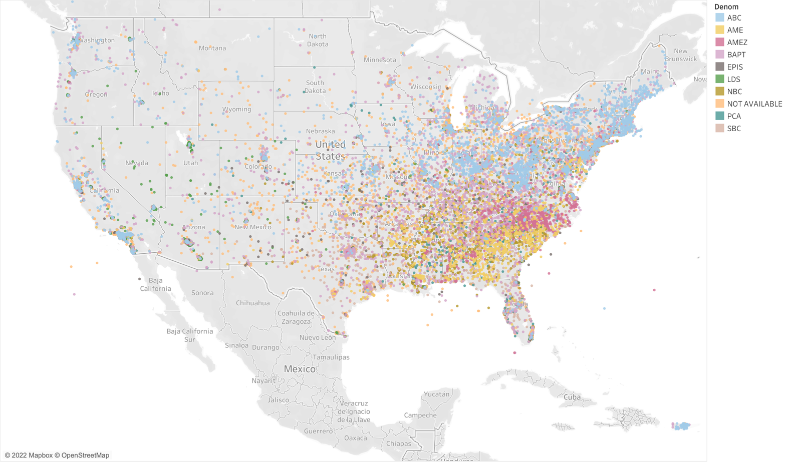

Fig. 1 Religious Gathering Places (Denomination Count > 1000)

The data for the above visualization has been filtered to include only denominations that have greater than one thousand meeting sites across the United States. From the above map we are able to see the most abundant denominations in the US. The Northeast and the West Coast have many American Baptist Churches (ABC). What I would call the Mideast is very Baptist (BAPT) and Episcopal (EPIS), including African Methodist Episcopal (AME) and African Methodist Episcopal Zion (AMEZ). The Southeast is a mixture of BAPT, EPIS, and AME. We also see that the West has a much lower density of places of worship. Fig 2. shows each state colored by the number of unique denominations present there, with darker states indicating more denominations.

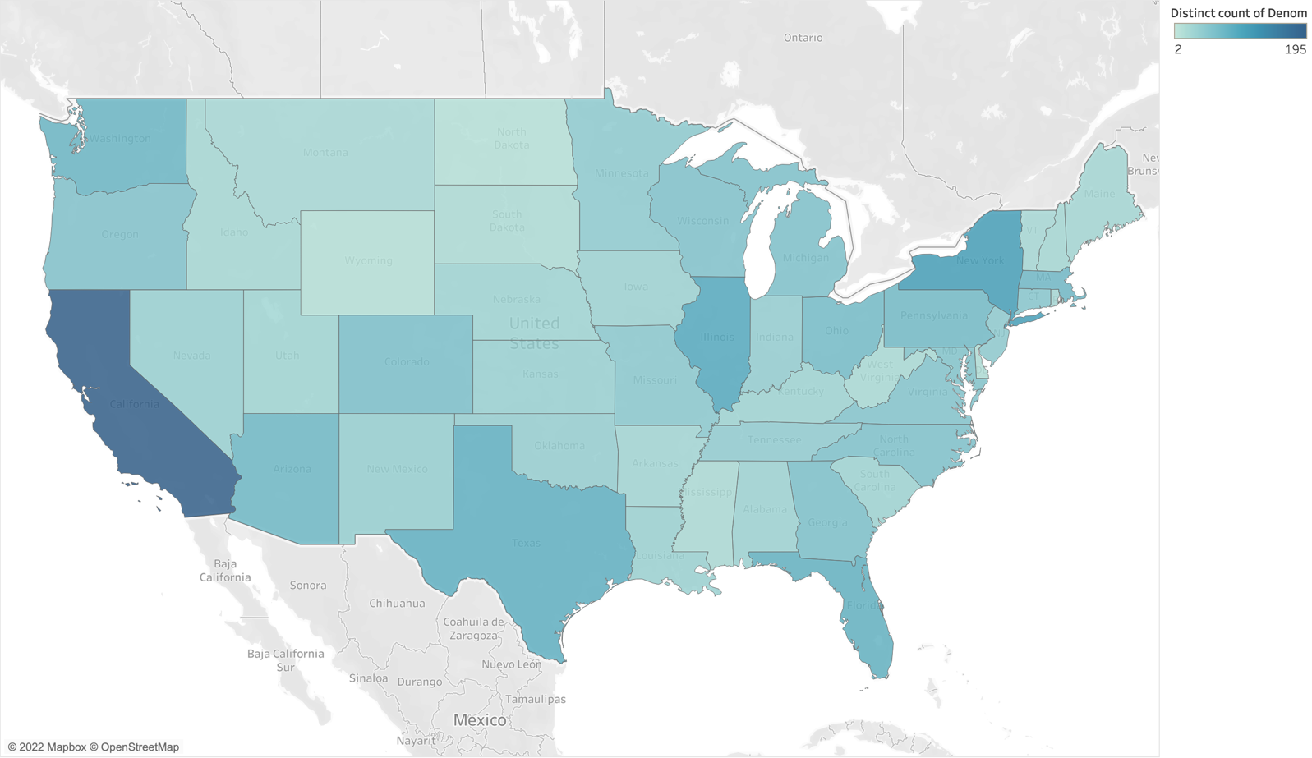

Fig. 2 Denomination Count per State

The figure shows that California has the most distinct religious denominations, followed by New York, Illinois, Texas, and Florida, respectively. Interestingly, California has nearly twice as many denominations as New York –195 versus 108. To clarify, this does not indicate that these denominations do not exist there, only that this dataset did not indicate that these denominations had places of worship there. We can also see that Wyoming and the Dakotas are the least diverse using these indicators. In Fig. 3, we have a density map of all the worship sites without filtering.

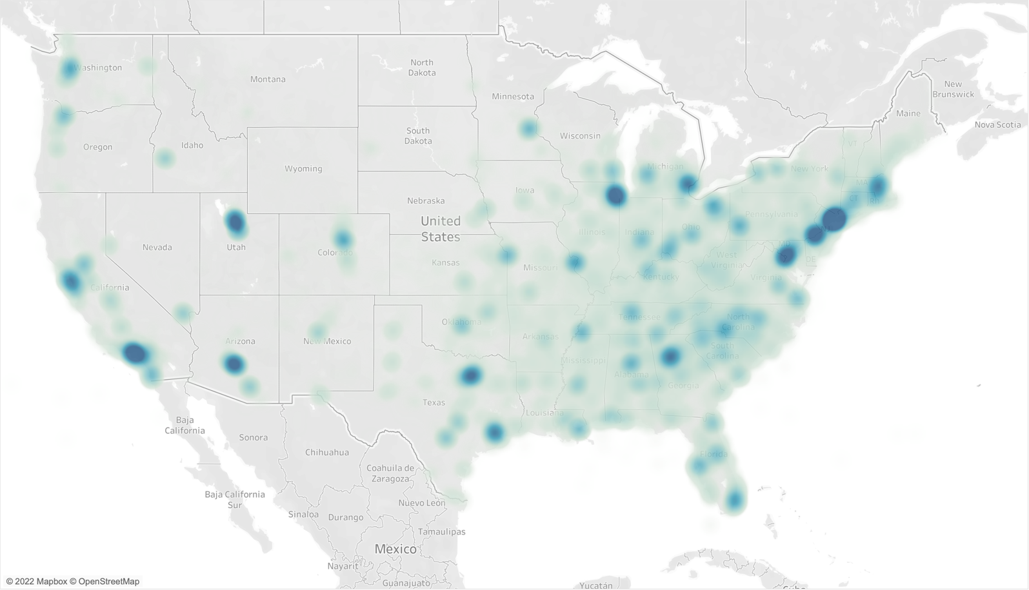

Fig. 3 Density of Places of Worship

The dark blue areas above indicate the highest density of religious sites. We see that these often correspond to areas with high population density like New York City, Phoenix, Los Angeles, and Chicago. Something of note would be how dense the Salt Lake City area is. I grew up in Utah and I would imagine that a large portion of the density is due to the LDS sites there, so I decided to restrict the area and look only at this region to test my hunch. Fig 4. is the same as Fig. 1 but restricted to Utah.

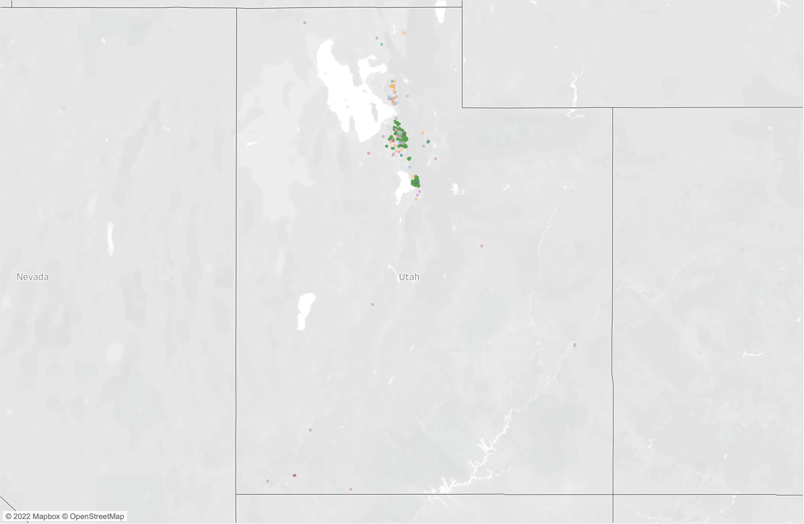

Fig. 4 Utah Places of Worship

The hunch was correct; the green above is representative of LDS church locations. We can see that the only major discernable cluster of sites belongs to the LDS denomination, and that these clusters are located in Northern Utah in the Salt Lake City / Provo area.

# Discussion

In this report we used geospatial data to create choropleth maps, heatmaps, and simple “” to explore the trends available via a dataset on religious worship sites in the United States. We looked at the prominent religious denominations across various regions in the United States, the density of worship sites, and the diversity (or lack thereof) in various states. We also dove deeper into a single observation to test the data against a personal hypothesis. With each visualization I kept the number of datapoints and dimensions reasonable to increase readability, and used the appropriate visual to represent the type of data at hand. I also made sure to use color schemes that were readable and increased the contrast between disparate data.

# Conclusions

Working with this dataset opened my eyes to a few of the potential use cases for different geospatial visualizations, and helped me appreciate Tableau’s usefulness in exploring the data and creating the final products for presentation purposes. I also learned quite a bit about the religious makeup of the United States through this data exploration.

##### References

[1] “US Places of Worship,” User Chris (@awram) via HIFDL [Online]. Available: https://data.world/awram/us-places-of-worship