Theorem Proving

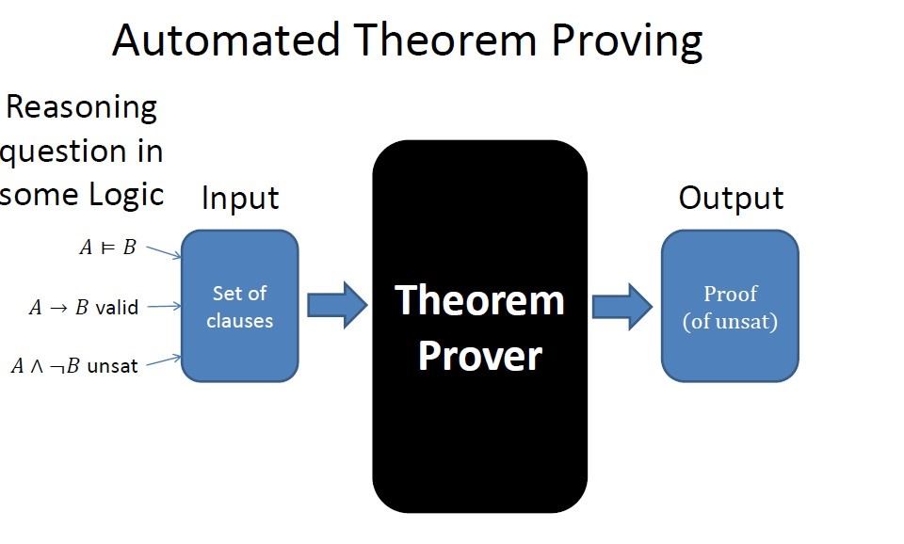

Lucien Ngalamou

A Framework for Software Verification

Introduction to Theorem Proving (Automatic Theorem Proving)

Hoare Logic

Outline

Class Activity

The KeY Project

I Convert the informal description R of requirements for an application domain into an ”equivalent” formula *φR* of some logic;

I Write a Program which is mean to realize *φR* in the programming environment supplied by your company, or wanted by the particular customer;

A Framework for Software Verification

I Prove that the program P satisfy the formula *φR*.

What is an automated theorem prover?

Input Output

Yes/no

Theorem Proof

ATP

“Counterexample”

# Example theorems

* Pythagoras theorem: Given a right triangle with sides A B and C, where C is the hypotenuse, then C2 = A2 + B2
* Fundamental theorem of arithmetic: Any whole number bigger than 1 can be represented in exactly one way as a product of primes

# The model checking approach

* Create a model of the program in a decidable formalism
* Verify the model algorithmically
* Difficulties

– Model creation is burden on programmer – The model might be incorrect.

* If verification fails, is the problem in the model or the program?

# The axiomatic approach

* Add auxiliary specifications to the program to decompose the verification task into a set of local verification tasks
* Verify each local verification problem • Difficulties

– Auxiliary spec is burden on programmer – Auxiliary spec might be incorrect.

* If verification fails, is the problem with the auxiliary specification or the program?

# Example Theorem

* The program “z = x; z = z + y;” computes the sum of ‘x’ and ‘y’ in ‘z’ according to the semantics of C
* Program-Semantics  Specification

# Theorem

* Theorem must be stated in formal logic
  + self-contained
  + no hidden assumptions
* Many different kinds of logics (propositional logic, first order logic, higher order logic, linear logic, temporal logic)
* Different from theorems as stated in math
  + theorems in math are informal
  + mathematicians find the formal details too cumbersome

# Human assistance

* Some ATPs require human assistance

– e.g.: programmer gives hints a priori, or interacts with ATP using a prompt

* Hardest theorems to prove are “mathematically interesting” theorems (eg: Fermat’s last theorem)

# Output

* Can be as simple as a yes/no answer
* May include proofs and/or counterexamples
* These are formal proofs, not what mathematicians refer to as proofs
* Proofs in math are
  + informal
  + “validated” by peer review
  + meant to convey a message, an intuition of how the proof works -- for this purpose the formal details are too cumbersome
* If the theorem prover says “yes” to a formula, what does that tell us?
  + Soundness: theorem prover says yes implies formula is correct
  + Subject to bugs in the Trusted Computing Base (TCB)
  + Broad defn of TCB: part the system that must be correct in order to ensure the intended guarantee
  + TCB may include the whole theorem prover
  + Or it may include only a proof checker
* If the theorem prover says “no” to a formula, what does that tell us?
  + Completeness: formula is correct implies theorem prover says yes
  + Or, equivalently, theorem prover says no implies formula incorrect
  + Again, as before, subject to bugs in the TCB
* ATPs first strive for soundness, and then for completeness if possible
* Some ATPs are incomplete: “no” answer doesn’t provide any information
* Many subtle variants
  + refutation complete
  + complete semi-algorithm

# Theorem Proving and Software

Meets spec/Found Bug

Theorem

in a logic

Program

Specification

Semantics

VC

generation

Validity

Provability

theorem proving

)

(

* Soundness:
  + If the theorem is valid then the program meets specification
  + If the theorem is provable then it is valid

Programs ! Theorems = Axiomatic Semantics

* Consists of:
  + A language for making assertions about programs
  + Rules for establishing when assertions hold
* Typical assertions: – During the execution, only non-null pointers are dereferenced
  + This program terminates with x = 0
* Partial vs. total correctness assertions
  + Safety vs. liveness properties
  + Usually focus on safety (partial correctness)

A Framework for Software Verification

Introduction to Theorem Proving (Automatic Theorem Proving)

Hoare Logic

Class Activity

The KeY Project

Hoare Logic

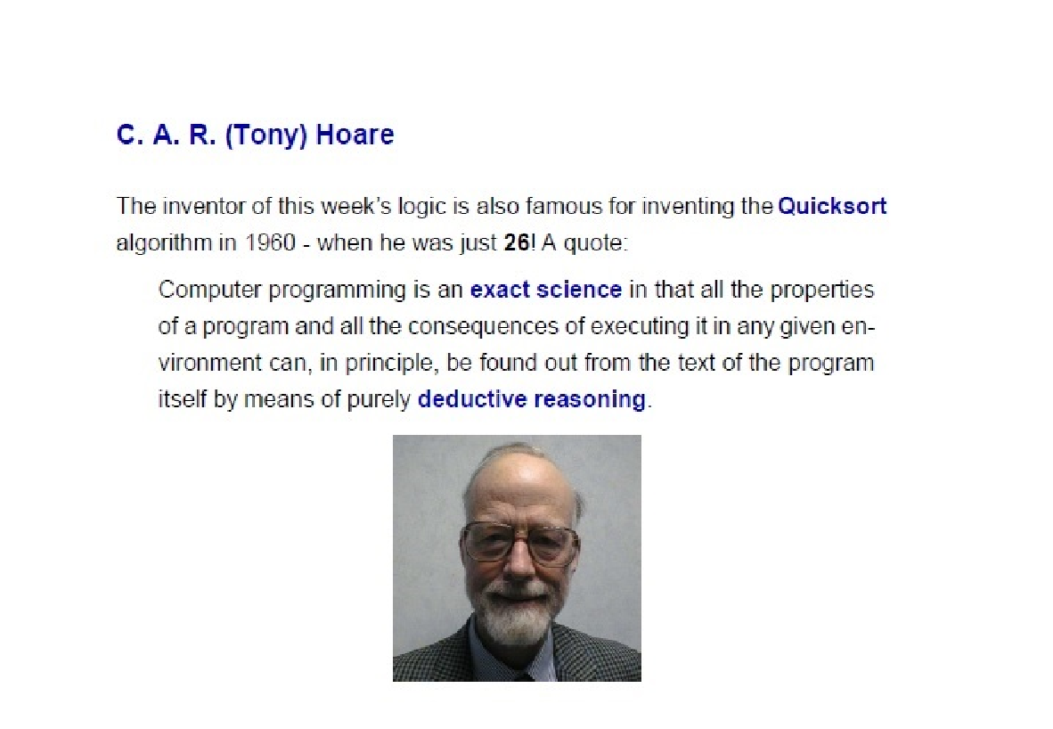

A way of asserting properties of programs.



Hoare triple: {*A*}*P*{*B*} asserts that “If program *P* is started in a state satisfying condition *A*, if it terminates, it will terminate in a state satisfying condition *B*.” A proof system for proving such assertions.

Hoare Logic



A way of reasoning about such assertions using the notion of “Weakest Preconditions” (due to Dijkstra).

A simple programming language skip x := *e* (assignment) if *b* then *S* else*T* (if-then-else) while *b* do *S* (while) *S* ; *T* (sequencing)



1. := n;a := 1; while (x ≥ 1) { a := a * x;

Example program



* 1. := x - 1

}

Programs as State Transformers

View program *P* as a partial map [*P*] : *Stores* → *Stores*.

All States

{*x* 7→ 2*, y* 7→ 10*, z* 7→ 3}



State

*s*

State

*t*

*P*

* 1. = y + 1;z = x + y

{*x* 7→ 2*, y* 7→ 11*, z* 7→ 12}

Predicates on States



All States

States satisfying

Predicate A

~~A~~

Eg.

*x*

≥

0

∧

*x*

*<*

*y*

Assertion of “Partial Correctness” {*A*}*P*{*B*}

{*A*}*P*{*B*} asserts that “If program *P* is started in a state satisfying condition *A*, either it will not terminate, or it will terminate in a state satisfying condition *B*.”

All States



*P*

*A*

*B*

{10 ≤ *y*}

1. = y + 1;z = x + y

{*x < z*}

Skip:

{*A*}skip{*A*}

Proof rules of Hoare Logic



Assignment

{*A*[*e/x*]}x := e{*A*}

Proof rules of Hoare Logic

If-then-else:

{*P* ∧ *b*} *S* {*Q*}*,* {*P* ∧¬*b*} *T* {*Q*}

{*P*}if *b* then *S* else *T* {*Q*}

While (here *P* is called a *loop invariant*)

{*P* ∧ *b*} *S* {*P*}

{*P*}while *b* do *S* {*P* ∧¬*b*}



Sequencing:

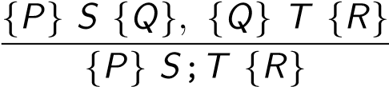

Weakening:

## *P* =⇒ *Q,* {*Q*} *S* {*R*}*, R* =⇒ *T*

{*P*} *S* {*T*}

I Download from BB (Week 5) and read the file hoare-logic.pdf

(15 minutes to 20 minutes)

A Framework for Software Verification

Introduction to Theorem Proving (Automatic Theorem Proving)

Hoare Logic

Class Activity

The KeY Project

Class Activity

I Discussion

I The KeY Tool (https://www.key-project.org) is a to Deductive Verification of Object-Oriented Programs

I The currently most prominent applications are:

I Program Verification (Standalone GUI, Eclipse Integration, KeYHoare)

A Framework for Software Verification

Introduction to Theorem Proving (Automatic Theorem Proving)

Hoare Logic

Class Activity

The KeY Project

The KeY Project (Formal Methods for Components and

Objects Conf. 2006)

I Debugging (Symbolic Execution Debugger)

I Information Flow Analysis / Security I Test Case generation (KeYTestGen)

Java as target language

Dynamic logic as program logic

Verification = symbolic execution + induction

Sequent style calculus + meta variables + incremental closure

Prover is interactive + automated Integration with two standard SWE tools:



TogetherCC, a commercial CASE tool

Eclipse, an open extensible IDE

Some Buzzwords Early On

Specification languages

JML

OCL/UML

Smart cards as main target application

Deductive Verification of OO Programs: Introduction 4 / 57

Object Constraint Language Part of the OMG standard UML

Supported Specification Languages:

OCL

Scope:

Add formal constraints to UML (class) diagrams

Java Modeling Language

Behavioral interface specification language for Java

International community effort lead by Gary T. Leavens, Iowa State building on the Larch approach

Supported Specification Languages:

JML

Comes with assertion and runtime checkers

## OCL and JML

both



specify method behaviour: pre/post conditions



specify admissible states: class invariants



essentially full first order



support inter-object navigation

differences



OCL model oriented:



attached to class diagrams



‘talks’ UML



JML implementation oriented:



attached to Java programs



‘talks’ Java



specifies exceptional behaviour also



JML only: restricting scope of side effects

## JML example

/*@ public normal_behavior

@ requires a != null;

@ ensures (\forall int j; j >= 0 && j < a.length;

@ \result >= a[j]);

@ ensures a.length > 0 ==>

@ (\exists int j; j >= 0 && j < a.length;

@ \result == a[j]);

@*/ public static /*@ pure @*/ int max(int[] a) { if ( a.length == 0 ) return 0; int max = a[0], i = 1; while ( i < a.length ) { if ( a[i] > max ) max = a[i];

++i;

}

return max;

}

## KeY Architecture

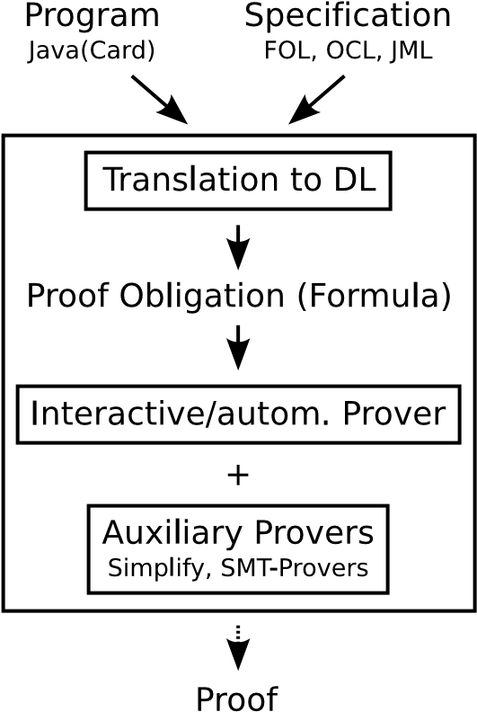

## Components of the Calculus

1. Non-program rules

first-order rules

rules for data-types (primarily: arithmetic) rules for modalities



1. Rules for reducing/simplifying the program (symbolic execution)

Replace the program by combination of

case distinctions (proof branches) and sequences of updates

1. Rules for handling loops

rules using loop invariants unwinding + induction

1. Rules for replacing a method invocations by the method’s contract
2. Update simplification

Deductive Verification of OO Programs: A Calculus for 100% JavaCard

Coverage of Java features

The calculus covers:



method invocation, dynamic binding



polymorphism



abrupt termination



checking for nullpointer exceptions



object creation and initialisation



arrays



finiteness of integer data types



transactions (JavaCard)



By that, KeY covers the full ‘JavaCard’ language.

## Java Card



Subset of Java, but with transaction concept



Sun’s official standard for

Smart Cards

and embedded devices

Why Java Card?



Good example for real-world object-oriented language

JavaCard has

*no*



garbage collection



dynamical class loading



multi-threading



floating-point arithmetic

Application areas



security critical



financial risk

(

e.g. exchanging smart cards

is expensive)

## Implementing Rules: Taclets

Uniform language for different classes of rules



First-order calculus



Specific to JavaDL: symbolic execution for Java



Axioms of theories: arithmetic, lists, etc.



Lemmas

Simple, high-level language



Adding, modifying, and removing formulas



Conditions restricting applicability of rules



No complex features like loops



Suitable both for interactive and automated systems



Lemmas are validated wrt. base taclets

## Library Case Studies

Java Collections Framework (JCF)

Part of JCF (treating sets) specified using UML/OCL Some parts of reference implementation verified

Java Card API

Most parts of JavaCard API specified using UML/OCL Some parts of reference implementation verified



Schorr-Waite Algorithm

Standard benchmark for verification systems

Graph marking algorithm for garbage collection

Java implementation: 2 classes, core algorithm 25 lines of code

Heavy aliasing, frame problem

Specified and verified

## Security Case Studies: Java Card Software

Safety/security properties specified in dynamic logic

‘Only certain exceptions can be thrown’

Transactions are properly used

(do not commit or abort a transaction that was never started, all started Transactions are also closed)



Data consistency

(also if a smartcard is “ripped out” during operation) Absence of overflows for integer operations

Two studies in this area

(for which some critical parts were verified)

Demoney (about 3000 lines):

Electronic purse application provided by Trusted Logic S.A.

SafeApplet (about 600 lines): RSA based authentication applet

## Safety Case Study

Computation of Railway Speed Restrictions

Software by DBSystems for computing schedules for train drivers:

Speed restrictions, required break powers

Software formally specified using UML/OCL (based on existing informal specification)

Program translated from Smalltalk to Java

Avionics Software

Java implementation of a Flight Manager module at Thales Avionics

Comprehensive specification using JML, emphasis on class invariants Verification of some nested method calls using contracts



Virtual Machine for Real Time Secury Java

Verification of some library functions of the Jamaica VM from Aicas