Emotion Recognition from Facial Expression
Nabil Sherif, Natalie Monged and Lillian Stephanos
Cairo University
Abstract. This study investigates the effectiveness of convolutional neural networks (CNNs) ResNet50, and VGG16 models, for facial expression- grounded emotion recognition. Originally, the study explores these models without an optimizer, counting on transfer literacy via fine- tuning ways withdrew-trained layers from ImageNet to classify seven distinct emotional countries from facial images. latterly, an optimized approach employing an inheritable optimizer is introduced. The inheritable optimizer is employed to fine- tune the CNN models, enhancing their capability to discern feelings from facial cues. relative analysis between the models trained without an optimizer and those optimized using the inheritable algorithm illustrates the impact of optimization on the delicacy and robustness of emotion recognition systems. The findings punctuate promising results in both scripts, showcasing the rigidity of CNNs for emotion recognition tasks.

- Introduction
The study of automatic emotion recognition is a quickly developing multidisciplinary area that combines the fields of human psychology and artificial intelligence (AI). By analyzing both spoken and nonverbal signs, such as physiological signals, vocal tones, and changes in facial expressions, it focuses on deciphering people’s emotional states [1, 7]

From lie detection and the development of multimodal human-computer interfaces to pain evaluation, neurology, clinical psychology, psychiatry, and smart settings, automated facial expression analysis has many applications [4]. It is impossible to overestimate the importance of facial expressions in human communication since they provide nonverbal cues that enhance spoken exchanges [7]. According to research, between 60 percent and 80 percent of human communication is thought to be nonverbal.

In their seminal study, Ekman et al. established six basic human emotions: pleasure, anger, contempt, fear, sadness, and surprise [8]. Emotion recognition was made possible with the introduction of the Facial Action Coding System (FACS) in 1978. To describe face motions, it uses Action Units (AUs) as classification units. A thorough description of face expressions is possible with FACS thanks to its 46 AUs, each of which corresponds to a different facial muscle [1].

Ekman identified six fundamental human emotions et al. in their groundbreaking research: pleasure, anger, contempt, fear, sadness, and surprise [8]. The Facial Action Coding System (FACS) was introduced in 1978 and made emotion recognition possible. Action Units (AUs) are used as classification units to represent face gestures. FACS’s 46 AUs, each of which correlates to a distinct facial muscle, enables a comprehensive description of facial expressions [1].

In 1967, Mehrabian conducted a groundbreaking study that revealed nonverbal cues as the main means of transmitting emotional information. This study highlighted the critical role that nonverbal communication plays in the conveyance of emotions, finding that 55 percent of emotional information is communicated visually, 38 percent through voice signals, and only 7 percent through spoken language [10]. Facial expressions are the most obvious and early nonverbal indications about someone’s emotional state among all these others.

Emotional recognition technology is unique in that it can determine someone’s emotional state without asking them directly. Beyond just understanding emotions, this capacity may also be used to identify early indicators of diseases or illnesses, which would support preventative healthcare. Through its exploration of the complex emotional network, this technology provides insightful information on a person’s mental state and general health [1].

According to statistical analyses conducted by Philipp et al., one of the most thoroughly studied modalities in emotion recognition is Automatic Facial Emotion Recognition (FER). But it presents difficulties because of things like personal differences in how they express their emotions, background, age, gender, and head position, and barriers from things like scarves, sunglasses, or skin disorders [2, 3, 5, 6].

Texture- and geometric-based approaches, such as Gabor wavelets, Local Binary Patterns (LBP), face Action Units (FAC), and Local Directional Patterns (LDA), are examples of traditional methods for extracting face features [2, 4, 5, 6]. These methods have proven crucial in the field of feature extraction and have established the basis for the identification of emotions on the face.

The objective of this study is to progress the development of accurate and effective methods for recognizing and interpreting facial expressions as indicators of emotion. It aims to deepen our understanding of human emotions and facilitate the creation of systems that can better mental health monitoring, human-computer interactions, and a host of other domains where emotion recognition is critical by investigating a variety of algorithms, methodologies, and applications.

- Related Work
  - Emotion Recognition via Facial Expressions
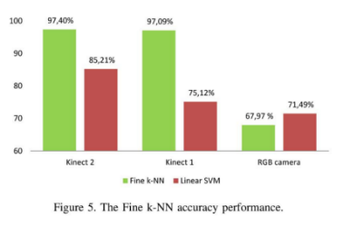
In this subsection, we examine one of the works that has been done in previous studies related to [Emotion Recognition]. Authors [Kahina Amara, Naeem Ramzan, Naeem Ramzan, Mahmoud Belhocine, Cherif Larbas, Cherif Larba] (2018) which was widely adopted due to its efficiency in the topic Emotion Recognition via Facial Expressions. in This work, a novel method for recognizing emotions through facial expressions is introduced, utilizing a combination of angle and distance measurements between key facial points as features. The paper also introduces a new data set containing performance data from 17 individuals. A performance comparison is conducted between RGB and RGB-D data for facial emotion recognition. The non-linear Fine K-NN algorithm consistently yields reliable results due to the nature of the data. According to the findings, the comparison chart clearly demonstrates that RGB-D data outperforms RGB data in terms of accuracy. It is observed that RGB-2D images lack the robustness required for recognizing facial emotions, given that faces are three-dimensional objects.

Additionally, RGB-D images can capture crucial geometric features that remain unaffected by various conditions, thereby ensuring higher precision and preserving intricate facial details.[11]

Based on the study’s findings, it is evident that RGB-D images have the capability to capture vital geometric characteristics with greater precision and resilience to variations in environmental conditions. Conversely, the underperformance of RGB data can be attributed to its sensitivity to the surroundings, particularly in response to changes in lighting conditions [12] and alterations in facial poses. In this study, they used for the non-linear training classifier Fine k-NN. It is conceptually simple, yet able to solve complex problems and to solve the multi-class problem, they defined six computational models to classify the six target six emotional states (surprise, fear, happiness, sadness, anger, and neutral) [11]

For models performance evaluation:
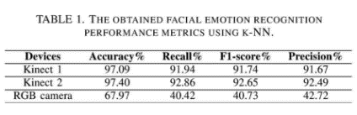
This is the result:

  - Emotion Recognition Based on Facial Expressions Using Convolutional Neural Network (CNN)
In this subsection, we examine one of the works that has been done in previous studies related to [Emotion Recognition]. Authors [Sabrina Begaj, Ali Osman Topal, Maaruf Ali] (2018) which was widely adopted due to its efficiency in the topic Emotion Recognition via Facial Expressions.

There are different methods that are used for Face Expression Recognition in the last 20 years but usually they are separated into two main methods: Conventional or Traditional FER Approach and Deep Learning-based approach [13]

There are some challenges that faced them in this work like

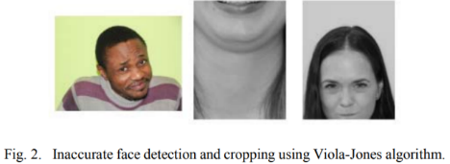
According to the dataset that had been used in this work the images are quite big with more than 66 percent of them having unnecessary information. That is why cropping of the face part was needed.

For this, two different approaches were utilized: firstly, the utilization of the Viola-Jones [14] algorithms for both detecting and cropping faces; secondly, the manual detection and cropping of faces. The primary objective of this was to assess the variations and the impact they would have on accuracy at a later stage. In terms of time efficiency, the use of the Haar Cascade algorithm proved to be a notably rapid and effective method, while manually cropping images one by one was notably time-consuming. However, in terms of accuracy, the algorithm sometimes produced incorrect crops by including the neck as part of the face, particularly in cases where the facial orientation was not perfectly aligned. Some instances of these inaccuracies are illustrated in Figure 2.[13]

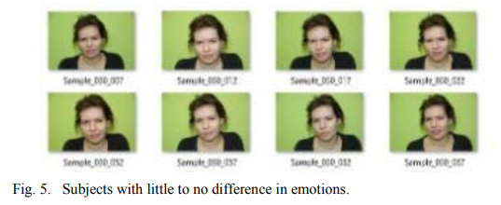
And another significant challenge that had consequences for the algorithm was the observation that certain individuals did not exhibit clear distinctions between different emotions. This issue presented challenges in accurately classifying emotions, as there could be instances of overlapping emotions. Figure 5 illustrates cases where subjects displayed minimal variations in their emotional expressions. [13

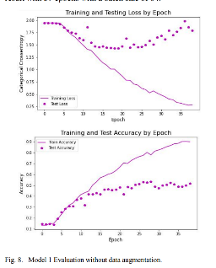
The initial CNN network implementation consisted of four Convolutional Layers, four Max Pooling Layers, one dropout layer, and two Fully Connected Layers, resulting in a total of 899,718 parameters within the model. In the initial process, the image underwent convolution with Conv2D filters, followed by the application of the ReLU (rectified linear activation function). Subsequently, the pooling layer (MaxPooling2D) selected the maximum values from the convolution layer, effectively reducing the image dimensions. The process then involved the Flatten and Dropout layers. Figure 8 displays the outcome achieved after training the model for 39 epochs with a batch size of 64.[13]

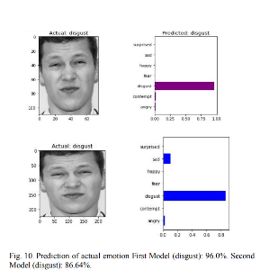
Their models determined emotions by assigning specific percentages to each emotion or label. The ultimate expression was decided based on the emotion with the highest weight, as depicted in Figure 10. Table II provides examples of the first two images, illustrating the probabilities (ranging from 1 to 0) assigned by the model to the seven emotions.[13]

  - Deep-Emotion: Facial Expression Recognition Using Attentional Convolutional Network:
The field of facial expression recognition research has been continuous and has encountered difficulties because of variances within the same emotion class. Conventional approaches struggle with more complicated datasets but work well in controlled environments since they rely on manually constructed features and classifiers. Deep learning has been used in recent techniques for end-to-end facial expression recognition, with better results but still potential for improvement. This paper presents a deep learning attentional convolutional network that can focus on important face regions and achieves notable improvements over earlier models on many datasets, such as FER-2013, CK+, FERG, and JAFFE. The study also uses a visualization tool to pinpoint key facial areas for recognizing distinct emotions, showing that certain emotions are connected to facial features.

2.3.1 The Proposed Framework

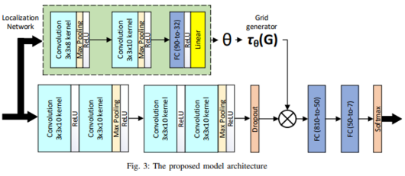
To categorize the underlying emotion in the face photos, we present an end-to-end deep learning system based on attentional convolutional networks. Adding extra layers or neurons, promoting gradient flow in the network (e.g., by adding skip layers), or enhancing regularizations (e.g., spectral normalization) are frequently the keys to strengthening a deep neural network, particularly for classification problems with a high number of classes. On the other hand, because there are not many classes, we demonstrate that using a convolutional network that is trained from start and has fewer than ten layers and attention may provide excellent results for facial expression detection, outperforming state-of-the-art models in many datasets. Not every feature in a facial picture is crucial for identifying a particular emotion, and frequently, we only need to address the specific regions to get a sense of the underlying emotion. Based on this observation, we add an attention mechanism, through spatial.

convert the network into our structure to highlight significant facial parts. The suggested model architecture is depicted in Figure 3. Four convolutional layers make up the feature extraction section.

Each pair is followed by a max-pooling layer and an activation function that uses rectified linear units (ReLUs). A dropout layer and two fully connected layers come next. Two convolution layers, each followed by max-pooling and ReLU, and two fully connected layers make up the spatial transformer, also known as the localization network. The warped data is obtained by transforming the input to the sample grid T () after regressing the transformation parameters. The spatial transformer module estimates a sample over the attended region to concentrate on the most pertinent portion of the picture. There are several ways to bend the input to the output; in this case, we employed an affine transformation, which is frequently employed in a variety of contexts. For further information on the spatial transformer network, see [16] After that, a loss function is optimized for this model using the Adam optimizer and the stochastic gradient descent technique. In this study, the classification loss (cross-entropy) and the regularization term are the only terms that make up the loss function.

2.3.2 Results:

They use multiple datasets, results of each dataset:
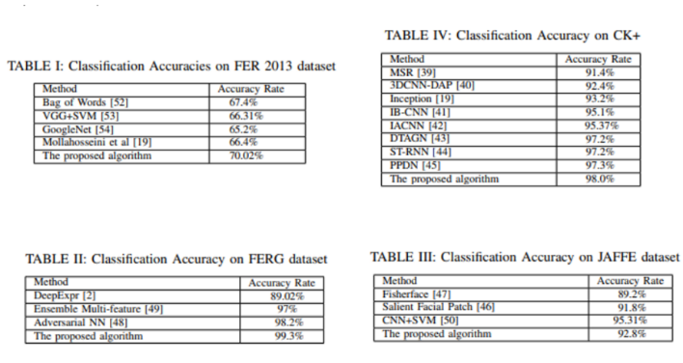

This research uses an attentional convolutional network to present a novel framework for facial expression recognition. We think that the ability to identify facial expressions—which may let neural networks with less than ten layers compete with, and sometimes even surpass, much deeper networks for the identification of emotions—is mostly dependent on attention. Additionally, we presented a thorough experimental study of our work using four widely used databases for facial emotion detection, with encouraging outcomes. Additionally, we have used a visualization technique to draw attention to the salient areas of face photos, which are the most essential elements for identifying various facial emotions.

- Dataset Description
The Facial Expression Recognition Dataset represents a comprehensive collection of facial images that summarize the rich tapestry of human emotions. This dataset has been carefully curated to accommodate a wide range of demographic factors, cultural backgrounds, and emotional expressions. Its primary purpose is to facilitate the training, evaluation, and improvement of models and algorithms geared toward recognizing and interpreting human emotions based on facial features.

  - Training Set
Is divided into seven emotion categories: angry, disgust, happy, neutral, sad, surprise, and fear. Each of these categories contains a specific number of images as detailed below: Train Dataset (Total: 28,704Images)
- Angry (3,962 Images)
- Disgust (436 Images)
- Happy (7,191 Images)
- Neutral (4,957 Images)
- Sad (4,861 Images)
- Surprise (3,201 Images)
- 7. Fear (4,096 Images)
  - Validation Set:
validation dataset for each of the seven emotional categories (angry, disgust, happy, neutral, sad, surprise, and fear) with the corresponding number of images for each category: Validation Dataset (Total: 3,588 Images)

- Angry (495 Images)
- Disgust (55 Images)
- Happy (898 Images)
- Neutral (620 Images)
- Sad (608 Images)
- Surprise (400 Images)
- Fear (512 Images)

  - Test Set:
Test dataset for each of the seven emotional categories (angry, disgust, happy, neutral, sad, surprise, and fear) with the corresponding number of images for each category: Test Dataset (Total: 3,595Images)

- Angry (496 Images)
- Disgust (56 Images)
- Happy (900 Images)
- Neutral (621 Images)
- Sad (608 Images)
- Surprise (401Images)
- Fear (513 Images)

- Proposed Model
  - Architectures:
This exploration was conducted within the Kaggle terrain, employing the computational power of binary NVIDIA T4 GPUs (T4 x2). The application of these high- performance GPUs significantly accelerated data analysis and model training processes, enhancing the overall effectiveness, and enabling the disquisition of large datasets.

For the foundational architecture of our proposed model, we have incorporated three well-established convolutional neural networks: ResNet50 and VGG16, each renowned for distinct strengths in image processing tasks.

Leveraging the Keras library's applications module, we load each model pre-trained on the ImageNet dataset. This allows us to benefit from the learned features while tailoring the architectures to our specific application needs. The top layers of each model, including densely connected neural network units, are excluded, ensuring adaptability to our unique requirements.

Furthermore, an input shape of (128, 128, 3) is specified, indicating our utilization of 128x128-pixel RGB images. This input configuration aligns with the characteristics of our dataset.

In the preparation phase for model training, the dataset undergoes a systematic process to extract features from a pre-trained ResNet50 and VGG16 model. Each of these models brings distinct strengths to the feature extraction process.

The features extracted from each model are then flattened, preserving the spatial relationships within the images. This transformation results in a one-dimensional representation that is well-suited for subsequent modeling steps.

Labels are meticulously assigned to the samples in both the training and test datasets, with careful consideration given to capturing test labels for evaluation purposes. This ensures that the model's performance is rigorously assessed on unseen data.

To foster a balanced representation of all classes in the dataset, a subset of samples is selected for both the training and test sets. Specifically, the first 10% of samples from each class are chosen, maintaining a diverse and representative dataset for model training and evaluation. This strategic sampling approach contributes to mitigating potential issues related to class imbalance, thereby enhancing the model's overall robustness.

This meticulous data processing strategy is designed to provide the model with a comprehensive learning experience during training. By addressing issues related to class imbalance and ensuring a diverse representation of samples, the model is better equipped to generalize well to unseen data, leading to improved performance and reliability in real-world applications.

To introduce an element of randomness and ensure the robustness of our model, we employ a data shuffling technique on both the training and test datasets, using ResNet50 and VGG16 for feature extraction.

A random seed, set to the integer value 42, is utilized to establish reproducibility. This seed serves as the starting point for the pseudorandom number generator, ensuring that the shuffling process remains consistent across different runs of the experiment.
Training Data Shuffling:

The indices of the training dataset are permuted randomly, disrupting any inherent order. This shuffling procedure is crucial to prevent the model from learning patterns based on the order of the input data. It introduces variability into the training process, reducing the risk of overfitting to specific patterns and promoting a more robust and adaptable model.

Test Data Shuffling:

Similarly, the indices of the test dataset undergo random permutation. This ensures that the model's evaluation is conducted on a diverse and representative subset of the data, enhancing its generalization capabilities. By introducing randomness into the evaluation phase, the model is evaluated on various scenarios, contributing to its overall robustness.

Incorporating this data shuffling step is a key component of our training strategy, enhancing the model's ability to manage different patterns and variations within the dataset. This approach mitigates the risk of overfitting and promotes a more reliable and adaptable model for real-world applications.

The purpose of these models is to capture unique face traits that correspond to different emotional moods. Feature Selection with Genetic Algorithm, the system incorporates a Genetic Algorithm (GA) to optimize feature selection. The pre-trained models' outputs are fed into the GA, which iteratively searches for the best collection of features. An SVM classifier is used by the GA's fitness function to assess the discriminating potential of features.

For Evaluation of the Fitness Function, The GA produces a binary mask that encodes subsets of characteristics, which the fitness function evaluates. To assess the prediction power of the chosen characteristics, an SVM classifier with a linear kernel is employed. Assuring efficient classification between various emotional states, the SVM classifier is trained on a subset of the training data consisting of the selected features and matching labels.

For Configuration of the Genetic Algorithm, the search for the ideal feature subset is guided by a set of parameters that the GA is set with. Mutation probability, elitism ratio, population size, and maximum iterations are some of the parameters that are chosen to coordinate an effective feature space exploration that improves classification accuracy.
For classification, Selective feature-based support vector machines (SVM) classifiers are trained using the features that were chosen during the GA-driven feature selection procedure. The subset of training data that the selected features reflect is used to train the classifier, resulting in strong learning of discriminative patterns linked to a range of emotional expressions on the face.
For Performance Metrics and Model Evaluation, on a different test set, the performance of the suggested architecture is assessed using common measures including accuracy, precision, recall, and F1-score. The SVM classifier's capacity to precisely recognize and categorize emotional states based on face characteristics is evaluated using the chosen features.
- Experimental Results
  - Proposed Models with the GA Optimizer

After applying the Support Vector Machine (SVM) classifier to the test dataset exercising the named features uprooted by each deep literacy model, a comprehensive evaluation is conducted, including different criteria and a visual representation of the confusion matrix. This analysis aims to give a holistic understanding of the performance of each model.

ResNet50 Results:

Weighted Average Precision: 0.21
Weighted Average Recall: 0.25
Weighted Average F1-Score: 0.19

Confusion Matrix Visualization:
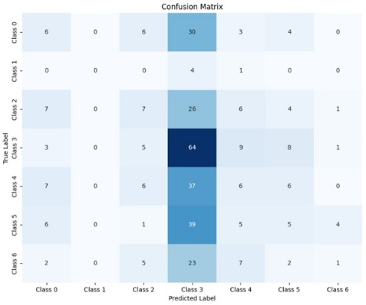

VGG16 Results:

Weighted Average Precision: 0.13
Weighted Average Recall: 0.13
Weighted Average F1-Score: 0.13

Confusion Matrix Visualization:
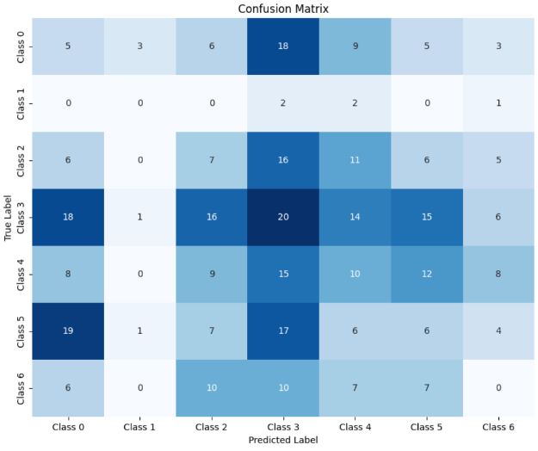

Explanation:

Weighted Average Metrics These criteria offer a consolidated view of each model's effectiveness across all classes, counting for implicit imbalances. Precision emphasizes the balance between true cons and false cons, recall assesses the model's capability to capture all true cons, and F1- Score represents the harmonious means of perfection and recall.

Confusion Matrix This detailed breakdown of prognostications by class provides precious perceptivity into the strengths and sins of each model. The heatmap visualization aids in interpreting true cons, true negatives, false cons, and false negatives for each class, helping point areas of enhancement and implicit challenges in model performance.

  - Proposed models without the GA Optimizer
After the relative analysis, we progressed to estimate the performance of ResNet50 and VGG16 models without the operation of optimizers, employing a harmonious transfer literacy approach.
This involved exercising-trained performances of each model, with a focus on retaining the knowledge captured in their convolutional layers by indurating them. Taking the VGG16 model and ResNet50, the integration involved subjoining thick layers to the-trained armature.

First, a GlobalAveragePooling2D subcaste was added to reduce spatial confines, followed by a thick subcaste with 256 units and RELU activation. This subcaste served as a point extractor, landing high- position representations from the-trained convolutional layers.
The final thick subcaste incorporated a SoftMax activation function and a specified number of units corresponding to the dataset's classes (7 in this case). Importantly, this approach was constantly applied across all models — ResNet50 and VGG16
The decision to indurate the convolutional layers ensures that the knowledge gained during training on large datasets, like ImageNet. The collected models were estimated using the Adam optimizer with a literacy rate of 0.001, categorical cross entropy as the loss function, and delicacy as the evaluation metric. Summaries of each model's armature were generated, furnishing a comprehensive overview of the configurations, including both’re-trained convolutional and recently added thick layers.

ResNet50 Results:

Weighted Average Precision: 0.425
Weighted Average Recall: 0.428
Weighted Average F1-Score: 0.415
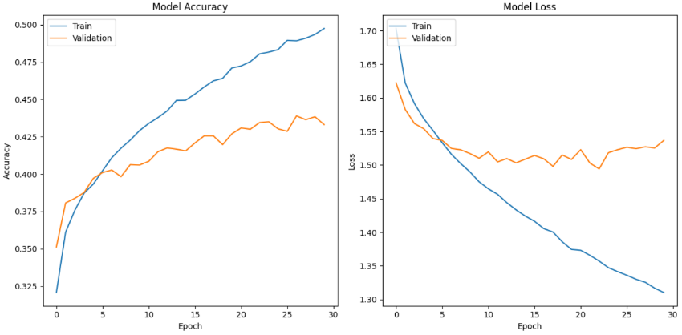

Confusion Matrix Visualization:
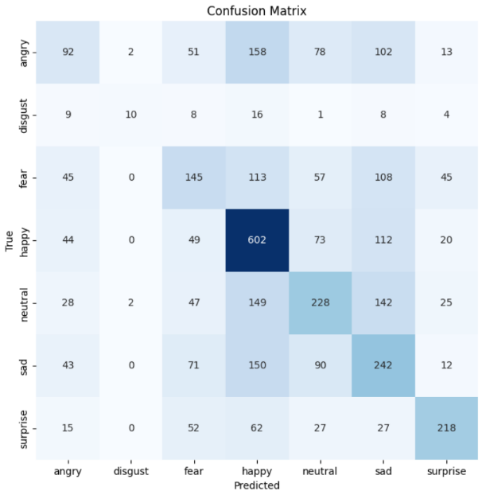

VGG16 Results:

Weighted Average Precision: 0.528
Weighted Average Recall: 0.505
Weighted Average F1-Score: 0.501
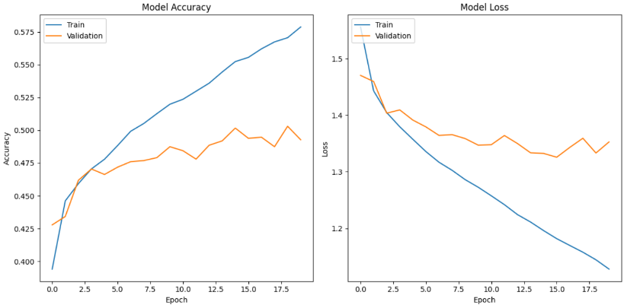

Confusion Matrix Visualization:

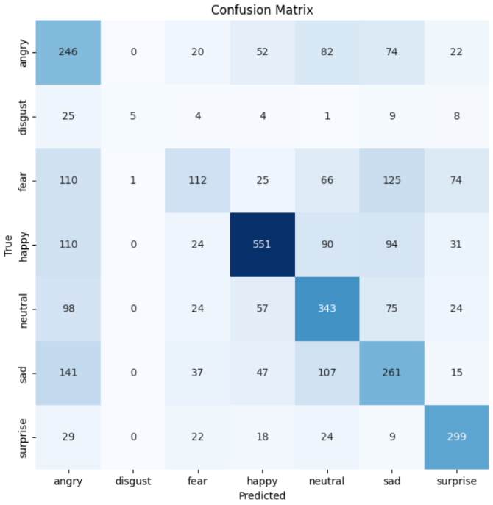

6 Conclusion
The research explored the utilization of ResNet50 and VGG16 models alongside a genetic optimizer for emotion recognition through facial expressions. It highlighted the effectiveness of deep learning models in discerning emotions, albeit encountering notable computational challenges due to the dataset's size and model complexities. Despite these hurdles, the study emphasized the potential of these models and the genetic optimizer in capturing nuanced emotional cues.
However, the extensive training process, driven by the large dataset and complex models, imposed considerable time constraints. This highlighted the practical limitations of training deep learning models, especially with limited computational resources.
The conclusion underscores the importance of utilizing advanced deep learning models for emotion recognition tasks while acknowledging the need to address computational challenges. It suggests future directions focusing on optimizing training processes, potentially through distributed computing or hardware enhancements, to mitigate time constraints associated with large datasets. Additionally, refining genetic optimization techniques to strike a balance between accuracy and training efficiency is proposed for enhancing real-time emotion recognition systems.

6 References
- https://www.sciencedirect.com/science/article/pii/S1877050920318019
- https://www.nature.com/articles/s41598-023-35446-4
- https://www.hindawi.com/journals/cin/2022/8379202/
- https://sci-hub.se/https://ieeexplore.ieee.org/document/9154121
- https://www.mdpi.com/2078-2489/13/6/268
- https://www.frontiersin.org/articles/10.3389/fpsyg.2021.627561/full
- https://ieeexplore.ieee.org/abstract/document/9143068
- Ekman, P., Dalgleish, T. Power, M. Handbook of cognition and emotion (Wiley, 1999).
- . He, K., Zhang, X., Ren, S. Sun, J. Deep residual learning for image recognition in 2016 IEEE conference on computer vision and pattern recognition (CVPR) 770–778 (IEEE, 2016).
- C. Marechal et al., ≪ Survey on AI-Based Multimodal Methods for Emotion Detection ≫, in High-Performance Modelling and Simulation for Big Data Applications: Selected Results of the COST Action IC1406 cHiPSet, J. Ko lodziej et H. Gonz´alez-V´elez, Ed. Cham: Springer ´ International Publishing, 2019, p. 307 324.
- Sci-Hub — Emotion Recognition via Facial Expressions. 2018 IEEE/ACS 15th International Conference on Computer Systems and Applications (AICCSA) — 10.1109/aiccsa.2018.8612852
- S. M. Lajevardi and H. R. Wu, ”Facial expression recognition in perceptual color space,” IEEE Transactions on Image Processing, vol. 21, no. 8, pp. 3721-3733, Aug 2012.
- Sci-Hub — Emotion Recognition Based on Facial Expressions Using Convolutional Neural Network (CNN). 2020 International Conference on Computing, Networking, Telecommunications Engineering Sciences Applications (CoNTESA) — 10.1109/contesa50436.2020.9302866
- Vikram and S. Padmavathi, “Facial parts detection using Viola Jones algorithm”, 2017 4th International Conference on Advanced Computing and Communication Systems (ICACCS), Coimbatore, 2017, pp. 1-4, doi: 10.1109/ICACCS.2017.8014636
- https://paperswithcode.com/paper/deep-emotion-facial-expression-recognition
- Jaderberg, Max, Karen Simonyan, and Andrew Zisserman.”Spatial transformer networks.” Advances in neural information processing systems, 2015.

