Cairo University  
Faculty of Computers and Artificial Intelligent

**CS251**

**Software Engineering I**

Garage Application

Software Design

Coders

1 June 2022

Contents

Team 3

Document Purpose and Audience 3

System Models 4

I. Class diagrams 4

II. Sequence diagrams 6

Class - Sequence Usage Table 10

Ownership Report 11

# Team

|  |  |  |  |
| --- | --- | --- | --- |
| **ID** | **Name** | **Email** | **Mobile** |
| 20200583 | نبيل شريف نبيل ابراهيم درويش | 11410120200583@stud.cu.edu.eg | 01026276662 |
| 20200196 | زياد اسامه عبد الفضيل محمد | 11410120200196@stud.cu.edu.eg | 01018420940 |
| 20200153 | حسن خالد حسن طه | 11410120200153@stud.cu.edu.eg | 01156341785 |
| 20200091 | الحسن على فاروق | 11410120200091@stud.cu.edu.eg | 01110357406 |

# Document Purpose and Audience

**What is this document?**

This document:

* is concerned with converting customer needs as defined in SRS document into a format that can be implemented using a programming language.
* Eases the programmer’s job as it will tell him the map that he should follow to make the program needed

**Who is expected to read this document?**

This document is expected to be read from a technical user (such as a software engineer, programmer, etc.).

A non-technical user can’t read this document as he won’t understand it and won’t give him any benefit.

# System Models

## I. Class diagrams

| **Class ID** | **Class Name** | **Description & Responsibility** |
| --- | --- | --- |
| 1 | Menu | It’s a boundary class to the user which will interact with the user for first time for setting the details of garage |
| 2 | SecondMenu | It’s a boundary class to the user which will interact with the user for selecting the future that will be used in the application |
| 3 | Controller | It’s a controller class which will control all the process of the application and do the main functions of the application |
| 4 | ControllerParkin | It’s used to check if you can parkin or not in the garage |
| 5 | ControllerParkout | It’s used to check if you can parkout or not in the garage |
| 6 | Reservation | It’s an entity class which will store the array of objects of Slot and Vehicle |
| 7 | DisplayList | It’s used to display all available slots in the garage |
| 8 | Slot | Each Slot will have its own id, width, depth, and the if it’s free or not and its vehicle |
| 9 | Vehicle | Each Vehicle will have its own id, model name, model year, fees of the parking and its specification |
| 10 | SlotVehicle | It’s used to reserve the slot for specific vehicle |
| 11 | ParkingConfig1 | It’s used to park the vehicle and use the method “first come…first served” |
| 12 | ParkingConfig2 | It’s used to park the vehicle and use the method “best fit approach” |
| 13 | Income | It’s used to set and get the total income of the garage in any point of time |

## II. Sequence diagrams

**Sequence diagram (1)**

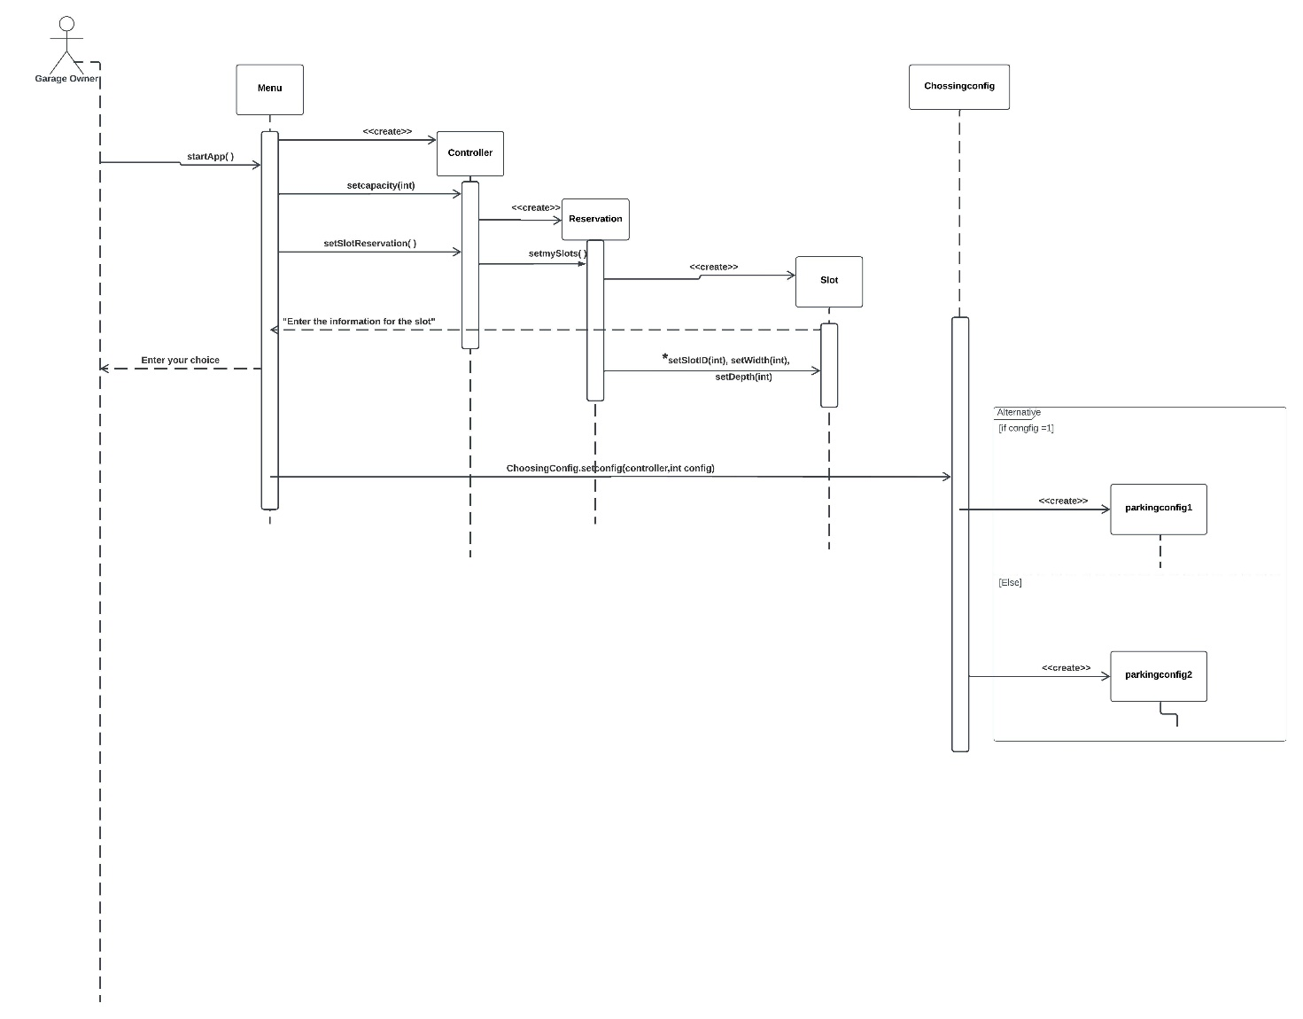

**Sequence diagram (2)**

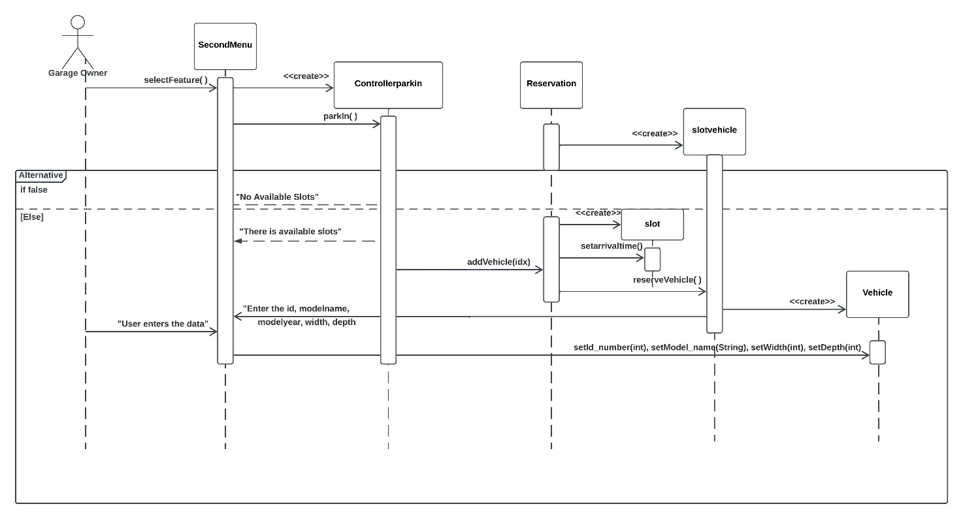

**Sequence diagram (3)**

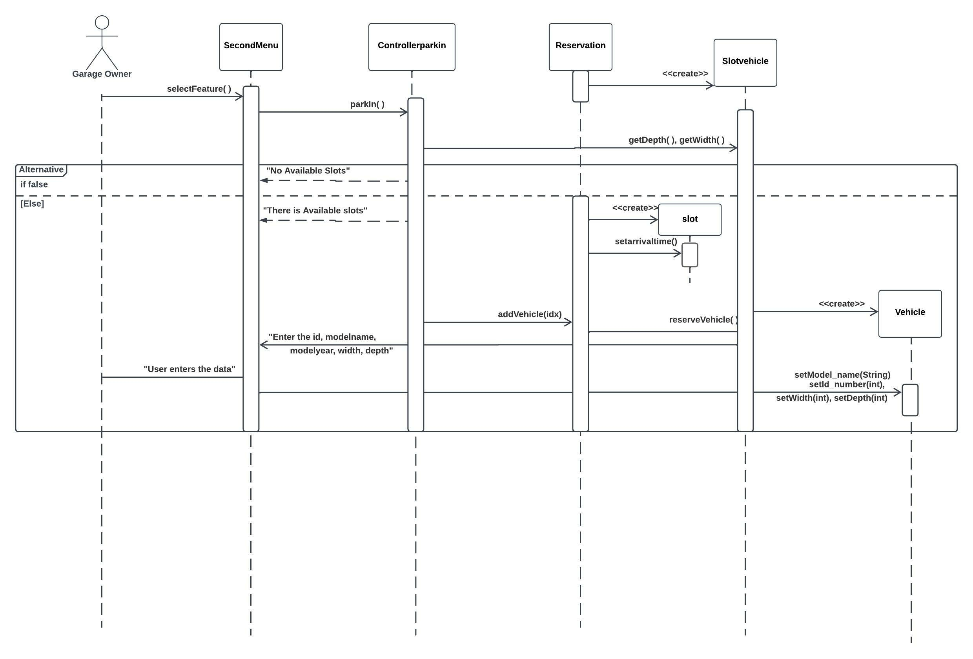

**Sequence diagram (4)**

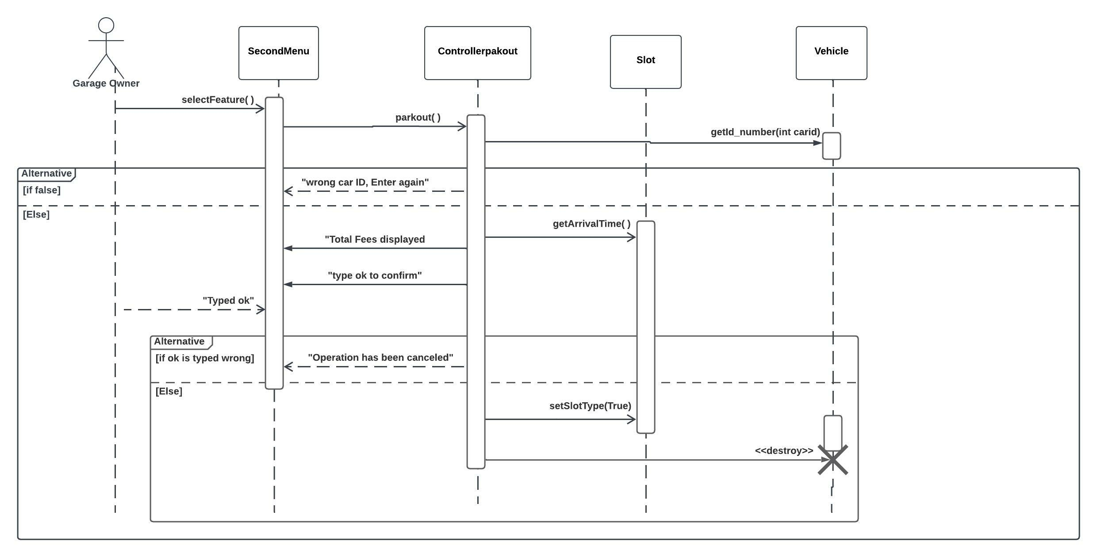

### Class - Sequence Usage Table

| **Class Name** | **Sequence Diagrams** | **Overall used methods** |
| --- | --- | --- |
| SecondMenu | 2,3,4 | selectFeature |
| Menu | 1 | startapp |
| Controllerparkin | 2,3 | parkin |
| Controllerparkout | 4 | parkout |
| Controller | 1 | Setcapacity, setSlotReservation |
| Reservation | 1,2,3 | Setmyslots,addVehicle |
| slotvehicle | 1,2,3 | reserveVehicle |
| slot | 1,2,3,4 | setSlotID, setWidth, setDepth, Setarrivaltime,getArrivalTime,setSlotType, |
| Vehicle | 1,2,3,4 | setModel_name,setWidth,setDepth,setId_number,getId_number |
| Chossingconfig | 1 | setconfig |

# Ownership Report

|  |  |
| --- | --- |
| **Item** | **Owners** |
| **Document purpose and audience** | نبيل شريف نبيل  حسن خالد حسن طه |
| **class diagrams** | نبيل شريف نبيل  حسن خالد حسن طه  الحسن على فاروق  زياد اسامه عبد الفضيل محمد |
| **Sequence diagrams** | نبيل شريف نبيل  حسن خالد حسن طه  الحسن على فاروق  زياد اسامه عبد الفضيل محمد |
| **Class - Sequence usage table** | الحسن على فاروق |
| **Source code** | زياد اسامه عبد الفضيل محمد |
| **Solid Principles - Design Patterns** | نبيل شريف نبيل  حسن خالد حسن طه  الحسن على فاروق  زياد اسامه عبد الفضيل محمد |