



**Online Library Marketplace**

Under supervision:

Dr. Doaa Saleh

|  |  |
| --- | --- |
| ID | Name |
| 20200603 | Noor Eldeen Nizar |
| 20200838 | Abdelrahman Hesham |
| 20200279 | Abdelrahman Ahmed Ali |
| 20200026 | Ahmed Abdelhameed Hassan |
| 20200583 | Nabil Sherif Nabil Ibrahim Darwish |
| 20201038 | Eman Ibrahim Shaban Gad |
| 20201061 | Dina Ahmed Abdelrady |
| 20200201 | Ziad Abdallah Sayed |

Table Of Contents

1 Project Idea 3

2 Project Logo 3

3 Our Slogan 4

4 Introduction 4

4.1 Purpose of Online Library Marketplace System 4

5 Planning 5

5.1 Organization Objective: 5

5.2 List Of Alternatives 6

5.2.1 Target User Count: 6

5.2.2 Profitability: 6

5.2.3 Developers And Technicians: 7

5.3 Premises to Base Each alternative: 7

5.4 Choosing Alternative: 8

5.5 Management Methodology: 9

5.6 The Chosen Management Methodology is Management by Objectives (MBO) 9

5.7 Management by Objectives: 9

5.8 MBO Parts: 9

5.9 MBO Steps: 10

5.10 The Elements of a Successful MBO Program 10

5.11 Advantages and Drawbacks of MBO Programs 11

6 Organizing: 11

6.1 Identification of activities 11

6.2 Functional organizing 12

6.3 Clarifying the functionality 13

6.4 Events organization 13

6.5 Facilitates administration 14

7 Influencing 15

7.1 Leadership: 15

7.2 Motivation: 16

7.3 Considering Group: 16

7.4 Communication: 17

7.5 Encouraging creativity and innovation: 18

7.6 Building a company culture: 19

8 Controlling: 20

8.1 Measuring Performance: 20

8.2 Comparing Measured Performance to Standards: 21

8.3 Taking Corrective Action: 21

1. **Project Idea**

Online Library Marketplace

1. Project Logo



1. Our Slogan

Preserve the past, Open the Future.

1. Introduction

# Purpose of Online Library Marketplace System

An Online library Marketplace system's goal is to run a virtual library more efficiently and at a lower cost than traditional physical libraries, saving people time. Because the system is completely automated, it simplifies all the library's operations. The software handles book purchases, book lending, categorizing, circulation recording, and stock checking. Such software reduces the human labour factor and reduces the likelihood of errors.

The marketplace section connects users with each other, By making the selling, trading, and buying process as easy as possible for the users by allowing a secure and reliable transaction. A user can search for a book and view the list of books that are available in the library.

1. Planning

# Organization Objective:

The Goal of Our Online Book Store is to Satisfy Customer Needs, Build the Best Community Possible for Book Enthusiasts, and Become the Leading Online Book Marketplace.

Attract 50,000 Users in the First Year, achieve 5000 Visits Per month, and Become Profitable 6 months after Launch. Attract 500 Authors to Join Event Platform, which is a platform for

hosting Authors’ Events Where They Announce (and Promote) Future Books, Give Talks

About Their previous books and discuss them with the Audience to Gather Feedback.

The Book Store Should Contain a Large and Diverse Collections of Books that cover different Genres such as Scientific, Fictional and Religious.

The Website will have a section for selling and trading used books where registered users can put up their books for sale, lending, or trading.

After 1 Year we are expected to launch an application for different mobile platforms, this application should ease user interactions and bring in more users potentially.

An Advertisement Campaign should be launched that will use Social Media Advertisements Through Reaching out to famous Book Bloggers and Influencers, as well as reaching out to Various Newspaper outlets.

The Platform Aims to Provide Best Book Pricing Among its competitors, it will provide an effortless way for Users to Interact with the Website/Application and Perform their Desired actions.

Customers Should be able to easily communicate with customer support, who should be available 24/7, to get their issues resolved

The company Will hire top-of-line Managers, Developers, Technicians, and Customer Service Agents To maintain and develop the product.

Company Managers should actively monitor the performance of workers and eliminate weak links periodically and reward Achieving Employees.

# List Of Alternatives

## Target User Count:

**1. Advertisements:**

* Social Media Advertisement
* Television Advertisements
* News Paper Advertisements.

**2. Promotions:**

* Sales
* Discounts
* Promo codes

**3. Events:**

* Holding Large Events Featuring Top Authors with Media Coverage.
* Numerous Smaller Events Spread out through the world For Reaching a Wider Audience

## Profitability:

* Monthly / Yearly Subscription Packages
* Application / Website Advertisements for Unsubscribed Free Users
* Free Trial
* Sponsors

## Developers And Technicians:

* Company Hires Its Developers and Technicians itself
* Company Relies on an Application Development Firm.

# Premises to Base Each alternative:

For Advertisement Television Advertisements Could Reach a Wider Audience but Its Relatively Costly and may have a relatively bad view to interest/action ratio, Social Media Advertisements could have an advantage in terms of reaching out to people who are interested in the topic, but it may require a special social media advertisements team/specialist to set up the advertisements correctly and efficiently,

Newspaper advertisements may be the cheapest option and would serve as a good start to the advertisement campaign if capital were limited.

If the Target user count could not be fulfilled in time whilst Advertising, as Users of old competitor platforms aren’t inclined to change platforms, the Product, Managers Could Implement such Sales, Discounts and distribute promo codes to Digital Reward Applications Such as Lucky to incentivize users to migrate to our platform.

Another Way of Gaining a Wider Network of Users is through the hosting and sponsoring of Events, in such events Popular Book Authors would be sponsored by our Product and Potentially other Sponsors, to give talks about future books, sneak peeks on future sequels, gather audience feedback Such Events Could Be held on two scales Annual Mega International Events or Weekly Minor Spread-out Events/Talks.

If Project Couldn’t Reach Target Profit in time, Managers could direct Developers to add advertisement slots that other companies could place their advertisements in, furthermore, Managers could direct developers to add in a basic subscription plan that would allow the Subscribed users to Browse Website or use the application ad-free, as well as a premium subscription plan where users will enjoy the benefits of the basic subscription plan with the addition of extra benefits of gaining monthly promo codes on select books and events, gaining VIP row access to events and talks, All Users Will be Granted free access to his desired book for 24hours weekly following with a partial discount on that book.

If in the first year of the project launch the Developer and Technicians Hiring and Employment process proved tedious or inefficient time or money-wise, the company could research available development and or technician supplement firms. While the company board would focus its resources and time on high-level managers.

# Choosing Alternative:

Initially, we could Rely on Advertisements as a Basis for Reaching our desired Target of Registered Users Count, Specifically, Newspaper advertisements as they proved to be the most cost-efficient as it targets the intended audience (readers)

Events will start out as small gatherings, continually growing up in size as the platform and its audience grows this will eliminate the risk of wasting a lot of our initial capital on an event that has a risk of failing or living up to its expectations.

To increase the chance of the project being profitable during the launch year, the managers should start out by following the plan of having a subscription system, in the future if the system proved profitable and the subscription profit was excess, it is advised to study the outcome of removing the subscription system ( free, basic) on the profit and customer experience and the potential increase customer numbers.

To minimize the risk of incompetent workers and save up on capital, while also keeping high-level managers focused on high-level decisions and details of projects rather than technical and human resource issues. In the future, after the company has secured enough profit, it could be studied whether the company should keep utilizing the contracted firm’s workers or start out hiring employees for itself for the technical side of the platform.

# Management Methodology:

# The Chosen Management Methodology is Management by Objectives (MBO)

# Management by Objectives:

Organizational objectives are such an important and fundamental aspect of management for some managers that they utilize a management technique based only on them. The management by objectives (MBO) concept was popularised primarily through Peter Drucker's publications. MBO is a valuable management tool for non-profit organizations such as libraries and community clubs, despite being discussed in the context of profit-oriented enterprises. The MBO strategy is divided into three sections.

# MBO Parts:

1. Every employee in an organisation is given a specific set of goals to achieve during normal business hours. Individuals and their managers work together to create and agree on these goals.

2. Periodic performance reviews are undertaken to determine how close individuals are to achieving their goals.

3. Individuals are rewarded based on how near they are to achieving their objectives.

# MBO Steps:

1. Review organisational goals—The manager acquires a thorough understanding of the company's overarching goals.

2. Set worker objectives—At a meeting with the worker, the management and the worker agree on worker objectives that must be met by the conclusion of the usual working time.

3. Monitor progress—During the normal operation time, the manager and worker check to see if the goals are being met at regular intervals.

4. Assess performance—At the end of the usual working time, the worker's performance is assessed based on how well he or she met the goals.

5. Give incentives—Incentives are given to employees based on how well they met their goals.

# The Elements of a Successful MBO Program

An MBO program's effectiveness is dependent on a few critical variables. First, top management must be committed to the MBO process and define proper organisational goals. Because all individual MBO goals are dependent on these overall objectives, if the overall objectives are ineffective, individual MBO goals will be ineffective as well, and related individual work activities will be ineffective.

Second, managers and subordinates must collaborate to define and agree on each person's objectives. To be taken seriously as a direction for action, both managers and subordinates must believe that the objectives are right and suitable. Third, staff performance should be carefully assessed against predetermined goals. This assessment determines whether the aims are reasonable and whether appropriate methods are being employed to achieve them. Fourth, management must act on employee performance evaluations by appropriately rewarding personnel.

# Advantages and Drawbacks of MBO Programs

Advantages: To begin with, MBO programs consistently emphasize what should be done within an organization to attain organisational goals. Second, the MBO process ensures employee commitment to the company's objectives. Both parties are committed to achieving such objectives.

Disadvantages: The creation of objectives can take an extended period. Another is that an MBO program requires thorough goal communication and performance evaluations, which increases the amount of paperwork in a business.

1. Organizing:

In an electronic library, organizing is a management function that involves creating an organizational structure and deploying people to reach their goals. It is also the function that follows the planning function. Organizing is a function that establishes orderly uses for all resources within the management system.

An organization chart, which depicts the chain of command inside an organization graphically, is commonly used to represent the structure. Organizational design is a decision made about the structure of an electronic library.

# Identification of activities

All the actions of an application that must be completed in concern must first be identified, for example, create an account, register, sell a book, buy a book, rent a book (hard or soft copies), event agrarianizing, choose the different sections of books, and so on. The software system must communicate with all the registrations in that library to facilitate the tasks that were mentioned before and must be done on the system.

# Functional organizing

The program should establish major tasks such as dividing the program into tasks and the tasks into subtasks. Tasks and subtasks begin with opening the website or downloading the application then registering to the system after that the customer will be able to do all the activities that the system can perform.

Dividing the system into major tasks makes the project easier and more successful.

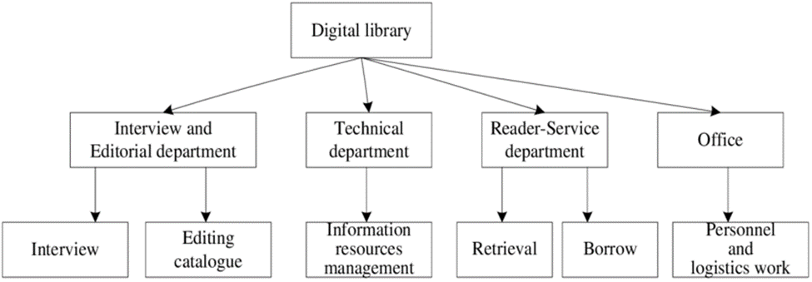

Figure.1

# Clarifying the functionality

Once the registered user opens the website or the application, he/she can select the function that he/she wants whether to borrow or sell, etc. Each function is clear and easy to choose by the user, at any time and any place. Each function in the system can be used by more than one user at the same time. The clarification of functions helps in bringing efficiency to the running of a concern. This aids in the operation of the application efficiency and this prevents time loss, effort in searching for a book kind, duplication or overlapping of attempts, wasting time learning and how the application works, as well as providing smoothness to the application search.

# Events organization

The electronic library system must send a mail to the registered users to announce them about any events for any well-known author, and check if they want to attend that event or not and what the reason is if he rejects the invitation.

# Facilitates administration

A well-designed and balanced electronic library makes management and operation of the company easier. It improves management efficiency and responsiveness. Moreover, it eliminates delays and duplication of labor, and it stimulates employees to do their jobs well with high efficiency.

The organization structure drops off unimportant duties and assigns them to lower-rated roles through proper division of labor, consistent delegation, and unambiguous job definition. Everyone works on the application with the manager.

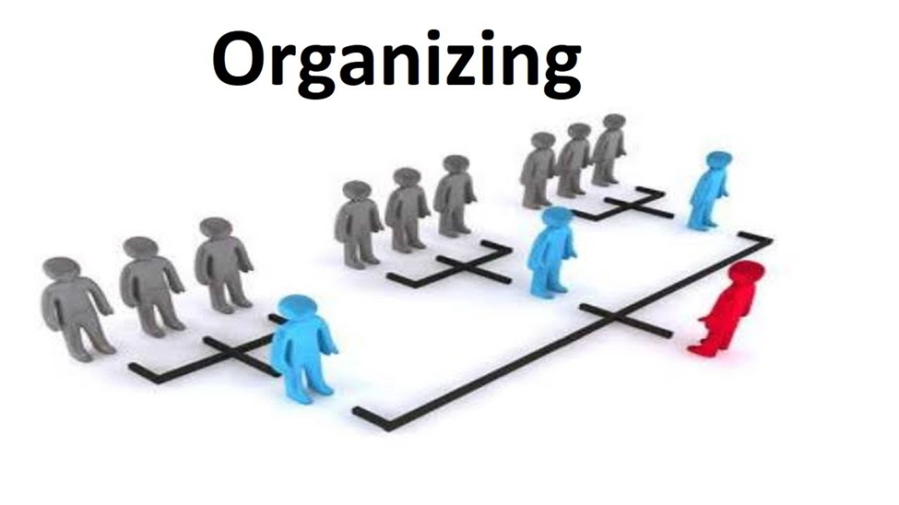Figure.2

1. Influencing

Influencing is the ability of an individual to transform and shape the opinions of others. Influencing at the workplace, then, is a process of transforming the behaviours of employees. For example, a team leader can influence subordinates through his communication, policies, and actions.

Influencing is one of the important soft skills required for every individual, irrespective of their hierarchical position at the workplace.

The process of the influencing subsystem involves the performance of six primary management activities:

1. Leadership
2. Motivation
3. Consider groups
4. Communication
5. Encouraging creativity and innovation
6. Building a company culture.

# Leadership:

Leadership is the potential to influence the behaviour of others. It is also defined as the capacity to influence a group towards the realization of a goal. Leaders are required to develop future visions, and to motivate the organizational members to want to achieve the visions.

-The Components of Effective Leadership**:**

[Effective leadership](https://www.investopedia.com/business-leaders-4689830) includes exhibiting a strong character. Leaders exhibit honesty, integrity, trustworthiness, and ethics. Leaders act in line with how they speak and earn the right to be responsible for others’ success in the company.

Strong leadership involves clear communication skills. Leaders speak with and listen to staff members, respond to questions and concerns, and are empathetic. Leaders use effective communication skills for moving the company forward and achieving new levels of success.

True leadership sees where the company is headed and plans the steps needed to get there. Visualizing what is possible, following trends in the industry, and taking risks to grow the business are all required of leaders.

Productive leadership shows optimism and provides positive energy for staff. Good leaders are supportive and are deeply concerned about the well-being of others. Leaders find answers to challenges and reassure and inspire workers when things go awry. Leaders find ways for staff to work together and achieve maximum results in an efficient and effective manner.

# Motivation:

Motivation is a general inspiration process which gets the members of the team to pull their weight effectively, to give their loyalty to the group, to conduct properly the tasks they have accepted and generally to play an effective part in the job that the group has undertaken.

Often, people confuse the idea of 'happy' employees with 'motivated' employees. These may be related, but motivation describes the level of desire employees feel to perform, regardless of the level of happiness.

Employees who are motivated to perform will be more productive, more engaged and feel more invested in their work. When employees feel these things, it helps them, and thereby their managers, be more successful.

it is in the project manager's interest to understand why motivation is not encouraged to drive toward project success by creating and maintaining a motivational environment for all team members by offering rewards for completing work to the fullest and trying to get close to employees and trying to solve their problems.

# Considering Group:

It is considered one of the minimum general factors that contribute to the effect on the members of the team in the same group for the sake of a specific task, since the leader must have a view of choosing employees in view of the needs of his work.

And here comes the role of the leader in dividing the Task Force into the members of the group. Make them work together and share ideas. It consists of their skills and their thinking through the help of the leader or members of the team in his attempt to develop this idea or present it in a better way.

# Communication:

Communication influence skills are abilities that help you make an impact on a person's thoughts and actions when interacting with them. You can persuade them to use the same techniques that you do to accomplish work tasks, and you can provide information about yourself that enables them to view you as a credible source. Communication influence manifests in the delivery of your speech behaviour and the quality of your responses when others speak. It also entails your ability to evaluate nonverbal cues for insight into a co-worker’s feelings. Communication influence skills can benefit leaders who aim to direct professional conduct.

communication influence skills are often essential for professionals who fulfil leadership positions. You can convince members of your team to follow your direction, and you can seek strong connections that create a positive work environment. Learning how communication influence materializes in the workplace can enable you to strengthen your abilities and build a rapport with key figures at work, such as clients, supervisors, and teammates. In this article, we provide examples of communication influence skills, explain ways to improve them and offer guidelines for highlighting them throughout your job search.

Communication and management are intricately linked together. Since communication is the process of information exchange of two or people and management include managers that gives out information to their people. Moreover, Communication and Management go hand in hand. it is the way to extend control, the fundamental component of project management. Without the advantage of a good communications management system, the cycles associated with the development of a task from start to finish can be genuinely compelled. It also gives the fundamental project integrity needed to give an information help among all individuals from the team. This information must stream descending, upward and horizontally inside the association. Moreover, it is both Master and servant of project control. It is the action component, the integrator of the process toward assembling the project. As project management is both a craftsmanship and a science, the project manager leads the multidiscipline of the plan and construct team.

The role of the leader lies in distributing the projects required of the company, where he tries to make the team cooperative and compatible with each other and makes the members of the team share their ideas and makes the team collaborative through the use of websites such as the Git Hub, as it enables the team to work together and share the parts among themselves when the company's engineers design the application, then one person uploads their part to the GitHub site, and then the other person can narrate these codes and do the rest of the work.

# Encouraging creativity and innovation:

To encourage the best creative and innovative mindsets in the workplace companies must strictly follow the above-given pillars. Innovation can only happen when an organization embraces the ‘way things could be’ and let’s go of the ‘way things are.’ The staff should learn to embrace the nuances in an already established idea and alter them for the better.

Innovation at the basic level is ‘what ifs,’ these are just ideas that may or may not work. After brainstorming and producing these ideas, companies have to go through a trial and error program to choose the best. But when you think of an idea, you modify it, process it, and experiment on it to mold it into an even better and bigger product or concept. This end product is the fruit of your innovation.

Encourage an active and creative workplace. Creative ideas should be the norm. Don’t care if the ideas start as basic cliches, don’t reject, explain the problem and why it won’t work in a market. Constructive criticism and practice are the best tools to encourage better ideas.

Raw intelligence can only get you to the moon. To reach the stars you need to work hard and grow with every mistake. Creativity and innovation are the best tools to possess in a business venture. **Creativity and innovation management** lead to the overall success of an organization since it’s better to have a task force of hardworking creative individuals than a few intelligent workers. [61%](https://innovationcloud.com/blog/20-innovationrelated-statistics-that-we-can-learn-from-in-2020.html) of workers in a survey stated they are embracing open innovation.

Creativity is the mix of combining two different thoughts. The divergence of these thoughts allows the staff to think of unique solutions and products while convergence focuses the flow of ideas on the basis of the organization’s objective, leading to new innovative products that can help your company grow and progress.

# Building a company culture:

An organization's culture defines the proper way to behave within the organization. This culture consists of shared beliefs and values established by leaders and then communicated and reinforced through various methods, ultimately shaping employee perceptions, behaviours and understanding. Organizational culture sets the context for everything an enterprise does. Because industries and situations vary significantly, there is not a one-size-fits-all culture template that meets the needs of all organizations.

A strong culture is a common denominator among the most successful companies. All have consensus at the top regarding cultural priorities, and those values focus not on individuals but on the organization and its goals. Leaders in successful companies live their cultures every day and go out of their way to communicate their cultural identities to employees as well as prospective new hires. They are clear about their values and how those values define their organizations and determine how the organizations run.

We have a great passion for achieving the highest levels of excellence and integrity in our daily business, showing respect to our counterparts and business partners, direct communication, and high transparency with clients, and to maintain this culture we increase the number of reviews on work and make sure to communicate our message.

Our Mission: To create and maintain an investment value for our shareholders over the long term.

Promote the concept of responsible fiscal management.

Providing high-quality financial products and services,

Promote a rewarding culture that works on, empowering and rewarding our shareholders. The aim of all the above is to strengthen the extent of the interdependencies between employees and peat to create, collaborate and innovate.

1. Controlling:

Control is a primary goal-oriented function of [management](https://businessjargons.com/management.html) in an organization. It is **a process of comparing the actual performance with the set standards of the company** to ensure that activities are performed according to the plans and if not then taking corrective action.

Every manager needs to monitor and evaluate the activities of his subordinates. It helps in taking corrective actions by the manager in the given timeline to avoid contingency or company’s loss.

Controlling is performed at the lower, middle, and upper levels of the management.

The process of the controlling subsystem involves the performance of primary management activities:

* Measuring Performance.
* Comparing Measured Performance to Standards.
* Taking Corrective Action

# Measuring Performance:

Performance against standards ought to be measured on a modern basis so deviations may be discovered and avoided before they happen. evaluative actual or expected performance is comparatively straightforward if criteria square measure properly drawn and ways for determinant specifically what subordinates do square measure obtainable.

The actual performance of the worker is then measured against the set standards. With the rise in levels of management, the activity of performance becomes quite troublesome.

# Comparing Measured Performance to Standards:

In the management method, determinative if performance meets the quality could be a straightforward however crucial step. It entails comparison the measured results to antecedently established norms. Managers could assume that "all is below control" if performance meets the benchmark.

Comparing the degree of distinction between the performance and therefore the set normal.

# Taking Corrective Action:

This section becomes essential if performance falls in need of expectations and therefore the analysis reveals that corrective action is needed. The remedial live may embrace an amendment in one or a lot of the organization's functions.

This is being initiated by the manager WHO corrects any forms of defects within the actual performance.