|  |  |
| --- | --- |
| **Practicum Case** |  |
| COMP6122 | COMP6122001  Framework Layer Architecture |
| **Computer Science** | **O221-COMP6122-CT01-04** |
| ***Valid on*** *Odd Semester Year 2021/2022* | **Revision 00** |

**Learning Outcome**

* LO1 – describe use of design pattern in java
* LO2 – apply design pattern in java

**Topic**

* Session 4 – Creational Design Pattern III

## Sub Topics

* Abstract Factory

1. **Abstract Factory Pattern**

Abstract Factory is a creational design pattern that lets you produce families of related objects without specifying their concrete classes. The first thing the Abstract Factory pattern suggests is to explicitly declare interfaces for each distinct product of the product family (e.g., chair, sofa, or coffee table). Then you can make all variants of products follow those interfaces. For example, all chair variants can implement the Chair interface; all coffee table variants can implement the CoffeeTable interface, and so on.

## Soal

*Case*

**Toppo Cafe**

Toppo Cafe is a popular beverage cafe in Jakarta that placed in a popular shopping center. Every day the Toppo cafe sells very little **tea** and **milk tea.** Because of that, the business can fall, Angel as the business owner of the Toppo Cafe has split her cafe into two cafes (before that she rented two places into one), and changes the cafe name into two kinds, which are Top Top and Tap Top. These two cafes have their own formulas to generate the beverages. Because you are one of her best friends. You decide to help her to create a program that can help her to improve her business. Below are the following details of the program:

There are **two types of beverages** in the shops, which are **milk tea and tea**. To generate milk tea and tea, below are the **ingredients** that they used for the beverages:

|  |  |
| --- | --- |
| **Beverage** | **Ingredients** |
| Tea | Leaf |
| Milk tea | Leaf and Milk |

These two shopshave their own **formula** in order to generate **milk tea and tea.** These are the **leaves** that they used:

|  |  |
| --- | --- |
| **Shop** | **Leaf** |
| Top Top | Green Leaf |
| Tap Top | Black Leaf |

And theseare the **milk** that they used:

|  |  |
| --- | --- |
| **Shop** | **Milk** |
| Top Top | Soy Milk |
| Tap Top | Full Cream Milk |

* **Main Menu**

At first, the program will show the menu. In this menu, the program will ask the user to choose between **1 and 2 (inclusive)**.

1. **Tap Top Cafe**
2. **Top Top Cafe**

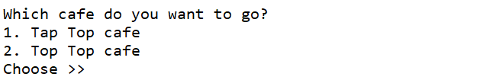

**Figure 1. Main Menu**

* 1. **Tap Top Cafe**

If the customer **chooses** **1**, then the program:

* **Shows** the **Tap Top menu**.
* **Asks** the user to input **between 0 and 2** for what he/she wants to order.
* If the user **input 1**, then the program will **generate milk tea**.
* If the user **input 2**, then the program will **generate tea**.
* If the user **input 0,** then the program will be show **ordered beverages** and **terminate** the program.

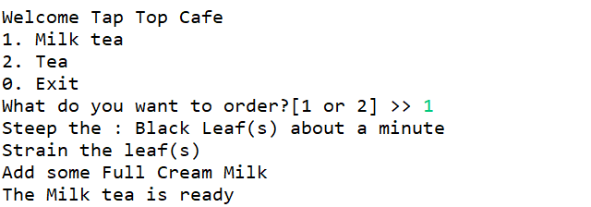

**Figure 2. Ordered Milk Tea in Tap Top**

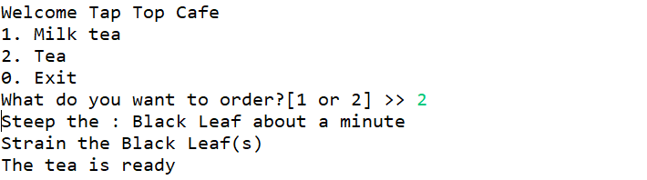

**Figure 3. Ordered Tea in Tap Top**

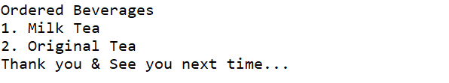

**Figure 4. Show Ordered Beverages in Tap Top**

* 1. **Top Top Cafe**

If the customer **chooses** **2**, then the program:

* **Shows** the **Top Top menu**
* **Asks** the user to input **between 0 to 2** for what he/she wants to order.
* If the user **input 1**, then the program will **generate milk tea**.
* If the user **input 2**, then the program will **generate tea**.
* If the user **input 0**, then the program will be show **ordered beverages** and **terminate** the program.

**Figure 5. Ordered Milk Tea in Top Top**

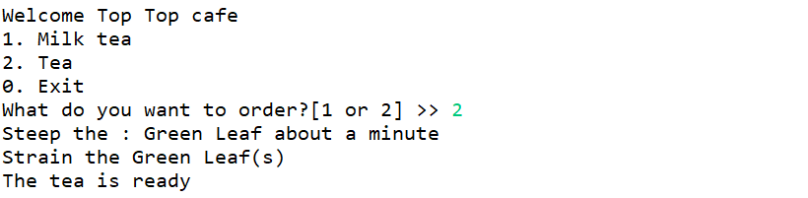

**Figure 6. Ordered Tea in Top Top**

**Figure 7. Show Ordered Beverages**