|  |  |
| --- | --- |
| **Practicum Case** |  |
| COMP6122 | COMP6122001  Framework Layer Architecture |
| **Computer Science** | **O221-COMP6122-CT01-07** |
| ***Valid on*** *Odd Semester Year 2021/2022* | **Revision 00** |

**Learning Outcome**

* LO2 – apply design pattern in java
* LO3 – design object oriented in design pattern

**Topic**

* Session 7 – Structural Design Pattern II

## Sub Topics

* Facade

1. **Facade Pattern**

Facade is a structural design pattern that provides a simplified interface to a library, a framework, or any other complex set of classes. A facade is a class that provides a simple interface to a complex subsystem which contains lots of moving parts. A facade might provide limited functionality in comparison to working with the subsystem directly. However, it includes only those features that clients really care about.

## Soal

*Case*

**The Lazy Angel**

Angel likes to play computer games every day. Every time she wants to play, she needs to start the CPU, monitor, and fan over and over repeatedly, and vice versa. Because she’s too lazy and you are one of her best friends. She asks you to create a program that automates to start her setup and finish from playing. Below are the following details of the program:

* **Main Menu**

**At first**, the program will show the menu and status of her setup. In this menu, the program will ask the user to choose between **1 and 2 (inclusive)**.

1. **Start Playing Game**
2. **Finish Playing Game**

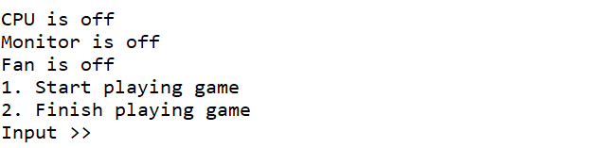

**Figure 1. Main Menu**

* **Start Playing Game**
  + - If the user **chooses** **1** andthe setups are **off**, then the program will:
* Turn **on** the **fan**.
* Turn **on** the **monitor**.
* Turn **on** the **CPU**.
* After CPU has turned on**,** the program will ask the user to input **her password** and validate the password **must be** ‘**admin**’.

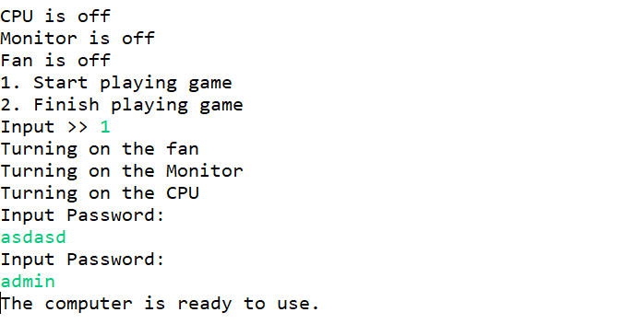

**Figure 2. Start Playing Game**

* + - If the user **chooses** **1** andthe setups are **on**, then the program will **print an error message**.

**Figure 3. Start Playing Game with Error Message**

* **Finish Playing Game**
  + - If the user **chooses** **2** andthe setups are **on**, then the program will:
* Turn **off** the **CPU**.
* Turn **off** the **monitor**.
* Turn **off** the **fan**.

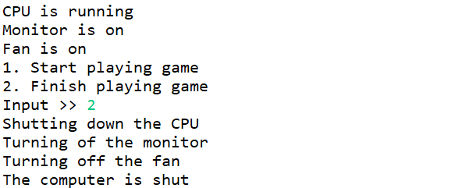

**Figure 4. Finish Playing Game**

* + - If the user **chooses** **2** andthe setups are **off**, then the program will **print an error message**.

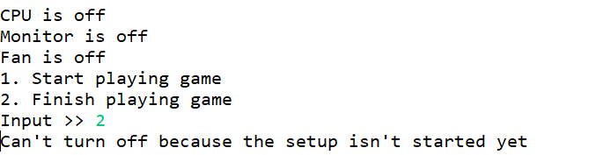

**Figure 5. Finish Playing Game with Error Message**