|  |  |
| --- | --- |
| **Practicum Case** |  |
| COMP6122 | COMP6122001  Framework Layer Architecture |
| **Computer Science** | **O221-COMP6122-CT01-08** |
| ***Valid on*** *Odd Semester Year 2021/2022* | **Revision 00** |

**Learning Outcome**

* LO2 – apply design pattern in java
* LO3 – design object oriented in design pattern

**Topic**

* Session 8 – Structural Design Pattern III

## Sub Topics

* Proxy

1. **Proxy Pattern**

Proxy is a structural design pattern that lets you provide a substitute or placeholder for another object. A proxy controls access to the original object, allowing you to perform something either before or after the request gets through to the original object. There are 3 types of proxy, such as security proxy, virtual proxy, and cache proxy. In this **case** you will need to **use cache** **proxy**.

## Soal

*Case*

**Angel Flix**

Angel Flix is one of the top streaming movie platforms. You as the junior programmer of Angel Flix, the manager asks you to create a simple program that could help to promote Angel flix. Below are the following details of the program:

Currently **available movies** in the **Angel Flix Database** are:

|  |  |
| --- | --- |
| Movie Name | Movie Description |
| Avengars | is an American superhero film |
| Tem & Jorry | is an American cartoon film about a cat and a mouse |
| Crayon Shinchon | is a popular cartoon from Japan also called anime, is about a 5 year old kid |

* The program will ask the user what **movie they wanted to know**.

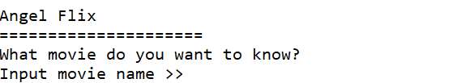

**Figure 1. Input Movie Name**

* If the input movie name is **available** in the Angel Flix database, then retrieve it from database and show the **name** and **description** of the movie.

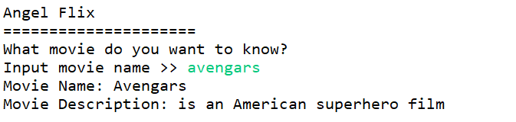

**Figure 2. Movie has Found**

* **Otherwise**, it will **show an error message**.

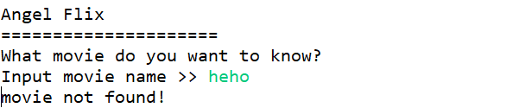

**Figure 3. Movie not Found**

There is one concern from the manager, that the database will have **lots of requests** that could cause the database will down, so the manager asks you to help to **lighten up the server** from the user.