|  |  |
| --- | --- |
| **Practicum Case** |  |
| COMP6122 | COMP6122001  Framework Layer Architecture |
| **Computer Science** | **O221-COMP6122-CT01-09** |
| ***Valid on*** *Odd Semester Year 2021/2022* | **Revision 00** |

**Learning Outcome**

* LO2 – apply design pattern in java
* LO3 – design object oriented in design pattern

**Topic**

* Session 9 – Behavioral Design Pattern I

## Sub Topics

* Observer

1. **Observer Pattern**

Observer is a behavioral design pattern that lets you define a subscription mechanism to notify multiple objects about any events that happen to the object they’re observing. The object that has some interesting state is often called subject, but since it’s also going to notify other objects about the changes to its state, we’ll call it publisher. All other objects that want to track changes to the publisher’s state are called subscribers.

## Soal

*Case*

**Angel Music**

Angel Music is one of the top streaming music platforms. At this moment, Angel Music wants to launch a music service for radio companies or maybe other platform companies. You as the programmer of Angel Music, the manager asks you to create a service program that could help to add the radio companies for those who wanted to get service from our company. Below are the following details of the program:

Currently **available** **subscribers** are:

|  |  |
| --- | --- |
| Company Name | Company Type |
| PT Gogo Company | Radio |
| PT Loga Company | Hotel |
| PT Lolo Company | Radio |

* The program will ask the user what **track is currently playing**.

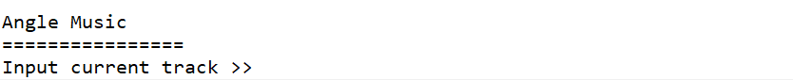

**Figure 1. Program Asks User to Input Current Track**

* If the user inputs the **track name**, then the Angel Music service company will **notify all the subscribers** about the current playing track.

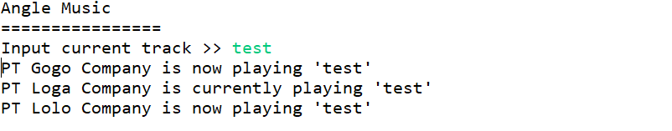

**Figure 2. Notify All of the Subscribers from each company**