**Johnny - Multiplication Program**

**Wiktor Zmiendak**

1. **Task:**

Create a program in Johnny to do Multiplication of two numbers.

1. **Flowchart:**

1. **Solution:**

To start, we initialize the result as 0 and set two operands, A and B. We then proceed to retrieve the value of the result, initially 0, and add the value of A to it. This marks the beginning of our loop. Within the loop, we update the result by assigning the value of the accumulator to it, and decrement B. We then check if B equals 0. If it does not, we return to the beginning of the loop and repeat the previous instructions. If B equals 0, the program terminates.

Steps:

* Set the result (010) to 5

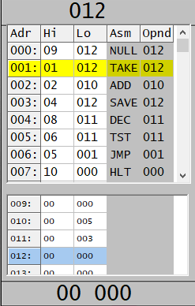

* Obraz zawierający tekst, zrzut ekranu, numer, wyświetlacz

  Opis wygenerowany automatycznieRetrieve the value of the result.
* Add A and save the result in the result address (009).

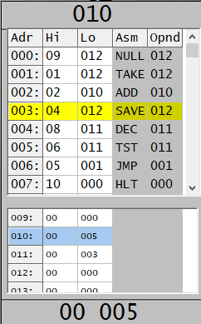

* Decrement B and check if it equals 0.

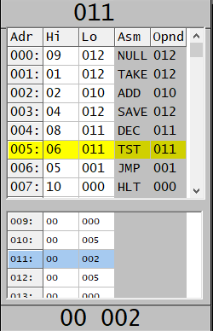

* If B is 0, end the program; otherwise, jump back to step 2 and repeat the previous instructions. Make note that it isn’t the best solution.

