**Finite State Automata**

**second part**

**Wiktor Zmiendak**

1. **Task:**

Design a state machine with two separate sequence arrays. We start from 0 point and create independent pair combinations. Inputs should create 1234 and 5678 sequences depending on the array.

1. 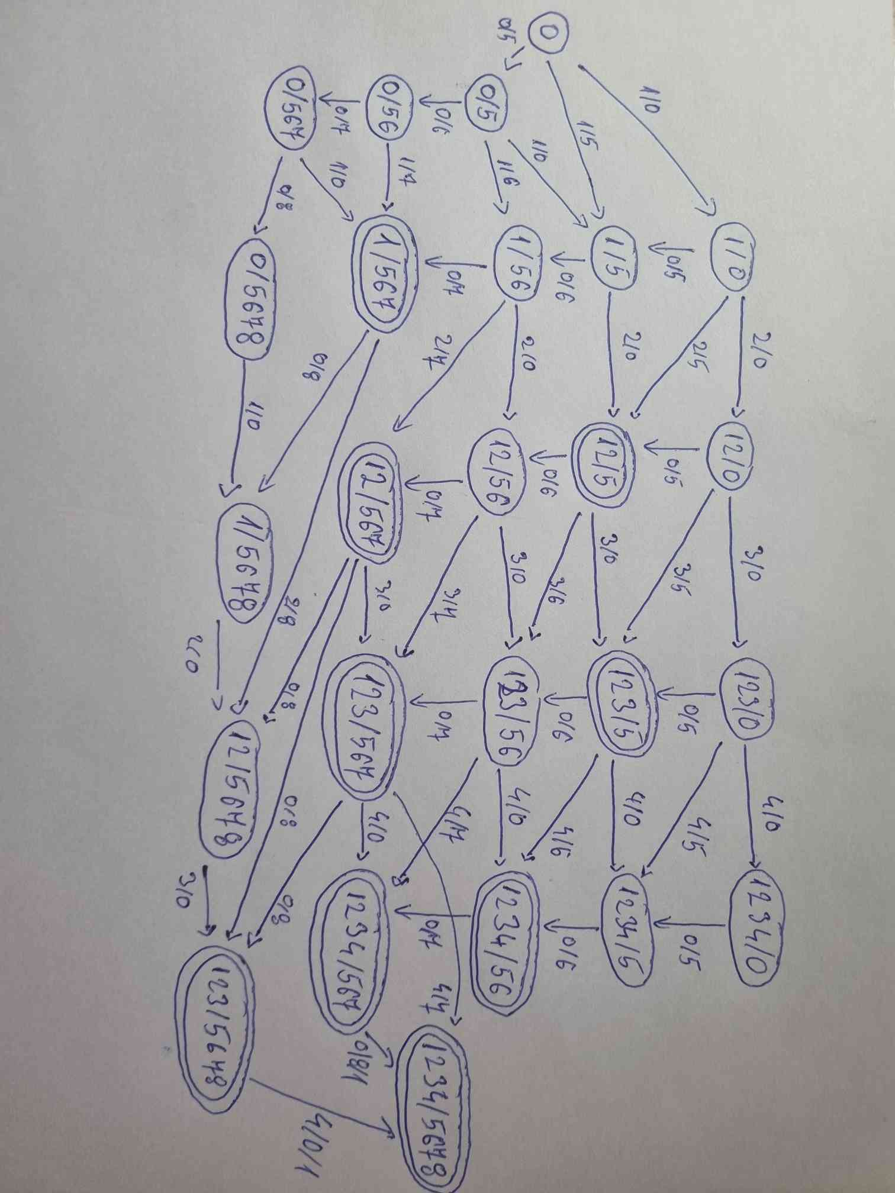**Solution:**