**Johnny - Addition Program**

**Wiktor Zmiendak**

1. **Task:**

Create a program in Johnny simulator to add two numbers.

1. **Flowchart:**

1. **Solution:**

To solve this problem it takes only four instructions to combine:

TAKE: The program begins at address 000 and retrieves the first variable, which is stored at address 004, placing it into the accumulator.

ADD: Next, the program performs addition by taking another variable and adding it to the accumulator.

SAVE: The program stores the result in a specified RAM memory location, in this case, at address 009.

HLT: Finally, the program halts and sends a message indicating that it has completed its task.

1. 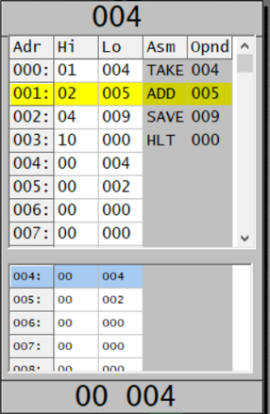**Program:**