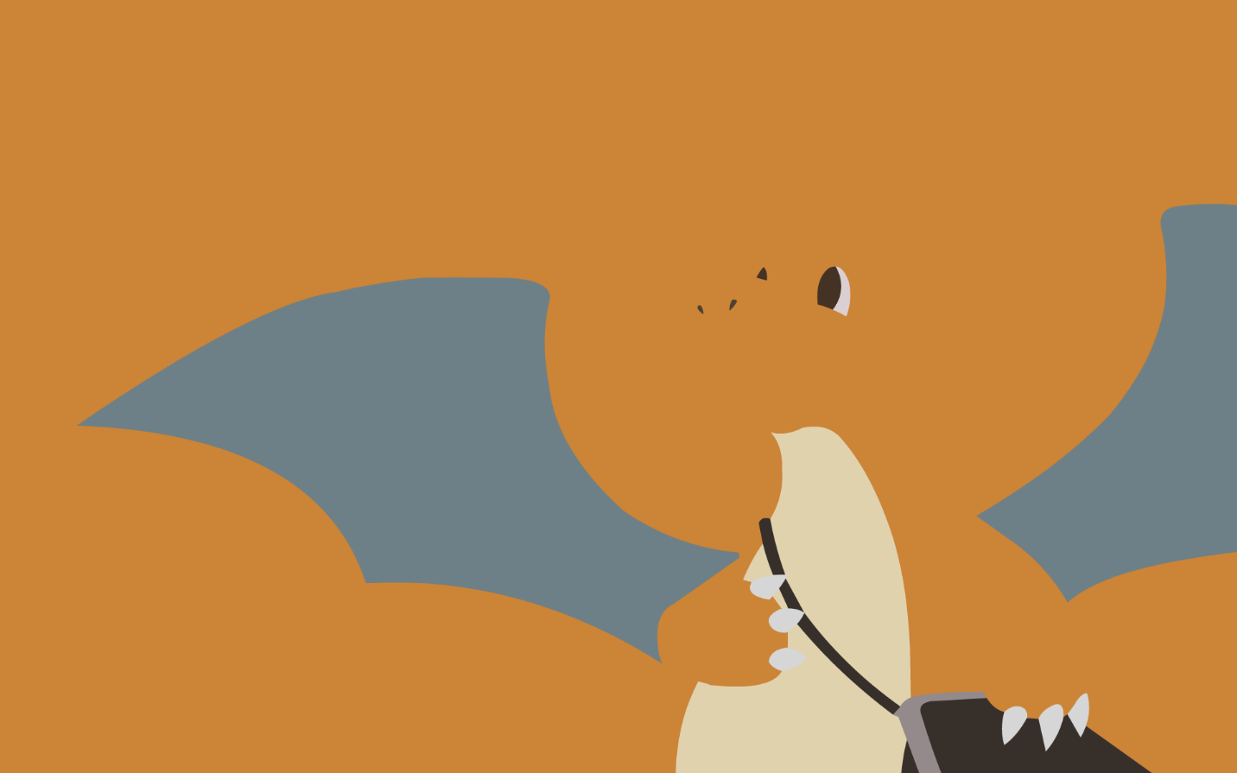

North

I found myself on the ground, too weak to even open my eyes, I was lying on some sort of moss, a very soft and comfortable moss even softer than my bed at home, then it struck me, what was I doing lying on the ground? Why wasn’t I in my bed at home? Where was I? What is this place? As I opened my eyes the sunlight blazed into my eyes as if there was the heat and light of a thousand embers burning, so powerful was this sun. It took me some time to adjust to my surroundings, there were trees, tall trees, the bark as dark as the fur of a bear, but not perfectly sculpted, the bark was rough, I could make it out from a distance, the crown of the tree was big and lush as green as a green meadow where the cow’s graze at my grandad’s farm, it was perfectly shaped just like the top of a mushroom it looked like a fitting crown for a tall tree so majestic. I then looked around; I was in a clearing in the forest a large clearing, the trees were a few meters away but the cast a dark and cool shade over the clearing, except where I was, I wondered why, I mustered enough strength to get up and see more, it took an exceptional amount of time since I was flushed, but I did. Once I got up, I stretched my arms and started walking a bit but that was a mistake. I fell. I realized the issue about the shade but thought it was the least of my problems right now, as I fell, I scraped and scratched through many branches and just when I thought I was done for I heard a “Swoosh” and a “Swish” and then a “Thump!” I was one something soft, something rubbery and jelly-like at the same time rough and uncomfortable, I had been saved but I now needed to figure out whether I was in the hands of a friend or was I the bread on the table.

I saw that I was on a DRAGON! The dragon had scales in the vibrant color of the sun, tiny nail like structures on its paws, tiny but immensely powerful wings, with an underside of the green color of the forest trees and grass, it had a friendly smile on its face which re-assured me and green eyes with a tinge of dark yellow and two ever-flaring nostrils, you might be telling right now that “But that’s how every dragon looks like” well you are wrong, WRONG, WRONG! There was a feeling of homeliness, a feeling of warmth and care, not like the war-like attitude of a regular dragon. I thought this mighty flying beast was the forest guardian because of its mellow color and resemblance to the forest, just as we passed the clearing, I saw some sort of a spirally, swirly thing switching and changing colors from purple to shades of blue, some sort of a portal a wormhole maybe but I established the idea that I had come from there and I needed to get back there. I fell, tired and sleepy.

I woke up a few hours later, the dragon had brought me to a its den and had some yellow gooey in a shell beside me, I guess it wanted me to eat that, I dipped my finger in and tasted it, to my surprise it was honey but not any honey this tasted different, sweet but not too sweet, yet it was perfect, I took the shell and gulped down all the honey at once my body was flushed with energy, I ran out of the den and found myself falling again to my relief the dragon came and caught me snickering a bit but also worried.

 As we reached the top of the cliff near the dragon’s den, I pointed towards the portal trying to tell it that I needed to get there as it was the way to my home it seemed to understand and we set out toward the wormhole a storm was brewing in the vicinity I realized I needed to get past that, the dragon glided past the dark clouds of the vicinity, but when we reached the clearing near the portal it was hopeless, there was a mighty fine tornado, perfectly horrible, the dragon seemed to be struggling but just as we reached the storm I was flung away towards its swirling mass I thought this was the end as I was really close to the end but the dragon glided and whooshed using the swirl of the tornado to its advantage it came near me and flung towards the ledge of the portal which was covered with mosses and net like brambles, with vines hanging all around, the dragon was falling swiftly into the tornado I needed to do something quick, I threw down a vine but it ripped, there was no hope, I then saw a thicker vine, tightened it and attached the net like, thorny bramble to it, I threw it down to the dragon hoping it would get stuck and I could pull it up but the dragon was too low but managed to grab the vines, I tried to pull it up but to no avail but flung the vine toward the side of the storm, I thought the dragon was gone but it used the power of the storm and after a few maneuvers reached the ledge where I was, I hugged the dragon it was warm and it hugged me back, as we saw the trees of the forest being ripped away we thought that there was no hope going back we needed to go through…

 As we went through I was flushed through all of my energy my vision was distorted and blurred I lost my sense of smell, this continued for some time but after that I heard a thud and fell it wasn’t a long fall, I landed on a grass field, and I moved my hands, I could touch the dragon he was lying on the ground tired and miserable just like me, I felt I couldn’t do anything else and decided to rest, “Just one more thing” I said to the dragon “Is it okay if I call you North”, the dragon chuckled, “Okay then North, you did great today, time to get a good rest”,  we both smiled flushed as we were, a calm sense of relief hit us, a sense of rest after a tremendous journey as we fell into a deep slumber.