1.Download Datasets

https://gitlab.com/shimorina/webnlg-dataset/tree/master/release_v3.0，Unzip, and the directory is the same as the code folder

2.makedir data/data/webnlg_pos_ordered/train.source(target)

3. python webnlg_2020.py

4.pip install pandas

5.python generate_datasets.py，get T5_large/data/webnlg20_ordered

The above folders I gave are all running well. You can run them yourself or use the results directly without running

——————————————————————————————————

The following is a must

5.Change the folder/path name (I have changed it in the code, but the root directory needs to be changed by myself). Note that all paths are consistent

6.anaconda3/envs/python36/lib/python3.6/site-packages/rouge_score/rouge_scorer.py", line 87, in RougeScorer

def score_multi(self, targets: list[str], prediction: str): list[str]->list

7.cd Graph-Masking-Pre-training-main/pretraining

bash ./finetune_masked_spans.sh t5-large 0

Possible problems:

1.The 2.95G model file is half downloaded

Solution: restart the terminal to run again

2.RuntimeError: CUDA error: CUBLAS_STATUS_EXECUTION_FAILED when calling `cublasSgemm‘ This is an environmental problem. The quickest way is to change the server. If you don't have it, you should check all versions. Refer to: 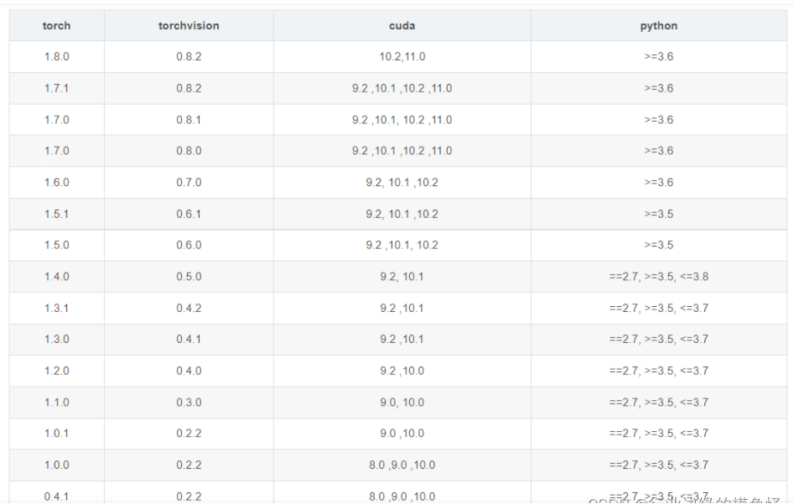

（Just look at 3.6 in this picture）

3.AttributeError: module 'tensorflow' has no attribute 'io'

Solution：pip install tensorflow-io

Screenshot of normal operation: