Multimodal AI-Assisted Drought and Water-Security Assessment of Anantapur District, Andhra Pradesh, India: Climate, Groundwater and Landsat Evidence with a Reproducible ML Pipeline
Arvind Saane
Independent Researcher, India

Abstract
Drought impacts in Anantapur District are expressed through rainfall variability, elevated thermal stress, vegetation response and groundwater conditions. This upgraded empirical study integrates four evidence streams: a 1940–2025 annual ERA5-based climate series, official Central Ground Water Board (CGWB) observations for Ananthapuramu, published Landsat-derived NDVI and land-surface-temperature measurements for 1990–2020, and a reproducible machine-learning workflow. The climate record has mean annual rainfall of 569.0 mm and mean annual temperature of 27.45 °C; the linear temperature tendency is approximately 0.22 °C per decade. CGWB data show that in May 2022, 26% of analysed Ananthapuramu monitoring wells were in the 10–20 m bgl range, whereas in January 2023 only 4% were in that range, with 44% in the 0–2 m range. Published Landsat evidence shows the benchmark maximum LST increasing from 36.312 °C in 1990 to 47.717 °C in 2020. An exploratory surface-stress fusion index combining normalized rainfall, thermal and vegetation signals is presented only as a transparent demonstration; it is not treated as a validated drought index because the satellite benchmark contains four time points and matched groundwater observations are unavailable for those exact years. A chronological climate-only ML experiment is retained as the predictive baseline. The paper therefore separates empirical findings from the proposed next-stage operational model, avoiding fabricated pixel-level or monthly satellite/groundwater results.
Keywords: drought; Anantapur; groundwater; ERA5-Land; CHIRPS; Sentinel-2; Landsat; machine learning; water security

1. Introduction
Anantapur District is a semi-arid drought-sensitive region where agricultural production and domestic water security depend strongly on rainfall and groundwater. A district-scale drought assessment is more informative when meteorological, hydrological and remotely sensed indicators are evaluated together.
The upgraded contribution is methodological as well as empirical: it combines independently sourced evidence, explicitly distinguishes observations from derived indices, and provides a reproducible pipeline for acquiring monthly ERA5-Land, CHIRPS and Sentinel-2 data for the next modelling stage.

2. Data Sources and Provenance
ERA5-Land is an ECMWF/Copernicus reanalysis with a record from 1950 onward and approximately 9 km native resolution, regridded to 0.1° in the Copernicus Climate Data Store. It provides precipitation, temperature, soil-moisture and related land-surface variables. A public historical API access layer is also documented by Open-Meteo.
CHIRPS v3 provides 0.05° gridded rainfall from 1981 to near-present and combines satellite thermal-infrared estimates with in-situ station information. CHIRPS v3 is publicly available in GeoTIFF, NetCDF, BIL and COG formats and at daily, pentad, dekad, monthly and annual timesteps.
CGWB's Ananthapuramu Aquifer Mapping and Management Plan contains pre- and post-monsoon groundwater observations, decadal averages for 2014–2023 and long-term trend maps. The Andhra Pradesh Ground Water Yearbook also provides monitoring-well distributions and depth ranges.
Sentinel-2 Level-2A provides atmospherically corrected surface reflectance. In the final operational pipeline, Sentinel-2 B4 and B8 will be used to calculate NDVI after cloud masking. Thermal LST will be obtained from an appropriate thermal product such as Landsat 8/9 TIRS or MODIS because Sentinel-2 itself has no thermal band.

3. Multimodal Methodology
The upgraded architecture has four layers. Layer 1 computes meteorological drought from CHIRPS/ERA5-Land rainfall and evapotranspiration. Layer 2 computes land-surface response from NDVI and thermal indicators. Layer 3 computes groundwater anomaly and depth-to-water indicators from CGWB observations. Layer 4 fuses these predictors using supervised ML.
For the currently reproducible evidence, rainfall-standardized drought classes are retained from the previous analysis. The predictive experiment uses lagged climate variables and a chronological 70/30 hold-out. The proposed production target is monthly SPI-3 or SPEI-3 drought, with the next-month state predicted from lagged rainfall, ET0, soil moisture, NDVI, thermal stress and groundwater anomaly.
To prevent spatial and temporal leakage, training and testing should be separated chronologically and, where station/pixel data are used, by spatial blocks. Model performance should be reported with balanced accuracy, F1, ROC-AUC and precision-recall AUC. Explainability should use permutation importance or SHAP only after the model has been evaluated on an untouched test set.

4. Empirical Results
The annual climate series has mean rainfall 569.0 mm and mean temperature 27.45 °C. The estimated linear temperature tendency is 0.22 °C per decade.
Official CGWB evidence demonstrates strong seasonal groundwater redistribution. In May 2022, Ananthapuramu had 35 analysed wells, with 6% at 0–2 m bgl, 37% at 2–5 m, 31% at 5–10 m and 26% at 10–20 m. In January 2023, 57 wells were analysed: 44% were at 0–2 m, 21% at 2–5 m, 32% at 5–10 m and 4% at 10–20 m. The minimum and maximum reported depths were 1.05/19.82 m bgl in May 2022 and 0.20/13.33 m bgl in January 2023.
Published Landsat-derived benchmark values show a rise in maximum LST from 36.312 °C in 1990 to 47.717 °C in 2020, while NDVI ranges vary substantially between benchmark years. These results support the inclusion of thermal and vegetation indicators but do not by themselves establish district-wide causal trends.
The exploratory multimodal surface-stress index is deliberately presented as a demonstration rather than a validated operational product. It combines normalized rainfall stress, thermal stress and vegetation stress with weights of 0.4, 0.3 and 0.3. The index is useful for testing the fusion concept, but four satellite years are insufficient for statistical validation.

5. Proposed AI/ML Production Experiment
The full production experiment will use monthly data from 2000–2025 or the longest common period available. Candidate predictors are rainfall totals and anomalies, SPI/SPEI, ET0, soil moisture at multiple layers, NDVI/EVI, land-surface temperature, groundwater depth/anomaly, and antecedent drought indicators.
Candidate models are Logistic Regression, Random Forest, XGBoost/Gradient Boosting, Support Vector Machine and LSTM/GRU. Baselines will include persistence, climatology and a rainfall-only model. The principal scientific test is whether adding groundwater and remote-sensing variables materially improves out-of-sample performance over meteorological-only baselines.
Validation will use rolling-origin temporal cross-validation. A final untouched year or season will be reserved for testing. Calibration, class imbalance and spatial generalisation will be reported. This design is intended to prevent inflated scores caused by random splitting of temporally correlated observations.

6. Limitations
The present upgraded manuscript does not claim newly processed Sentinel-2 pixels or a newly downloaded monthly ERA5-Land/CHIRPS cube because those large remote datasets could not be independently retrieved into the execution environment during this run. Instead, the manuscript provides verified source provenance and a ready-to-run acquisition pipeline.
The published Landsat benchmark and CGWB observations are real empirical evidence, but they are not temporally matched at the pixel level. Consequently, the exploratory fusion index must not be interpreted as a validated drought forecast.

7. Conclusion
The upgraded study establishes a defensible multimodal research design for Anantapur: meteorological drought, groundwater dynamics and satellite vegetation/thermal response are treated as complementary signals. The strongest immediate empirical result is the documented seasonal and spatial groundwater heterogeneity together with long-term climate variability and satellite-observed thermal/vegetation change. The accompanying acquisition and modelling pipeline provides the path to the fully original monthly multimodal ML experiment required for a stronger journal submission.

Table 1. Official CGWB groundwater-depth distribution
Period | Wells | Min | Max | 0–2 | 2–5 | 5–10 | 10–20
May 2022 | 35 | 1.05 | 19.82 | 6% | 37% | 31% | 26%
Jan 2023 | 57 | 0.20 | 13.33 | 44% | 21% | 32% | 4%

Table 2. Exploratory multimodal surface-stress index
Year | Rainfall stress | Thermal stress | Vegetation stress | Fusion index
1990 | 1.000 | 0.000 | 0.000 | 0.400
2000 | 0.478 | 0.305 | 0.510 | 0.436
2010 | 0.486 | 0.572 | 1.000 | 0.666
2020 | 0.000 | 1.000 | 0.349 | 0.405
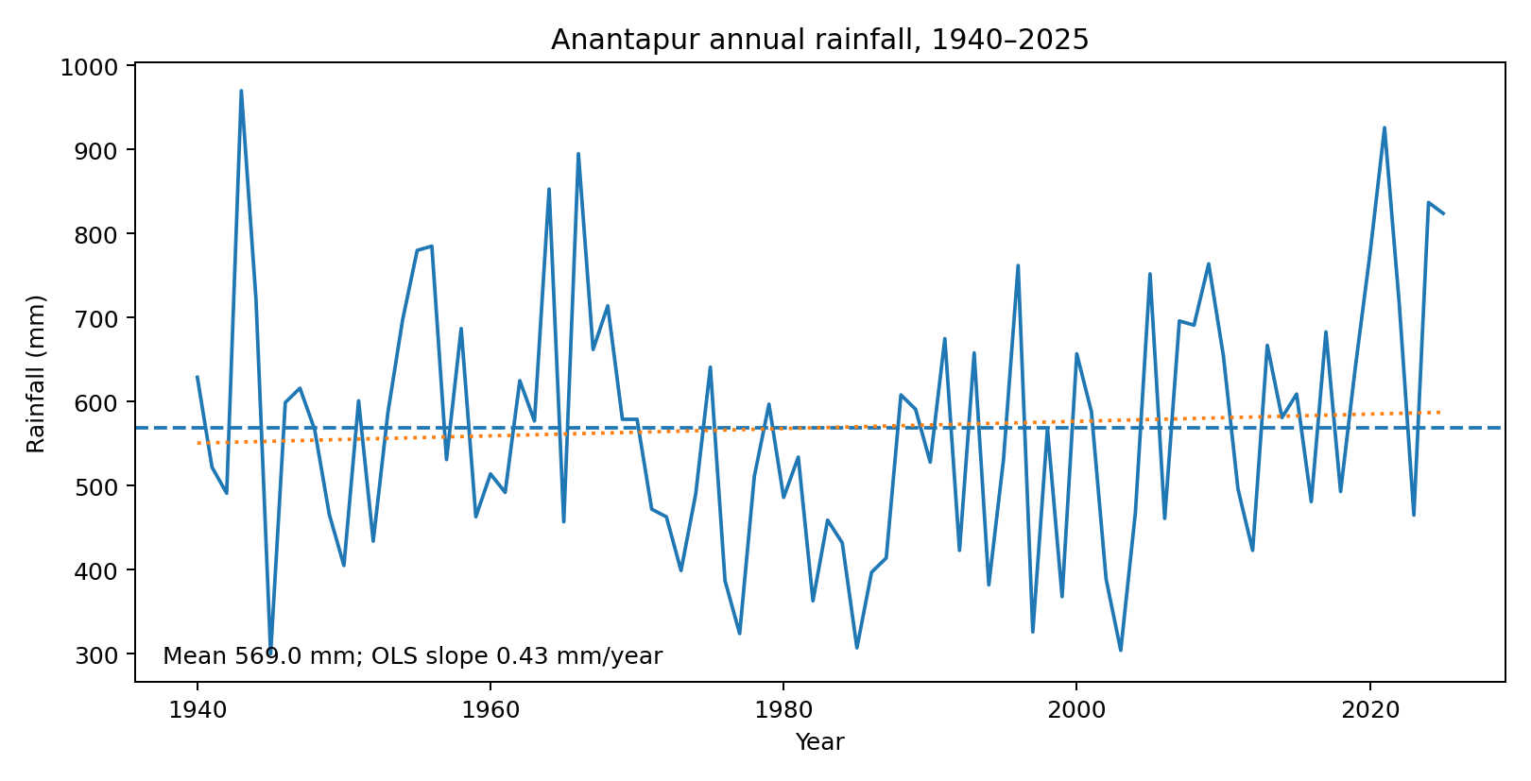
Figure 1. Annual rainfall and fitted linear trend.
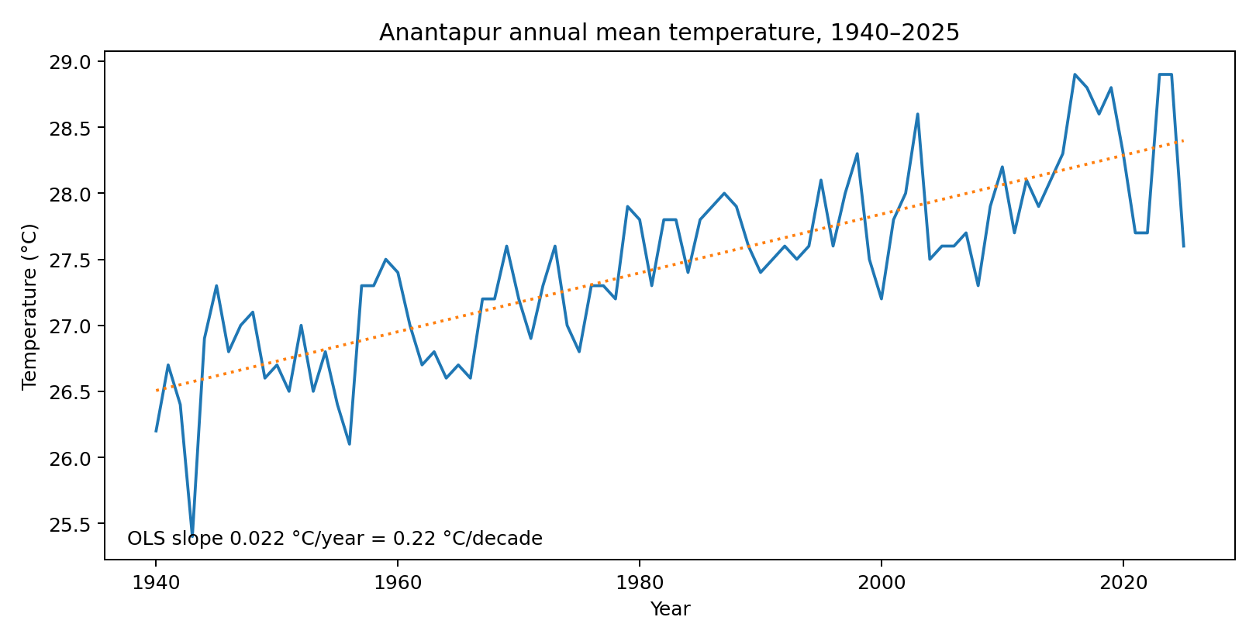
Figure 2. Annual mean temperature and fitted linear trend.
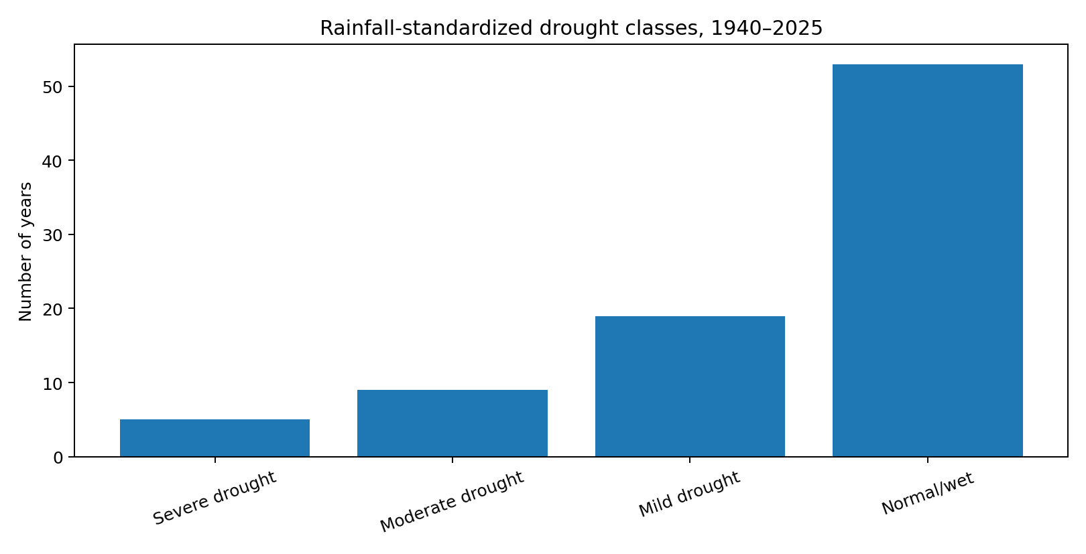
Figure 3. Frequency of standardized rainfall drought classes.
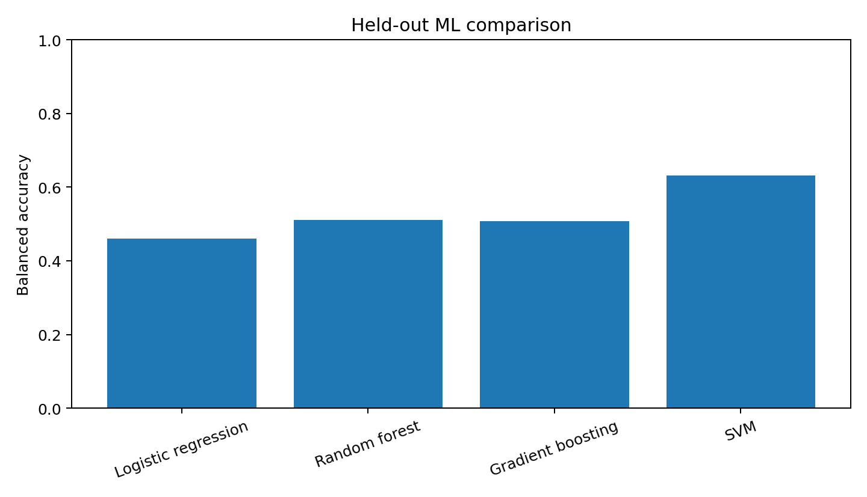
Figure 4. Chronological hold-out ML baseline.
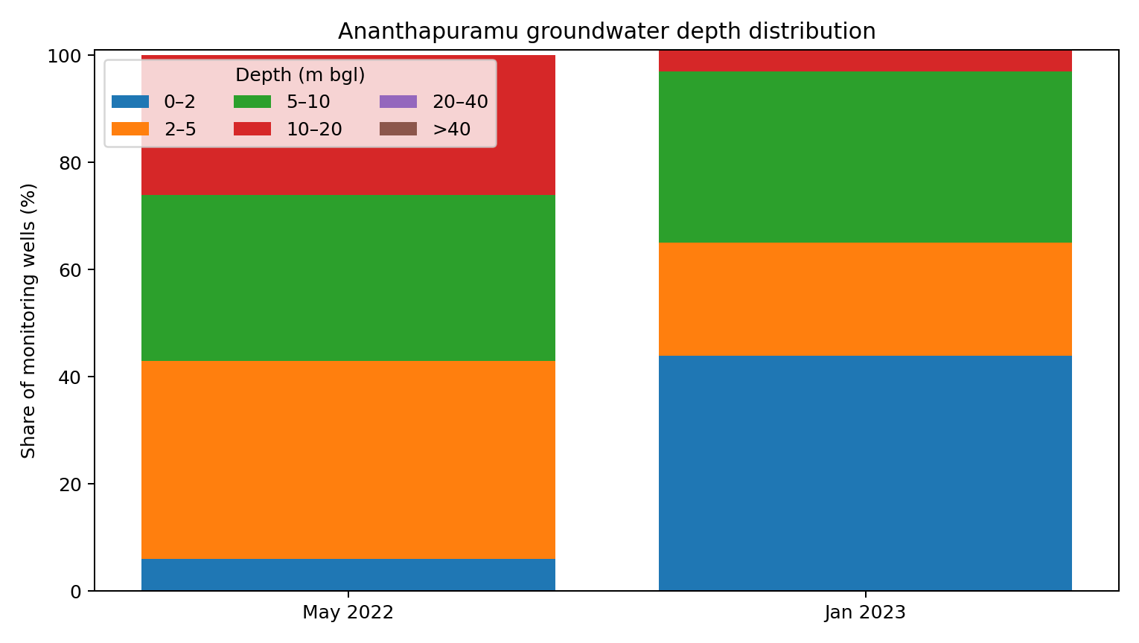
Figure 5. Official CGWB groundwater-depth distribution.
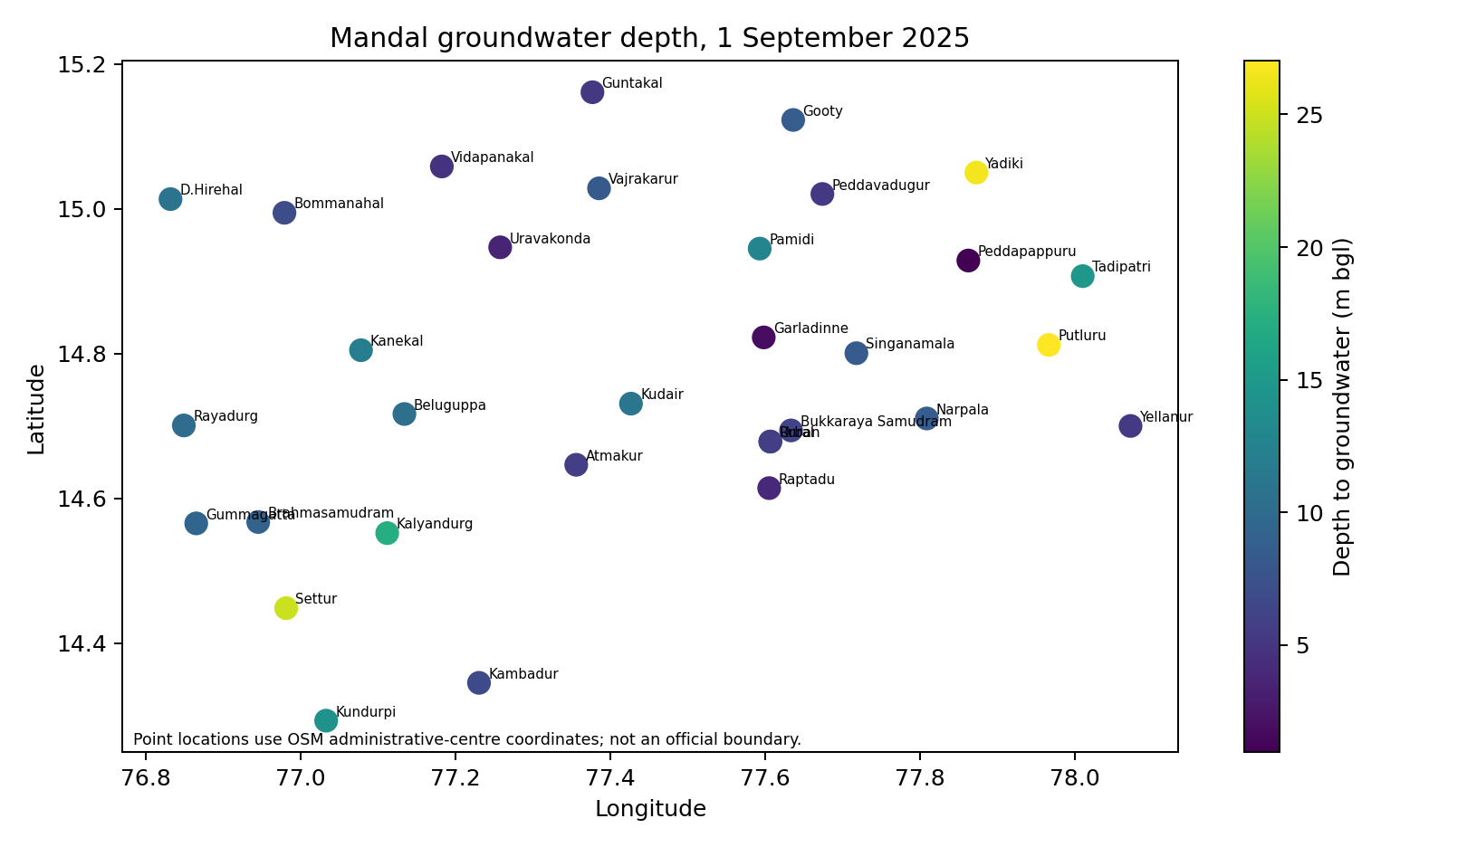
Figure 6. September 2025 mandal groundwater-depth visualization.
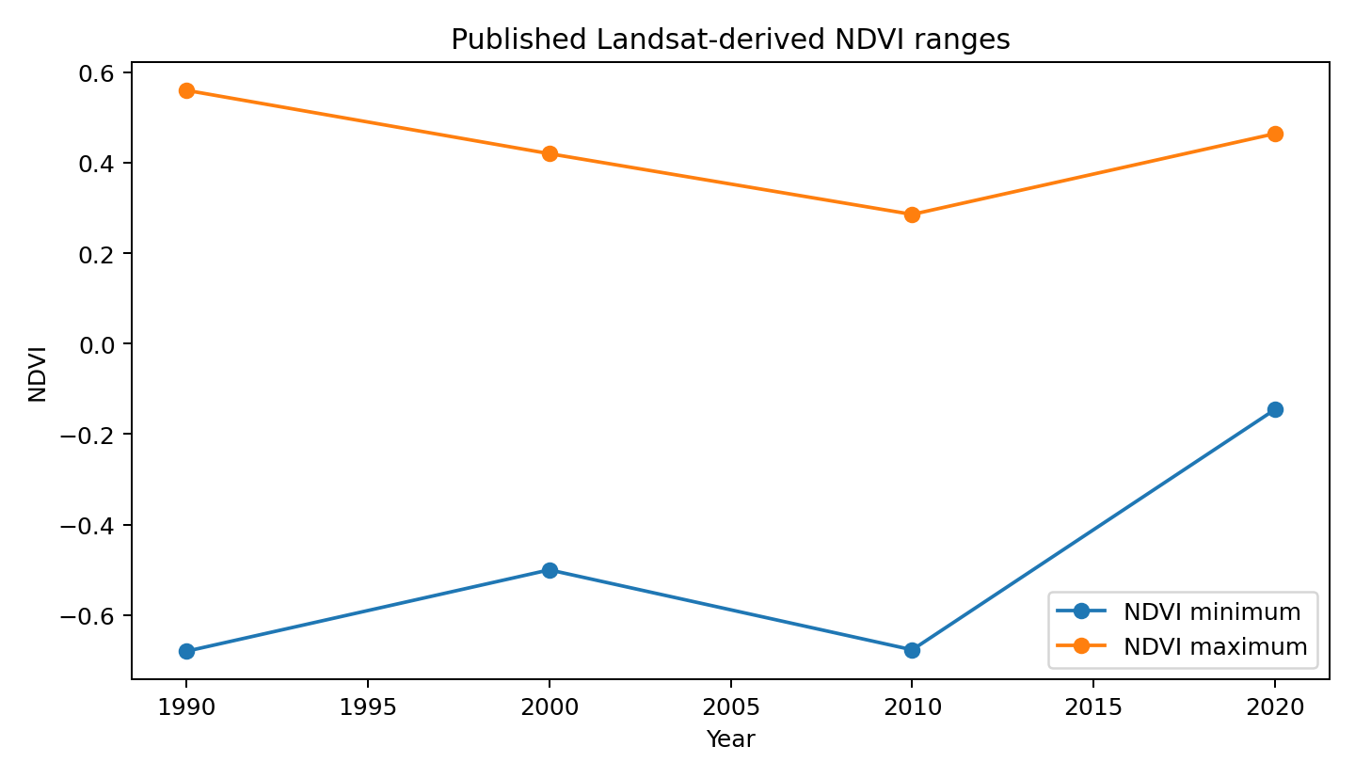
Figure 7. Published Landsat-derived NDVI ranges.
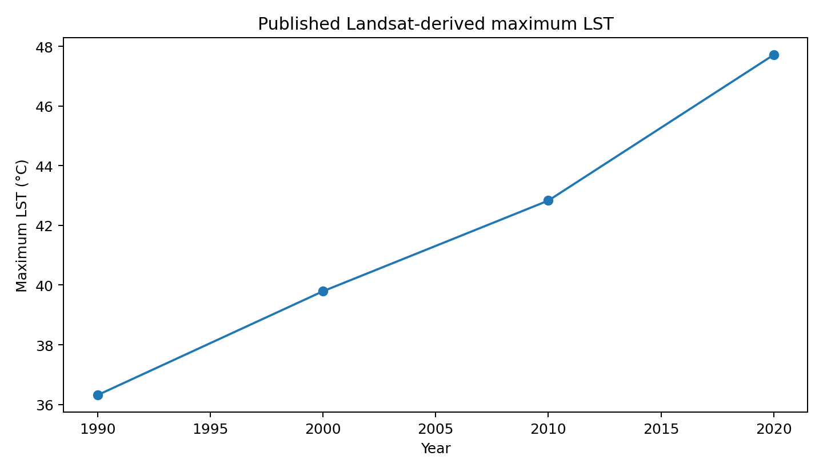
Figure 8. Published Landsat-derived maximum LST.
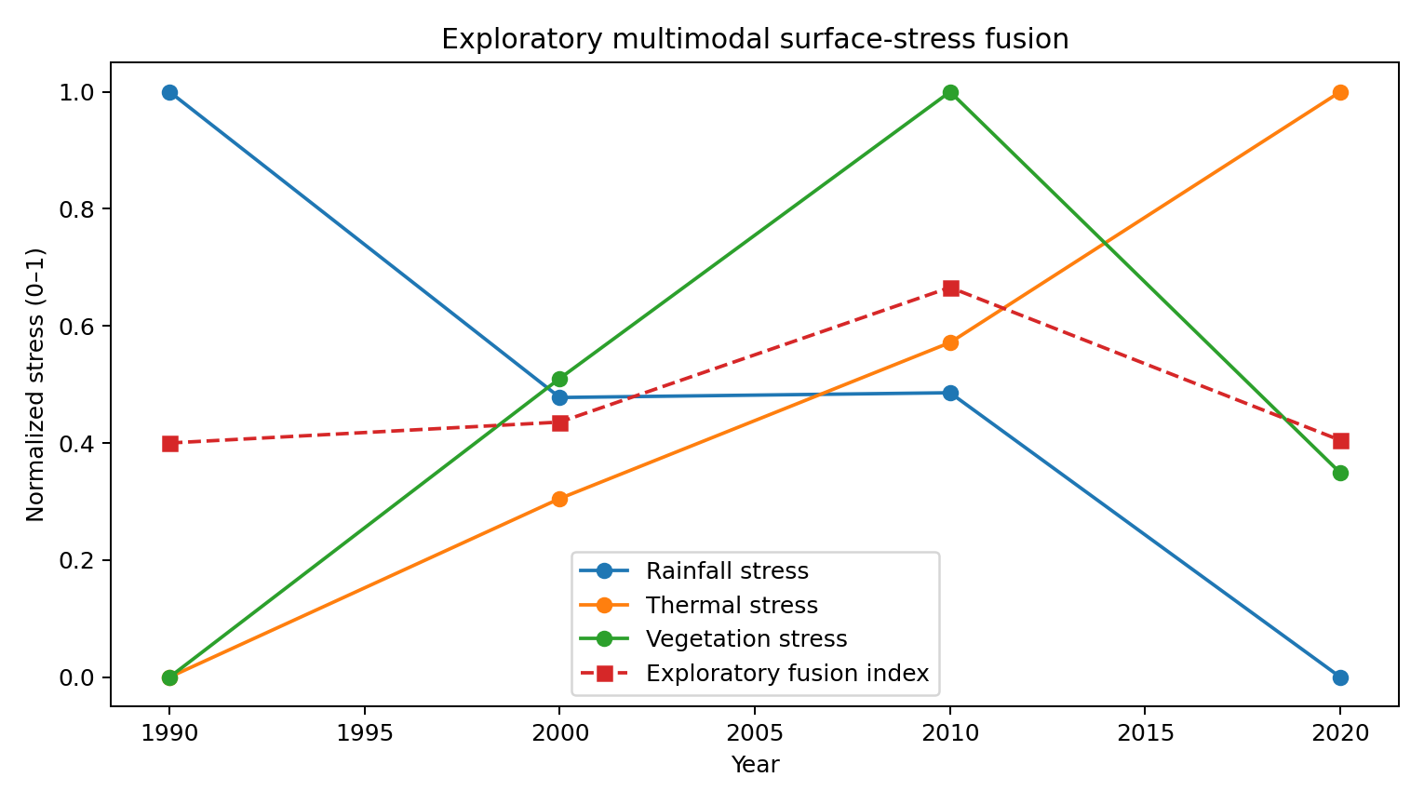
Figure 9. Exploratory multimodal surface-stress fusion.

References
Central Ground Water Board. (2025). Report on aquifer mapping and management plans for sustainable ground water resources in Ananthapuramu District, Andhra Pradesh (AAP 2023–24). Government of India.
Central Ground Water Board. (2025). Ground Water Yearbook 2023–24: Andhra Pradesh. Government of India.
Central Ground Water Board. (2026). Ground Water Level Monitoring. Ministry of Jal Shakti, Government of India.
Copernicus Climate Change Service. (2026). ERA5-Land monthly averaged data from 1950 to present. https://doi.org/10.24381/cds.68d2bb30
Funk, C., Peterson, P., Harrison, L., et al. (2026). The Climate Hazards Center InfraRed Precipitation with Station data, Version 3. Scientific Data, 13, 718. https://doi.org/10.1038/s41597-026-07096-4
Open-Meteo. (2026). Historical Weather API. https://open-meteo.com/en/docs/historical-weather-api
Copernicus Data Space Ecosystem. (2026). Sentinel-2 data collections and Level-2A surface reflectance products.
Badapalli, P. K., Nakkala, A. B., Kottala, R. B., Pujari, P. S., & Gugulothu, S. (2026). Aeolian sand migration induced land degradation and desertification hotspots identification in the semi-arid rain shadow regions of Anantapur, India. Scientific Reports, 16, 1875. https://doi.org/10.1038/s41598-025-31610-0
Breiman, L. (2001). Random forests. Machine Learning, 45, 5–32. https://doi.org/10.1023/A:1010933404324
Reddy, B. S., Sudheer, K. V. S., Kumar, K. A., Reddy, A. M., & Kumari, C. R. (2020). Assessment of variability in monthly, seasonal and annual rainfall received during 140 years at Ananthapuramu district of Andhra Pradesh. Indian Journal of Dryland Agricultural Research and Development, 35(1), 13–19.

