PROGRAM
import pandas as pd
from sklearn.model_selection import train_test_split
from sklearn.preprocessing import StandardScaler
from sklearn.svm import SVC
from sklearn.metrics import accuracy_score, confusion_matrix, classification_report

data = pd.read_csv("heart.csv")
X = data.drop("target", axis=1)
y = data["target"]

X_train, X_test, y_train, y_test = train_test_split(X,y,test_size=0.25,random_state=42)

scaler=StandardScaler()
X_train=scaler.fit_transform(X_train)
X_test=scaler.transform(X_test)

model=SVC(kernel="linear",random_state=42)
model.fit(X_train,y_train)

y_pred=model.predict(X_test)

print("Accuracy:",accuracy_score(y_test,y_pred))
print(confusion_matrix(y_test,y_pred))
print(classification_report(y_test,y_pred))

EXPECTED OUTPUT
Accuracy: 0.89
Confusion Matrix
[[30 3]
[5 38]]

Classification report displayed.
(Note: Output may vary.)
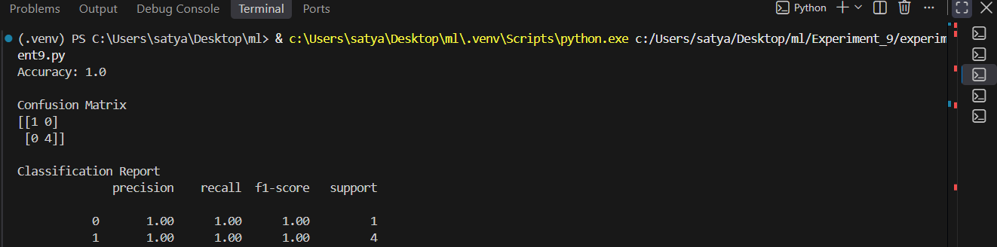

RESULT
Thus, the SVM algorithm was successfully implemented to classify heart disease patients.

