**MINI-PROJECT REPORT**

Student RecordSystem



# NAME: - Potla Siva

**TABLE OF CONTENTS**

|  |  |  |
| --- | --- | --- |
| **SERIAL No.** | **CONTENT** | **PAGE No.** |
| 1 | Introduction | 3 |
| 2 | Objective | 3 |
| 3 | Features | 3 |
| 4 | 4 W’s 1H | 4 |
| 5 | SWOT Analysis | 4 |
| 6 | Requirements | 6 |
| 7 | Architecture | 7 |
| 8 | Use case diagram | 8 |
| 9 | Expected results/Outcomes | 9 |

# Introduction

The Project Student Record System is to allow the administrator of any organization to edit and find out the personal details of a student and allows the student to keep up to date his profile .It’ll also facilitate keeping all the records of students, such as their id, name, mailing address, phone number, DOB etc. So all the information about an student will be available in a few seconds. Overall, it’ll make Student Record System an easier job for the administrator and the student of any organization. The main purpose of this SRS document is to illustrate the requirements of the project Student information System and is intended to help any organization to maintain and manage its student’s personal data.

# Objective:

Student Record System can be used by education institutes to maintain the records of students easily. Achieving this objective is difficult using a manual system as the information is scattered, can be redundant and collecting relevant information may be very time consuming. All these problems are solved using this project.

# Benefits:

# Features

The Website provides following functionalities to the users :

♣ Administrator :

o Login/Logout

o View student information

o Edit Student Information

o Enable/disable student accounts

o Search students

♣ Student :

o Login/Logout

o View profile

o Edit profile

o Change password

o Register new profile

# Who:

This is everyone who uses to manage the record of the students by maintaining all the Activities Done by students.

# What:

Student Record System is Design to help manage the Daily School Activities of Recording Maintaining by Automating it.

# Where:

This is used by the School or Organization in day to day life where they can track the Student Activities daily or monthly.

**How**:

Student Record systems provide capabilities for registering students in courses; documenting grading, transcripts of academic achievement and co-curricular activities, and the results of student assessment scores; forming student schedules; tracking student attendance; generating reports and managing other student.

**SWOT Analysis**

**Strengths**

* Improved Management of Student Enrollment.
* Centralized Billing and Accounting Management.
* Easier Integration of Administrators, Teachers, and Parents.
* Easy Exam Scheduling.
* Efficient Management of Student-Related Activities.

# Weaknesses

* The student result management system is prone to hacks.
* Administration cannot edit or modify scores after the deadline.
* Extensive modules and features make it difficult for a user to utilize the application.
* Minor technical glitches and issues

# Opportunities

* Creates awareness about Educational management
* Allows Students To maintain their Activities in efficient way
* Help you to Find the information About Students

# Threats

* Malware. Digital hackers are watching your every move and trick you to download malware and take control of your computer remotely.
* Theft & Loss.
* Unsafe data.
* Negligence.
* Third party APIs

# REQUIREMENTS



**High Level Requirements**



|  |  |  |  |
| --- | --- | --- | --- |
| **ID**    HR01 HR02 HR03 HR03 HR04  HR05 | **Description**    New student can create account  Student can mantain a Balance  Student information can be displayed Student can pay the bill from e-wallet  Students can maintain money in account's wallet    The last transaction amount of the student in the store have to be maintained | **Category**  Techinal Technical Technical Techinal technical  Technical | **Status**      TBI TBI TBI TBI  TBI |
| HR06 | student can opt for home delivery | Technical | FUTURE |

# Low Level Requirements



|  |  |  |  |
| --- | --- | --- | --- |
| **ID**    LR01    LR02  LR03 LR04 | **Description**    For Each new account a new array cell of structure type have to be created    Balance can be mantanied by creating a structure array each cell holding information of the user and their balance    Student information can be displayed by printing the structure array    When students the balance attribute is modified and updated | **HRID**  HR01  HR02  HR03 HR04 | **Status**    TBI    TBI  TBI TBI |
| LR05 | The home delivery option cane be implemented by taking the address of the student | HR06 | FUTURE |

**Architecture:**

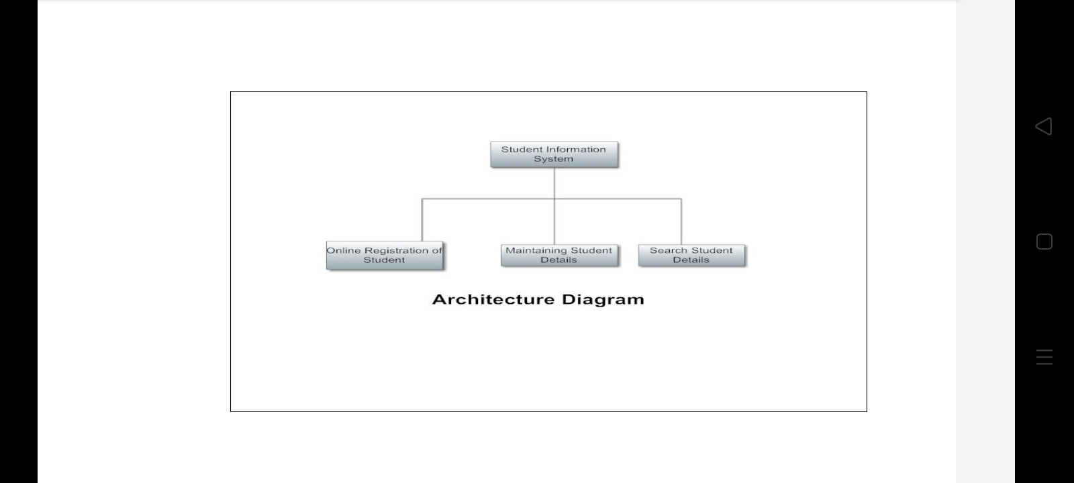

# Use Case Diagram

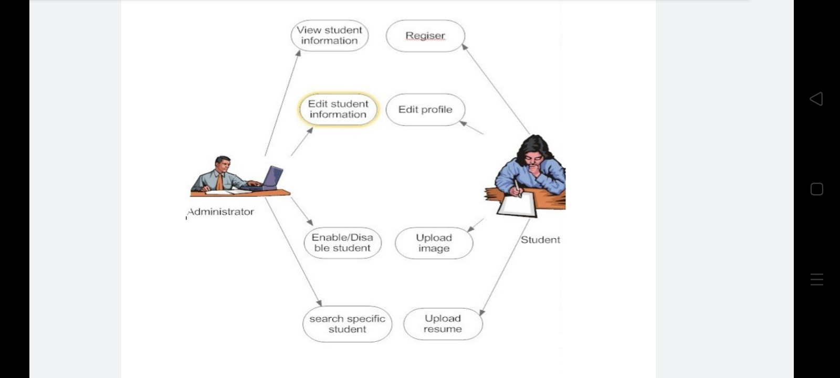

**Output Images:**

