Oscar Mahlangu

ELEN3009: Software Development 2

Project: Duel Space invaders

University of the Witwatersrand

Abstract – This report documents the design and implementation of the arcade game, space invaders. Where it has been modified for two-player mode – duel space invaders. The project requirements are listed and the mechanics described in the report. The game uses SFML for the graphics and doctest for running tests.

1. Introduction

Duel invaders is an arcade game based on the original space invaders. It includes a two player mode function.

1. Project Requirements and constraints

Project requirements are meet when the game meets basic functionality and the set constrains are meet. The game must display correctly on a screen with a resolution of 1920\*1080 pixels (game window). OpenGL and other libraries other than SFML may not be used [1].

1. Game mechanics

The game mechanics are best illustrated by figure 1 below. The dotted lines indicate the alien’s movements and the player’s movements. The diamonds are the alien’s laser shots while the square represents the player’s laser shots. In the game there are three game objects – players’ laser cannons, the aliens and the player laser shots [1]. The rectangles represents the alien armadas and the triangles represent the players’ laser cannons.

There are different keys to control the player’s movements. Which each is assigned on the Qwerty key board. The SFML library enables such functions. This includes sprites, etc – for the assigning of geometrical shapes previously mentioned.

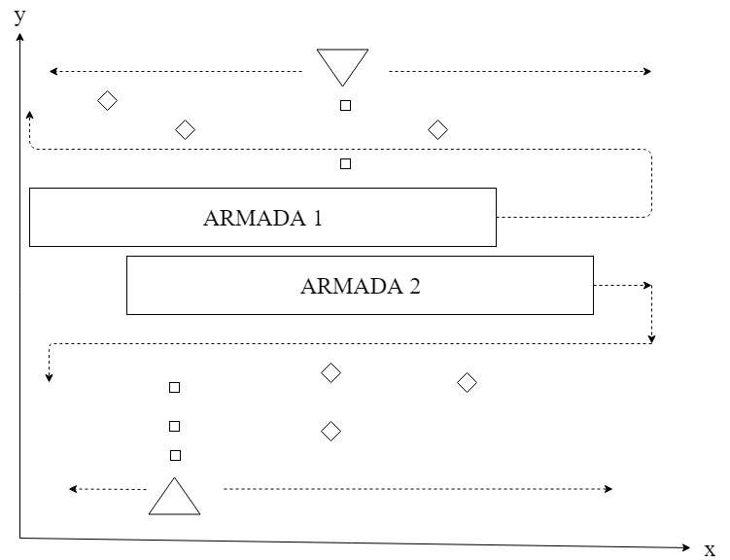

Figure 1: Duel space invaders diagram.

1. Future recommendations

For simplicity, considering a single player mode would be a moving linked players. For instance on the Cartesian plane illustrated by figure 1 above the x-coordinates would be the same for player 1 and player 2. A more complex game which uses AI on the original space invaders can be observed [2].

1. References

[1] Project – Duel Invaders, Electrical and information engineering, University of the Witwatersrand, Johannesburg, 2019.

[2] A Fuste, J Amores, S Perdices, S Ortega, D Miralles, *LSInvaders Cross reality environment inspired by the arcade game Space Invaders*, IEEE, 21 March 2013.