DEVELOPING A ARABIC RESTAURANTR WEBSITE USING HTML

A PROJECT REPORT

*Submitted by*

AL ADNAN MOHAMMED.C

*in partial fulfilment for the award of the degree* *of*

# BACHELOR OF TECHNOLOGY(CSE)



Lovely Professional University, Punjab

Registration no: 12401118

OCT 2024

INDEX PAGE: -

TABLE OF CONTENTS

|  |  |  |
| --- | --- | --- |
| CHAPTER NO. | CHAPTER NAME | PAGE NO. |
|  | Title Page | 1 |
|  | Index Page | 2 |
|  | Introduction to project | 2 |
|  | Technology Used | 3 |
|  | Workflow | 3 |
|  | Working on the project | 4 |
|  | Code snippets of the project | 5 - 18 |
|  | Output Screenshots | 19-20 |
|  | Conclusion | 21 |
|  | References | 21 |

INTRODUCTION:

Creating a simple Arabic restaurant website using HTML and CSS is a great way to start building user-friendly web interfaces! Below, I'll walk you through the basic structure for a restaurant page. The website will provide customers with an engaging online experience for customers as easy and simple. It showcasing the restaurant’s menu, contact details and about all. With the growing demand for online food ordering and reservation systems, this project seeks to create a user-friendly platform that enhances the overall dining experience for customers

* HTML Form: The form collects basic customer details, like name and details.

* CSS Styling: CSS provides a clean look with padding, background colour and rounded corners

TECHNOLOGY USED:

Building a restaurant website with HTML and CSS forms the front-end foundation.

However, for a fully functional restaurant system, additional technologies are typically used. Here’s an overview of the technologies commonly involved:

1. HTML (Hypertext Markup Language)
   * Purpose: Structures the content of the restaurant website.
   * Usage: Creates the form for user input fields like username and email.
2. CSS (Cascading Style Sheets)
   * Purpose: Styles the website to make it visually appealing and user-friendly.
   * Usage: Designs the layout, colours, fonts, and adds interactivity (like hover effects on buttons)

WORKFLOW:

The workflow of a restaurant website involves a sequence of interactions between the user interface (UI) and the backend. Here’s a breakdown of how the workflow typically proceeds, from when a user accesses the site to the restaurant:

1. User Accesses the Website: -

○ Front-End (HTML & CSS): The user opens the restaurant website, which loads the HTML and CSS files to display the restaurant images.

1. User Can Fills Out the join Form: -
   * Front-End (HTML): The user enters their information in the form fields, selecting in which category the users are interested and also the country where they wants to

work.

* + CSS: Provides a polished, accessible design for easy data input.

WORKING ON PROJECT:

○ A restaurant website project is a great way to apply HTML and CSS skills, and it can be expanded to include JavaScript for interactivity and server side features if needed.

HERE ARE SOME IDEAS TO ENHANCE THE PROJECT:

1. Responsive Design: Make the form adapt to different screen sizes, so it looks good on mobile and desktop.
2. Interactive Features: Consider using JavaScript to validate form inputs or create a dynamic games picker.
3. Styling Options: You could try different CSS styles, such as adding animations or hover effects to buttons.

Code snippets of the project:

# restaurant.html

<!DOCTYPE html>

<html lang="en">

<head>

    <meta charset="UTF-8">

    <meta name="viewport" content="width=device-width, initial-scale=1.0">

    <meta name="description" content="Discover Authentic Arabic Cuisine at Our Restaurant. Indulge in the rich flavors of the Middle East, brought to life with the finest ingredients.">

    <meta name="keywords" content="Authentic Arabic Cuisine, Middle Eastern Food, Arabic Restaurant, Restaurant Kerala">

    <meta name="author" content="Arabic Restaurant">

    <title>Authentic Arabic Restaurant | Best Middle Eastern Cuisine</title>

    <!-- External CSS -->

    <style>

        /* General Reset */

        * {

            margin: 0;

            padding: 0;

            box-sizing: border-box;

        }

        /* Body and Font Settings */

        body {

            font-family: 'Arial', sans-serif;

            line-height: 1.6;

            color: #941818;

            background-color: #121212;

        }

        /* Header Section */

        header {

            background: url('restaurant-hero.jpg') no-repeat center center/cover;

            height: 100vh;

            display: flex;

            justify-content: center;

            align-items: center;

            text-align: center;

            color: white;

            position: relative;

        }

        header h1 {

            font-size: 4rem;

            text-transform: uppercase;

            letter-spacing: 3px;

            margin-bottom: 20px;

        }

        header p {

            font-size: 1.5rem;

            margin-bottom: 30px;

        }

        /* Navigation Bar */

        nav {

            position: absolute;

            top: 20px;

            width: 100%;

            display: flex;

            justify-content: center;

            background-color: rgba(62, 58, 58, 0.6);

            padding: 10px;

        }

        nav a {

            color: #d7cdcd;

            text-decoration: none;

            padding: 10px 20px;

            font-size: 1.1rem;

            text-transform: uppercase;

            letter-spacing: 1px;

            margin: 0 20px;

            transition: color 0.3s ease;

        }

        nav a:hover {

            color: #bfeb0d;

        }

        /* About Section */

        .about {

            padding: 80px 20px;

            text-align: center;

            background-color: #fbfafa;

        }

        .about h2 {

            font-size: 2.5rem;

            margin-bottom: 30px;

        }

        .about p {

            font-size: 1.2rem;

            color: #555;

            max-width: 800px;

            margin: 0 auto;

        }

        /* Menu Section */

        .menu {

            padding: 80px 20px;

            text-align: center;

            background-color: #f7f7f7;

        }

        .menu h2 {

            font-size: 2.5rem;

            margin-bottom: 40px;

        }

        .menu-items {

            display: flex;

            justify-content: center;

            flex-wrap: wrap;

            gap: 30px;

        }

        .menu-item {

            background-color: white;

            border-radius: 8px;

            box-shadow: 0 4px 8px rgba(0, 0, 0, 0.1);

            padding: 30px;

            width: 280px;

            text-align: center;

        }

        .menu-item img {

            width: 100%;

            border-radius: 8px;

            height: 180px;

            object-fit: cover;

            margin-bottom: 15px;

        }

        .menu-item h3 {

            font-size: 1.8rem;

            margin-bottom: 10px;

            color: #333;

        }

        .menu-item p {

            font-size: 1rem;

            color: #777;

            margin-bottom: 10px;

        }

        /* Contact Section */

        .contact {

            padding: 80px 20px;

            background-color: #222;

            color: white;

            text-align: center;

        }

        .contact h2 {

            font-size: 2.5rem;

            margin-bottom: 30px;

        }

        .contact p {

            font-size: 1.2rem;

            color: #ddd;

            margin-bottom: 20px;

        }

        .contact-info {

            margin: 20px 0;

        }

        .contact-info i {

            margin-right: 10px;

        }

        .contact-info span {

            font-size: 1.1rem;

        }

        /* Footer */

        footer {

            background-color: #111;

            color: white;

            padding: 20px;

            text-align: center;

        }

        footer a {

            color: #d4ff00;

            text-decoration: none;

            font-size: 1.1rem;

        }

        footer a:hover {

            text-decoration: underline;

        }

        /* Media Queries */

        @media (max-width: 768px) {

            .menu-items {

                flex-direction: column;

            }

        }

    </style>

</head>

<body>

    <!-- Header Section -->

    <header>

        <nav>

            <a href="#home">Home</a>

            <a href="#about">About Us</a>

            <a href="#menu">Menu</a>

            <a href="#contact">Contact</a>

        </nav>

        <div>

            <h1>Authentic Arabic Cuisine</h1>

            <p>Experience the rich flavors of the Middle East, right here in Kerala</p>

        </div>

    </header>

    <!-- About Section -->

    <section id="about" class="about">

        <h2>About Us</h2>

        <p>Welcome to our restaurant, where we bring the finest and most authentic Arabic cuisine to Kerala. Our team of expert chefs craft traditional Arabic dishes using the best spices and freshest ingredients. Whether you're craving Shawarma, Kebabs, or a full Middle Eastern feast, we promise a dining experience like no other.</p>

    </section>

    <!-- Menu Section -->

    <section id="menu" class="menu">

        <h2>Our Menu</h2>

        <div class="menu-items">

            <div class="menu-item">

                <img src="https://www.licious.in/blog/wp-content/uploads/2020/12/Chicken-Shawarma.jpg" alt="Shawarma">

                <h3>Shawarma</h3>

                <p>Deliciously seasoned meat, grilled to perfection and served with pita, garlic sauce, and pickled vegetables.</p>

            </div>

            <div class="menu-item">

                <img src="https://th.bing.com/th/id/OIP.gWisITkX3kVfRE9uNBCBeQHaFj?rs=1&pid=ImgDetMain" alt="Kebabs">

                <h3>Mixed Kebabs</h3>

                <p>Grilled to perfection, these skewers of lamb, chicken, and beef are the perfect savory delight.</p>

            </div>

            <div class="menu-item">

                <img src="https://www.munatycooking.com/wp-content/uploads/2022/07/mansaf-feature-image.jpg" alt="Mansaf">

                <h3>Mansaf</h3>

                <p>A traditional Jordanian dish with lamb cooked in yogurt sauce, served over rice and garnished with almonds.</p>

            </div>

        </div>

    </section>

    <!-- Contact Section -->

    <section id="contact" class="contact">

        <h2>Contact Us</h2>

        <p>We'd love to hear from you! Visit us or reach out to us through the contact information below.</p>

        <div class="contact-info">

            <p><i class="fas fa-map-marker-alt"></i><span> XYZ Road, Kochi, Kerala, India</span></p>

            <p><i class="fas fa-phone-alt"></i><span> +91 123 456 7890</span></p>

            <p><i class="fas fa-envelope"></i><span> info@arabicrestaurant.com</span></p>

        </div>

    </section>

    <!-- Footer -->

    <footer>

        <p>&copy; 2024 Authentic Arabic Restaurant. All Rights Reserved.</p>

        <p><a href="mailto:info@arabicrestaurant.com">Email Us</a></p>

    </footer>

</body>

</html>

<div class="pet-card">

<img src="/th (1).jpg" alt="Cute Dog">

<h3>Buddy</h3>

<p>Age: 2 years</p>

<p>Breed: Labrador Retriever</p>

<button class="adopt-button">Adopt Me</button>

</div>

<div class="pet-card">

<img src="/th (2).jpg" alt="Playful Cat">

<h3>Luna</h3>

<p>Age: 1 year</p>

<p>Breed: Siamese Cat</p>

<button class="adopt-button">Adopt Me</button>

</div>

<div class="pet-card">

<img src="/th (3).jpg" alt="Friendly Dog">

<h3>Max</h3>

<p>Age: 3 years</p>

<p>Breed: Golden Retriever</p>

<button class="adopt-button">Adopt Me</button>

</div>

<div class="pet-card">

<img src="/th (4).jpg" alt="Calm Cat">

<h3>Whiskers</h3>

<p>Age: 4 years</p>

<p>Breed: Persian Cat</p>

<button class="adopt-button">Adopt Me</button>

</div>

<div class="pet-card">

<img src="/th (5).jpg" alt="Energetic Dog">

<h3>Rocky</h3>

<p>Age: 5 years</p>

<p>Breed: Bulldog</p>

<button class="adopt-button">Adopt Me</button>

</div>

<div class="pet-card">

<img src="/th (6).jpg" alt="Cute Cat">

<h3>Kitty</h3>

<p>Age: 6 months</p>

<p>Breed: Maine Coon</p>

<button class="adopt-button">Adopt Me</button>

</div>

<div class="pet-card">

<img src="/th (7).jpg" alt="Charming Dog">

<h3>Charlie</h3>

<p>Age: 2 years</p>

<p>Breed: Beagle</p>

<button class="adopt-button">Adopt Me</button>

</div>

<div class="pet-card">

<img src="/th (8).jpg" alt="Affectionate Cat">

<h3>Oliver</h3>

<p>Age: 3 years</p>

<p>Breed: British Shorthair</p>

<button class="adopt-button">Adopt Me</button>

</div>

</div>

</section>

</body>

</html>

# Output Screenshots:

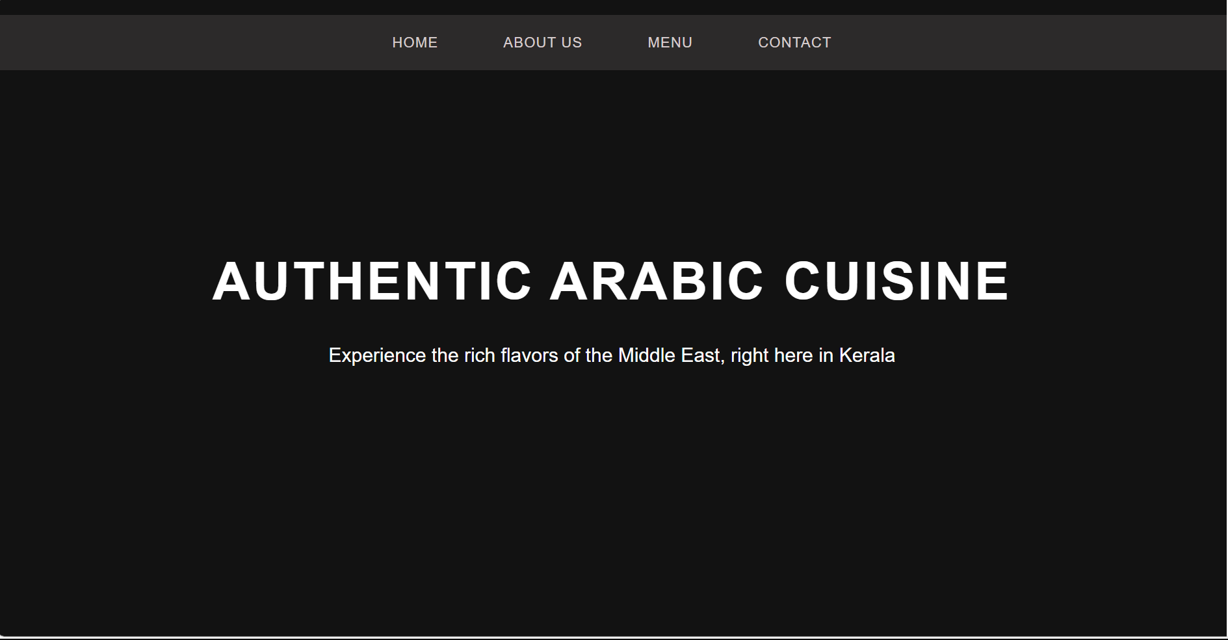

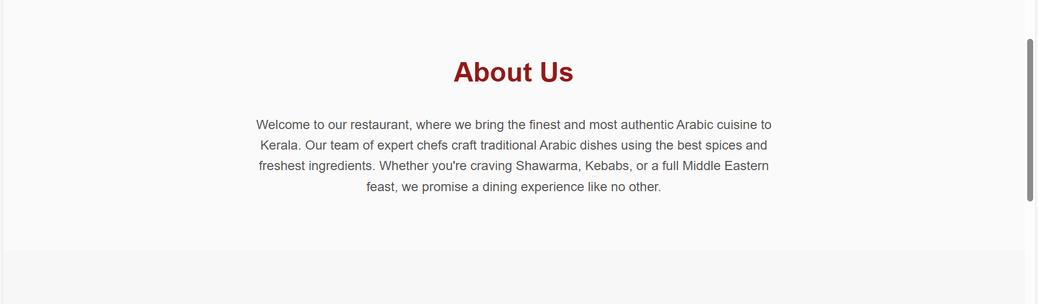

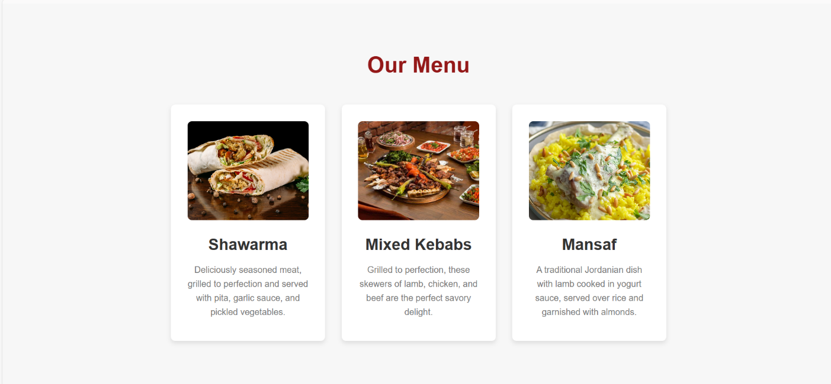

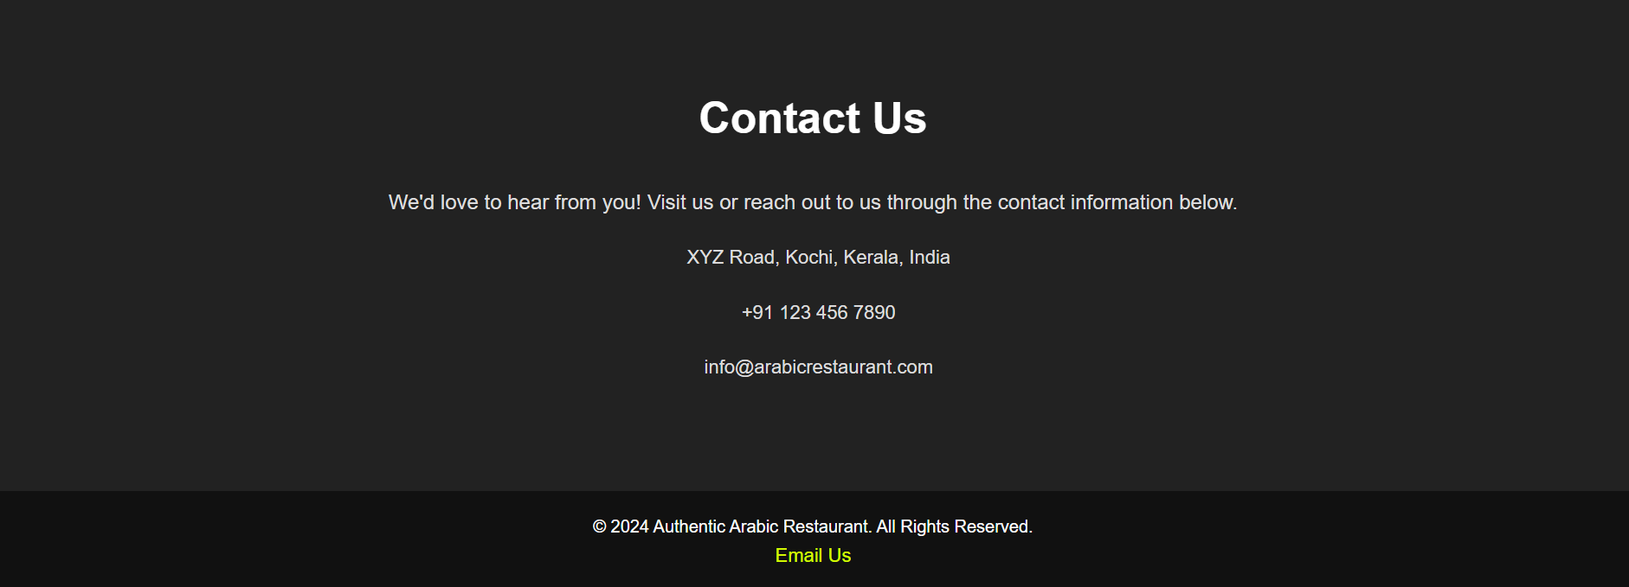

# CONCLUSION:

The RESTAURANT website project has demonstrated the effectiveness

Of HTML in creating a visually appealing and functional online presence.

The website’s responsive design, intuitive navigation, and essential features

Provide an engaging user experience. Through this project, I have successfully

Applied HTML concepts to create a website that showcases the restaurant’s

Offerings and enhances customer engagement.

# REFERENCES :-

W3Schools, YouTube,