Date : 07.01.2022

PSL Analysis Report

Sr. No. | Description | Observation
1 | Job Name | Plain Label
2 | Type of Face Paper | Chromo Paper
3 | Type of Release Liner | Glassine Paper
4 | Type of Adhesive | Acrylic
5 | Total Caliper (micron) | 130
6 | Total GSM | 160
7 | Face Paper GSM | 64
8 | Release Liner GSM | 64
9 | Adhesive GSM | 32
10 | Face Paper (micron) | 60
11 | Release Liner (micron) | 60

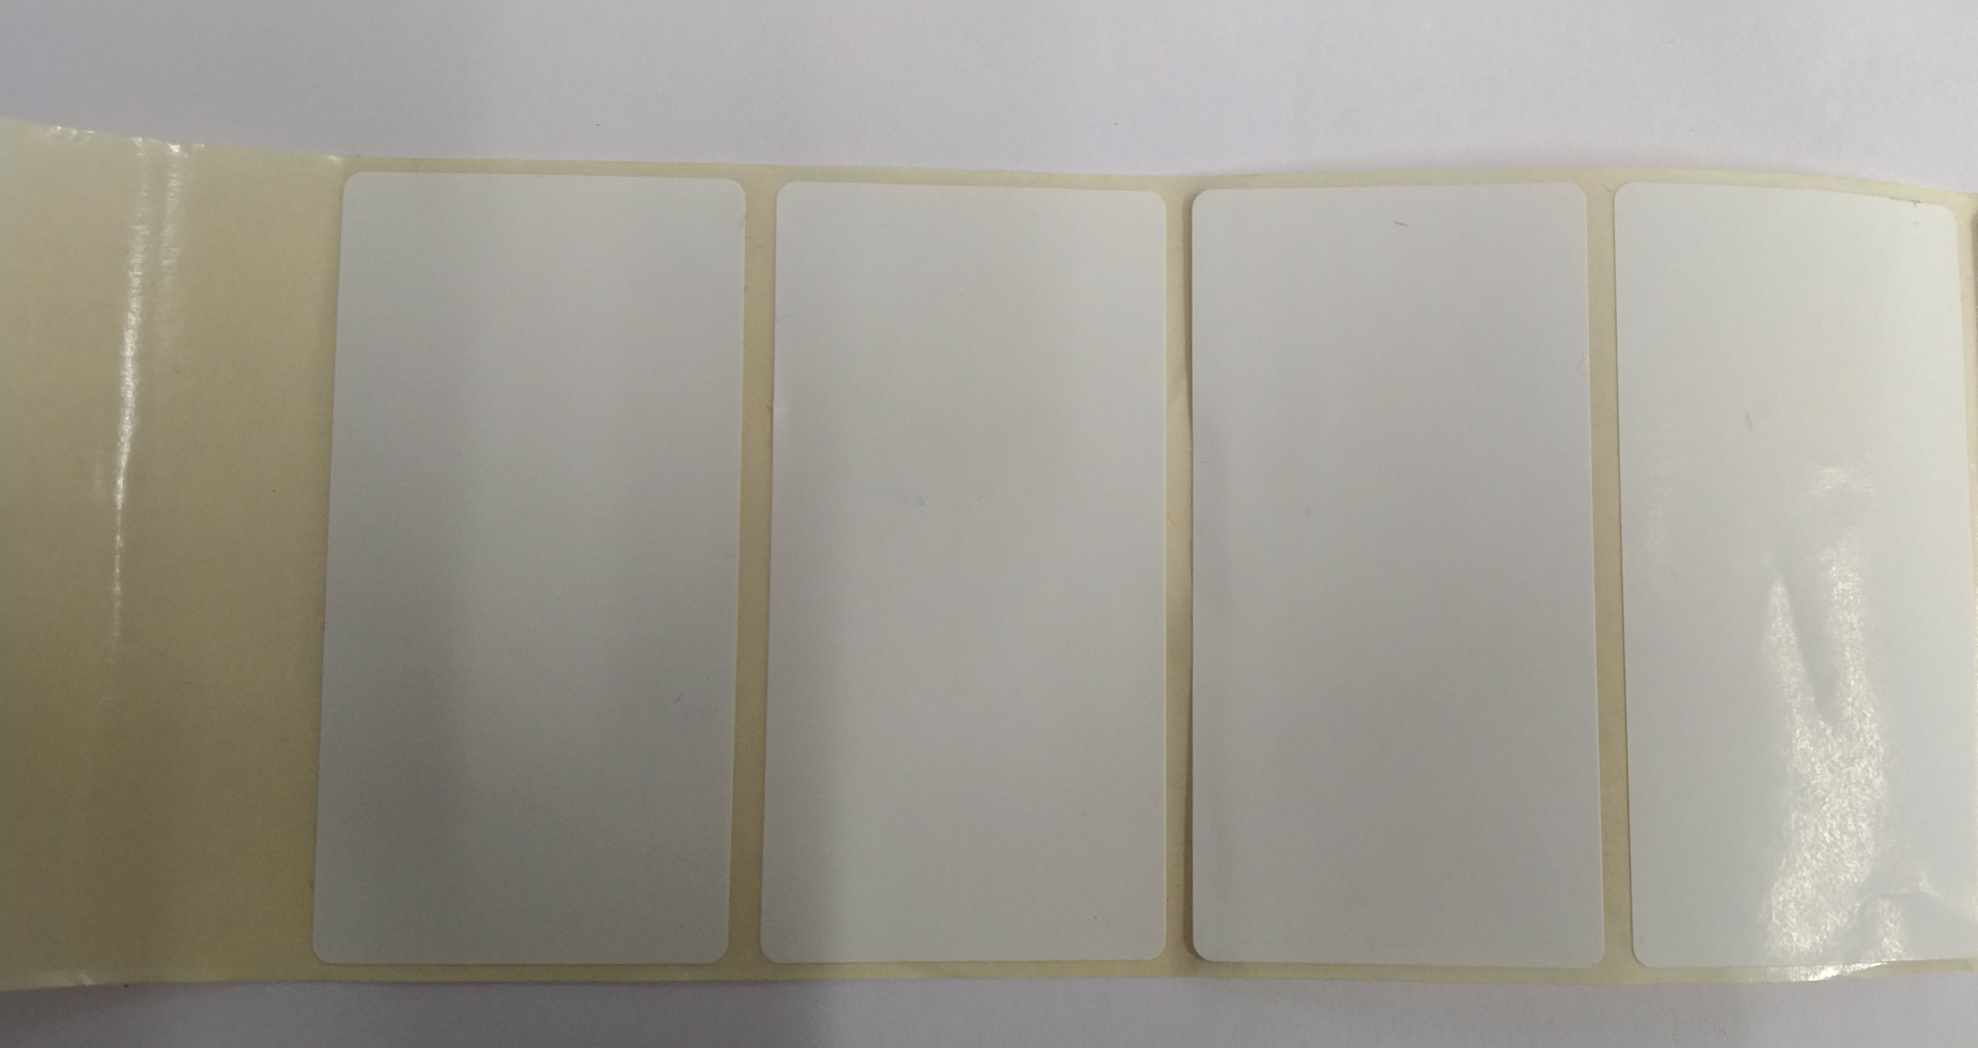

Testing By Approved By

Karan Kapila

(QA Executive) (QA Manager)

