**ABSTRACT**

We intend to explore the global influence (internationality) of academic institutions in terms of non-local citations(global citations). This can be of great interest to many potential students, academicians as well as researchers. The influence of institutions over time and is a non-linear system and can incorporate chaos. We posit a novel method to model this influence by using the Constant Elasticity of Substitution (CES) function optimized using the Particle swarm optimization algorithm(PSO) under chaotic conidtions.

Since such a system is non-linear,it may be subject to chaotic behaviour.We examine the chaos theoretic implications of the model via the nature of convergence of the model to a local minima and investigate if CES admits to strange attractors,fixed points etc.This is done by extracting first order ODE from the model,by approximate and regular analytical methods.

**Keywords:** Machine Learning,influence,CES(Constant Elasticity of Substitution Chas theory.

**Chapter 1**

# Introduction

## 1.1 PURPOSE OF THE PROJECT

Influence of an institutions based on their research work can be quantified using the Constant Elasticity of Substitution(CES) function optimized using the Particle swarm optimization algorithm(PS0).Parameters used for this purpose are the number of citations and the number of articles published by an institution and the future influence of research done by an institution can be predicted using time series prediction.

## 1.2 SCOPE

The CES function was developed by Arrow, Chenery, Minhas and Solow in their new famous paper of 1961

*Q* = *A*[*αKρ* +(*l−α*)*Lρ*]*ηρ*

CES is an economic production function that models the quantity of output produced due to a percentage change in factors K and L In our application we are assuming K and L to be the global influence of the institutions in terms of global citations and extent of international collaboration

The PSO is a method to optimise a problem by iteratively trying to improve acandidate solution It is a metaheuristic as it makes few or no assumptions about the problem being optimized and can search very large spaces of candidate solutions. It does not require the optimization problem to be differentiable, compared to classic optimization methods such as gradient descent.

## 1.3 PROBLEM STATEMENT

We intend to explore the scholarly influence of academic institutions which can be of great interest to many potential students,academicians as well as researches. The influence of institutions over time and is a non-linear system and can incorporate chaos. We posit a novel method to model this influence by using the Constant Elasticity of Substitution(CES) function optimized using the Particle swarm optimization algorithm(PS0) under chaotic conditions.

## 1.4 SUMMARY

This chapter gave a brief introduction on what exactly the proposed system is. It also covered the future scope and demand of this project. Also how this can help the other sectors. Apart from this, we are trying different approach reffering papers mentioned and trying to get accuracy as high as possible.

**Chapter 2**

# Literature Survey

In this chapter,we see the work previously done in this area by the CES production function optimized using the Particle swarm optimization algorithm(PS0). After some of the research, following are the research papers that we have gone through in order to achieve our objective.

**2.1 Strogatz Non-linear dynamics and Chao:Chaotic be-**

## hviour

1. Chaotic systems are dynamical systems that are highly sensitive toinitial conditions, popularly known as butterfly effect
2. The butterfly effect causes exponential divergence of the trajectoriesof two identical chaotic systems started with nearly the same initialconditions
3. The chaos phenomenon was first observed in weather models byLorenz
4. In our application conditions such as superstar effect can cause asimilar divergence the in trajectory of an institution’s influence

## 2.2 B. Goswami, J. Sarkar, S. Saha and S. Kar Stochastic Frontier AnalysisApproach to Revenue Modeling in Cloud Data Centers, J. CommunicationNetworks and Distributed Systems

1. The CES model has also been used for revenue optimization in cloud data centers.
2. A modified version of CES was used for optimizing cost to a minimum value

*y* = *f*(*S,I,P,N*) = (*Sρ* +*Iρ* +*Pρ* +*Nρ*)

1. S = cost of servers, I=cost of infrastructure, P = cost of power and N = cost of network
2. The chaos phenomenon was first observed in weather models byLorenz
3. In our application conditions such as superstar effect can cause asimilar divergence the in trajectory of an institution’s influence

**2.3 Suryoday Basak, Snehanshu Saha, Archana Mathur, Kakoli Bora, Simran Makhija, Margarita Safonova, Surbhi Agrawal CESSA Meets Machine Learning: From Earth Similarity to Habitability Classification of Exoplanets, Astronomy and Computings**

1. The CES approach (CEESA)’, has also been used to address the shortcoming of previous metrics, Cobb Douglas Habitability score.
2. Presents an example of how CES can be optimized using PSO

## 2.4 Arun John, Anish Murthy, Snehanshu Saha CDHPF: Chaotic QuantumBehaved Particle Swarm Optimization for Multiobjective Optimization inHabitability Studies

a. Based on the Quantum-behaved Particle Swarm Optimization algorithm an algorithm was developed to optimize a multiobjective optimization problem, namely the Cobb Douglas Habitability function which is based on CES production functions in Economics.

**2.5 Summary**

**This chapter explains the Literature survey for the proposed project.**

# Chapter 3 Project Planning

## 3.1 Flow Chart

1. We collect scientometric data from web of science that includes which institutions and what is the citation count.
2. Then we perform data preprocessing on data available to transform it into an understandable format by eliminating null values and data points that differs siginificantly from other observations.
3. Thirdly,we select the attributes that require for the influence of institutions over time.The attributes are Institute, Articles,Authors and Department of affiliations.
4. Then model this influence by using the Constant Elasticity ofSubstitution (CES) function optimized using the Particle swarm optimization algorithm(PSO) under chaotic conidtions.

P *Total number of local authors w.r.t institute−a given paper−p*

1. *L* = *p∈P*(*a*) *Total number of international|P*(*aauthors*)*| w.r.t institute−a given paper−p*

where P(a) = set of all papers with at least 1 author affiliated to institute a

*K* = P*p∈P*(*a*)*No of global citation*

A citation can be considered a global citation if at least one author from the cited paper is affiliated to an international institute.

## 3.2 Flow Diagram

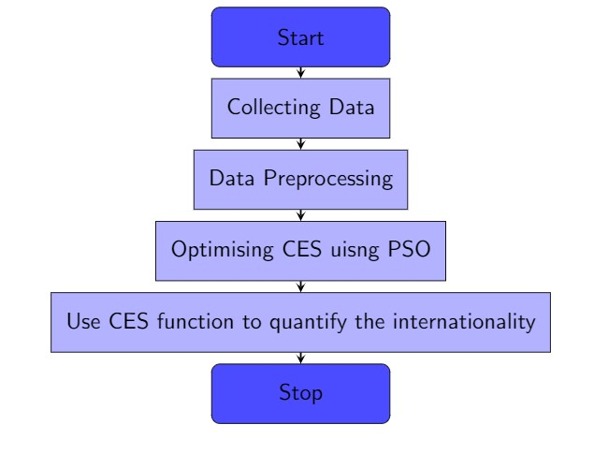

**Figure 3.1:** Flow diagram

**Chapter 4**

# Hardware and Software Requirements Specification

## 4.1 Requirement Specification

### Requirement specification is the movement of interpreting the data assembled amid investigation into prereuisite report

**Software and Hardware requirements specifications are the detailed enlisting of all necessary requirements that arise in the project. The aim of having these requirements is to gain an idea of how the project isn to be implented and what is to be expected as a result of the project. The sections in this chapter deal with the various kinds of software, hardware and other functional and non functional requirements of the project.**

## 4.2 Software Requirements

1. Python 2.7 or Python 3.5+
2. Numpy
3. Scikit-learn
4. Pandas
5. Operating system : Linux or Windows XP/7/8/10

## 4.3 Hardware Requirements

**Hardware Requirements include:**

1. GPU & CPU
2. Processor: Quad Core, 2.0 GHz or greater
3. Memory: 4 GB of RAM or more

## 4.4 Functional Requirements

**Functional requirements are a formal way of expressing the expected servicees of a project, We have identified the unctional requirements for our project as follows:**

1. The system should be able to influence of institutions over time and is a non-linearsystem and can incorporate chaos.

## 4.5 Non Functional Requirements

**Non-functional requirements are the various capabilities offered by the system. These have nothing to do with expected results, but focus on how well the results are achieved.**

1. Reliability: :The prediction subsystem should give accurate results.
2. Usability: The Overall system should be user friendly and convenient for users to operate.
3. Extensiblity: The system should be extensible i.e. it should be such that additional functional requirments can be added to the system.
4. Re-usability: The degree to which ecisting applications can be reused in new application. The predicted output could be reused in many fields.

## 4.6 Summary

**This chapter discussed the basic software and hardware requirements. More importantly it discusses the functional and non-functional requirements.**

**Chapter 5**

# System Design

We intend to explore the global influence (internationality) of academic institutions in terms of non-local citations(global citations). This can be of great interest to many potential students, academicians as well as researchers. The influence of institutions over time and is a non-linear system and can incorporate chaos. We posit a novel method to model this influence by using the Constant Elasticity of Substitution (CES) function optimized using the Particle swarm optimization algorithm(PSO) under chaotic conditions

## 5.1 The CES function

In the extant literature, convex optimization principle has been used in the recent past to solvefundamental problems in science. Notwithstanding, optimization associated with technology relatedto performance in data centers and the problem of cost minimization remains an important issue. Weare aware of the cross-effects of reducing the use of one factor vis-a-vis another and apply the CESproduction function to estimate the impact of reducing the cost of the contributing factors on revenuemaximization at the data centers. It is well-known that CES belongs to the family of neoclassicalproduction functions and the CES production function for two inputs can be represented in the formbelow:

*Q*(*L,K*) = (*αKρ* +(1*−α*)*Lρ*)*η/ρ,* (5.1)

where

Q= Quantity of output (Inteernationality score)

K = ICR (International Collaboration Ratio) L = NLIQ (Non- Local Influence Quotient) *ρ* = Elasticity of substitution and *α* = Share parameter

## 5.2 CES derivations

In oder to minimize the CES function we attempt to find the first order derivative of the CES equation with respect to *ρ*. In our research, we explore two methods for differentiating Q with respect to *ρ*; 1) using Tayor Series approximation 2) using Chain Rule.

### 5.2.1 CES differentiation using chain rule

*R* = [*αKρ* +(1*−α*)*Lρ*]

*Q* = *γ*[*αKρ* +(1*−α*)*Lρ*]*ηρ*

Applying log to the above equation on both sides of the equality

log *Q* = *η* log([*αKρ* +(1*−α*)*Lρ*]) *γ ρ*

Differentiating the equation w.r.t *ρ* using chain rule we get

*γ dQ* = *η* 1 *∗*(*αKρlog*(*K*)+(1*−α*)*Lρlog*(*L*)) *Q dρ* 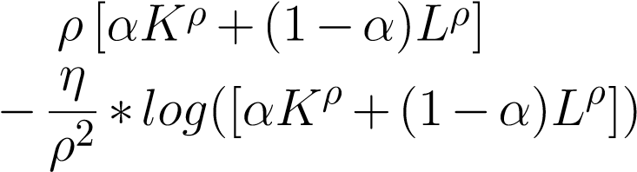

Replace *γ*[*αKρ* +(1*−α*)*Lρ*] with R, we get,

*γ dQ* = *η*[ 1 [*αKplog*(*K*)+(1*−α*)*Lρlog*(*L*)]*−* 1*log*(*R*)]]

*Q dρ ρ R ρ*

*γ dQ* = *η* [*αKρlog*(*K*)+(1*−α*)*Lρlog*(*L*)*− Rlog*(*R*)]]

*Q dρ Rρ ρ*

*γ dQ η KαkρLLρ*(1*−α*)

= [*log*( )] *Q dρ Rρ RR/ρ*

*dQ ηQ KαkρLLρ*(1*−α*)

= [*log*( )] *dρ Rργ RR/ρ*

### 5.2.2 CES derivation using taylor series approximation

The general form of the Constant Elasticity of Substitution (CES) production function (CESArrow) for two inputs is

*Q*(*L,K*) = *γ*(*αKρ* +(1*−α*)*Lρ*)*η/ρ ,*

where *Q*= quantity of output/CEESA score, and *L,K* represent input parameters. Define *ρ*= *s−s*1; *s*= 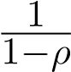, *ρ>*0. CEESA has as its limits the Cobb-Douglas production function (CDHS), i.e.

*−α α−*1

lim *Q* = *γK L . ρ→∞*

**Proof:** We can rewrite the above equation as

*Q* = *γ*(*αLρ* +(1*−α*)*Kρ*)*η/ρ ,*

*Q* = (*αKρ* +(1*−α*)*Lρ*)*η/ρ* (5.2)

*Q* = exp(*η/ρ·*ln[*αKρ* +(1*−α*)*Lρ*]) (5.3)

We consider first order Taylor expansion centered at zero of the term inside the logarithm,

*αKρ* +(1*−α*)*Lρ* = *αK*0 +(1*−α*)*L*0 +*αK*00 *·K*0 *·*ln(*K*)(*ρ−*0)

*−α*)*L*00 *·L*0 *·*ln(*L*)(*ρ−*0)+ (*ρ−*0)2 *·f*2(*x*)

= (1

2!

= *α*+(1*−α*)+*α·ρ·*ln(*K*)+(1*−α*)*·ρ·*ln(*L*)+*O*(*ρ*2) = 1+*α·ρ·*ln(*K*)+(1*−α*)*·ρ·*ln(*L*)+*O*(*ρ*2)*.*

*αKρ* +(1*−α*)*Lρ* = 1+*ρ*ln*Kα ·L*(1*−α*)+*O*(*ρ*2)*.* (5.4)

Now, combining the equations 5.2 & 5.4, we obtain

*Q* = h1+*ρ*ln*Kα ·L*1*−α*+*Oρ*2i*η/ρ .*

Define 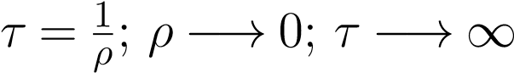. Therefore,

*Q Q*

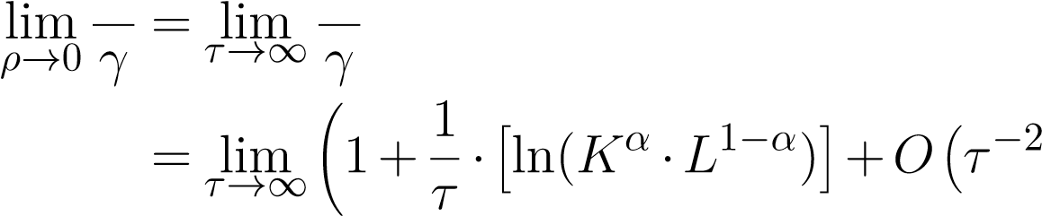!*ητ*

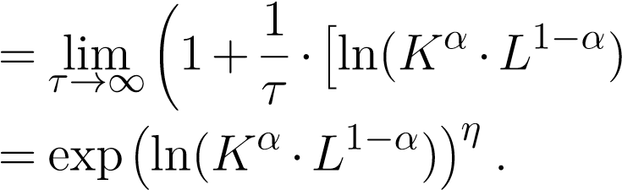i!*ητ*

Consequently we can write:

lim *Q* = *γ*(*Kα ·L*1*−α*)*η ρ→*0

Assuming elasticity of scale *η* = 1, and constant of elasticity *γ* = 1, we get

lim *Q* = *Kα ·L*1*−α .*

*ρ→*0

This is the CDHS formulation as mentioned in (Bora2016, Saha2018) and is used in this paper with kNN imputation.

*Q* = 1+*ρ*[ln(*KαL*1*−α*)]

*Qρ*1 = 1+*ρηρ*1[ln(*KαL*1*−α*)] *ρ*

where = *ρ*1 *n*

*ρ* = *ηρ*1

ln*QQρ*1 *dQ* = *η*ln(*KαL*1*−α*)

*dρ*1

1 *dQ −ρln*(*KαL*1*−α*)

= *Q*

*η dρ*1 *lnQ*

*dQ* = *Q−ηρ* ln*KαL*1*−α* (5.5)

*dρ* ln*Q*

**Approximation of** *ρ* **and fixed point using 4th order Runge-Kutta**

### 5.2.3 1st order ODE

*kl* = *f*(*xn*)∆*t k*2 = *f*(*xn* +0*.*5*k*1)∆*t k*3 = *f*(*xn* +0*.*5*k*2)∆*t k*4 = *f*(*xn* +*k*3)∆*t xn*1 = *xn* + (*k*1 +2*k*2 +2*k*3 +*k*4)

Here, we assume f(x) to be

*dQ 0 f*(*x*) = = *Q*

*dρ*

## 5.3 Summary

In this chapter we preprocess scintometric data from web of science and accordingly use Particle swarm optimization algo-rithm(PSO) to quantify the influence of institutions overtime.

**Chapter 6**

# Implementation

## 6.1 Dataset

Our data set consists of two variable that are used as input to the CES function. These are Non-Local Influence Quotient (NLIQ) and International Collaboration Ratio(ICR).

### 6.1.1 Non-Local Influence Quotient (NLIQ)

Defining and measuring internationality as a function of influence diffusion of scientific journals is an open problem. There exists no metric to rank journals based on the extent or scale of internationality. We propose Non-Local Influence Quotient (NLIQ) as one such parameter for internationality computation. NLIQ can be calculated as follows:

P*p∈P*(*a*)*No of global citation for paper p*

*L* =

*Total citations on paper p*

## 6.2 Dataset

Our data set consists of two variable that are used as input to the CES function. These are Non-Local Influence Quotient (NLIQ) and International Collaboration Ratio(ICR).

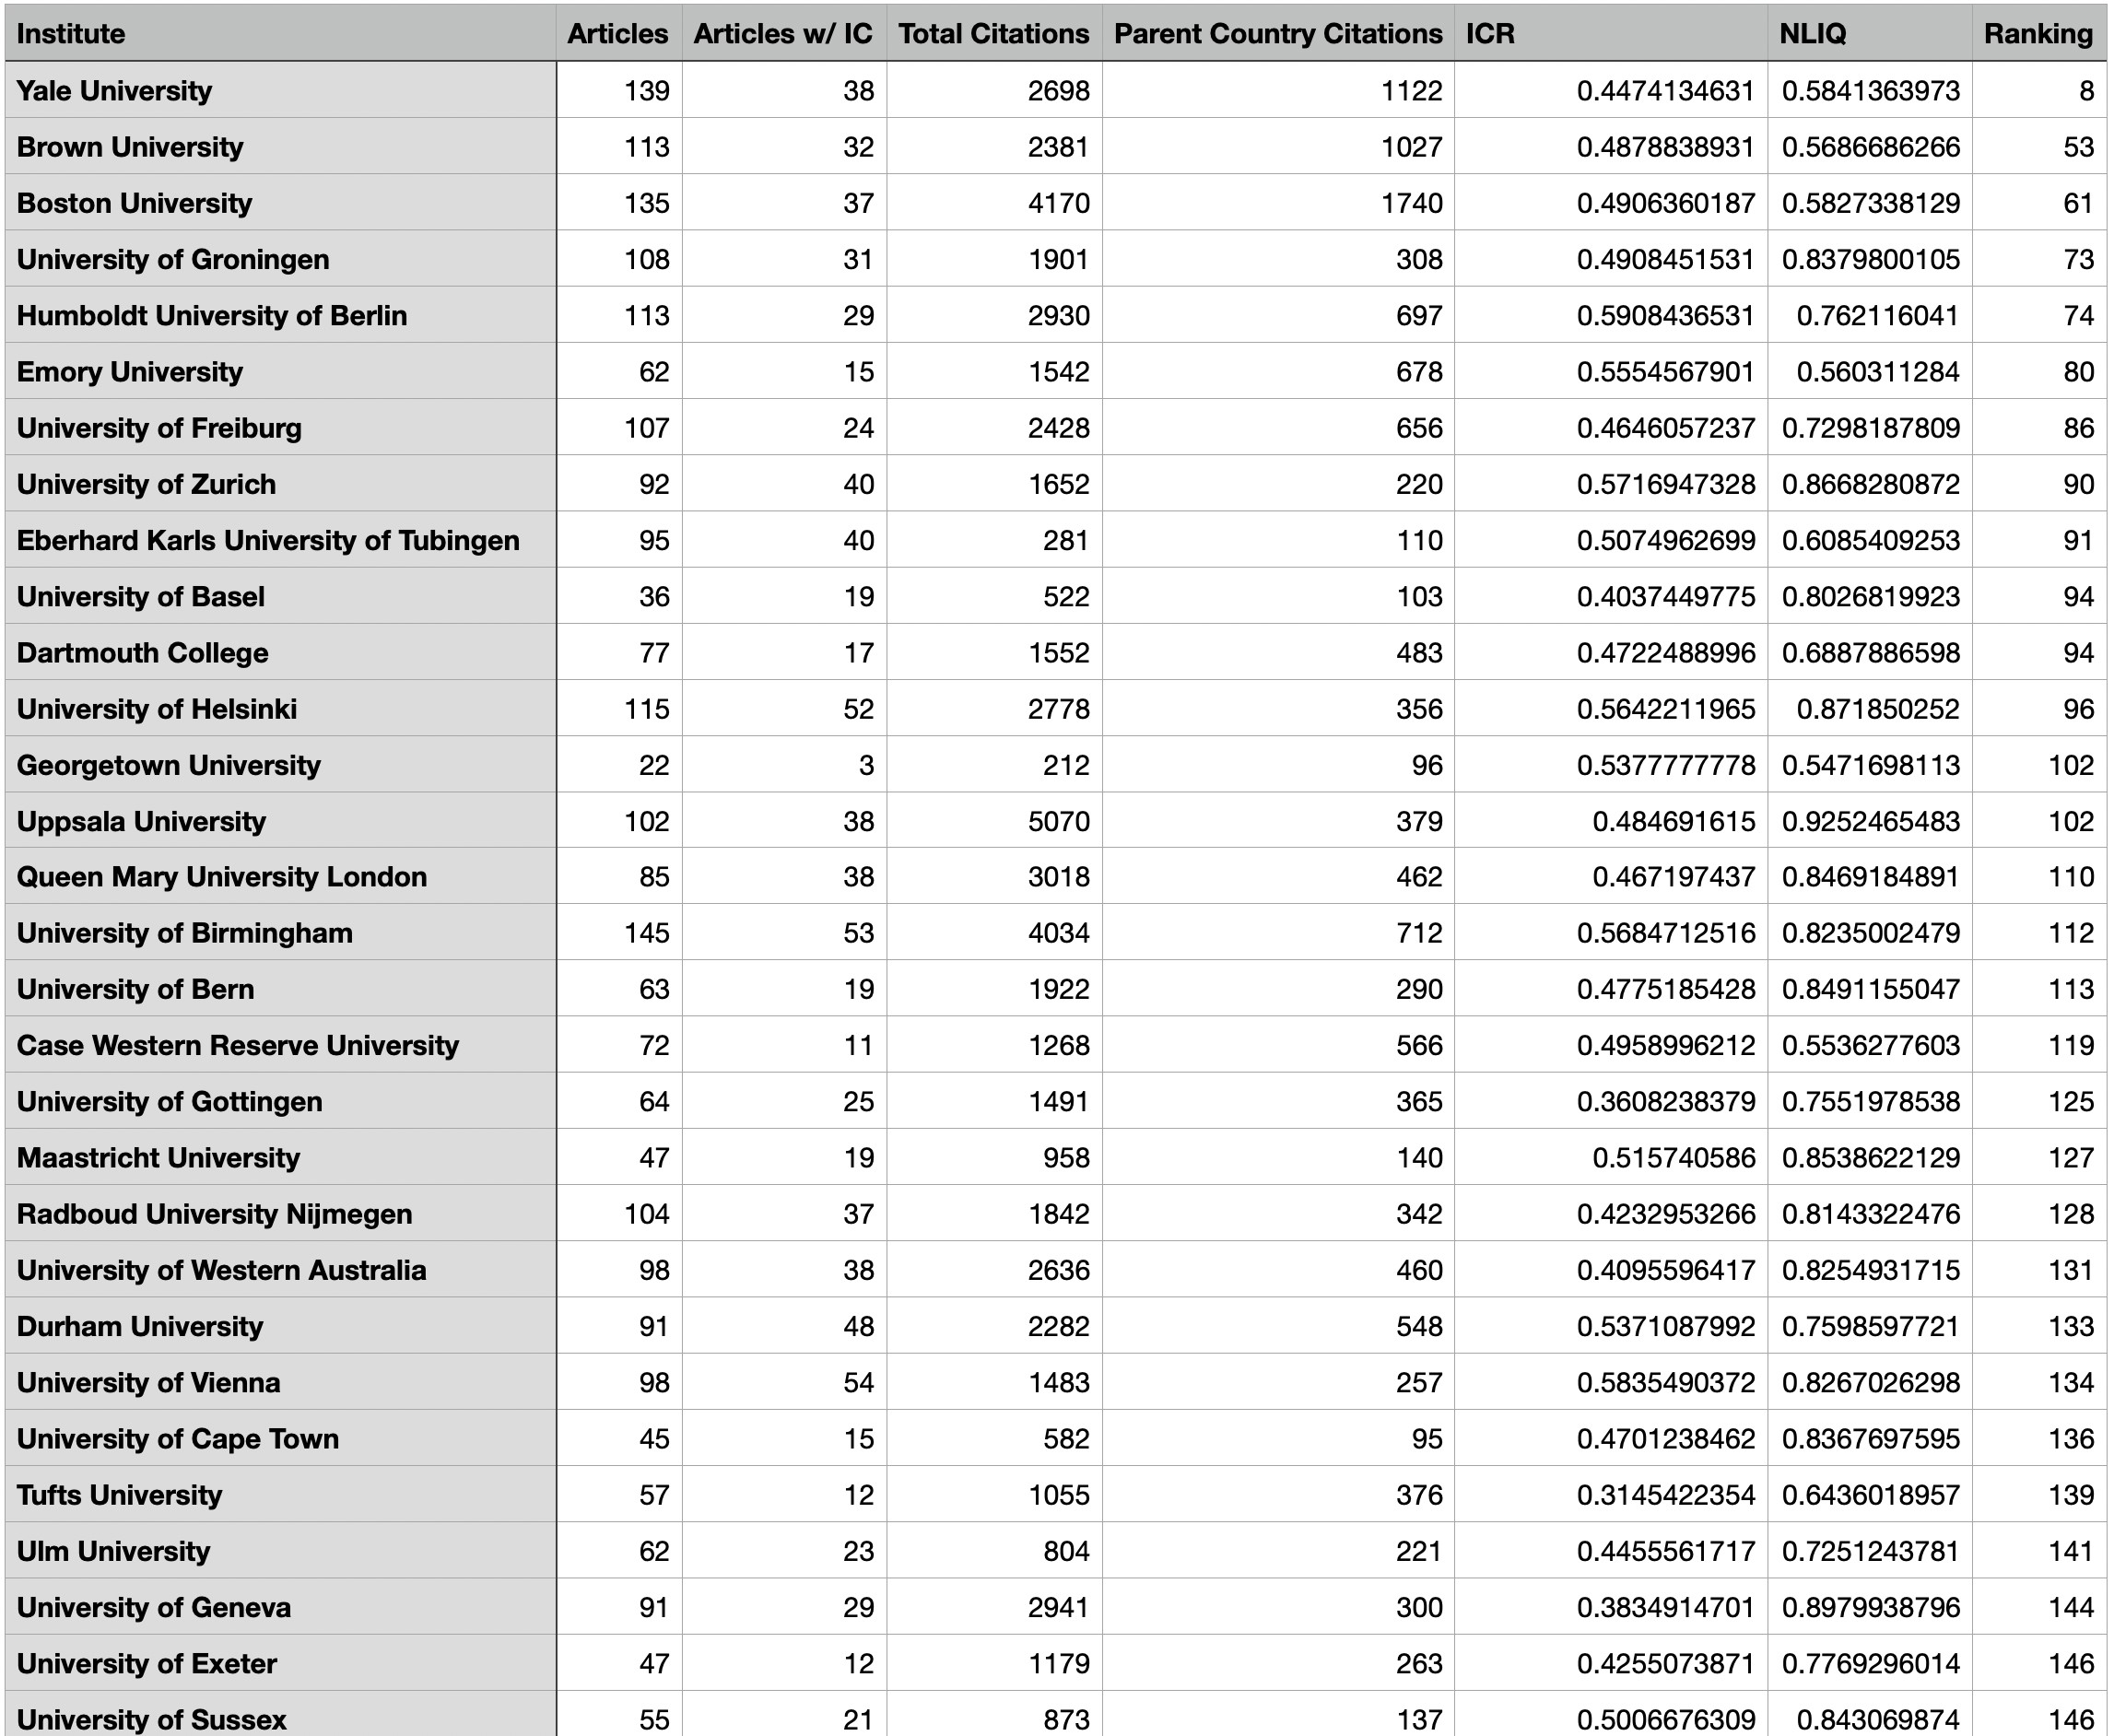

**Figure 6.1:** Slice of the dataset

### 6.2.1 Non-Local Influence Quotient (NLIQ)

Defining and measuring internationality as a function of influence diffusion of scientific journals is an open problem. There exists no metric to rank journals based on the extent or scale of internationality. We propose Non-Local Influence Quotient (NLIQ) as one such parameter for internationality computation. NLIQ can be calculated as follows:

P*p∈P*(*a*)*No of global citation for paper p*

*L* =

*Total citations on paper p*

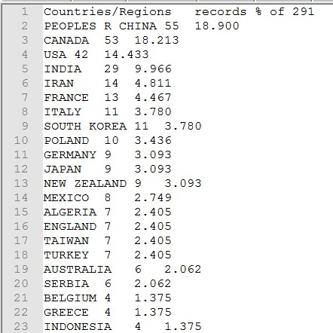

Country Wise Citation report for a university

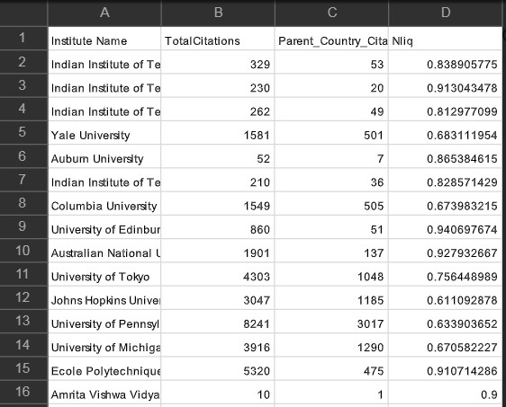

Calculated Nliq values with respective Institutions

### 6.2.2 International Collaboration Ratio(ICR)

The international Collaboration Ratio (ICR) is a novel metric that quantifies the extent to which each university collaborates with international collaborators. For each university, ICR can be broadly defined as the ratio between the weighted sum of the contributions of domestic authors and the weighted sum of the contributions of international collaborators.

### 6.2.3 Calculation of ICR

ICR calculation requires the following fields for each paper for each university.

* Number of authors who have authored the paper
* Number of authors belonging to different countries grouped by countries. Eg. 2 authors from India and 4 authors from USA.
* (Optional) Number of authors belonging to the same countries but different universities grouped by university. Eg. Out of 4 authors from India be 3 belong to PES and 1 belong to IISc.

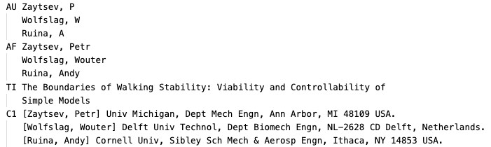

Sample data: A single paper from Cornell University

### 6.2.4 ICR Algorithm

1. Calculate the weight of each article belonging to each institution as follows

*No. of different collaborating countries for article*

*Weight* = *Total no. of authors*

*No. of authors from institution to which article belongs*

1. Calculate ratio of normalised weights and the total number of articles from the university which are written with International Collaboration

P*Normalised Weights*

*ICR* =

*Total no. of articles written with IC*

### 6.2.5 ICR Calculation Example

If an article has 5 authors where 2 authors from India, 3 from USA (2 from same institution in USA, 1 from different institution in USA)

* For Indian institution, weight of article will be

*W*1

*Weight,W*1 =  *and Normalised weight,NW*1 =

2 5

* For institutions from USA, weight of articles will be

2 2

5 + 5 *and Normalised weight,NW*2 = *W*2 *Weight,W*2 = 2 1 5

* ICR calculation

P(*NW*1*, NW*2)

*ICR* = = 0*.*16

1

**6.3 Implementation part 1**

## Estimating internationality scores using PSO

We have used PSO to find the value of *ρ* at which the output,Q of the CES function is maximum. PSO is a computational method that optimizes a problem by iteratively trying to improve a candidate solution with regard to a given measure of quality.

### 6.3.1 PSO algorithm

**Algorithm 1** Particle Swarm Optimization Algorithm

|  |  |
| --- | --- |
| **Result:** 1) Position and velocity of particles at which cost is optimal 2) Optimum cost  1: Initialize an array of particles with random positions [x1,x2,x3,....] and velocities [v1,v2,v3....] on d dimensions in the problem space  2: **while** stopping condition is not met **do**  3: Evaluate the objective function, (in our case the CES function) for each particle | |
| 4: | **if** current particle’s fittness is better than the previous best, ’pbest’ **then** |
| 5: | current particles best is saved as the ’pbest’ and the ’pbest’ location corresponds to thecurrent location in D-dimensional space. |
| 6: | **end if** |
| 7: | Compare Pbest of particles with each other and update the swarm global best location with the greatest fitness (gbest). |
| 8:  9: 10: | Modify the velocity and position of the particles according to the following equation *v*[*i*+1] = *w∗v*[*i*]+*c*1*∗rand*1*∗*(*pbest−x*[*i*])+*c*2*∗rand*2*∗*(*gbest−x*[*i*]) (6.1)  *x*[*i*+1] = *x*[*i*]+*v*[*i*+1] (6.2)  **end while return** best position and cost. |

### 6.3.2 PSO Python pseudocode

We have implemented our proposed model using the Particle Swarm Algorithm (PSO).

|  |
| --- |
| # Import pyswarm package for PSO implementation import pyswarms as ps import math import pandas as pd import numpy as np  # Load dataset df = pd. read csv ( ’ data/icr*−*nliq*−*combined . csv ’ ) df = df . f i l l n a (0)  # Define constraints for rho max bound = 1.0 *∗* np. ones (1) min bound = 0 *∗* np. ones (1) bounds = (min bound , max bound)  # Define options for PSO  #  #v [ i +1] = w*∗*v [ i ] + c1*∗*rand1*∗*( pbest*−*x [ i ]) + c2*∗*rand2*∗*( gbest*−*x [ i ])#  #  # Define variables c1 , c2 and w for the above PSO equation options = *{* ’c1 ’ : 0.6 , ’c2 ’ : 0.3 , ’w’ : 0.9*}*  #Run PSO Iteratively for each record in the dataset  internationality = [ ]  rho = [ ]  K =[]  L=[] for d in range ( len ( df ) ) [ : ] :  q . setparams (K=df [ ’ICR ’ ] [ d] ,L=df [ ’NLIQ’ ] [ d ])  print (q .K, q .L)  # Set*−*up optimizer optimizer = ps . single . GlobalBestPSO( n particles =25, dimensions=1, options= options , bounds =bounds)  # Function f is the CES function which takes outputs the internationality score Q.  inter , r = optimizer . optimize ( f , iters =100) print ( ’ internationality : %f *\*Rho%f ’%(inter , r ) )  # Plot the internationality internationality . append( inter )  rho . append( r [0])  # Append to dataframe df [ ’ internationality ’ ] = internationality df [ ’ rho ’ ] =rho |

1

2

3

4

5

6

7

8

9

10

11

12

13

14

15

16

17

18

19

20

21

22

23

24

25

26

27

28

29

30

31

32

33

34

35

36

37

38

39

40

41

42

43

44

**6.4 Implementation part 2**

## CES derivation

We plot the graphs of Q(internationality scores) VS *ρ* and the graphs of the Q’(derivative of Q) VS *ρ*. Through these plots we aim to establish that the CES equation has a fixed point within the specified bounds i.e 0 to 1. Hence, the equation converges and an optimal solution of the equation can be found using an optimization algorithm such as the Particle Swarm Optimization(PSO) algorithm. The internationality score is represented by the CES equation given as:

*Q*(*L,K*) = *γ*(*αKρ* +(1*−α*)*Lρ*)*η/ρ ,*

where

Q= Quantity of output (Inteernationality score)

K = ICR (International Collaboration Ratio) L = NLIQ (Non- Local Influence Quotient) *ρ* = Elasticity of substitution and *α* = Share parameter

The derivative of Q given by Q’ can be written as:

### By chain rule

*0 ηQ KαkρLLρ*(1*−α*)

*Q* = [*log*( )]

*Rργ RR/ρ*

### By Taylor series expansion

*0 −ηρ* ln*KαL*1*−α*

*Q* = *Q*

ln*Q*

We observe how the value of internationality, Q and it’s derivative Q’ varies with elasricity *ρ*. *ρ* being the elasticity models how the output internationality score varies when the input parameters, NLIQ and ICR are kept constant. The changing value of Q and Q’ with minute changes in *ρ* is an indicator of the chaotic nature of the CES function. In economics this is known as the superstar effect. The plots of Q VS *ρ* and Q’ VS *ρ* also show if the CES function has a fixed point within the specified intervals.

1. 0-1
2. 0.001-0.1
3. 0.101-0.9
4. 0.9-0.99
5. *>* 1

**Chapter 7**

# Results

## 7.1 Part 1: Estimation of internationality scores using PSO

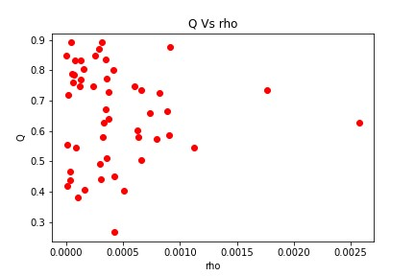

**Figure 7.1:** The above graph is a scatter plot of the internationality, Q VS elaticity *ρ*. Each point on the graph represents a separate institution.

### 7.1.1 PSO learning curve

The below graph shows a trace of the cost history duting PSO optimization. It is the learning curve when K(ICR) = 0.01 and L(NLIQ) = 0.666666667. The values of *ρ* and internationality (cost) at the global optima is:

*rho*=0.4382448117430233 and internationality=0.00057745

### 7.1.2 Result for constrained PSO optimization

We compare the different values of rho obtained after restricting the values of *ρ* between different intervals 1) 0.0-1.1 2) 0.001-0.1 3) 0.101-0.9 4) 0.9-0.99 5)

*>* 1

This table below shows the internationality scores of each institute calculated

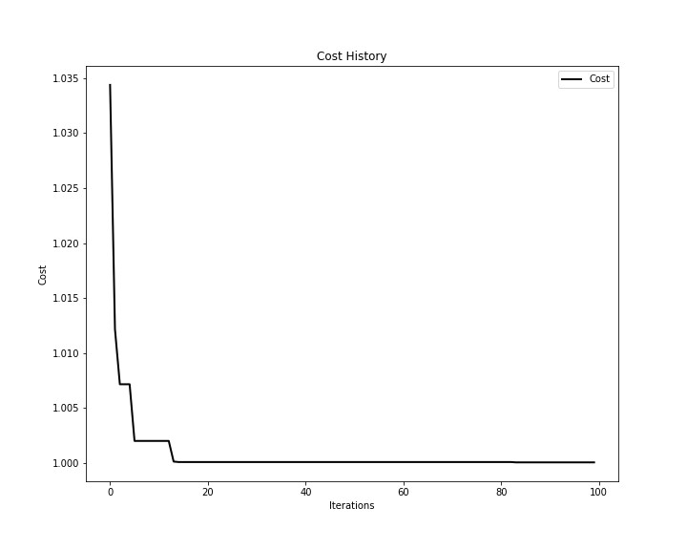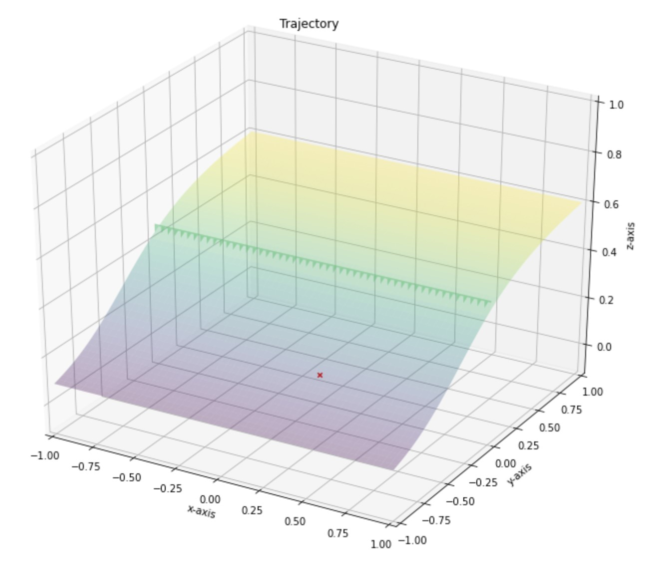

**(a)**

**(b)**

**Figure 7.2:** Learning curve for PSO optimization

based on the fixed NLIQ and ICR values and the optimized elasticity, *ρ* values. The results are arranged in the decreasing order of their internationality score.

|  |  |  |  |  |  |  |  |
| --- | --- | --- | --- | --- | --- | --- | --- |
| Institution | ICR | NLIQ | 0-1 | 0.001-  0.1 | 0.101-  0.9 | 0.9-  0.99 | ¿1 |
| University of Southern Queensland | 0.75 | 0.90 | 0.8917 | 0.8917 | 0.8919 | 1 0.8930 | 0.0 |
| Alexandria University | 0.5833 | 0.9348 | 0.8917 | 0.8917 | 0.8926 | 0.8989 | 0.0 |
| Auburn University | 1.0 | 0.8653 | 0.8779 | 0.8780 | 0.8781 | 0.8788 | 0.9981 |
| Australian National University | 0.4929 | 0.9279 | 0.8711 | 0.8711 | 0.8726 | 0.8833 | 0.0 |
| IISC - Bangalore | 0.8571 | 0.8486 | 0.8494 | 0.8494 | 0.8494 | 0.8494 | 0.0 |
| BITS Pilani | 0.3333 | 0.94 | 0.8474 | 0.8475 | 0.8515 | 0.8769 | 0.0 |

**Table 7.1:** Cost i.e Q(Internationality) values for each institute for 6 different ranges pf *ρ*. This table shows the NILQ, ICR and cost values for the first 5 universities. The value of alpha=0.1

|  |  |  |  |  |  |  |  |
| --- | --- | --- | --- | --- | --- | --- | --- |
| Institution | ICR | NLIQ | 0-1 | 0.001-  0.1 | 0.101-  0.9 | 0.9-  0.99 | ¿1 |
| Auburn University | 1.0 | 0.8653 | 0.9303 | 0.9303 | 0.9305 | 0.9324 | 0.9992 |
| IISC - Bangalore | 0.8571 | 0.8486 | 0.8528 | 0.8528 | 0.8528 | 0.8528 | 0.0 |
| University of Southern Queensland | 0.75 | 0.90 | 0.8257 | 0.8257 | 0.8261 | 0.8291 | 0.0 |
| Alexandria University | 0.5833 | 0.9348 | 0.7384 | 0.7385 | 0.7405 | 0.7570 | 0.0 |

**Table 7.2:** Cost i.e Q(Internationality) values for each institute for 4 different ranges pf *ρ*. This table shows the NILQ, ICR and cost values for the first 5 universities. The value of alpha=0.5

Table 7.1 shows the ranking of institutions after executing PSO for the following ranges of *ρ*; 1) 0.0-1.1 2) 0.001-0.1 3) 0.101-0.9 4) 0.9-0.99 5) *>* 1 Apparently, results for all conditions are consistent and it can be noticed that the ranking results are same for most of the institutes till *rho <* 0*.*9. This shows that the model works in harmony for all ranges of *ρ* between 0 and 1. Also, score is at higher side for candidates that have high NLIQ and ICR. Evidently the model gives more weightage to lineage independent parameters while computing scores, and brings out candidates with larger NLIQ and ICR at higher positions if these values are large.

Table 7.2 shows the ranking of the institutions when *α* is set to 0.5. We can see that the ranking slightly changes as equal weight is given to both ICR and NLIQ. For example Auburn university which has ICR=1 and NLIQ=0.86 is ranked 1 when *α* = 0*.*5 but when *α* = 0*.*1, University of Southern Queensland is ranked first. This shows that when *α* = 0*.*1, institutions with larger values of NLIQ is ranked higher, but when *α* = 0*.*5 equal weightage is given to both ICR and NLIQ.

|  |  |  |  |  |  |  |  |
| --- | --- | --- | --- | --- | --- | --- | --- |
| Institution | ICR | NLIQ | 0-1 | 0.001-  0.1 | 0.101-  0.9 | 0.9-  0.99 | ¿1 |
| Indian Institute of Technology  (IIT) - Kharagpur | 0.4633 | 3 0.8129 | 0.7685 | 0.7685 | 0.7696 | 0.7772 | 0.0 |
| Simon Fraser University | 0.4620 | 0.8364 | 0.7882 | 0.7882 | 0.7895 | 0.7981 | 0.0 |

**Table 7.3:** Comparison between 2 universities having similar NLIQ and ICR values.

Table 7.3 shows 2 universities having comparable NLIQ and ICR values; Simon Fraser University and IIT-Kharagpur. We see that the value of rho and internationality varies although the NLIQ and ICR values are very similar. This is at par with our initial hypothesis, where we considered this system modelled using CES to be chaotic in nature.

## 7.2 Part 2: CES derivation

### 7.2.1 Plotting output of production function of different values of *ρ*

Traditional approaches are aimed at varying K and L input factors and monitoring the variation of output with changing input factors such as an increase in ICR or NLIQ. However, in economic models, the output of a system can also change due to unexplainable random events, popularly known as the superstar effect. The Superstar Effect refers to the change in performance caused by the presence of a highly ranked player - a superstar - in a rank-order competition. In the CES equation this super star effect is captured by the elasticity variable *ρ*. In the above figure we plot the rate of change of output as well as the output with respect to the elasticity, *ρ*. We can observe that the rate of change of output increases with changing elasticity. Moreover, the output itself also increases with increase in elasticity.

We are trying to find the rate of change output with respect to the an unknown factor(unexplainable value) *ρ*. *ρ* signifies an unknown factor that could cause an increase in the output Q.

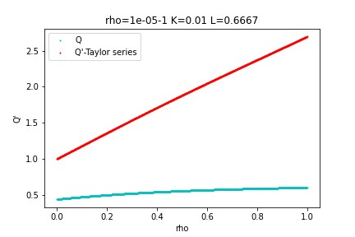

**Figure 7.3:** The above figure shows how the internationality (Q) varies with *ρ*. *α* = 0*.*1

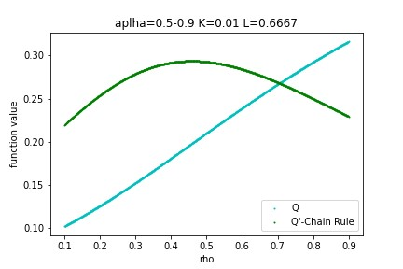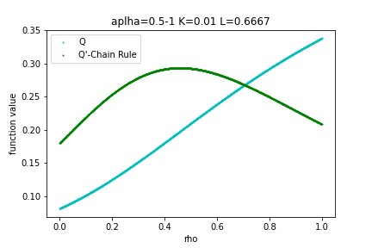

**(a)** Function Value v/s *ρ*(0.0 *<ρ<*0.1) **(b)** [Function value v/s *ρ* (0.1 *<ρ<*0.99]

**Figure 7.4:** Plots to see how CES function changes with the values of *ρ*. Function v/s *ρ* is plotted for K=0.01 and L=0.6667. This is evident from the plots that, as value of *ρ* changes, it attains an optimum value.

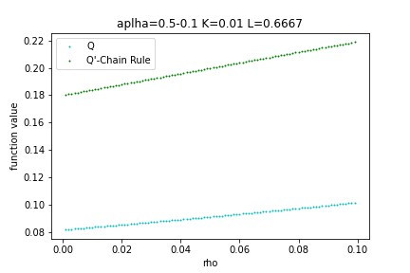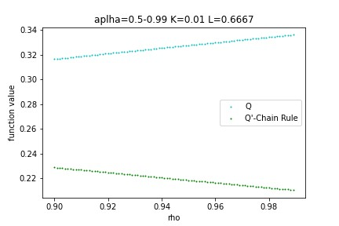

**(a)** Function value v/s *ρ* (0.0 *<ρ<*0.1) **(b)** Function value v/s *ρ* (0.1 *<ρ<*0.99)

**Figure 7.5:** Plots to see how CES function changes with the values of *ρ*. Function v/s *ρ* is plotted for K=0.01 and L=0.6667. This is evident from the plots that, as the value of *ρ* changes, it attains an optimum value.

.

## 7.3 User Interface

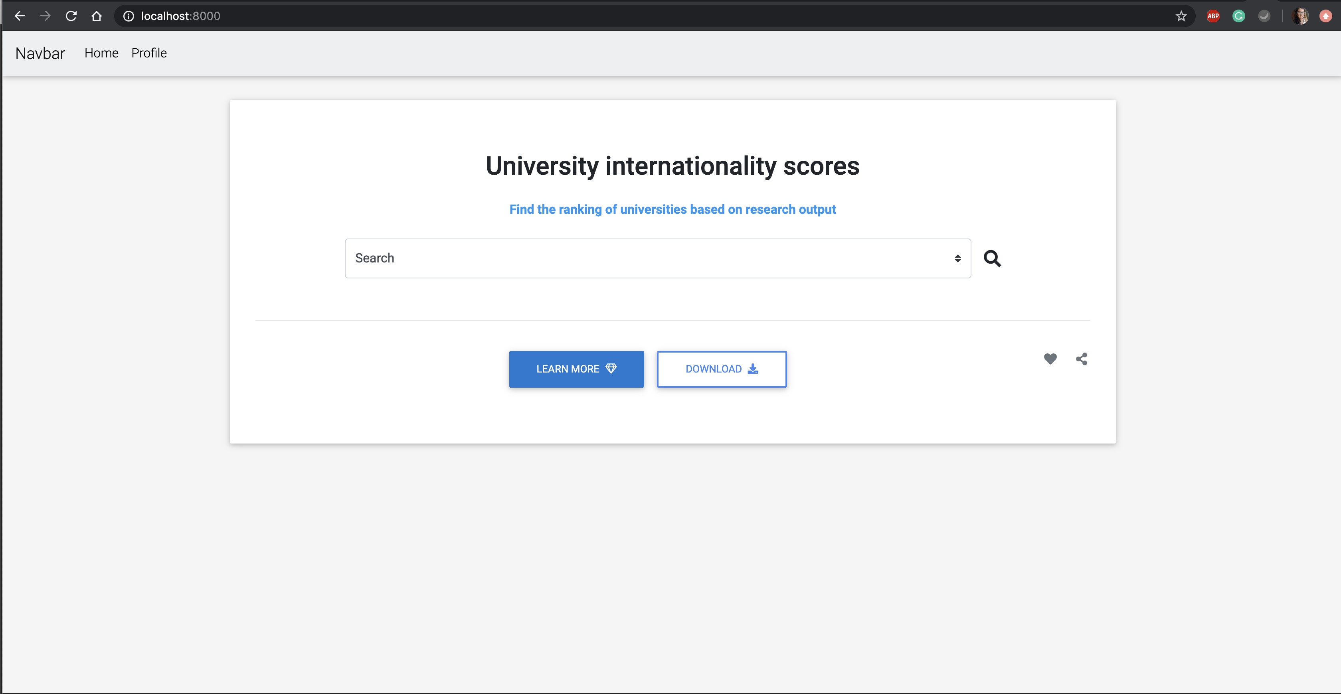

**Figure 7.6:** UI home page



**Figure 7.7:** Search for a university

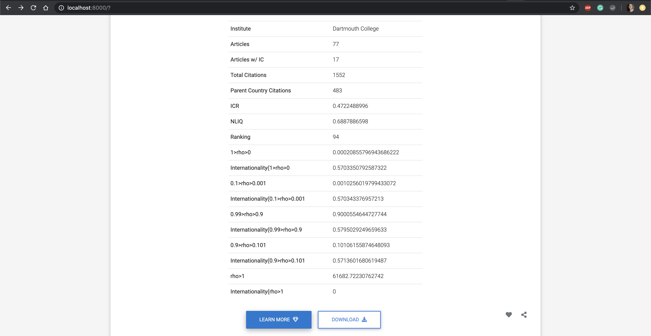

**Figure 7.8:** University NLIQ, ICR and corresponding internationality scores for *ρ* within 5 constraints: 1) 0.0-1.1 2) 0.001-0.1 3) 0.101-0.9 4) 0.9-0.99 5) *>* 1

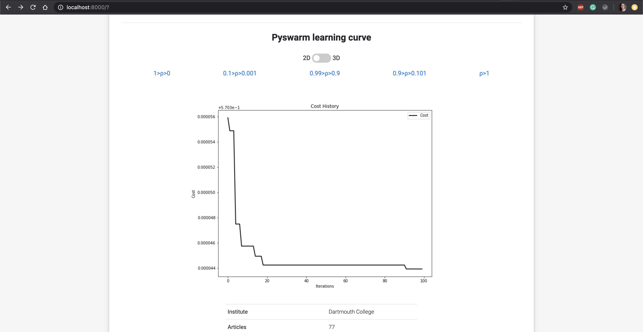

**Figure 7.9:** 2D Learning curve - cost history

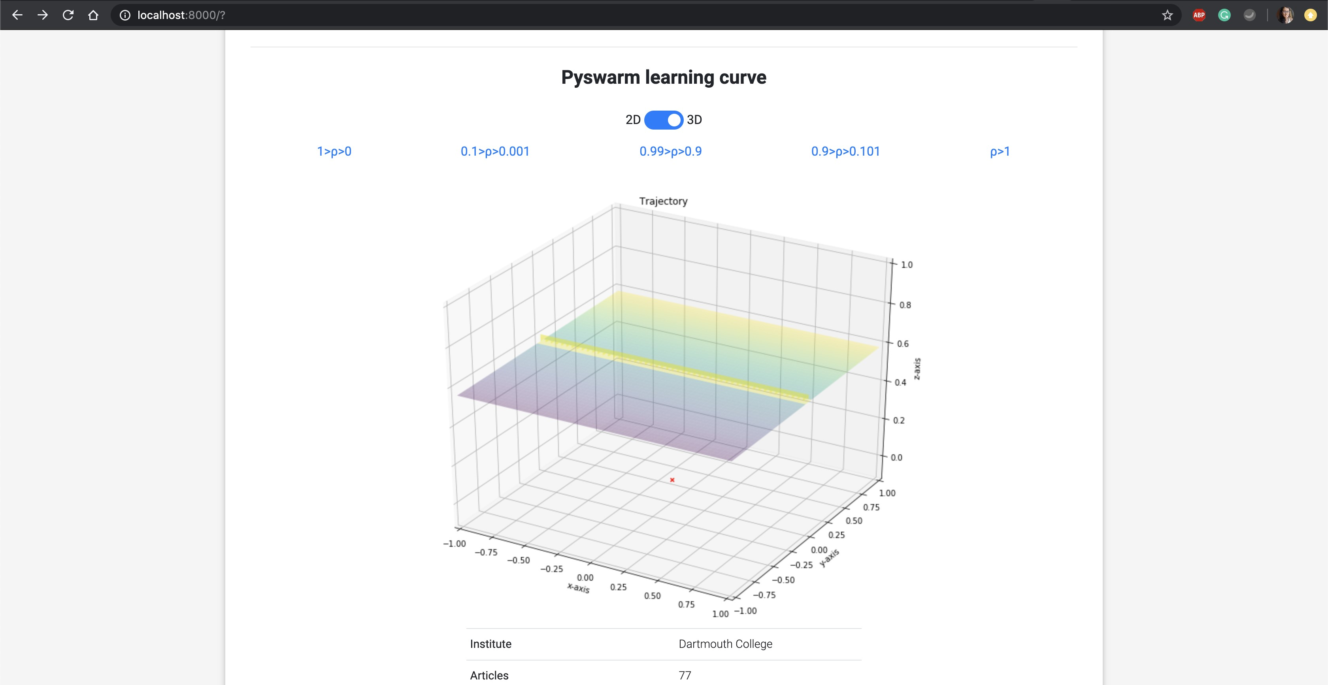

**Figure 7.10:** 3D Learning curve - cost history