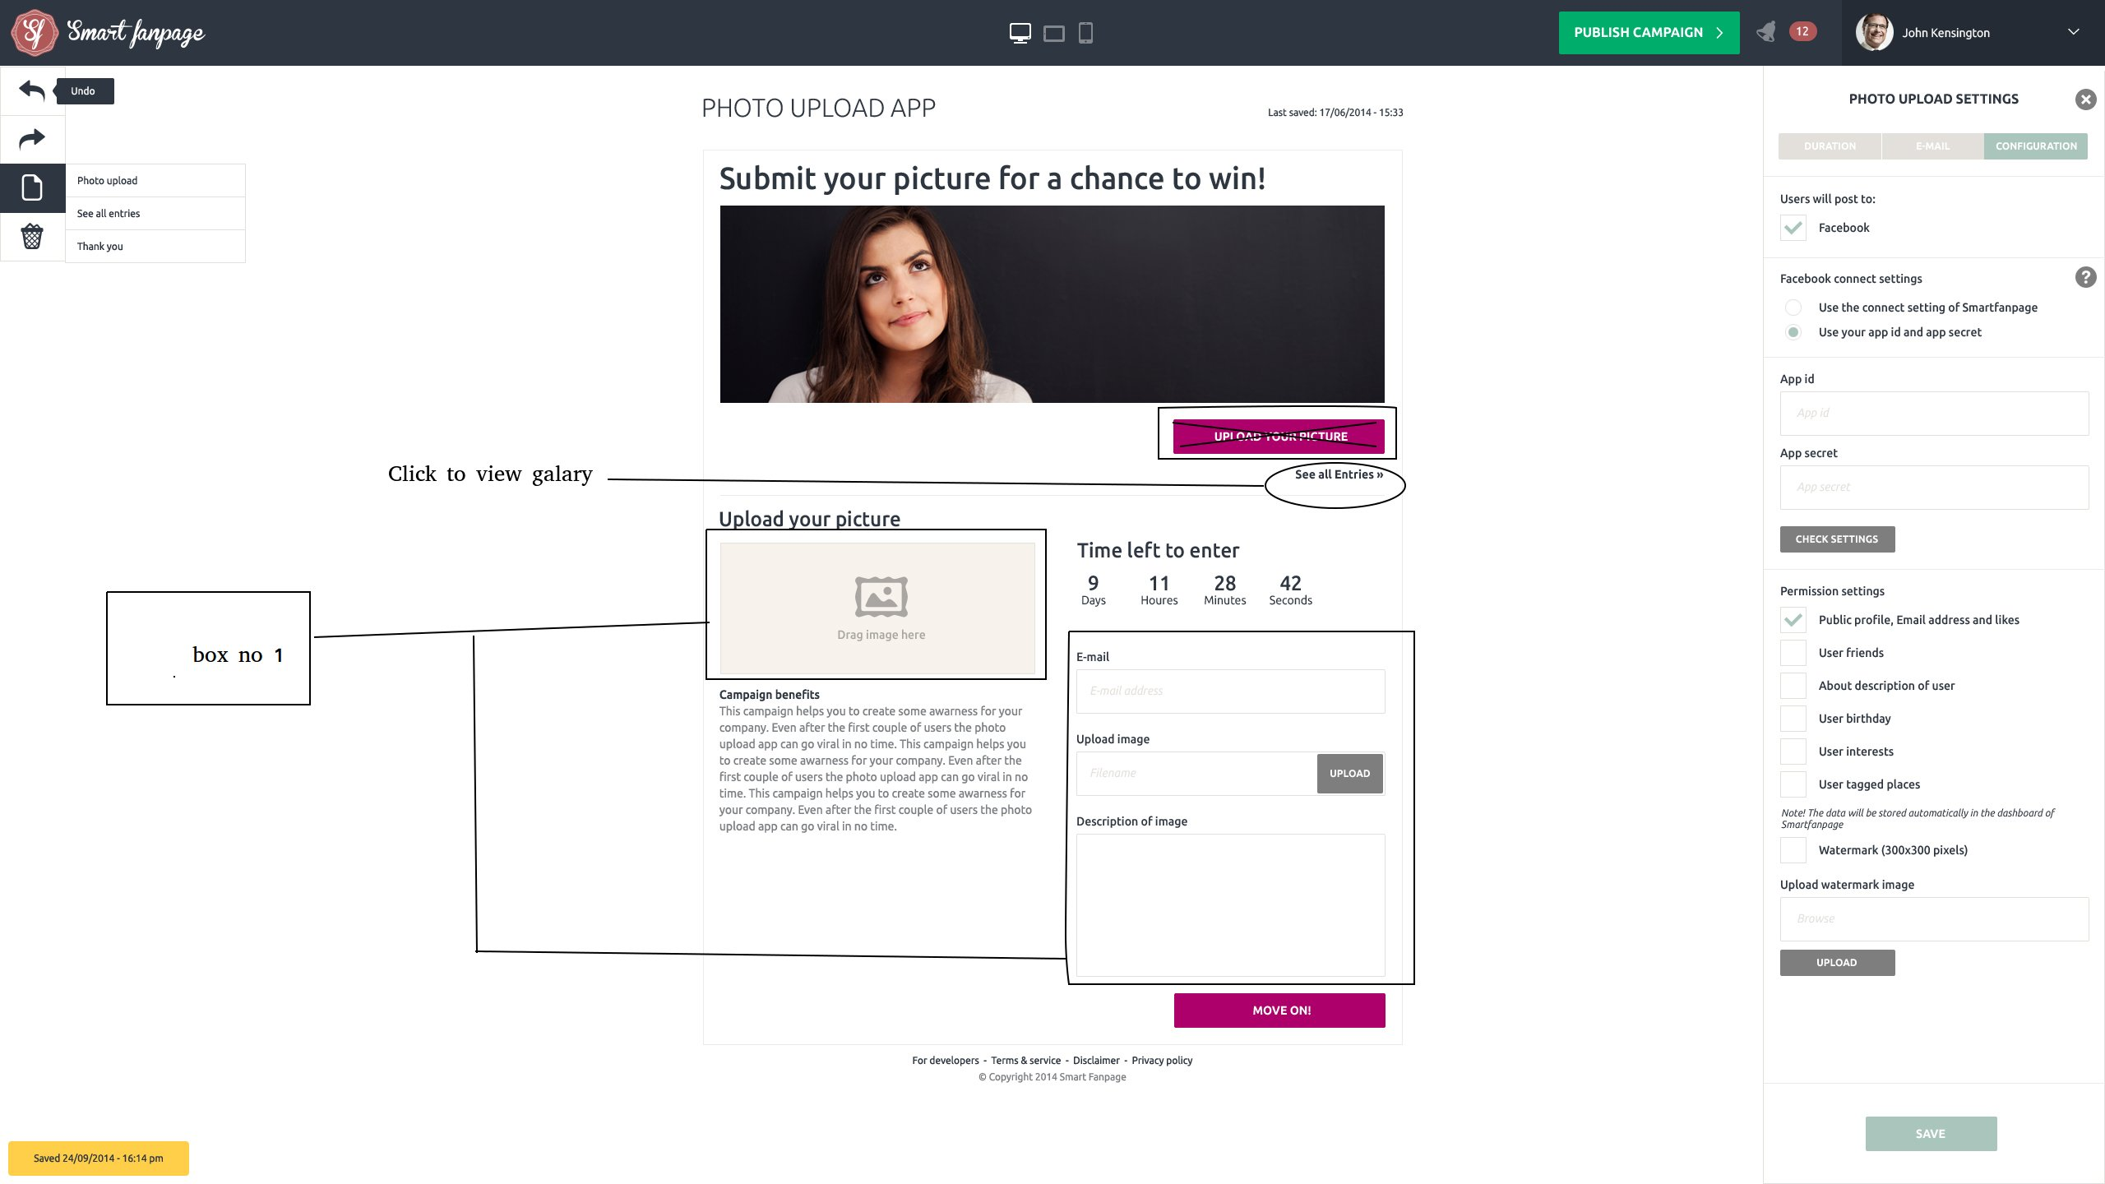
First page for end user

If the end user click on the oval box then the gallery of images been uploaded by others will be shown in an pop up.Now,box no 1 is pointing at two boxes,and by both of those areas images can be uploaded.If any user Upload an image thorough the drag and drop functionality then he/she have to put email and descriptions on the right side about that image.

And those things are mandetory.after finishing this steps if the end user wants to move on then he / she has to click on the pink button on the bottom part.

Pop up flow
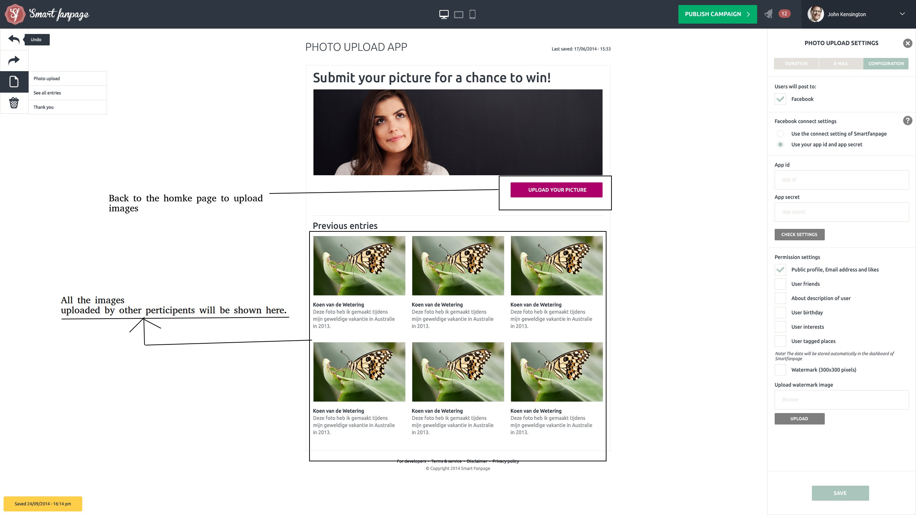
The box which contanins multiple images is the gallery of images where different several images been uploaded by diffrent contestants.If the user want to get back to the home hen he/she has to click on the button on the top with pink color .

Thank you page

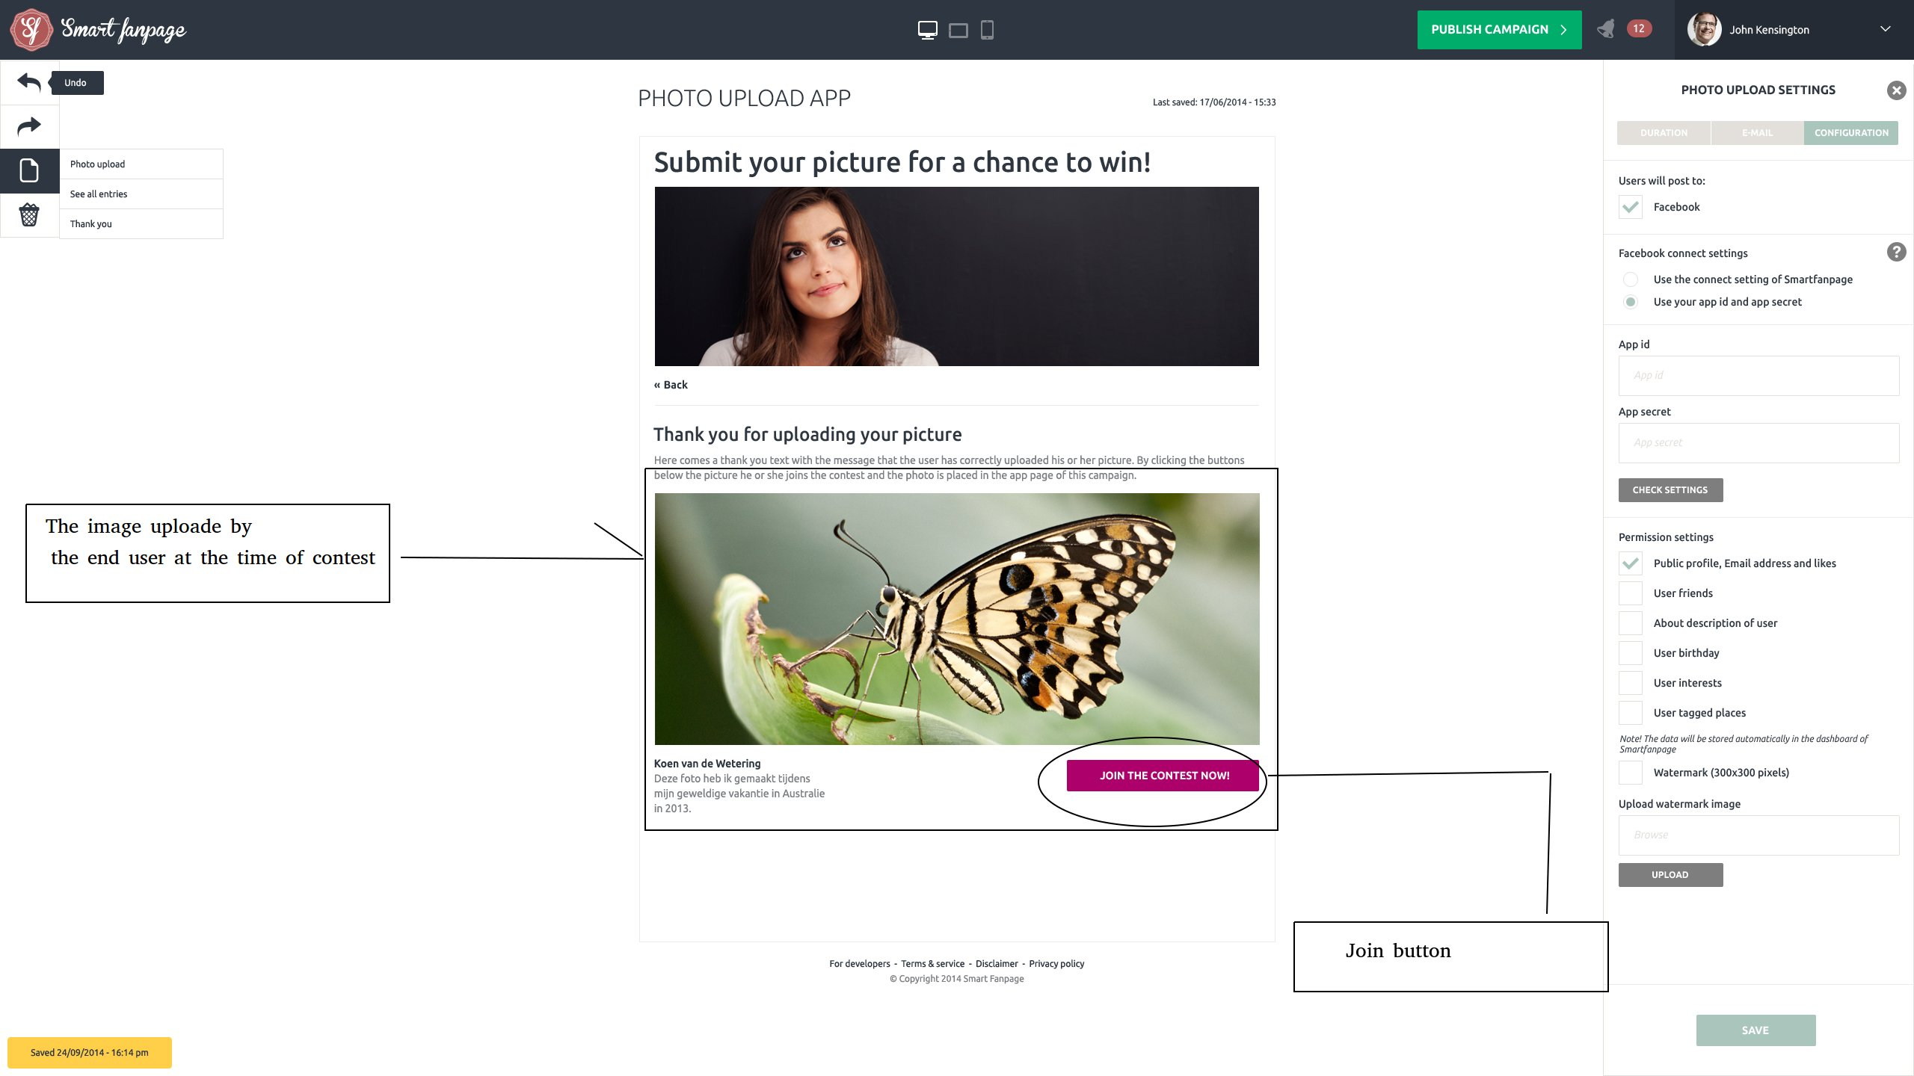
The image on the box is showing the image uploaded by the contestant and the by clicking on the pink button under oval box the and user is able to join the contest.

