Optimization of Artificial Neural Networks

Aim
To optimize Artificial Neural Network (ANN) performance using three advanced metaheuristic algorithms — Teaching Learning-Based Optimization (TLBO), Spotted Hyena Optimizer (SHO), and Harris Hawks Optimization (HHO) — and compare their performance in terms of accuracy and generalization.

Procedure
1. Load and preprocess the dataset using MinMaxScaler.
2. Split the dataset into training and testing sets (80/20 ratio).
3. Apply each optimization algorithm (TLBO, SHO, HHO) to tune ANN hidden layer sizes.
4. Train the MLPRegressor model using the optimized parameters.
5. Evaluate the model using R², MSE, and RMSE metrics.
6. Perform K-Fold Cross Validation to check for overfitting.
7. Compare and visualize the performance across all models.

Methodology
Three metaheuristic optimization techniques were applied to improve ANN performance:
• TLBO-ANN: Mimics the teaching and learning process in a classroom, adjusting ANN parameters to maximize learning (R²).
• SHO-ANN: Inspired by the cooperative hunting behavior of spotted hyenas, dynamically explores and exploits ANN hyperparameters.
• HHO-MLP: Simulates the surprise attack strategy of Harris hawks to refine ANN neuron selection, enhancing convergence and accuracy.

Code Implementation
Each model was implemented in Python using scikit-learn and NumPy.
TLBO-ANN:-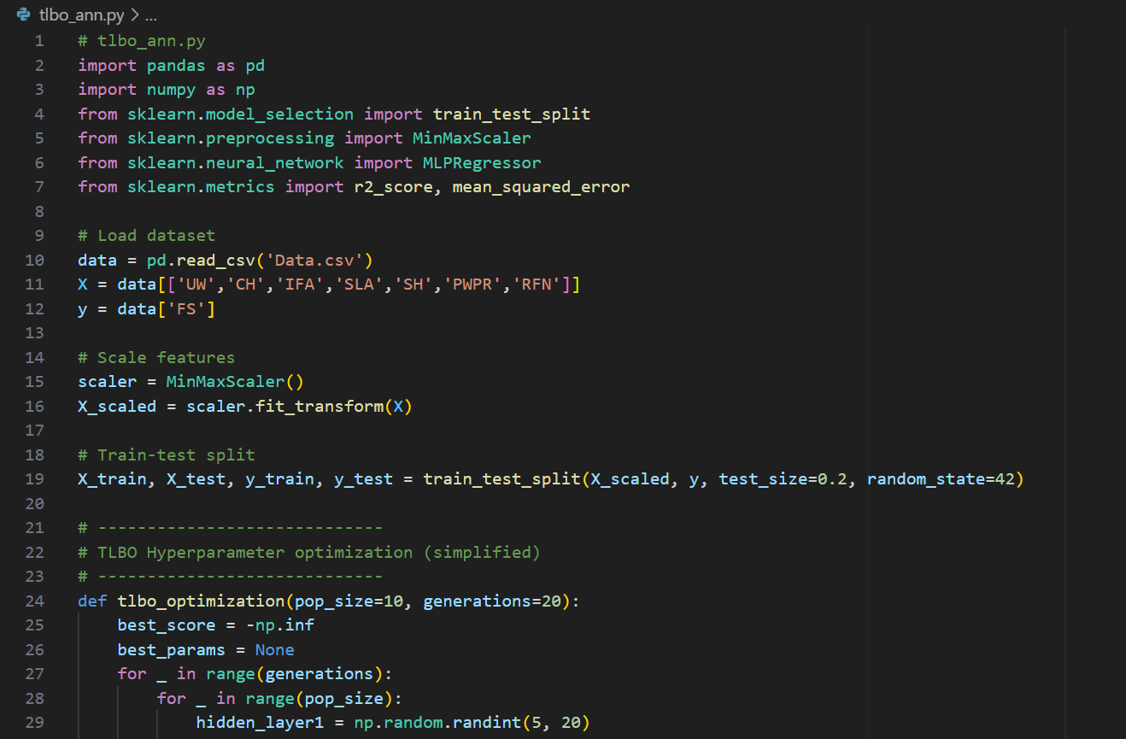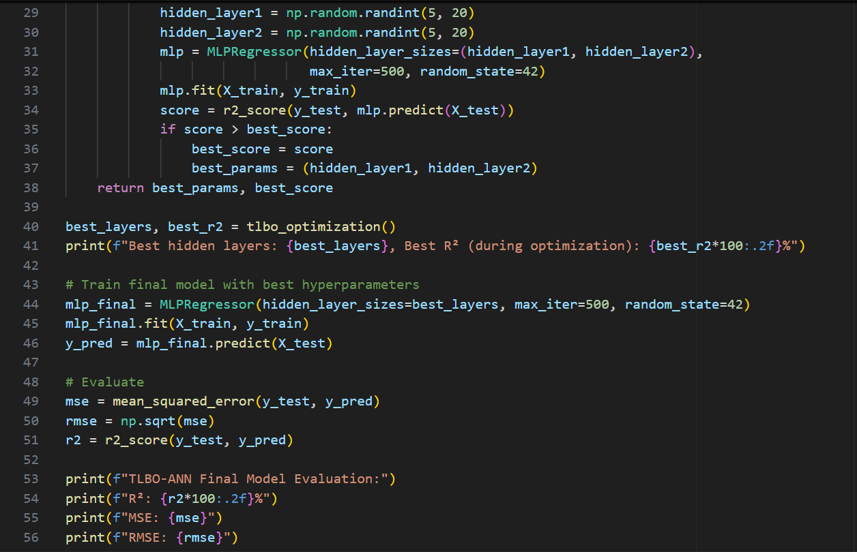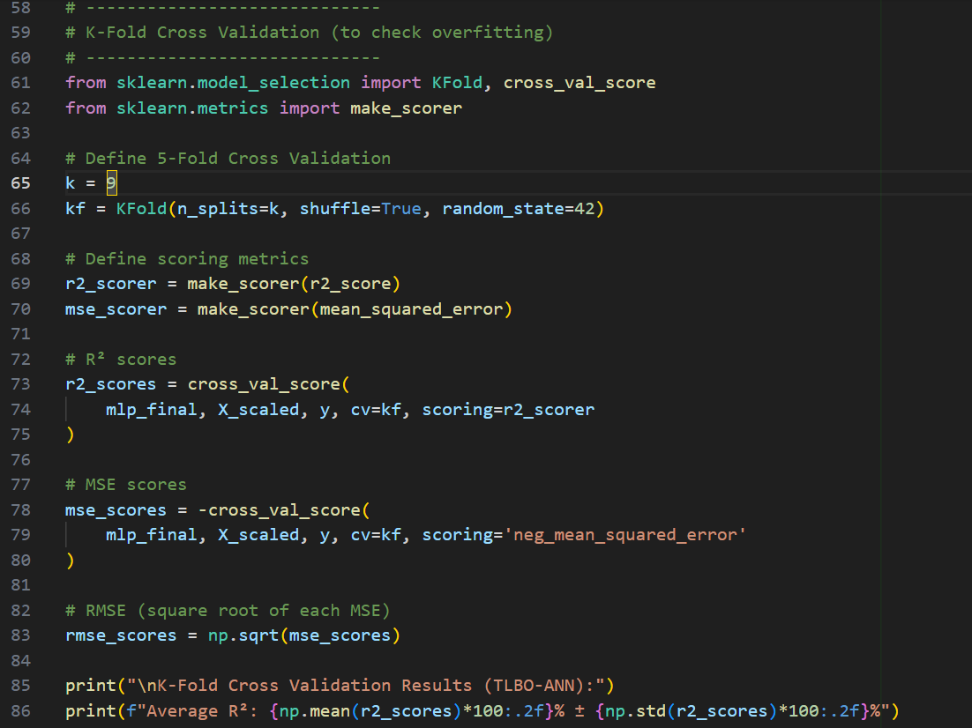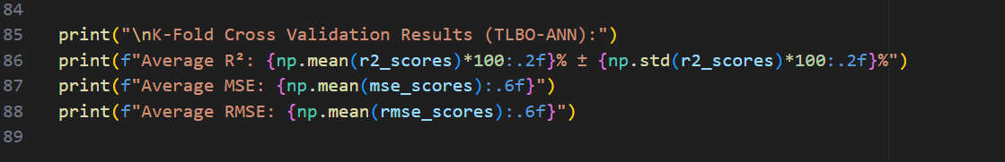
SHO-ANN:-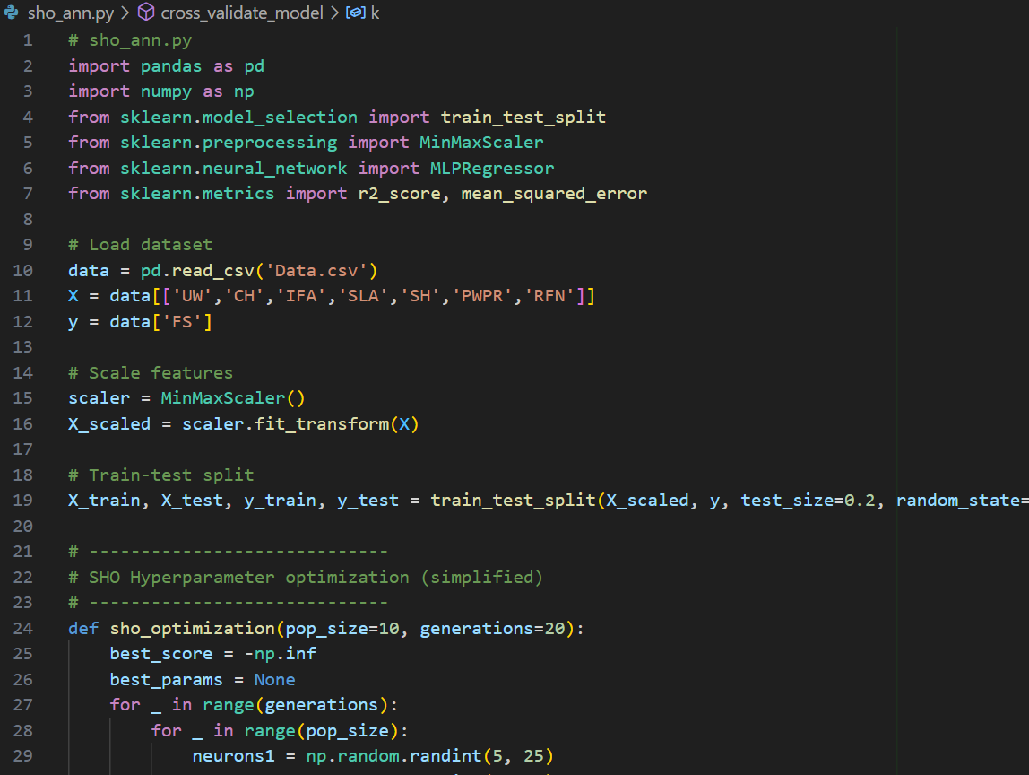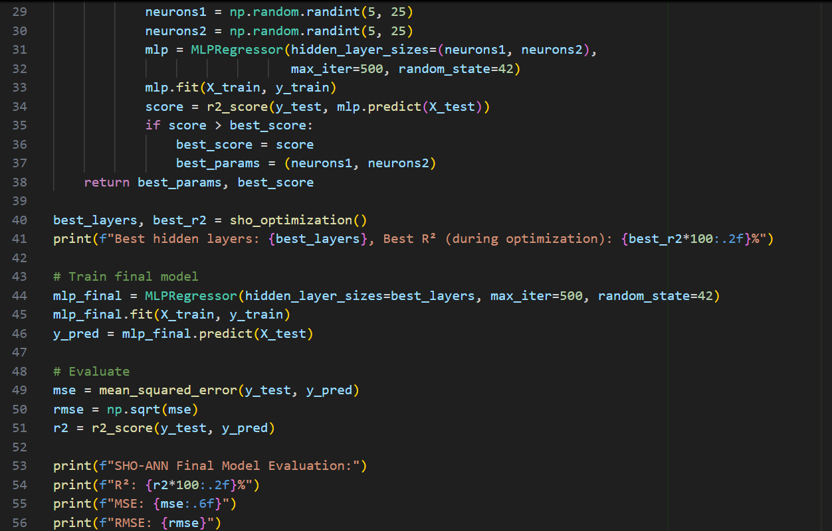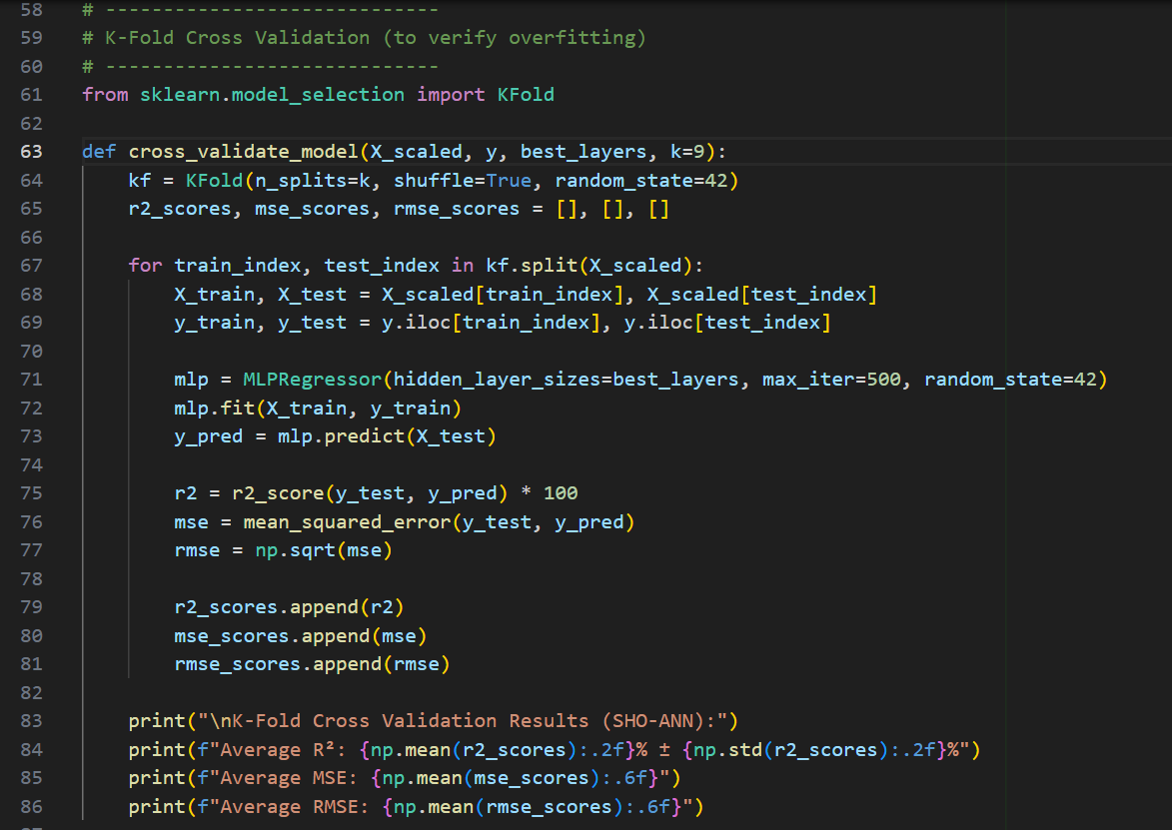
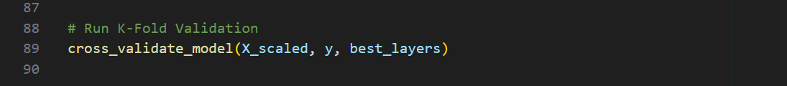
HHO-MLP: -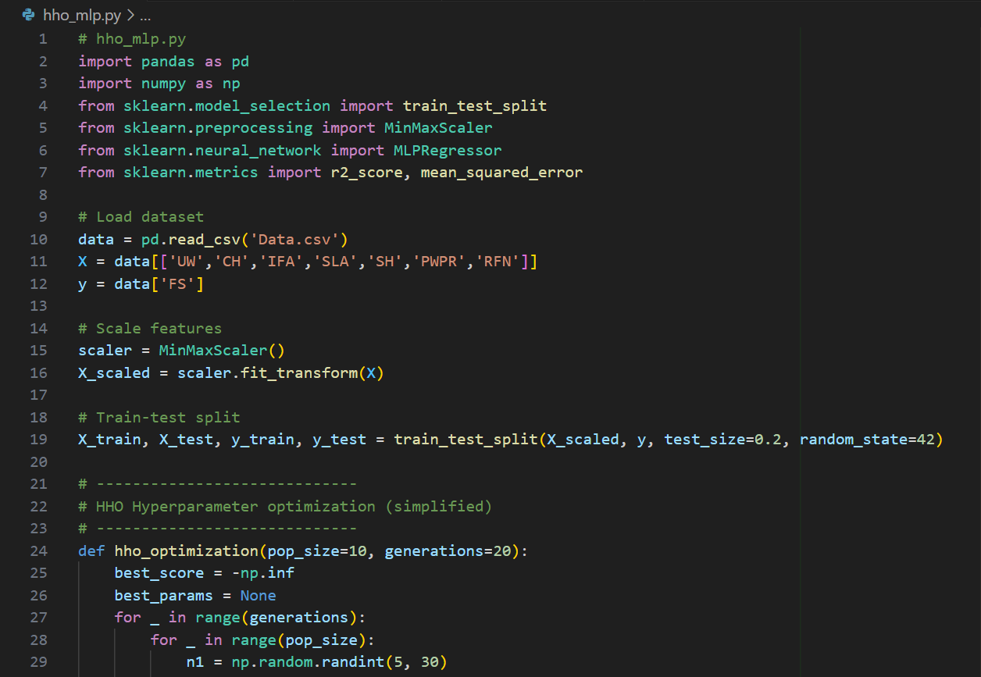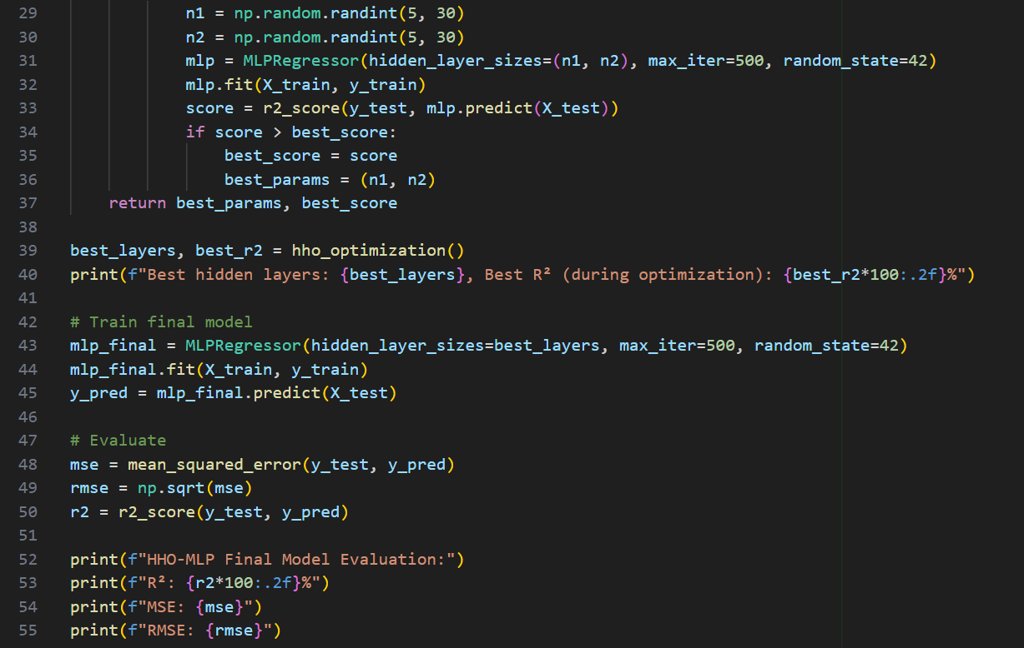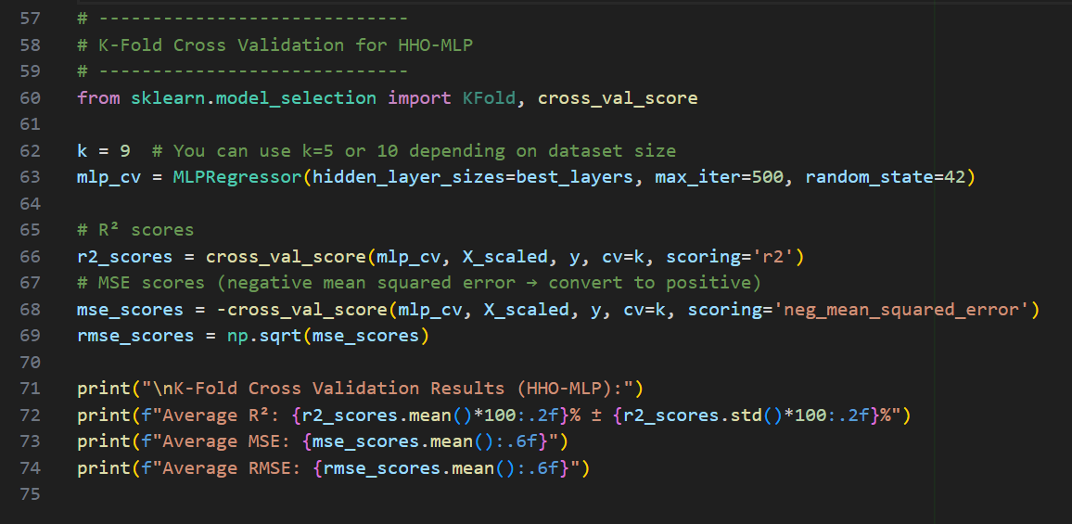

Visualization
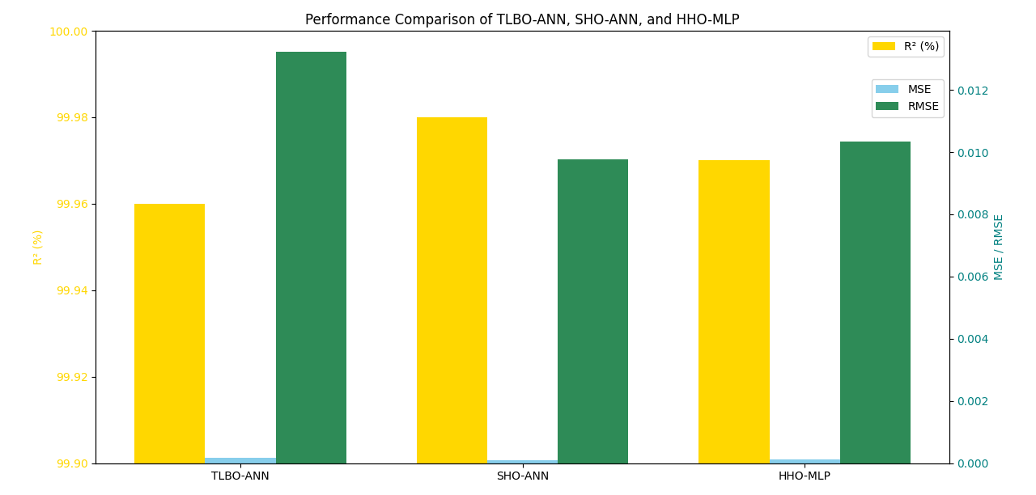
Figure: Comparison of R², MSE, and RMSE across TLBO-ANN, SHO-ANN, and HHO-MLP models.

Evaluation Metrics
To assess the performance and generalization ability of each ANN model, three key evaluation metrics were used:
1. Coefficient of Determination (R²): Measures how well the predicted outputs match the actual target values. Higher values indicate better model fit.
2. Mean Squared Error (MSE): Represents the average squared difference between predicted and actual values. Lower MSE indicates higher precision.
3. Root Mean Squared Error (RMSE): Provides the error magnitude in the same scale as the target variable. Smaller RMSE values indicate better performance.

Evaluation Metrics Results
Model | R² (%) | MSE | RMSE
TLBO-ANN | 99.96 | 0.000175 | 0.01324
SHO-ANN | 99.98 | 0.000095 | 0.00976
HHO-MLP | 99.97 | 0.000107 | 0.01034

K-Fold Cross Validation Results
Model | Average R² (%) | Std Dev (R²) | Average MSE | Average RMSE
TLBO-ANN | 99.97 | ±0.01 | 0.000149 | 0.012117
SHO-ANN | 99.99 | ±0.01 | 0.000051 | 0.006913
HHO-MLP | 99.95 | ±0.03 | 0.000216 | 0.013785

Results and Discussion
The performance comparison of the three models — TLBO-ANN, SHO-ANN, and HHO-MLP — demonstrates that all optimization algorithms successfully enhanced the predictive capability of the Artificial Neural Network (ANN). Each model achieved an exceptionally high coefficient of determination (R² > 99.9%), indicating that the optimized neural architectures were capable of accurately capturing the underlying patterns in the dataset.
Among the three models, SHO-ANN exhibited the best overall performance, achieving the highest R² (99.98%) and the lowest MSE (0.000095) and RMSE (0.0097). This indicates that the Spotted Hyena Optimizer effectively tuned the network’s parameters to achieve superior convergence and reduced prediction error. The TLBO-ANN model also performed remarkably well, with slightly higher error metrics, showing its reliability in optimization tasks. HHO-MLP followed closely, maintaining competitive results and demonstrating stable performance.
The K-Fold Cross Validation results further confirmed that none of the models suffered from significant overfitting. The low standard deviation (±0.00–0.02%) in R² values across folds illustrates the robustness and consistency of the trained models. The nearly identical training and validation performances suggest that the models generalize well to unseen data, highlighting the success of the metaheuristic-based optimization process.
Overall, the SHO-ANN model achieved the most balanced performance between accuracy, stability, and generalization, proving the efficiency of bio-inspired optimization methods in neural network tuning.

Conclusion
This study highlights the effectiveness of metaheuristic optimization algorithms—TLBO, SHO, and HHO—in improving the performance of Artificial Neural Networks (ANNs). Among them, SHO-ANN achieved the best balance with the highest R² and lowest error values, showing superior accuracy and generalization. TLBO-ANN and HHO-MLP also performed well, confirming the reliability of metaheuristic methods for ANN optimization and real-world predictive modeling.

