SQL assignment:

(f and t mean false and true, respectively)

Please share query and output for each:

Questions:

1. What is the time period used?

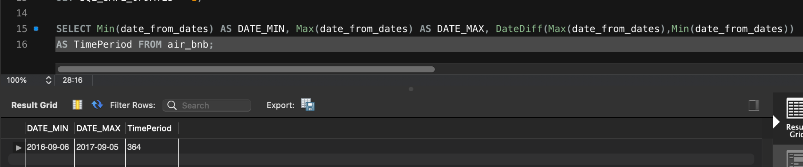

1. How many properties have duplicate entries? Remove duplicate rows (say a row appears 3 times, remove 2 and keep 1)

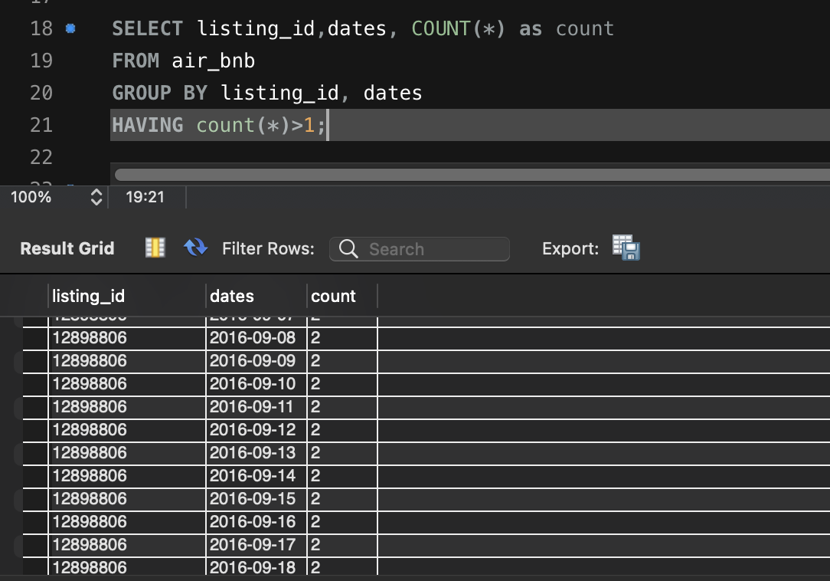

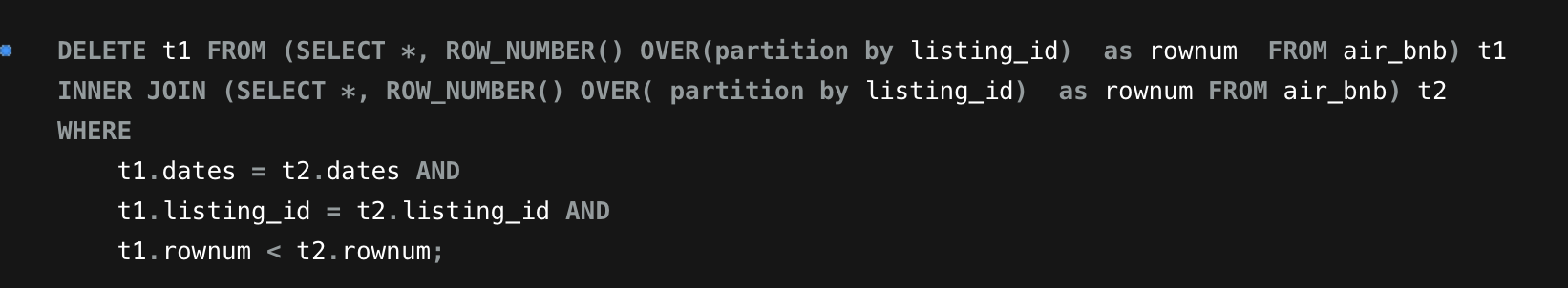

1. For each property, find out the number of days the property was available and not available (create a table with listing_id, available days, unavailable days and available days as a fraction of total days)

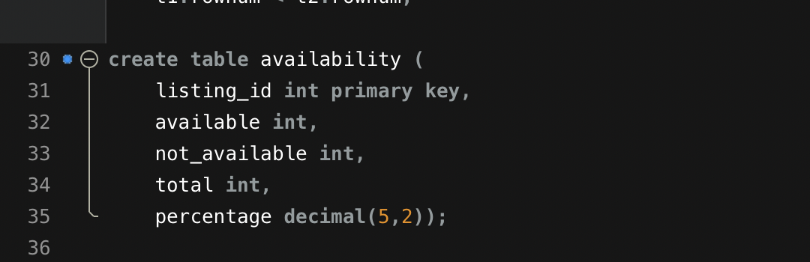

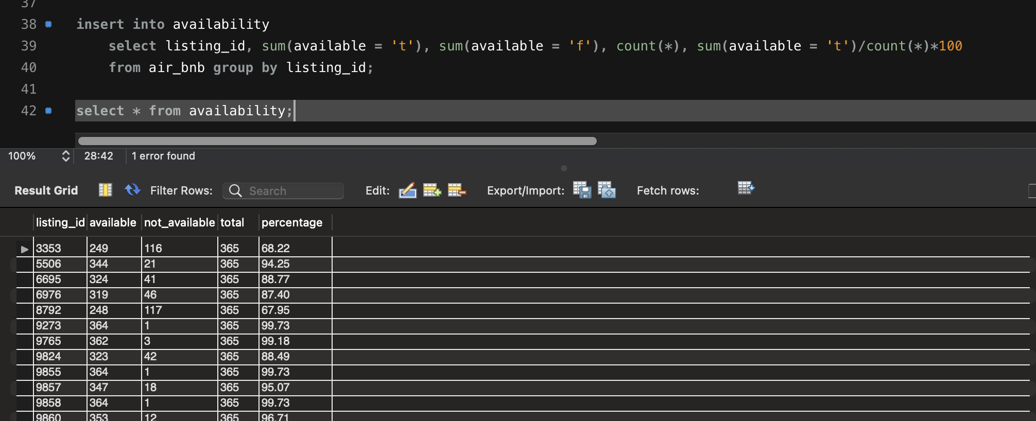

1. How many properties were available on more than 50% of the days? How many properties were available on more than 75% of the days?

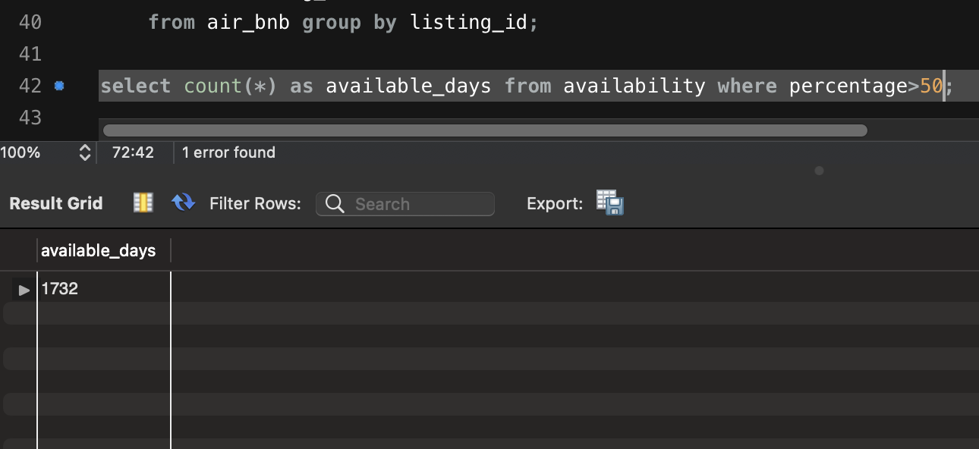

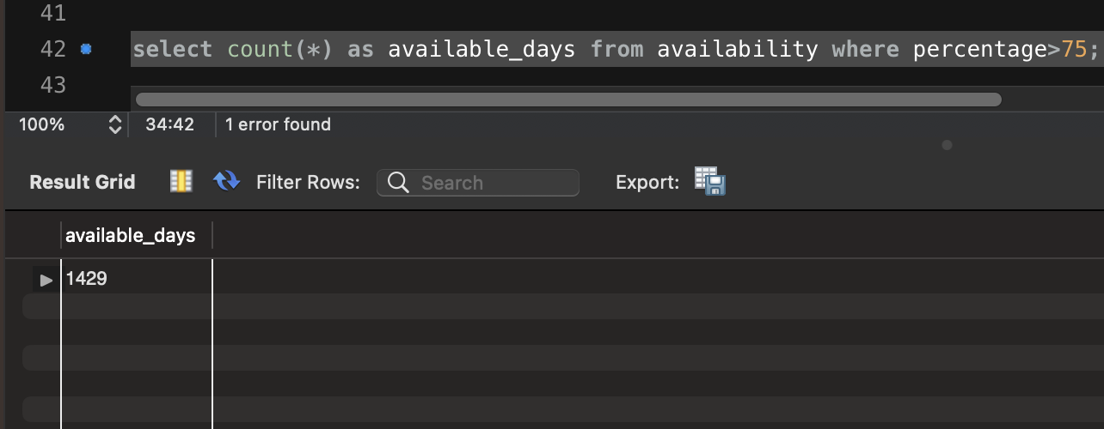

1. Create a table with max, min and average price of each property

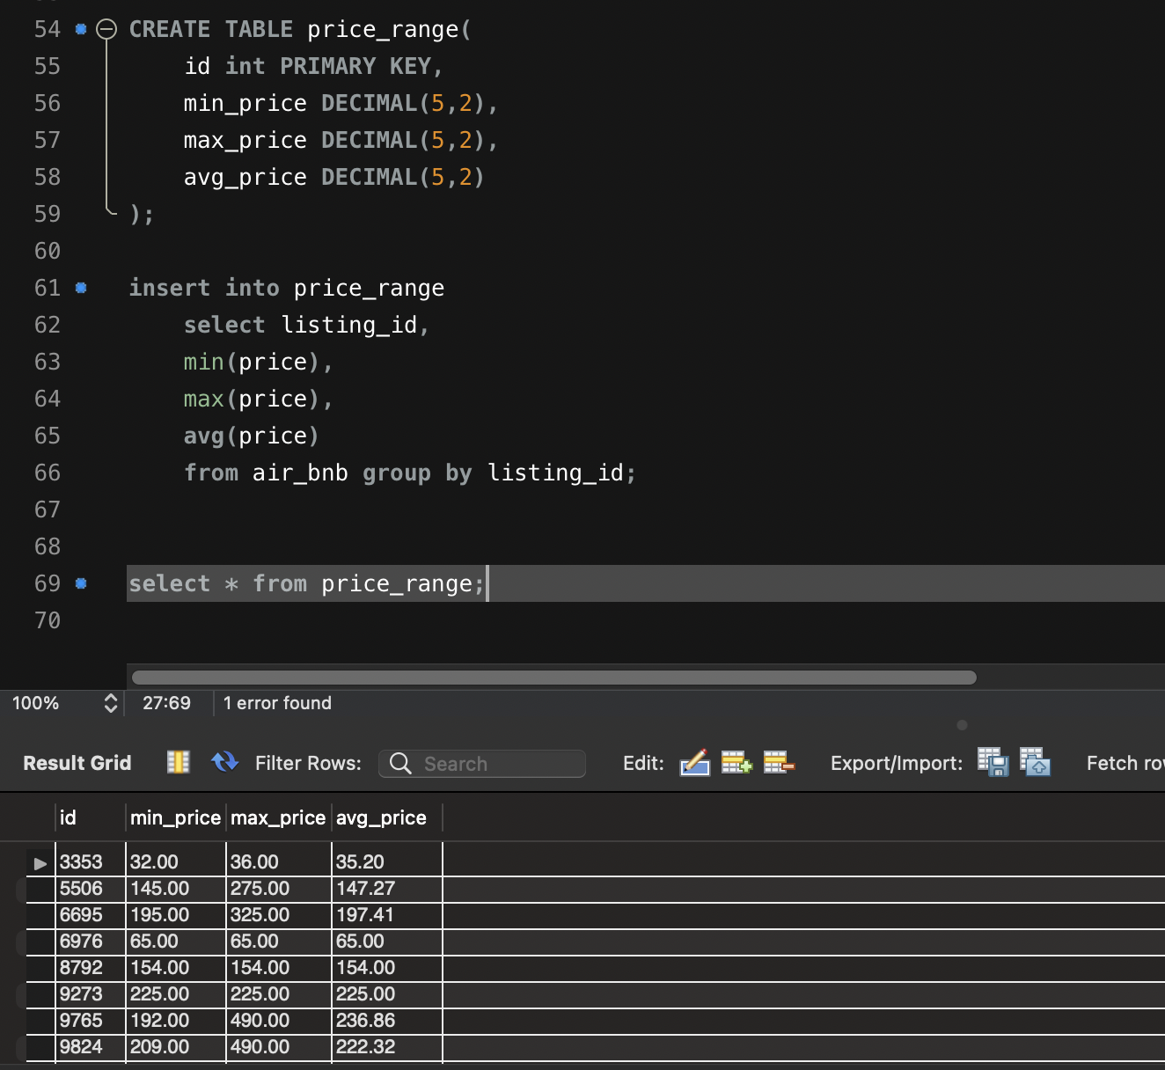

1. Extract properties with an average price of more than $500

