|  |  |  |  |
| --- | --- | --- | --- |
| Interrupt Integration: Adaptation of Infineon IRQ module  Elektrobit Automotive   |  | | --- | | **Document version: 0.1, Draft on 2019-08-10** | |  |   Elektrobit Automotive GmbH Am Wolfsmantel 46 91058 Erlangen, Germany Phone: +49 9131 7701 0 Fax: +49 9131 7701 6333 <http://automotive.elektrobit.com> | |
|  |  |



Legal disclaimer

Company-confidential and proprietary information

ALL RIGHTS RESERVED. No part of this publication may be copied in any form, by photocopy, microfilm, retrieval system, or by any other means now known or hereafter invented without the prior written permission of Elektrobit Automotive GmbH.

Copyright 2015, Elektrobit Automotive GmbH

# Document history

|  |  |  |  |
| --- | --- | --- | --- |
| Date | Version | Editor | Description |
| 2020-07-23 | 0.1 | mabh270739 | Draft version |

# Table of contents

Document history 2

Table of contents 3

1 General 4

2 How to configure IRQ for Lin and Uart: 4

# 

# General

Infineon has its own IRQ module that handles the ISRs in a project. This IRQ module cannot be use together with OS in real projects. Because of this incompatibly when Infineon MCAL is integrated, we also have to implement handling to be able to use the ISR files provided by Infineon with the OS module.

# How to configure IRQ for Lin and Uart:

IRQ’s of Lin driver are shared between Lin driver and Uart driver. In order to use these shared IRQ’s. Project has to configure respective the channels IRQ’s in McalExt.xdm file as shown in below.

Ex:

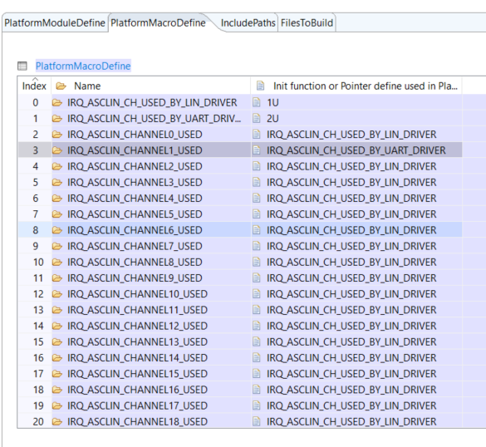

Depending on which channel is used by the driver, respective define shall be provided in configuration file.