



**Documentation**

**Fingerprint mechanism**

**in GenericScons**

**ITK Engineering AG**   
www.itk-engineering.de  
Im Speyerer Tal 6  
76761 Rülzheim  
Tel: +49-7272-7703-0  
Fax: +49-7272-7703-100

1. General

|  |  |
| --- | --- |
| Document state: | draft |
| Date: | 09 July 2014 |
| Author: | André Fischer-Ext (uidg5297) |
| Projekttitel: | GenericScons |

Change history

|  |  |  |  |  |  |
| --- | --- | --- | --- | --- | --- |
| No | Date | Vers. | Stelle | Grund | Kürzel |
| 1 | 08.07.2014 | 0.1.0 |  | First draft | uidg5297 |
| 2 | 09.07.2014 | 0.1.1 |  | Minor corrections | uidg5297 |

1. Terms, abbreviations and definitions
   1. Terms
   2. Abbreviations
   3. Definitions
2. Contents

I General 2

II Terms, abbreviations and definitions 2

II.1 Terms 2

II.2 Abbreviations 2

II.3 Definitions 2

III Contents 3

1. Introduction/Motivation 4

2. GenericScons Fingerprint Manual 4

2.1 Installation 4

2.1.1 Modifying Existing .scfg-Files 4

2.1.2 Adding and Maintaining New .scfg-Files 4

2.1.3 Generating the Fingerprints 5

2.2 Working with the Fingerprint Mechanism 5

Remark: 7

# Introduction/Motivation

From Checkpoint 1.40 on GenericScons supports the generation of a so-called fingerprint mechanism. A fingerprint header file is generated for all algo sources and for all eve sources respectively. Those header files contain the hashsums of the corresponding sources and typically the actual revision label and number. Once included in the source code it hence allows to track and map the revision of the targets and the version of its source files in use. In doing so bug hunts may be facilitated later.

In the following the label “xxx” usually has to be replaced by the component in question.

# GenericScons Fingerprint Manual

## Installation

### Modifying Existing .scfg-Files

Following files need to be modified:

* 03_Workspace\algo\xxx\sconstruct_config.scfg:

In order to activate the fingerprint feature within GenericScons, add the following line:

generate_fingerprint = True

* 03_Workspace\algo\xxx\sconstruct_setup_config.scfg:

In order to copy the SConscript_fingerprint.py to the correct location, add the following blocks:

{

"name" : "fingerprint ",

"copy" : True,

"dest_folder" : "04_Engineering/03_Workspace/algo/" + component_name,

"source" : ["fingerprint/SConscript_fingerprint.py"]

},

### Adding and Maintaining New .scfg-Files

Following files need to be added and maintained:

* 03_workspace/algo/xxx/xxx_algo_ver_history.scfg
* 03_workspace/algo/xxx/xxx_arp_ver_history.scfg

Templates for those files can be found in:

02_Development_Tools/scons_tools/scons_templates/03_workspace/algo/xxx.

See paragraph 2.2 for more details on those files.

### Generating the Fingerprints

Invoking the command “scons.bat xxx_fingerprint” in 03_Workspace/algo/xxx creates the fingerprint files and stores them in 04_Build/algo/xxx/fingerprint. This is also automatically done before any algo library is built.

## Working with the Fingerprint Mechanism

The goal of this fingerprint mechanism is to create fingerprint-header files which contain the correct revision labels and numbers when making a release.

In this respect those new files, mentioned in 2.1.2, serve for the ability to map the hashsums of the sources to the revision labels and numbers. GenericScons will read that data and store it in the fingerprint file.

In order to explain the workflow in some more detail, let us consider the following exemplary xxx_algo_ver_history.scfg – file.

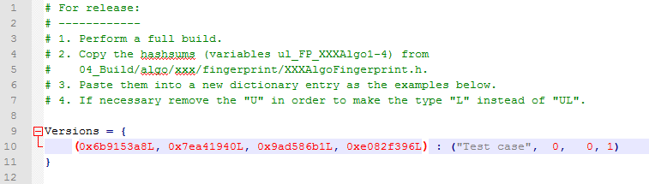

This file contains a single dictionary “Versions”, where the keys are hashsums and the values represent the corresponding tuples of revision label and number.

Having stored such a file in the correct location allows the build of a XXXAlgoFingerprint.h by “scons.bat xxx_fingerprint”. In an example taken from LD the first part may look as follows[1]:

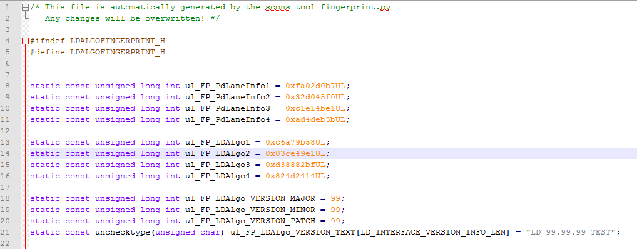

Per default, if the combination of hashsums ul_FP_XXXAlgo1 – ul_FP_XXXAlgo4 in XXXAlgoFingerprint.h is not contained as a key in the dictionary “Versions” – as it is the case here – , the version number will be 99.99.99 with the revision tag “XXX 99.99.99 TEST”, see line 18-21.

Suppose we just successfully built the whole sandbox and we want to make this a release version with label “Revision XY” and revision number 0.0.2. In order to have the XXXAlgoFingerprint.h contain this information, we need to read off the hashsums in XXXAlgoFingerprint.h, i.e. variables ul_FP_XXXAlgo1 – ul_FP_XXXAlgo4, and to add a new dictionary entry as follows:

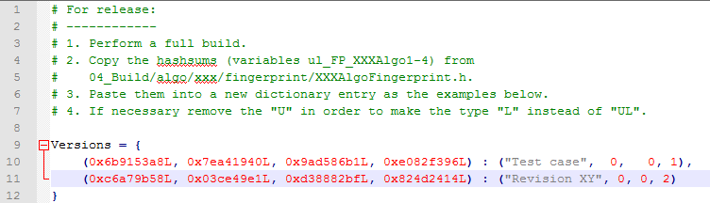

It is important to remove the “U” in “UL”. Rebuilding the sandbox then results in the following XXXAlgoFingerprint.h, which will then be included into the source code:

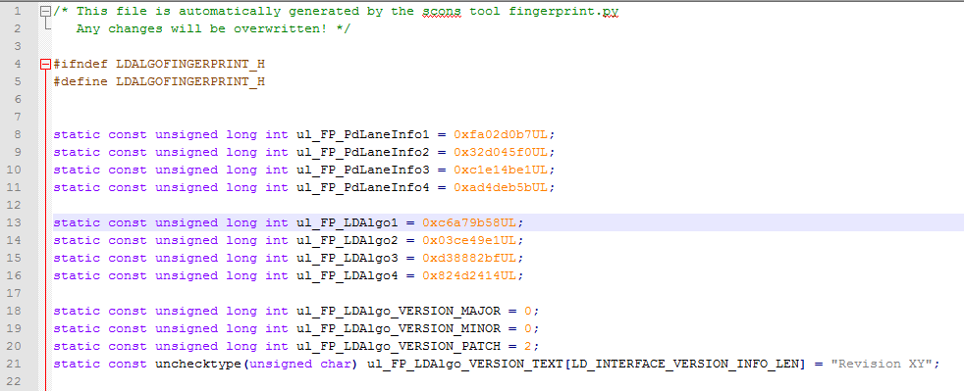

Remark:

The individual steps just described also apply when generating an XXXAlgoArpFingerprint.h-file for arp with the input file 03_workspace/algo/xxx/xxx_arp_ver_history.scfg.

1. Further down below the hashsums of all sources being used will appear. Since those data are not relevant for this manual, they are not displayed here.