**Generic SCons**

**Release Definition and Process**

|  |  |
| --- | --- |
| Document Control: | |
| Project: | ETK: SCT_Sconstools |
| Revision: | 0.7 |
| Last Change: | 20-Jun-2016 |
| Confidence Level: | 🞏 Public 🗷 Confidential |

CONFIDENTIAL AND PROPRIETARY PROPERTY OF ETK - ALL RIGHTS RESERVED

|  |  |
| --- | --- |
| Document State: | |
| State: | Draft |
| Author: | Lenin Palanisamy |
| Reviewed by: | Vishal Singh |
| Released by: | 28-Jul-2016 |

Revision History

| Version | Date | Change Description | Responsible | Approver |
| --- | --- | --- | --- | --- |
| 0.1 | 30-Apr-2015 | Initial draft version for review | Lenin Palanisamy | Medhat Hussain |
| 0.2 | 21-May-2015 | Updated based on Review comments | Lenin Palanisamy | Medhat Hussain |
| 0.3 | 12-Jun-2015 | Updated to add more information as part of further improvements | Lenin Palanisamy | Medhat Hussain |
| 0.4 | 24-Jun-2015 | Updated based on further comments   1. Update sections 1.3 and 2.2 2. Heading 3 with indices and TOC | Lenin Palanisamy | Medhat Hussain |
| 0.5 | 22-Jul-15 | Update the section 1.3 and 3.3 for referencing LL document | Lenin Palanisamy | Medhat Hussain |
| 0.6 | 06-Jun-16 | Updated as part of continuous improvement:   1. Section 1.3 for IMS location 2. Section 1.4.2 Support demands 3. Replace MKS with IMS in all sections | Lenin Palanisamy | Vishal Singh |
| 0.7 | 20-Jun-16 | Updated Section 3.2 point 4 to correct the notification email to counterpart. | Lenin Palanisamy | Vishal Singh |
|  |  |  |  |  |
|  |  |  |  |  |

Table of Contents

1 Introduction 4

1.1 Purpose 4

1.2 Scope 4

1.3 Reference documents 4

1.4 Overview 5

1.4.1 New Feature/Change/Problem Requests 5

1.4.2 Support demands 5

1.5 IMS Items and Workflow 6

1.5.1 IMS Items 6

1.5.2 Analysis Task Workflow 6

1.5.3 Task Workflow 7

1.5.4 Issue Workflow 8

1.5.5 Realization Order Workflow 8

1.5.6 Release Workflow 9

1.5.7 IMS Legend 10

2 Release Definition 11

2.1 Roles and Responsibilities 11

2.2 Release Checklist 11

3 Release Guidelines 12

3.1 Prerequisite 12

3.2 Release steps 12

3.3 Lessons Learned 13

# Introduction

## Purpose

This document contains a “How to” guideline and process for releasing all modifications carried out based on the issue/Realization Order (RO) raised in Generic SCons.

## Scope

This document applies for releases done in SCT_Sconstools of Engineering Tool Kit (ETK) project.

## Reference documents

|  |  |  |
| --- | --- | --- |
| **S. No.** | **Reference Document** | **Location** |
| 1 | Release Checklist template | <http://ims-adas:7001/si/viewrevision?projectName=/nfs/projekte1/REPOSITORY/Base%5fDevelopment/05%5fAlgorithm/ETK%5fEngineeringToolKit/04%5fEngineering/SCT%5fSconstools/docs/processes/templates/project.pj&selection=Release%5fChecklist.xlsx> |
| 2 | GenericSCons Testing Process | [http://ims-adas:7001/si/viewrevision?projectName=/nfs/projekte1/REPOSITORY/Base%5fDevelopment/05%5fAlgorithm/ETK%5fEngineeringToolKit/04%5fEngineering/SCT%5fSconstools/docs/processes/project.pj&selection=GenericSCons%5fTesting%5fProcess.docx](http://mks-psad:7001/si/viewrevision?projectName=/nfs/projekte1/REPOSITORY/Base%5fDevelopment/05%5fAlgorithm/ETK%5fEngineeringToolKit/04%5fEngineering/SCT%5fSconstools/docs/processes/project.pj&selection=GenericSCons%5fTesting%5fProcess.doc%20http://ims-adas:7001/si/viewrevision?projectName=/nfs/projekte1/REPOSITORY/Base%5fDevelopment/05%5fAlgorithm/ETK%5fEngineeringToolKit/04%5fEngineering/SCT%5fSconstools/docs/processes/project.pj&selection=GenericSCons%5fTesting%5fProcess.docx) |
| 3 | Release checklist record for current release | <http://ims-adas:7001/si/viewrevision?projectName=/nfs/projekte1/REPOSITORY/Base%5fDevelopment/05%5fAlgorithm/ETK%5fEngineeringToolKit/04%5fEngineering/SCT%5fSconstools/docs/release%5fnotes/checklists/project.pj&selection=Release%5fChecklist.xlsx> |
| 4 | GenericSCons Lessons Learned | [http://ims-adas:7001/si/viewrevision?projectName=/nfs/projekte1/REPOSITORY/Base%5fDevelopment/05%5fAlgorithm/ETK%5fEngineeringToolKit/04%5fEngineering/SCT%5fSconstools/docs/generic%5fscons/project.pj&selection=GenericSCons%5fLessons%5fLearned.docx](http://mks-psad:7001/si/viewrevision?projectName=/nfs/projekte1/REPOSITORY/Base%5fDevelopment/05%5fAlgorithm/ETK%5fEngineeringToolKit/04%5fEngineering/SCT%5fSconstools/docs/generic%5fscons/project.pj&selection=GenericSCons%5fLessons%5fLearned.docx) |

## Overview

The following activities are done in SCT_Sconstools development of ETK project:

* New Feature/Change/Problem Requests
* Support demands

### New Feature/Change/Problem Requests

Generic SCons modules are modified or added based on the New Feature or Change or Problem Requests described in IMS issues/ROs. The below execution process flow provides the complete flow/steps for all issues/ROs planned for a delivery/release:

The section focuses on the steps to be carried for each release.

### Support demands

In addition, there are few support demands received from algo developer whoever using the Generic SCons via emails, Lotus Notes Sametime meeting, Phone calls and etc. These are addressed based on priority.

These support activities should be managed via IMS change management system by creating Analysis Task or Task item in IMS depending on the support demand. Hence, those support demands would be prioritized, assigned, tracked and closed systematically.

## IMS Items and Workflow

### IMS Items

The following IMS items are created and edited for GSCons activities according to the workflow described below for each item:

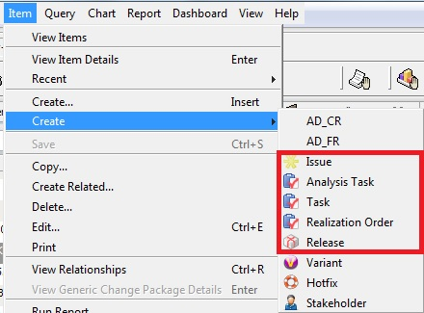

### Analysis Task Workflow

Analysis Task item is mainly created for any support demand for which only clarification to be provided to the requester. The following workflow is to be followed in IMS.

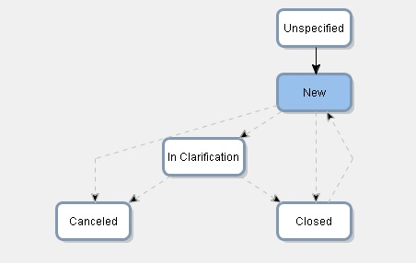

### Task Workflow

Task item is mainly created for any support demand for which support work to be provided to the requester. The following workflow is to be followed in IMS.

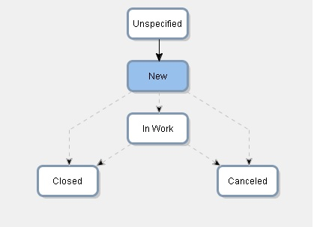

### Issue Workflow

Issue item is mainly created for a New Feature/Change/Problem Requests in GSCons that should be planned, tracked, tested and released as described in the release definition (Ref. section ). The following workflow is to be followed in IMS.

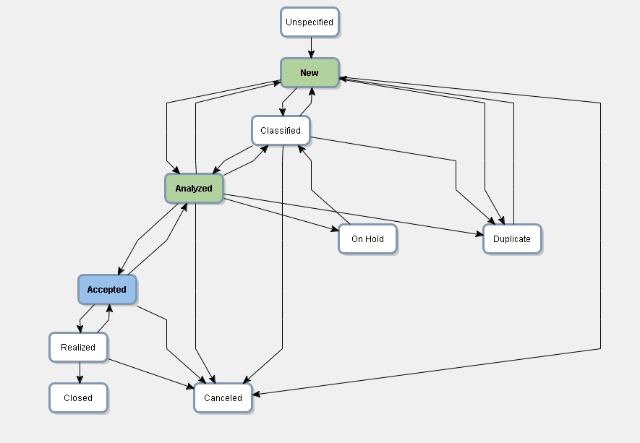

### Realization Order Workflow

One or more Realization Order (RO) is to be created for each issue item to check in the modified files into SCT_Sconstools project in IMS. The following workflow is to be followed in IMS.

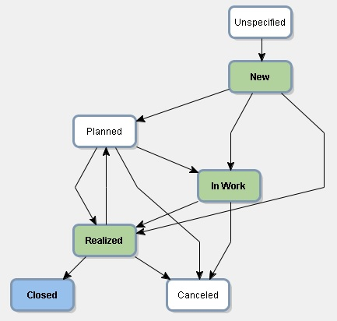

### Release Workflow

Release item is created to plan and attach list of Issue for a GSCons delivery (Ref. section ). The following workflow is to be followed in IMS.

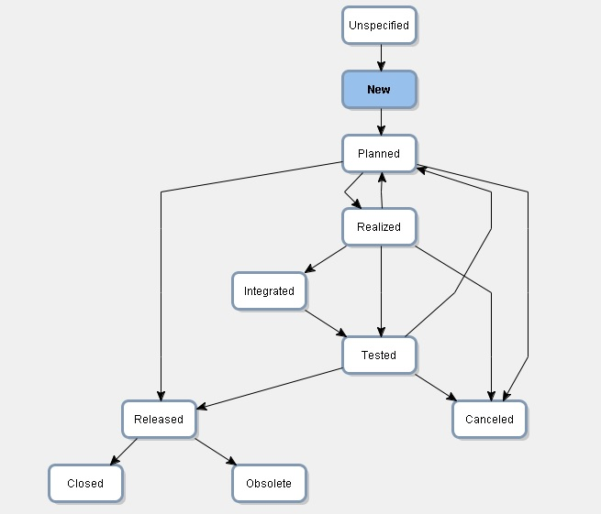

### IMS Legend

State notation for a IMS item as follows:

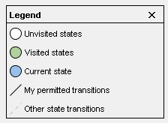

# Release Definition

Generic SCons development team committed to deliver a set of Issues/ROs based on the priority and defines the process for each delivery/release.

1. Create an item “Release” in IMS with planned release date and assign the list of issues for the release

* Release date would be every last Friday of month
* Plan, assign and commit the list of Issues to be delivered for next release after the current release (Maximum 1 week) and communicate to Project Management.

1. Create realization order in IMS for each issue to be delivered, so it is attached to the issue.
2. Check all work flow and process followed for each issue to be delivered. All modifications are checked in to IMS.

* Track the progress and send the weekly status report on every Wednesday to Project Management
* Ensure the quality of deliverables before delivery/release (Ref. point 2 and 3 in section 1.3)
  + GenericSCons Testing Process and Issue checklists
  + Release checklist

1. Lessons Learned for continues improvement

## Roles and Responsibilities

Project Manager of Generic SCons will be responsible for releases and quality commitment.

## Release Checklist

For each release, a release checklist needs to be filled up to confirm that all steps and processes are verified. Details for each check point can be given in the checklist in “Remarks” column and the checklist should be edited with current release details, rename the sheet name with release label and checked in to IMS (Ref. point 3 in section 1.3) before closing the release item in IMS.

Note: The latest release checklist template Release_NNNNNN_Checklist should be used for each release and the template configured at IMS location (Ref. point 1 in section 1.3).

# Release Guidelines

## Prerequisite

Project Manager Rights is required in IMS to carry out few steps mentioned in release steps.

## Release steps

The below steps are mainly focused on the delivery steps:

1. Update release notes with all major and minor changes and check in to IMS.
2. Close all Issues/ROs/Change Packages created for the release
3. Create a new check point and label for SCT_Sconstools.

**Checkpoint creation**

“Project” Menu -> Select “Checkpoint” Menu will display below:

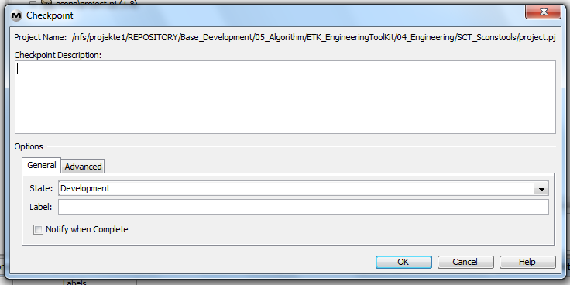

Mention the label, for example AL_ETK_SCT_01.12.00, in both “Checkpoint Description” and “Label” field.

**Add Label**

“Member” Menu -> “Properties” Menu 🡺 Select “Add Label”

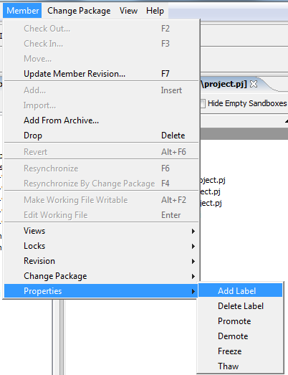

**Link checkpoint with Release item**

* Open the Release item, for example “325719”,
* Select “Edit” Menu, Move the state to “Planned” in “General” tab
* Go to “Relationship” Tab, select the project ETK\SCT_Scons and latest check point

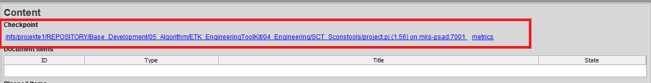

* Move the state to “Released” in “General” tab

1. Send a notification email with release details to the person whoever responsible for distributing to algorithm owners.

## Lessons Learned

For each release, all lessons learned points need to be recorded in the document for continuous improvement in release process and quality of deliverables.

Lessons Learned document would be found at the IMS location (Ref. point 4 in section 1.3)