Setup of the CCS-Project: qspi-flash-writer-reloaded

|  |  |
| --- | --- |
| Document Control: | |
| Project: | MFC4T0, Toyota Mono |
| Revision: | 1.1 |
| Last Change: | 29.10.2013 |
| Confidence Level: | 🞏 Public 🗷 Confidential |

Printed copy is uncontrolled!  
  
CONFIDENTIAL AND PROPRIETARY PROPERTY OF A.D.C. GmbH - ALL RIGHTS RESERVED

|  |  |
| --- | --- |
| Document State: | |
| State: | Draft |
| Author: | Harald Heim-Ext |
| Reviewed by: | - |
| Released by: |  |

Table of Contents

1 Introduction 2

2 Change Log 2

3 Use TI Compiler 3

4 Step by Step creating new CCS Project 3

4.1 Create wizard 3

4.2 Copy the Source files to the directory: 4

4.3 Rename output folder to VH28_debug 5

4.4 Switch off optimization 6

4.5 Add include paths for *.h-files 7

4.6 All other values leave on default 7

5 Specifications 8

# Introduction

You can use this document as an example, to setup new CCS Projects.  
Also it is the documentation for the CCS-Project qspi-flash-writer-reloaded.

# Change Log

|  |  |  |  |  |
| --- | --- | --- | --- | --- |
| **Version** | **Date** | **Editor** | **Description** | **Pages /**  **Chapter** |
| 1.1 | 29.10.2013 | Heim | Initial Revision | all |
|  |  |  |  |  |
|  |  |  |  |  |
|  |  |  |  |  |
|  |  |  |  |  |
|  |  |  |  |  |
|  |  |  |  |  |
|  |  |  |  |  |
|  |  |  |  |  |
|  |  |  |  |  |
|  |  |  |  |  |

# Use TI Compiler

Reason: GNU for A15 core doesn’t work:   
TI known Problems: Code from reset vector to main() is missing.   
Solution for “reset vector to main()” at other VH28 projects with GNU:

* CA8.ccspoject (S11_APPL) uses av_bios
* SBL.ccspoject (S11_SFBL) uses special ASM-Code.

# Step by Step creating new CCS Project

## Create wizard

First create a new CCS project within the folder (Location): *\qspi-flash-writer-reloaded .*

Project name here also is “qspi-flash-writer-reloaded”.

|  |  |
| --- | --- |
|  | Pulldown:  Use  **Generic CortexA8 Device** for our MPU CortexA15.  At Conti don’t use specific VH28 entries circled above! At normal use Generic Cotex A8.  At SBL (Secondary Bootloader) DM8148 is used.  Responsible Persons: Colin Ward and Hermann Brugger.   Don’t install Chip Support Libraries to get these specific VH28 entries. We don’t use them. |

## Copy the Source files to the directory:

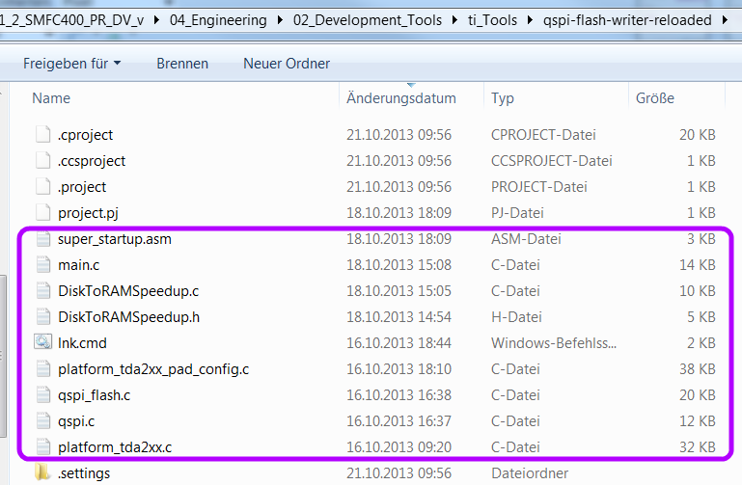

## Rename output folder to VH28_debug

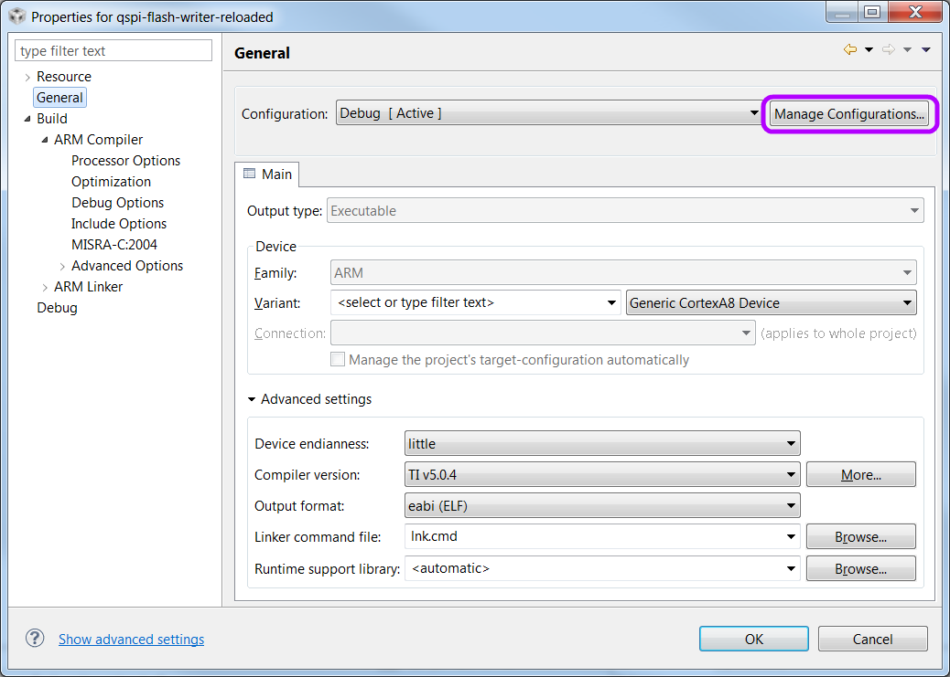

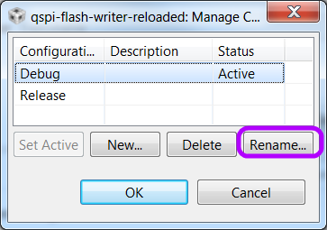 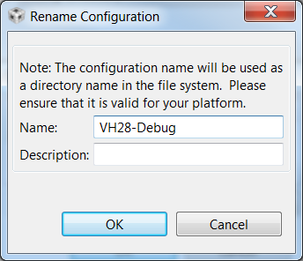

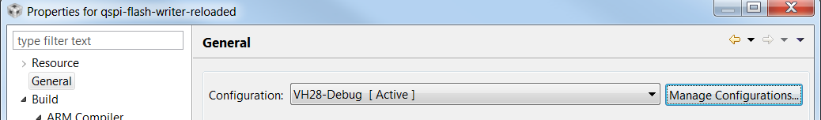

**Attention: use underscore “VH28_Debug”!**

## Switch off optimization

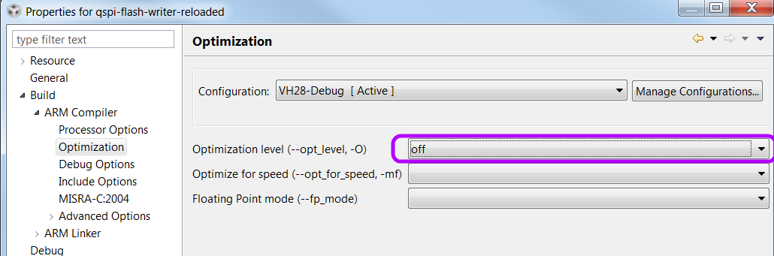

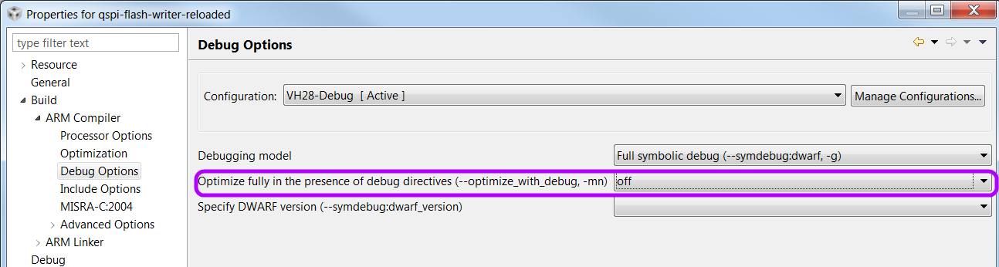

## Add include paths for *.h-files

The project here uses *.h-files from starterware, that’s special.   
Add only necessary paths, you need e.g. "${workspace_loc:/${ProjName}/src}".

Add following include paths for all *.h-files.

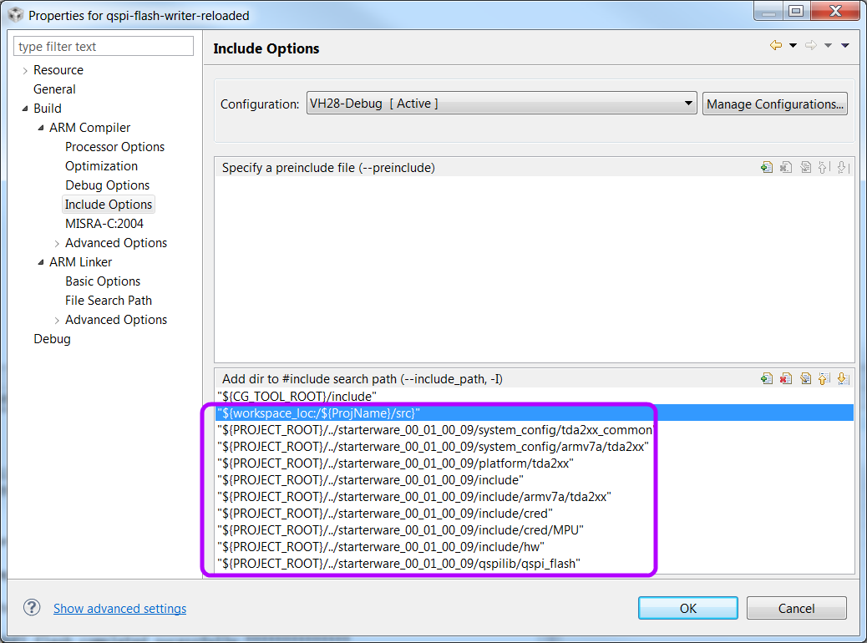

"${workspace_loc:/${ProjName}/src}" "${PROJECT_ROOT}/../starterware_00_01_00_09/system_config/tda2xx_common"

"${PROJECT_ROOT}/../starterware_00_01_00_09/system_config/armv7a/tda2xx"

"${PROJECT_ROOT}/../starterware_00_01_00_09/platform/tda2xx"

"${PROJECT_ROOT}/../starterware_00_01_00_09/include"

"${PROJECT_ROOT}/../starterware_00_01_00_09/include/armv7a/tda2xx"

"${PROJECT_ROOT}/../starterware_00_01_00_09/include/cred"

"${PROJECT_ROOT}/../starterware_00_01_00_09/include/cred/MPU"

"${PROJECT_ROOT}/../starterware_00_01_00_09/include/hw"

"${PROJECT_ROOT}/../starterware_00_01_00_09/qspilib/qspi_flash"

## All other values leave on default

# Specifications

**Beginning situation, how it has been done in the past:**Within the actual MKS the folder **no CCS-Project existed:**

*${yoursandbox}\04_Engineering\02_Development_Tools\ti_Tools\qspi-flash-writer-reloaded*

There was only a main.c, an *.out-File, linker-Command-Files and a makefile within this folder.  
These files only was MKS archived Files.  
Building-Process has been done within *\starterware_00_01_00_09\build\tools\flashtools\qspi_flash_writer*,  
by command line: “>gmake PLATFORM=tda2xx CORE=m4"

After modifying main.c you had to copy it to *\starterware_00_01_00_09\tools\flashtools\qspi_flash_writer*,and build it there.

Before you could do this, you had to do some preparation:

* modify env.mk to correct paths like installed on your computer:  
  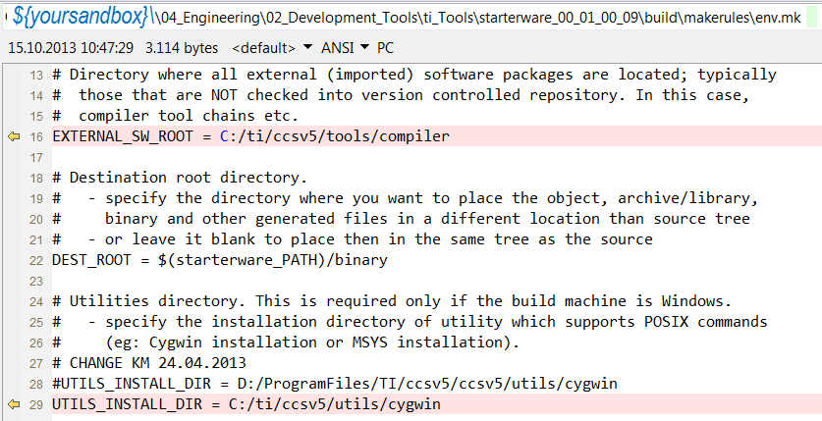
* Add following paths to your computers environmental variables (Right click ”My Computer”->Properties->”Advanced system settings”->”Environment Variables”):   
  ***C:\ti\ccsv5\utils\cygwin; C:\ti\ccsv5\utils\bin***
* If still not work, refer to SW-userguide starterware: *C:\ti\starterware_00_01_00_09\docs\TDA1Mxx_TDA2xx_StarterWare_UserGuide.pdf*

How to build, step by step

* Open DOS-window : start cmd.exe
* >cd D:
* >cd *${yoursandbox}\04_Engineering\02_Development_Tools\ti_Tools\starterware_00_01_00_09*
* > set ROOTDIR=*D:/${yoursandbox}\04_Engineering\02_Development_Tools\ti_Tools\starterware_00_01_00_09*
* >cd *build\tools\flashtools\qspi_flash_writer*
* > gmake PLATFORM=tda2xx CORE=m4

**Target situation:**Replace complete the content of the MKS folder. Generate a CCS-Project with every source files there.*${yoursandbox}\04_Engineering\02_Development_Tools\ti_Tools\qspi-flash-writer-reloaded*

It should be possible to “Import existing project” with CCS and do work as usual with the new CCSproject.