Network Management

1. NM Selective wakeup 2

2. NM network mode 5

1.1 Bus Sleep Mode 7

2.1 Prepare Bus-Sleep Mode 7

3.1 Network Mode 7

1.1.1 Repeat Message State 7

2.1.1 Normal Operation State 7

3.1.1 Ready Sleep State 7

3. NM Time Sequence 8

|  |  |  |  |  |
| --- | --- | --- | --- | --- |
| Version | Data | Author | Status | Remarks |
| V0.0.1 | 2022.06.10 | Chaoqiang | Init | Init Version |
|  |  |  |  |  |
|  |  |  |  |  |
|  |  |  |  |  |
|  |  |  |  |  |
|  |  |  |  |  |

Network Management

# NM Selective wakeup

Customer requirement as below capture.

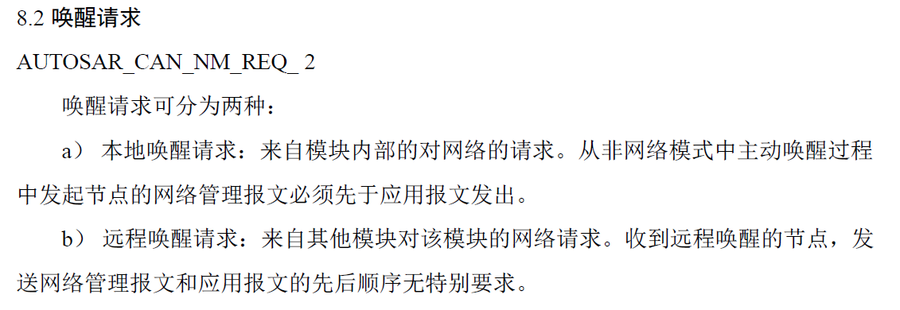

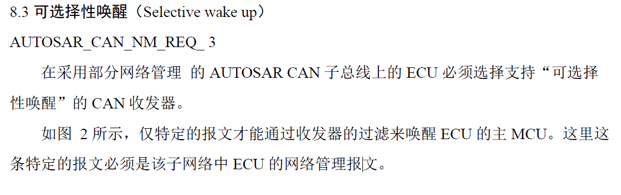

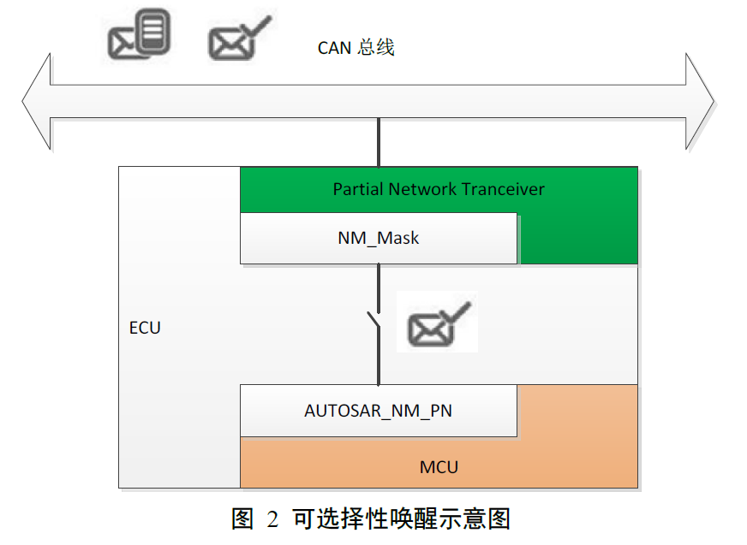

In MFC5J3 ECU , Support local event wakeup as KL15 and remote can wakeup by frame message.

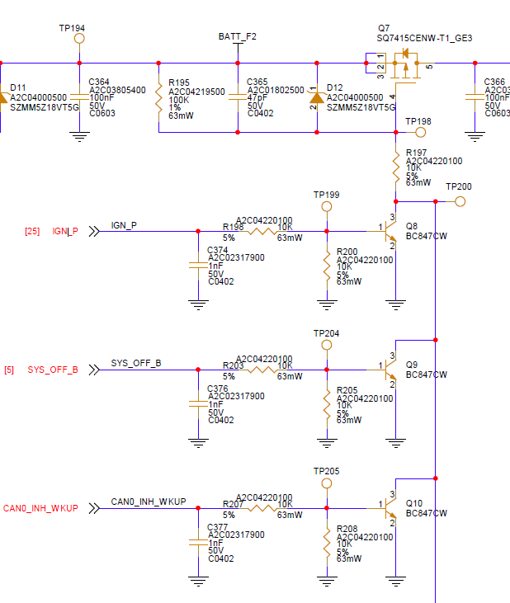

NM Wakeup

In EB tool ,configure wakeup frame 0x430-0x4ff as wakeup frame

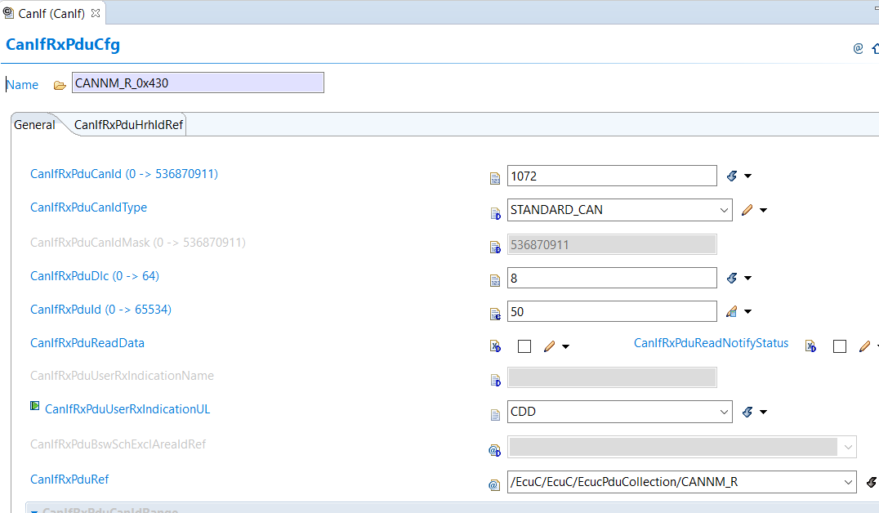

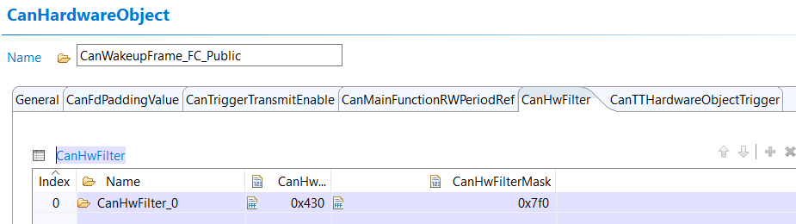

# NM network mode

From requirement , need support 3 network mode, like below capture

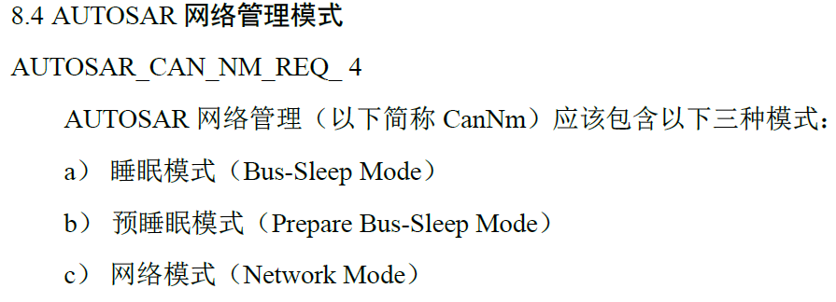

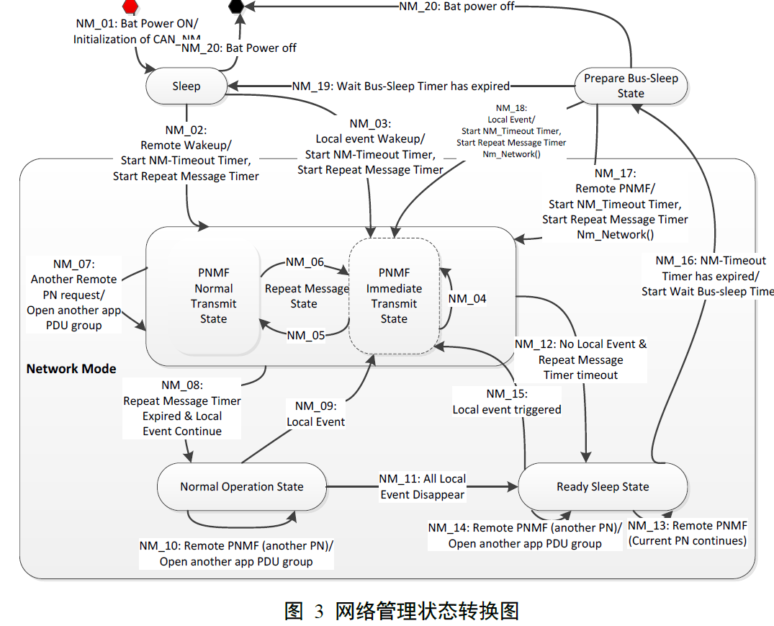

In Autosar NM module, which support this 3 network mode :

## Bus Sleep Mode

## Prepare Bus-Sleep Mode

## Network Mode

### Repeat Message State

### Normal Operation State

### Ready Sleep State

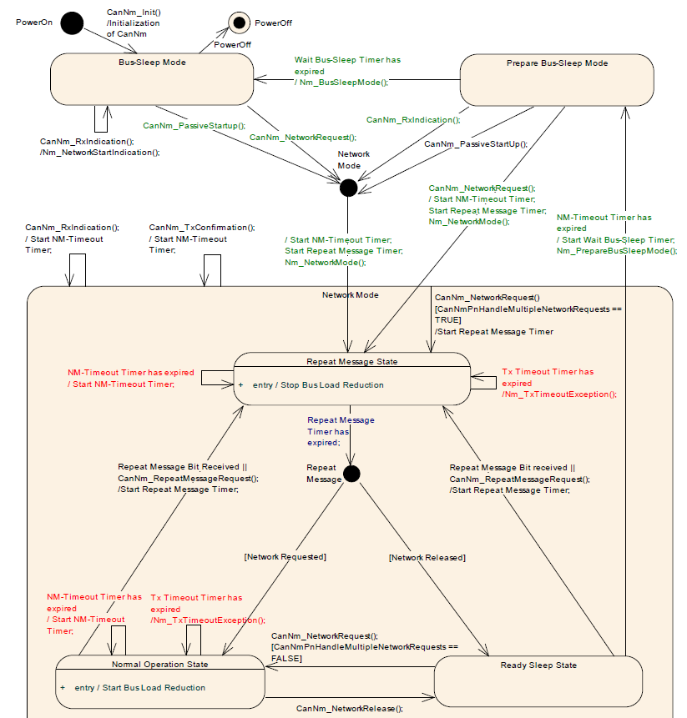

# NM Time Sequence

In Requirement ,it define network management time exchange sequence, like below

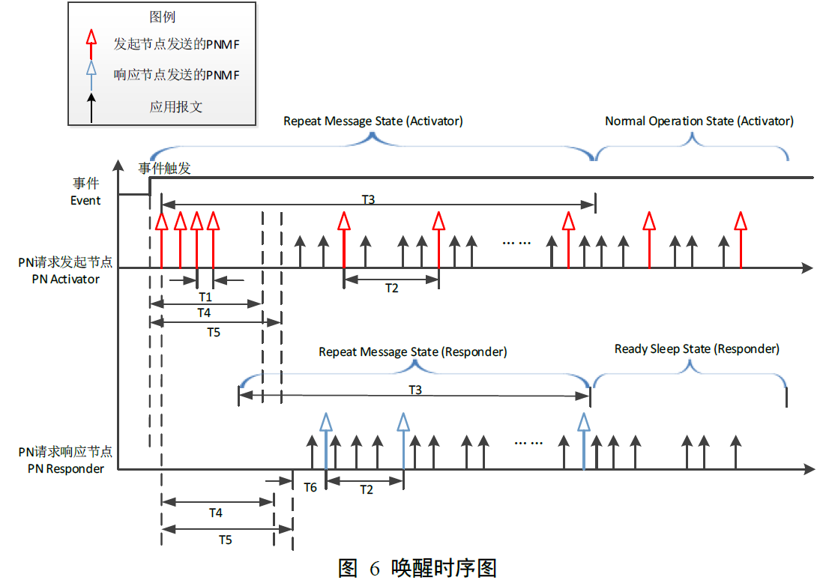

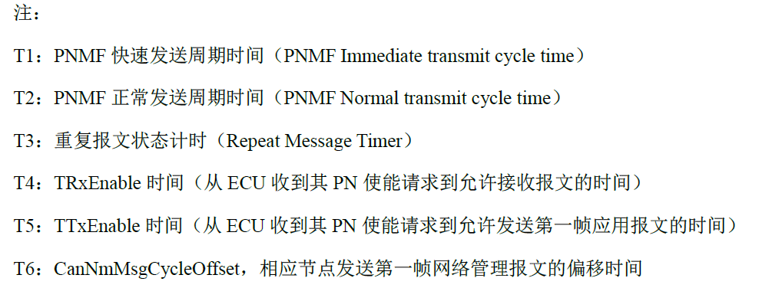

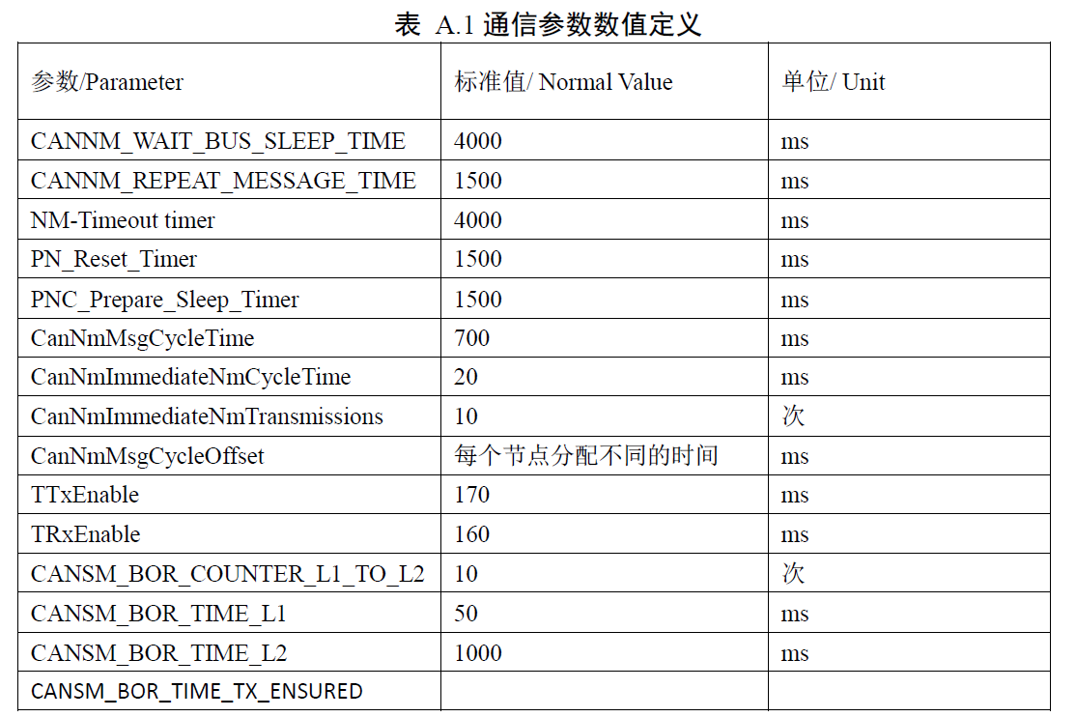

In EB configuration , we support this requirements.

