## Problem 1

|  |
| --- |
|  |

某气象观测站测得某日6：00~18:00之间每隔2小时的室内外温度（ºC）如实验表所示，试用三次样条插值分别求该日室内外6:30~17:30之间每隔2h各点的近似温度。

|  |  |  |  |  |  |  |  |
| --- | --- | --- | --- | --- | --- | --- | --- |
| 时间h | 6 | 8 | 10 | 12 | 14 | 16 | 18 |
| 室内温度t1 | 18.0 | 20.0 | 22.0 | 25.0 | 30.0 | 28.0 | 24.0 |
| 室外温度t2 | 15.0 | 19.0 | 24.0 | 28.0 | 34.0 | 32.0 | 30.0 |

### MATLAB Code

|  |  |
| --- | --- |
|  | |
| 1  2  3  4  5  6  7  8  9  10  11  12  13  14 | *%% problem 1*  t = 6:2:18;  T1 = [18.0  20.0    22.0    25.0    30.0    28.0    24.0];  T2 = [15.0  19.0    24.0    28.0    34.0    32.0    30.0];  tq = 6:0.5:18;  T1q = spline(t,T1,tq);  T2q = spline(t,T2,tq);  T1q(2:4:24)  T2q(2:4:24)  clearvars t T1 T2 tq T1q T2q |
|  | |

### Output

|  |  |
| --- | --- |
|  | |
|  | ans =  18.5020 20.4986 22.5193 26.3775 30.2051 26.8178  ans =  15.6553 20.3355 24.9089 29.6383 34.2568 30.9594 |
|  | |

## Problem 2

已知lgx在[1,101]区间10个整数采样点的函数值如表所示：试求lgx的5次拟合多项式p(x)，并绘制出lgx和p（x）在[1,101]区间的函数曲线。

|  |  |  |  |  |  |  |  |  |  |  |  |
| --- | --- | --- | --- | --- | --- | --- | --- | --- | --- | --- | --- |
| x | 1 | 11 | 21 | 31 | 41 | 51 | 61 | 71 | 81 | 91 | 101 |
| lgx | 0 | 1.0414 | 1.3222 | 1.4914 | 1.6128 | 1.7076 | 1.7853 | 1.8513 | 1.9085 | 1.9590 | 2.0043 |

### MATLAB Code

|  |  |
| --- | --- |
|  | |
| 1  2  3  4  5  6  7  8  9  10  11  12  13  14  15  16  17  18  19 | *%% problem 2*  x = 1:10:101;  lgx = [0    1.0414  1.3222  1.4914  1.6128  1.7076  1.7853  1.8513  1.9085  1.9590  2.0043];  p = polyfit(x,lgx,5);  xx = 1:0.5:101;  poly5lgx = zeros(1,length(xx));  *for* i = 1:6      poly5lgx = p(i)*xx.^(6-i) + poly5lgx;  *end*  plot(xx,poly5lgx,'k','LineWidth',1.2);hold on  plot(x,lgx,'ro');grid on  legend('5次多项式拟合','采样点');  xlim([0,101]);  clearvars x xx lgx poly5lgx p i |
|  | |

### Output

5次拟合多项式系数（降幂）分别为

0.0000 -0.0000 0.0001 -0.0058 0.1537 -0.1326

绘制曲线如下

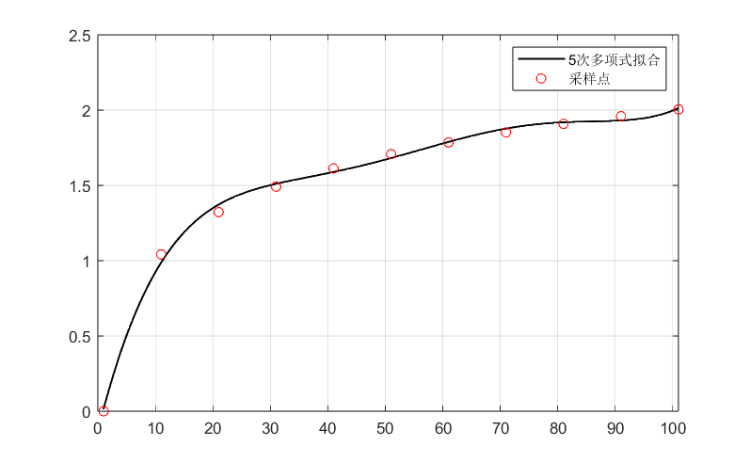

## Problem 3

有3个多项式，



试进行下列操作：（1）求



（2）求P（x）的根

（3）当x取矩阵A的每一个元素时，求P（x）的值，其中：



（4）当以矩阵A为自变量时，求P（x）的值，其中A的值与第（3）题相同。

### MATLAB Code

|  |  |
| --- | --- |
|  | |
| 1  2  3  4  5  6  7  8  9  10  11  12  13  14  15  16  17  18  19  20  21  22  23  24 | *%% problem 3*  poly1 = [1 2 4 0 5];    *% P1 = x^4+2x^3+4x^2+5*  poly2 = [1 2];          *% P2 = x + 2*  poly3 = [1 2 3];        *% P3 = x^2 + 2x + 3*  *% problem 3-1*  poly = poly1 + [0 conv(poly2,poly3)]  *% problem 3-2*  roots(poly)  *% problem 3-3*  A = [-1         1.2     -1.4;       0.75       2       3.5;       0          5       2.5];  polyA = zeros(1,9);  *for* i = 1:9      polyA(i) = polyval(poly,A(i));  *end*  polyA  *% problem 3-4*  polyvalm(poly,A) |
|  | |

### Output

|  |  |
| --- | --- |
|  | |
|  | poly =  1 3 8 7 11  ans =  -1.3840 + 1.8317i  -1.3840 - 1.8317i  -0.1160 + 1.4400i  -0.1160 - 1.4400i  polyA =  1.0e+03 *  0.0100 0.0223 0.0110 0.0382 0.0970 1.2460 0.0125 0.4122 0.1644  ans =  1.0e+03 *  0.0076 -0.1281 -0.0775  0.1328 1.3900 1.1644  0.1824 1.7364 1.5198 |
|  | |