In the name of ALLAH

Big communication companies investments and projects on blockchain

In this part we look further to those companies which was mentioned before

1.first we look at china :

KEY POINTS

* China, once seen as an imitator when it came to technology, is now looking to become a global leader in areas from blockchain to artificial intelligence (AI).
* At East Tech West, CNBC’s premier technology conference held in the Nansha district of Guangzhou, China, the AI, blockchain, fintech and the future of smartphones will be among the topics discussed.
* China has turned on its next-generation 5G mobile networks while President Xi Jinping threw his weight behind blockchain technology.

Reference : <https://www.cnbc.com/2019/11/15/china-technology-trends-from-blockchain-to-ai-and-fintech.html>

In other hand almost there are against blockchain;

Chinese President Xi Jinping has called for the stepped-up development of blockchain technology in the country.

But even if the People’s Bank of China (PBoC) is considering coming up with its own digital currency, it is “neutral” towards the technology that underpins the virtual money, a PBoC official said.

In fact, if the digital currency ever materializes, it may not be powered by blockchain, also known as distributed ledger technology (DLT), because the decentralized aspects of the technology do not favor monetary policymaking, the official said.

The PBoC said it has been exploring the possibility of issuing a digital currency as an alternative to cash, and market observers expect it to be launched in the next few months, making China the first country to roll out a digitized domestic currency.

During a panel discussion at the Hong Kong FinTech Week 2019 on Wednesday, Mu Changchun, deputy director-general of the PBoC’s Institute of Digital Currency, said the project initially started with the objective of safeguarding China’s currency sovereignty at a time when Bitcoin was starting to make waves in the market.

Authorities also wanted to provide “a universal payment instrument” for the nation amid a fragmented mobile payment market.

“Our prototype was actually based on pure DLT, but then we found that the DLT is not suitable for our [central bank digital currency or CBDC],” said Mu.

Although President Xi, in his recent remarks, highlighted the importance of blockchain technology to the nation, Mu cited the weaknesses of the technology, such as those pertaining to scalability, network storage capacity, interoperability, security and privacy.

He said China’s digital currency electronic payment (DCEP) seems to have little to gain from the decentralized aspects of blockchain, which is an important element of the technology underpinning cryptocurrencies like Bitcoin.

“As the central bank, we have to run a centralized system. Because we have to be in control of the whole monetary policy issues and macroeconomic potential issues, we have to keep centralized operations,” he said, “[But] for DLT, it naturally has the characteristic of decentralization.”

Mu said the central bank is “neutral” towards the technology used to power the digital currency, which will not be dependent on a sole technology platform.

He said that was likely to create a “horse race” on the use of technology when it is launched as commercial banks and other institutions would compete to provide the best services using the new form of money.

The idea behind the digital currency is to enable anyone, across and beyond the nation, who don’t have an account in the Chinese banks, to use a digital wallet and enjoy mobile payment services in China, Mu said.

Currently, Alibaba’s Alipay and Tencent’s WeChat Pay are the two major players in China’s mobile payment sector, accounting for over 90 percent of the market.  China’s proposed digital currency is expected to curb their dominance.

Mu, however, said he could only see a synergy between the digital currency and the two mobile payment services, rather than competition. “We just change their payment instrument from the commercial banks’ deposit money to the central bank’s money,” he said. “We are not changing their use cases, their service will remain the same.”

Social media giant Facebook is also planning to create its own digital currency called Libra, which could compete with China’s CBDC, especially in emerging markets.

Mu acknowledged that “stablecoins” like Libra would definitely present “a threat to the implementation of monetary policies and financial stability, especially for those countries with [weak] capital management and less strong sovereign currencies”.

There is also the issue of “supervisory arbitrage” as most of the members of the Libra Association, which will govern and run the Libra crypto-based payment network, are located in the United States, he said.

“All central banks should consider putting the [Libra] project under the close supervision of central banks or international supervisory organizations, at least,” Mu said.

Asked about regulating Libra if it enters China, Mu said that the nation already issued a statement back in 2017 “that all [initial coin offerings or ICOs] and crypto-assets [are] Ponzi schemes” and all ICO activities and crypto-asset exchanges are prohibited.

“Also, as Facebook cannot operate in China, I don’t think we have any supervisory issue with Libra,” he added.

<http://www.ejinsight.com/20191108-blockchain-not-suitable-for-china-s-digital-currency-pboc/>

2.another important fact is being successful ; why china seems to be that?

**Reason 1: Establishing the blockchain standard**

China is big on technology innovations and is always trying to be the leader. What we are seeing now with blockchain is the third time the government has promoted certain technology. Previously this was done with 5G and AI and it worked; we saw a boost in the technology across the world. For example, Huawei, one of the largest Chinese companies with the massive power of 76,000 research and development staff and [Q1 2019 revenues of $26 billion](https://www.techradar.com/news/huawei-revenue-soars-despite-us-allegations-and-restrictions), is already implementing the [largest 5G projects in Europe](https://huawei.eu/what-we-do/5g-europe). Now, China is doing the same with blockchain; by declaring it a national priority they will have every Tier 1 and 2 cities implementing their own blockchain and digital assets policies and enforcing the blockchain standard

**Reason 2: Getting an advantage in the trade war with the USA**

It’s no secret to anyone that the trade war talks between China and the United States are not getting any better. After imposing tariffs on exports and agriculture, the battleground is shifting to technology now. China, having lost its largest trading partner, has found itself looking for new export locations in Europe, the Middle East and Africa, mainly around the “Silk Road Economic Belt.” The advantage of having a superior blockchain technology will give China an enormous trading opportunity with the emerging technology markets.

**Reason 3: Digital RMB can be a global currency**

China is going all-in on digital assets and as part of it they are developing Digital Currency Electronic Payments (DC/EP) platform which requires users private information when they sign up but still providing “*controlled anonymity*”.

This is the initiative that aims to develop a Chinese Central Bank Digital Currency (CBDC) issued by the People’s Bank of China (PBoC), backed by fiat reserves and having some transaction anonymity and extensive encryption services. The goal here is to push this new digital yuan to be a global currency. The reality now is that the yuan (RMB), in its current form, is not accessible and liquid on the international foreign exchange markets. For example, for 2018 the foreign exchange reserves consists of [61.74% USD, 20.67% EUR and 1.89% RMB](https://en.wikipedia.org/wiki/Reserve_currency#Global_currency_reserves), so there is definitely room for growth here.

With this new digital RMB, China will be able to offer cross-border payments at a lower cost and with increased speed. Furthermore, using the automation features of smart contracts will provide easier liquidity management and trading efficiency and eventually establish the digital RMB as an upgraded version of the current M0 supply.

**Reason 4 – They want a counterpart for Libra**

When Facebook announced the launch of Libra and that it will work with and be backed by a basket of currencies excluding the RMB, the Chinese government, particularly the leadership of the PBoC, felt excluded and decided to respond. In contrast with the Libra Association, which is established in Switzerland and faces the need to satisfy all the regulators in all countries they want to operate in, potentially risking its existence, the digital yuan initiative has a clear path to launch, coming as a top-down endorsed policy. Everything Libra is trying to achieve looks like it will be much easier to accomplish by China, having the payment rails of UnionPay and AliPay, plus the super-app WeChat’s massive exposure of 1 billion monthly active users and already operating as a digital bank.

After Xi’s announcement, a wave of blockchain initiatives and funding news went public; for example, Hande Financial Technology Holdings (HDFH), based out of Shenzhen, revealed an investment fund of $1 billion targeted for blockchain consortium development. The fund was created by HDFH, the Zhongguancun Private Equity & Venture Capital Association (ZVCA) and Yillion Bank.

All of this is great news for companies focusing on [enterprise blockchain technology](https://www.forbes.com/sites/biserdimitrov/2019/07/08/major-improvements-are-coming-to-blockchain-in-2020/) as it will drastically push it forward and will have a real-world usage at scale. Surprisingly those new advancements will be coming from China rather than the usual blockchain production areas like New York and San Francisco and lastly, they won’t be open-sourced and accessible to the world as we are used to

<http://www.ejinsight.com/20191108-blockchain-not-suitable-for-china-s-digital-currency-pboc/>

3.general case study ; blockchain

CHINA STRUGGLES TO BALANCE DECENTRALIZED NETWORK SECURITY WITH CENTRAL CONTROL China takes a unique approach to blockchain technology, eager to exploit its potential and yet, at the same time, to centralize control over this genuinely decentralized technology. China’s Cyberspace Administration (CAC) published new regulations in February 2019 requiring all blockchain companies to register their users and to hand personal data and activity sheets over to the authority on request. The PRC banned international crypto-currencies in 2017 because of their potential to destabilize the financial system. Raising funds for new cryptocurrency projects is prohibited,46 and a committee has been tasked with detecting fraudulent blockchains. Activities and motives: Harnessing private sector innovation President Xi Jinping called blockchain “a breakthrough technology” in May 2018; a month later a CCTV2 documentary described blockchain as 10 times more valuable than the internet. There is a blockchain educational guide for officials, and the People’s Bank of China (PBoC) has published several white papers on blockchain. Chinese private investors and companies practically ran the Bitcoin business by themselves until a clampdown in 2017. Between 2010 and 2018, average funding for blockchain projects was higher in China than anywhere else (25 million USD)47. Today, the private sector is being increasingly replaced by local governments. Authorities in the eight biggest blockchain hubs have set aside 3.57 billion USD for project development since 2016.48 Achievements: Catching up and expanding the spectrum of applications The race for technological leadership in blockchain technology is a close one: the United States outstrips all other countries in the number of startups and total funding of blockchain companies. However, a recent survey of international tech executives found most respondents saw China as the emerging blockchain leader.49 China ranks third in total blockchain-related spending by region.50 Chinese companies filed more than half of blockchain patents worldwide in 2017 (225 out of 406). Many applications are being pioneered in China: Chancheng district civil administration with 1.3 million residents in Guangdong Province has been lifted onto a blockchain. A recent addition was the so-called community correction application (区块链+社区矫正), which tracks and evaluates the movement of former prison inmates. Since September 2018, China’s Supreme Court has accepted evidence in legal disputes on blockchain. Perhaps the most notable project is the PBOC’s ongoing attempt to develop crypto RMB in order to establish a “cashless society”. China’s large numbers of blockchain personnel is likely its greatest strength. Although some people left after international crypto-currencies were banned, the majority stayed and now form a workforce of highly specialized engineers. Organizations in China are hiring more staff with blockchain experience51 than anywhere else. Case studies MERICS | PAPERS ON CHINA No 7 | 31 Challenges: Finding a suitable level of political control The biggest obstacle to the establishment of blockchain technologies over a wide range of sectors is the CCP’s uncertainty: Its policies veer between protectionist measures and development stimuli. Companies are hesitant to develop successful applications further and are waiting for policy normalization.52 Interaction with international tech circles has become more difficult since international blockchains were banned in China. Domestic specialists must therefore become self-reliant to find solutions. The current approach of exerting central control over blockchains (which are decentralized by inherent design) could lead to interoperability issues and less robust algorithms. Isolation makes future conflicts over blockchain standards almost inevitable. Some challenges are already visible on the horizon: the data that blockchain companies must register with the CAC can potentially be scrutinized by China’s authorities at any time. Governments and citizens of other countries interacting with Chinese blockchains may soon face a similar dilemma as in the 5G question and will have to decide whether to sacrifice data security for economic benefits. Some observers believe that a blockchain with Chinese characteristics similar to the self-enclosed Chinese internet, is already in the making.

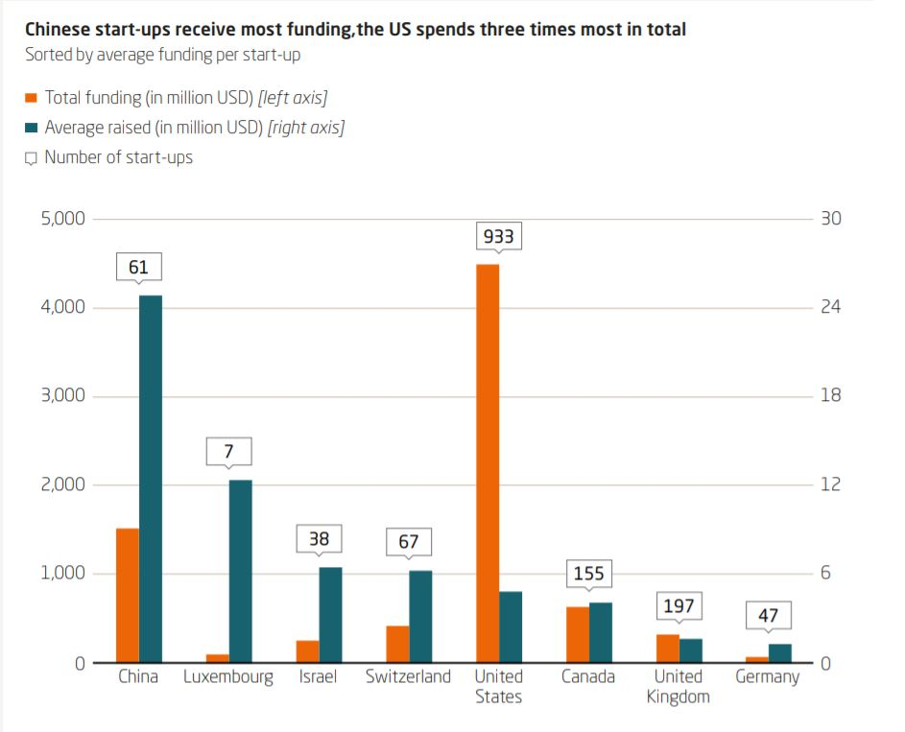

<https://www.merics.org/sites/default/files/2019-04/MPOC_No.7_ChinasDigitalRise_web_4.pdf>

4. china mobile

At [**Digital Transformation Asia**](https://dta.tmforum.org/) (November 12-14: Kuala Lumpur) they will showcase the technological and process requirements which would enable such a system and demonstrate various use cases which highlight the benefits for each of the stakeholders in the platform ecosystem – the CSP, partners and developers, and the end-users themselves.

The platform could also allow other third-party companies to provide their APIs and onboard in the marketplace.The *DAPP-based Capability Exposure and Marketplace* Catalyst will show:

* How CSPs can expose network capabilities such as end-to-end assurance, data analytics, security, and charging and billing, etc. via APIs as digital assets in a blockchain and onboard them in the marketplace
* How partners and developers can find the necessary APIs and build decentralized applications easily, then onboard the DAPPs in the marketplace
* How end users can find the most useful DAPPs easily from the marketplace
* How payments can be settled among CSPs, partners and end-users based on smart contracts and tokens

For example, the APIs could be used to develop and test tools such a ‘top-up’ application which allows the end-user (such as a gaming company) to increase network resources to meet demand or gamers themselves to increase data to reduce latency. The DAPP could be embedded on e-commerce websites or within a gaming app.

“This Catalyst is innovative because carriers have not so far leveraged blockchain technology for capability exposure for the creation of DAPPs, said Mujin Liu, senior product manager, HPE. “It gives CSPs a new way to participate in the decentralized economy.”

**Trust built in**

The platform will allow telcos to make their APIs available to developers and settle payments automatically using tokens via smart contracts – this ensures trust for all stakeholders and will allow CSPs to drastically scale the number of partners they can work with by removing manual settlements.

Further, CSPs can offer rewards to developers who create apps which generate a significant number of API calls or onboard high numbers of end-users. They could either provide more tokens to the developer to give them some API calls free of charge or they could offer ‘superstar developers’ access to additional premium APIs. This gamification incentivizes developers to not only create apps but to promote usage too, increasing the benefits for all in the ecosystem – the ‘network effect’.

**Under the hood**

The architecture is based on three layers as below:

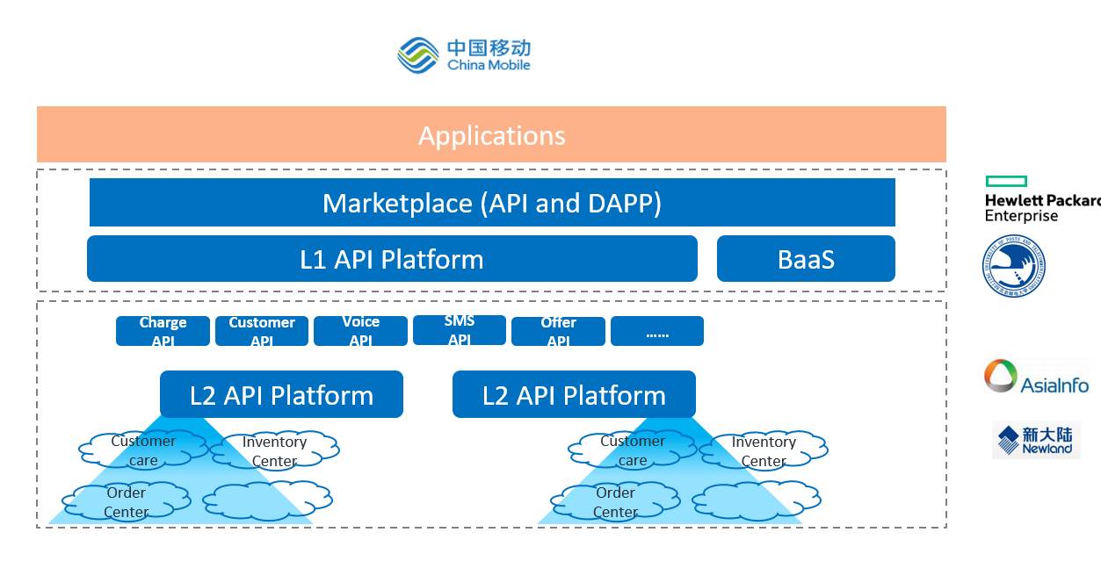

It supports [**functional programming**](https://en.wikipedia.org/wiki/Functional_programming) to speed up and simplify app development and deployment.

The platform is based on and will contribute back to TM Forum’s collaborative tools and best practices, particularly the [**Open API program**](https://www.tmforum.org/open-apis/).

The team is using the following TM Forum APIs: Product catalog, Product ordering, Customer management, Appointment and Party management.

Their work will provide some key extensions back for the benefit of the whole TM Forum membership community, including new hierarchical structure information for the Product Catalog API.

The team is also creating a whitepaper which will help other telcos benefit from this new blockchain use case.

See the Catalyst in Action at [**Digital Transformation Asia**](https://dta.tmforum.org/) (12-14 November: Kuala Lumpur).

TOP Network;

<https://hackernoon.com/four-ways-blockchain-technology-will-disrupt-telecommunications-48357404928c>

In March of this year, Jeff Bezos, founder of Amazon, unseated Bill Gates for the position of[richest man in the world](https://www.forbes.com/billionaires/#4ddc36c4251c). The feat was the result of a massive $40 billion jump in net worth — the largest ever,[according to Forbes](https://www.forbes.com/sites/cartercoudriet/2018/03/08/jeff-bezos-nearly-40-billion-net-worth-jump-is-the-biggest-increase-this-century/).

With Bezos, Zuckerberg and others reaching the uppermost echelon of wealth, it’s easy to forget the days when the dot.com bubble burst, and companies like Amazon were the pariahs of the stock market. The move from the bottom to the top reflects both the fickle public sentiment of investors, and the underlying fundamental value that made Amazon what it is today.

In a similar vein perhaps, the Bitcoin bubble has officially burst. Dropping nearly 80% from its highs at the end of 2017, the first and greatest cryptocurrency has come on tough times.

**Fundamentals are key**

Nevertheless, the underlying fundamental value that made Bitcoin boom and bust may someday create the next Jeff Bezos. Blockchain technology, the foundation that Bitcoin is built on, has already received [substantial accolades](https://www.forbes.com/sites/bernardmarr/2016/05/27/how-blockchain-technology-could-change-the-world/#59e4832b725b) in the press.

As a distributed ledger (think of a secure database shared over thousands of different computers), blockchain technology provides unique ways to solve problems that are facing various industries, from banking to logistics. In recent developments, both [Facebook](https://www.forbes.com/sites/andrewarnold/2018/05/29/how-social-media-can-benefit-from-blockchain-technology/#111b8edb1018) and [Amazon Web Services](https://www.forbes.com/sites/soorajshah/2018/11/28/aws-finally-buys-into-blockchain-hype-with-two-new-products/#a8d2aec6f617.)are considering blockchain solutions. But perhaps nowhere is the potential for change more clear than in the communications industry.

The very nature of blockchain — secure, distributed information made accessible through private keys — provides a solution to the common speed/security problems facing communications. Below are four ways that blockchain technology will disrupt the way consumers and businesses think about and use communications systems going forward.

**Secure Messaging**

One of the first issues with all technology, and particularly with communications, is security. [Recent developments](https://www.forbes.com/sites/laurencebradford/2018/03/30/why-people-should-learn-about-cybersecurity-in-2018/#767fc6225d00) in the cybersecurity industry have made this a ubiquitous issue for consumers and corporations alike.

According to Gordon Yilin Lu, the Deputy Chairman of Instanza Inc. and owner of SOMA Messenger, “The telecommunications industry is evolving at the speed of technology. A major concern for the media and communications industry is a responsibility to adapt to the preferences of the community. People worry about their private data being sold by the large social media platforms like Facebook. The future is about privacy and social awareness.”

However, blockchain technology, like that offered by SOMA, provides an elegant solution to this apparently insurmountable problem. By decentralizing data, the technology provides a way for only intended users to access any set of data. And new messaging systems have begun to capitalize on this powerful concept.

Lu continues, “Blockchain technology provides a secure solution to these communication problems faced by large platforms because information is only released with private keys. That’s why SOMA is currently integrating blockchain technology to provide encrypted messaging and a crypto wallet designed to reward users for their engagement, and at the same time protect the privacy and contribution of users.”

**Enterprise-level Communications**

[TOP Network](https://www.topnetwork.org/), a Sunnyvale-based blockchain startup, is building the world’s first decentralized cloud communication network on the blockchain. Individuals and organizations can contribute their idle resources (such as a spare server in a data center) to the network, and receive rewards based on their contribution. The company is creating a transparent sharing economy where all telecom operators and service providers around the world can share resources and serve customers. The consensus mechanism, which is a series of mathematical algorithms accepted by all participants on the blockchain-based networks, can reward participants fairly by measuring their contribution to the network.

By allowing resource and service providers around the world to join the network transparently via blockchain technology, the company is able to build in much wider coverage and higher-quality services at lower prices than any single telecom operator can achieve in the upcoming 5G era. The blockchain-powered sharing economy can decentralize the physical footprint of the network, freeing the company from passing on costly overhead to its users.

Additionally, the security offered by blockchain technology is substantially more robust, and the blockchain startup is looking to build on that foundation.

According to Steve Wei, CEO of TOP Network, “When it comes to data security in the communication sector, blockchain technology can raise the bar higher. On a blockchain-version Facebook, users will be more comfortable posting on their timelines as no centralized organization can control their information. Because the data decentralized in nodes across the entire network, it is virtually impossible for hackers to tamper with data or governments to censor contents.”

Finally, through a decentralized cloud communication network, blockchain technology is able to create seamless integrations between applications. This greatly reduces the complexity of communication.

“For example, an iMessenger user cannot interact with a WhatsApp user directly, but blockchain can break the boundary between different social communication apps. TOP Network, for instance, creates a standard communication protocol to make all the decentralized apps in its ecosystem interoperable. The interoperability realized with blockchain can facilitate Internet of Things, which requires the seamless connection of various apps and devices,” says Steve Wei.

**Secure VoIP**

While communications providers and consumers are seeking security and speed, they are also pursuing cost effectiveness. Already a vastly cheaper option that customary telephony, Voice over Internet Protocol, or VoIP, has a genuine future as a decentralized network system.

Current VoIP solutions require a centralized ‘landing point’ which routes the calling party’s signal to a receiving number. Generally, a centralized system requires fees for making those connection (think of a traditional phone operator), even if the system is digitized.

However, blockchain technology removes that centralized access point and replaces it with a distributed network that is shared by all the users on the network. This means that there is never a routing cost, as all routes are already established by the distributed ledger.

Additionally, security is maintained via the distribution, and speed of data transfer is maximized. The [TOP Network](https://www.topnetwork.org/) has just such a solution in place, as do other companies like [ENUMER](https://medium.com/@emer.tech/voip-made-free-with-blockchain-introducing-enumer-35235c4abec5). These networks create viable solutions for companies to have effectively free telecommunications with equal or better security than their traditional counterparts.

**CDNs**

Finally, blockchain technology is creating a helpful solution for content delivery networks (or CDNs). Since the internet is really just an interconnected group of servers, for data to travel globally, it must pass through CDNs.

These provide a critical service for information transfer, but also represent an intrinsic cost for data transfer, as well as a weak point of security risk.

Blockchain technology provides a methodology for optimizing unused bandwidth from servers all over the world and links them together into a complex nest of servers which are able to move data seamlessly throughout the world. And, because the data is all distributed and can only be accessed via private keys, such system provides maximal security for users.

A number of companies have already created just such a network, built on blockchain technology, and able to move data internationally for those who use their network. For example, [Gladius](https://gladius.io/product" \t "_blank)(Latin for a Roman foot soldier)**,**a decentralized CDN company, has recently released just such a system. Users can sell their unused bandwidth, and also purchase bandwidth for DDoS ([distributed denial of service](https://en.wikipedia.org/wiki/Denial-of-service_attack)) attacks.

Because blockchain technology decentralizes those points of bandwidth, any single server crash or service interruption can be almost instantly healed by rerouting through the many thousands of other nodes, or points on the network. Therefore, even from a reliability perspective, blockchain is solving CDN related issues.

As these examples show, the underlying fundamentals of blockchain technology promise to create a fast, simple and secure way of communicating. Because the distributed information is both secure and accessible, the technology provides a unique solution for bringing speed and security together.

The bubble/bust cycle of technology is nothing new. Because new technological innovations are exciting, investments flow in and move a market like a traditional bubble. However, with blockchain, like its dot.com predecessor, it seems the technology is here to stay

Messaging apps!

Encrypted messaging app [Telegram](https://www.cbinsights.com/company/telegram) raised [$1.7B from private investors](https://techcrunch.com/2018/05/03/telegrams-billion-dollar-ico-has-become-a-mess/) before canceling the public sale of its planned $1.2B initial coin offering (ICO). Around a year later, the company launched the test client for its blockchain-based TON (Telegram Open Network). Telegraph’s TON Labs has also partnered with Wirecard, a European financial services entity, to build a digital banking platform.

Chat platform [Kik](https://www.cbinsights.com/company/kik) has [raised over $100M](https://techcrunch.com/2017/09/26/kik-ico-100-million/) via an ICO for its in-app currency. And [Line](https://www.cbinsights.com/company/line), Japan’s most popular message service, is reportedly [planning](https://www.bloomberg.com/news/articles/2018-01-30/line-is-said-to-plan-expansion-into-crypto-trading-and-insurance) to expand into cryptocurrency trading.

Different investments on blockchain ;

This [pdf](cz-2018-deloitte-global-blockchain-survey.pdf) file compare exising different industries;

Available path for blockchain throughout of telecom and media;

<https://www2.deloitte.com/us/en/insights/industry/telecommunications/blockchain-telecom-media-entertainment.html>

more blockchain big companies invest in blockchain;

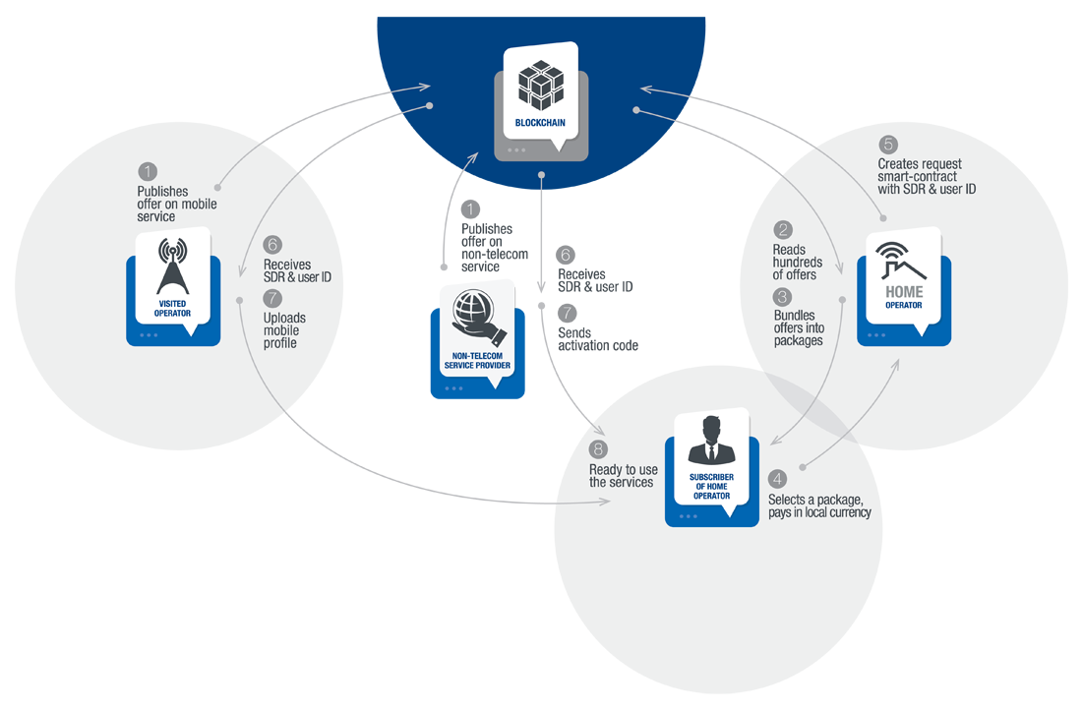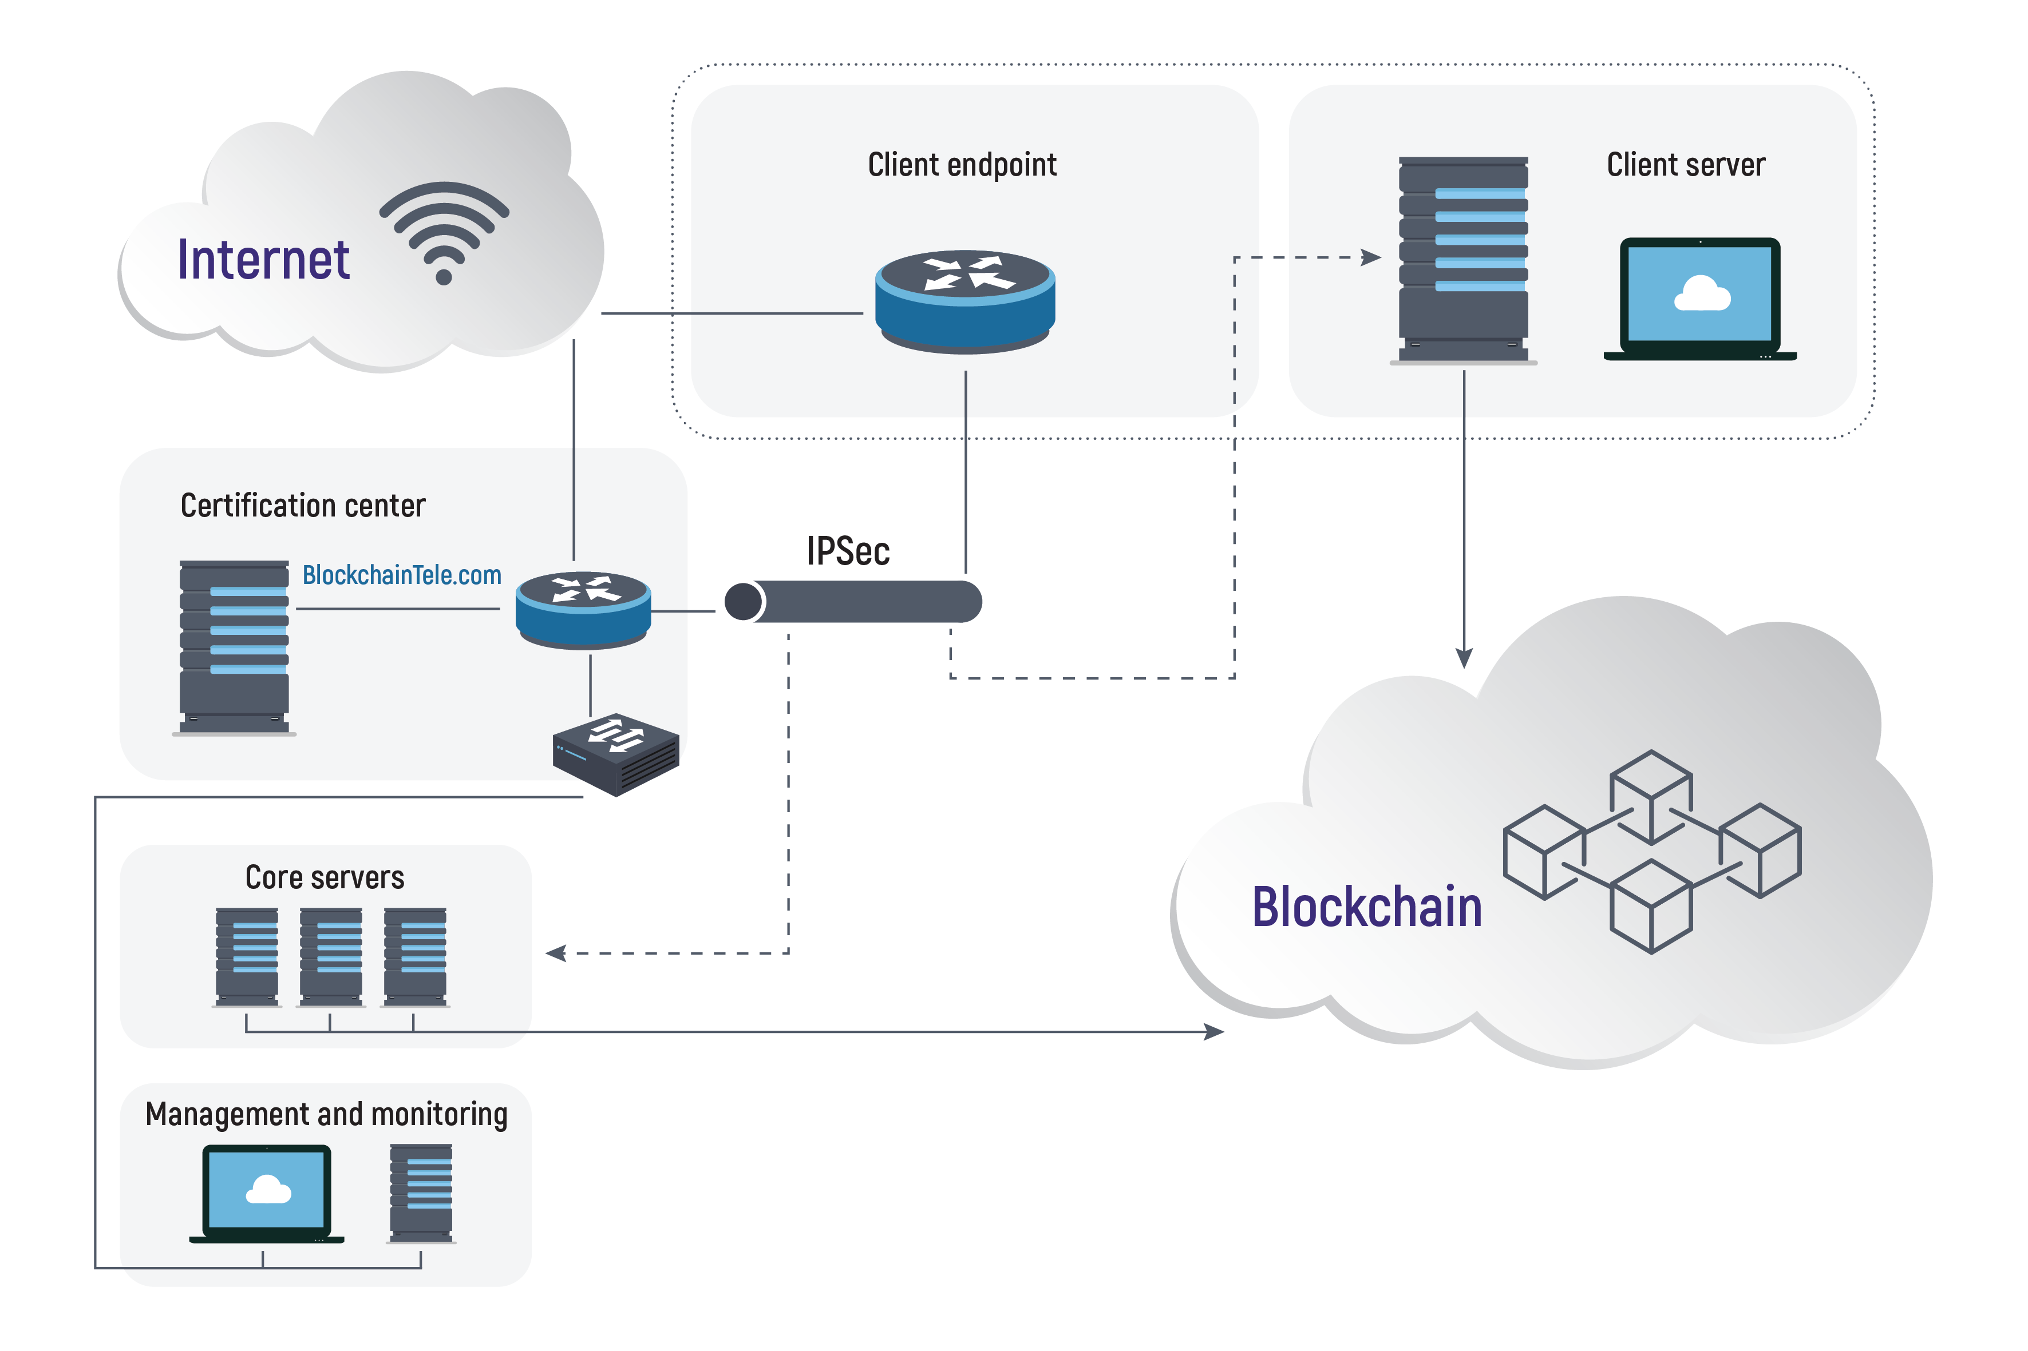

<https://www.forbes.com/sites/michaeldelcastillo/2018/07/03/big-blockchain-the-50-largest-public-companies-exploring-blockchain/#7690258b2b5b>