**AI-Generated Multiple Choice Questions from  
RadioGraphics Top 10 Reading List  
(Gastrointestinal Imaging - R4)**

# Question 1:

A 65-year-old man presents with right upper quadrant pain and weight loss. Based on the findings in the provided figure, which of the following is the most likely diagnosis?

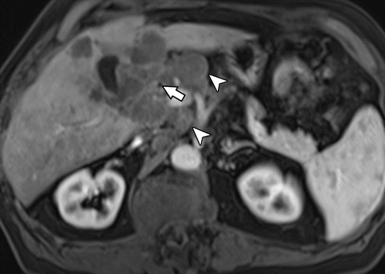

A: Gallbladder adenocarcinoma with liver invasion and extensive lymphadenopathy

B: Primary lymphoma of the gallbladder

C: Exophytic hepatocellular carcinoma

D: Pericholecystic abscess due to perforated cholecystitis

E: Metastatic liver lesion

# Answer:

A. Gallbladder adenocarcinoma with liver invasion and extensive lymphadenopathy. The figure shows a gallbladder mass invading the liver with extensive lymphadenopathy, which is a typical presentation of gallbladder adenocarcinoma. The patient's age, symptoms, and the presence of a gallbladder mass with liver invasion and lymphadenopathy are all consistent with this diagnosis. Primary lymphoma of the gallbladder (option B) is exceedingly rare and would typically involve the submucosa, which is not mentioned in the figure caption. Exophytic hepatocellular carcinoma (option C) and metastatic liver lesion (option E) are less likely given the specific gallbladder mass and lymphadenopathy shown in the figure. Pericholecystic abscess due to perforated cholecystitis (option D) is typically associated with acute symptoms, not the chronic to subacute symptoms seen in this patient.

---Source:

Gallbladder Carcinoma and Its Differential Diagnosis at MRI_ What Radiologists Should Know

---Original Figure Caption:

Figure 6b.Suspicious lymph nodes in a 65-year-old man with right upper quadrant pain and weight loss.(a, b)Axial T2-weighted image(a)and early contrast-enhanced T1-weighted image(b)show a gallbladder mass (arrow) invading the liver with extensive lymphadenopathy, including paraceliac nodes (arrowheads).(c)Axial contrast-enhanced T1-weighted image shows a ring-enhancing liver lesion (arrow) from metastasis.

# Question 2:

A 55-year-old male patient presents with persistent upper abdominal pain. A CT scan was performed and the coronal reformatted image is provided. Based on the figure, which of the following best describes the tumor stage and its implications?

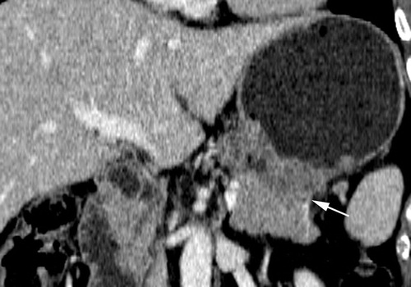

A: Stage T1 tumor with focal nontransmural enhancement in the upper body of the stomach

B: Stage T2 tumor with a localized, transmurally enhancing ulcerative mass without perigastric extension in the lower body of the stomach

C: Stage T3 tumor with gross infiltration of the perigastric fat tissue in the antrum of the stomach

D: Stage T4 tumor with invasion of the colon and accompanied by obliteration of the fat plane and thickening of the colonic wall

E: Stage T4 tumor infiltrating the distal pancreatic body

# Answer:

The correct answer is E, Stage T4 tumor infiltrating the distal pancreatic body. According to the figure caption and context, a Stage T4 tumor represents advanced cancer with gross infiltration of adjacent organs. In this case, the tumor is infiltrating the distal pancreatic body. This stage of cancer makes surgery difficult due to the extensive invasion into adjacent structures. Furthermore, with massive tumor invasion, there is little possibility of resection. The other options A-D are incorrect as they do not match the findings in the provided figure. Options A and B describe earlier stages of the tumor which are limited to the gastric wall and do not show infiltration into adjacent organs. Option C describes a stage T3 tumor which shows infiltration into the perigastric fat tissue but not into adjacent organs. Option D describes a stage T4 tumor, but it describes invasion of the colon, not the distal pancreatic body as seen in the figure.

---Source:

CT and PET in Stomach Cancer_ Preoperative Staging and Monitoring of Response to Therapy

---Original Figure Caption:

Figure 1e.Stage T1–T4 gastric tumors.(a)Coronal reformatted image shows a stage T1 tumor (arrows) with focal nontransmural enhancement in the upper body.(b)Axial CT scan shows a stage T2 tumor (arrow), a localized, transmurally enhancing ulcerative mass without perigastric extension, in the lower body.(c)Coronal reformatted image shows a stage T3 tumor (arrows), with gross infiltration of the perigastric fat tissue in the antrum.(d)Axial CT scan shows a stage T4 tumor with invasion of the colon. The tumor represents an advanced cancer of the antrum and is accompanied by obliteration of the fat plane and thickening of the colonic wall (arrows).(e)Coronal reformatted image shows a stage T4 tumor (arrow) infiltrating the distal pancreatic body.(f)Axial CT scan shows a stage T4 tumor (arrows), an advanced cancer with gross infiltration of the lateral segment of the liver.

# Question 3:

A 49-year-old woman presents with abdominal pain, weight loss, nausea, and jaundice. A coronal CT image of the abdomen is provided. Based on the imaging findings, which of the following is the most likely diagnosis?

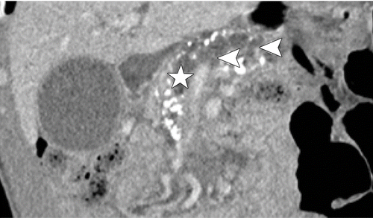

A: Acute pancreatitis

B: Chronic pancreatitis

C: Pancreatic ductal adenocarcinoma (PDAC)

D: Gallstones

E: Pancreatic cyst

# Answer:

The correct answer is C. Pancreatic ductal adenocarcinoma (PDAC). The figure shows a dilated pancreatic duct and side branches, which is seen in 80% of tumors in the head of the pancreas and in 50% of tumors in the body of the pancreas. This is a classic finding of PDAC. Additionally, the patient's clinical presentation of abdominal pain, weight loss, nausea, and jaundice commonly overlap with the patient history and risk factors of PDAC. Therefore, based on the imaging findings and the clinical presentation, the most likely diagnosis is PDAC.

---Source:

Chronic Pancreatitis or Pancreatic Tumor_ A Problem-solving Approach

---Original Figure Caption:

Figure 6b.PDAC and chronic pancreatitis in a 49-year-old woman.(a)Axial CT image shows an ill-defined and slightly hypoattenuating mass in the pancreatic head (circle), peripheral displacement of calcifications (yellow arrow), an SMA-to-SMV (red and blue arrows, respectively) ratio of almost 1, and a teardrop sign in the SMV. The perivascular fat planes are invaded by the mass (white arrow).(b)Coronal CT image shows the dilated pancreatic duct (☆) and side branches (arrowheads).(c)Axial CT image shows the dilated common bile duct (double arrows).

# Question 4:

A 63-year-old woman presents with an incidentally found polypoid gallbladder lesion. An axial T2-weighted image is provided in the figure. Based on the figure and the context, which of the following is the most likely diagnosis?

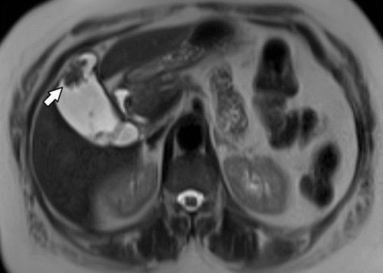

A: Gallbladder metastases from melanoma

B: Acute cholecystitis

C: Gallbladder carcinoma

D: Chronic cholecystitis

E: Adenomyomatosis

# Answer:

The correct answer is C, Gallbladder carcinoma. The figure caption describes a hypointense polypoid gallbladder lesion in a 63-year-old woman, which is characteristic of gallbladder carcinoma. Additionally, the context explains that gallbladder carcinoma often manifests as a polypoid lesion and can be incidentally detected at imaging studies. The other options are less likely: Gallbladder metastases from melanoma (Option A) are usually discovered only at autopsy or incidentally at imaging, but the context does not suggest a history of melanoma. Acute cholecystitis (Option B) and chronic cholecystitis (Option D) may cause symmetric wall thickening, which is not described in the figure caption. Adenomyomatosis (Option E) is a benign cause of gallbladder wall thickening, which also does not align with the figure caption.

---Source:

Gallbladder Carcinoma and Its Differential Diagnosis at MRI_ What Radiologists Should Know

---Original Figure Caption:

Figure 5a.Gallbladder carcinoma in a 63-year-old woman with an incidentally found polypoid gallbladder lesion.(a)Axial T2-weighted image shows a 2.3-cm hypointense polypoid gallbladder lesion (arrow).(b)Axial contrast-enhanced T1-weighted image shows enhancement of the polypoid mass (arrow). The mass was surgically proved to be gallbladder carcinoma (T2NXM0).

# Question 5:

A 64-year-old woman with a history of mucinous adenocarcinoma of the ovary 5 years previously presents with abnormal findings on an axial portal phase CT image. Based on the imaging findings, which type of metastasis is most likely present?

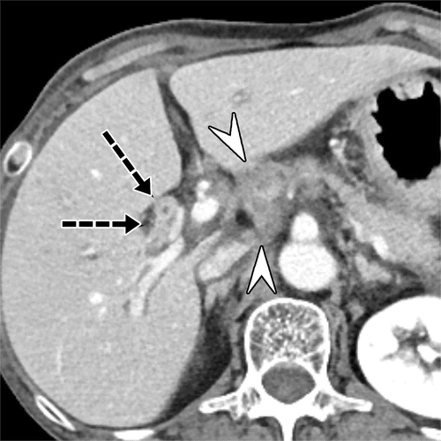

A: Intrahepatic tumor thrombus

B: Intraluminal metastases of the bile duct

C: Biliary epithelium metastasis

D: Extrabiliary epithelium metastases

E: Intrahepatic lymphatic invasion by tumor cells

# Answer:

C: Biliary epithelium metastasis. The image likely shows a case of biliary epithelium metastasis, which is a type of biliary metastasis that involves homogeneous thickening and enhancement of the bile duct. This is often seen in patients with a history of certain types of carcinomas, such as the mucinous adenocarcinoma of the ovary in this patient. The other options are less likely based on the given patient history and the typical imaging findings associated with those conditions.

---Source:

Liver Metastases_ Correlation between Imaging Features and Pathomolecular Environments

---Original Figure Caption:

Figure 21.Biliary epithelium metastasis in a 64-year-old woman with a history of mucinous adenocarcinoma of the ovary 5 years previously. Axial portal phase CT image shows an intrahepatic bile duct (arrows) with diffuse thickening; this was clinically diagnosed as biliary epithelium metastasis. Multiple lymph node metastases (arrowheads) in the hepatoduodenal ligament also are depicted.

# Question 6:

A 52-year-old woman presents with perianal discomfort and discharge. Based on the normal anatomy of the anal canal as shown in the figure, where would you expect to find the anal glands that could be associated with the formation of perianal fistulas?

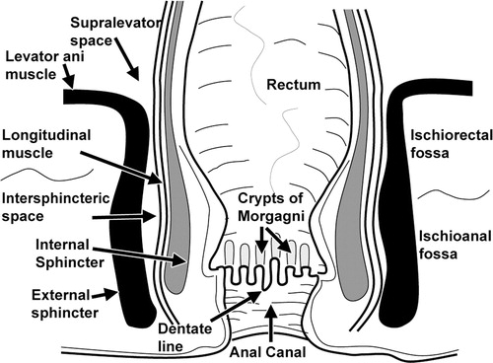

A: At the level of the dentate line

B: Above the anal valves at the base of the crypts of Morgagni

C: In the distal half of the anal canal

D: In the proximal half of the anal canal

E: At the anal verge

# Answer:

The correct answer is B: Above the anal valves at the base of the crypts of Morgagni. The anal glands are branched glandular structures with a stratified columnar epithelium lining. They are evenly distributed around the circumference of the anal canal, with ducts opening into the base of the crypts of Morgagni, located above the anal valves. These glands can be associated with the formation of perianal fistulas, which could explain the patient's symptoms of perianal discomfort and discharge.

---Source:

MR Imaging Evaluation of Perianal Fistulas_ Spectrum of Imaging Features

---Original Figure Caption:

Figure 3Drawing shows the normal anatomy of the anal canal in the coronal plane.

# Question 7:

A 57-year-old woman with a history of pancreatic ductal carcinoma presents with new-onset jaundice. Based on Figure 1, which of the following best describes the role of tumor exosomes in the metastatic progression of her disease?

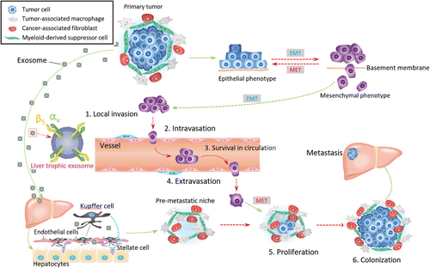

A: They directly cause cell death in the primary tumor

B: They are responsible for the initial invasion of the basement membrane

C: They facilitate the transformation of hepatic stellate cells into cancer-associated fibroblasts and induce liver fibrosis

D: They prevent the extravasation of tumor cells into secondary tissues

E: They block the colonization of secondary tumor sites

# Answer:

C: They facilitate the transformation of hepatic stellate cells into cancer-associated fibroblasts and induce liver fibrosis. According to Figure 1, tumor exosomes derived from the primary cancer contribute to the formation of a premetastatic niche in the liver. These exosomes preferentially fuse with Kupffer cells in the liver, which in turn transform hepatic stellate cells into cancer-associated fibroblasts. This transformation process induces liver fibrosis, creating a favorable environment for the metastatic progression of the disease. The other options are not supported by the information provided in the figure and context.

---Source:

Liver Metastases_ Correlation between Imaging Features and Pathomolecular Environments

---Original Figure Caption:

Figure 1.Tumor microenvironment and premetastatic niche formed by means of tumor exosome effusion during metastasis progression. The tumor microenvironment is composed of tumor-associated macrophages, cancer-associated fibroblasts, and myeloid-derived suppressor cells in addition to tumor cells. Tumor exosomes derived from the primary cancer are seen as small gray circles. A magnification of one exosome is shown together with integrins αv and β5 (left side of figure). The primary tumor antecedently consolidates the microenvironment of the metastatic site by effusing organ-specific exosomes that preferentially fuse with Kupffer cells, which transform hepatic stellate cells into cancer-associated fibroblasts and induce liver fibrosis; this process is formation of a premetastatic niche. Metastatic tumor progression is divided into six major steps:1.Invasion of the basement membrane and cell migration.2.Intravasation into the surrounding vasculature or lymphatic system.3.Survival in the circulation.4.Extravasation from the vasculature to secondary tissues.5.Proliferation at the distant location.6.Colonization at secondary tumor sites.EMT= epithelial-to-mesenchymal transition,MET= mesenchymal-to-epithelial transition.

# Question 8:

A 45-year-old woman presents with a recurrent rectovaginal fistula. Despite multiple attempts at closure, the fistula keeps reopening. You decide to proceed with a procedure. Based on the provided illustration, which of the following steps correctly describes the initial part of this procedure?

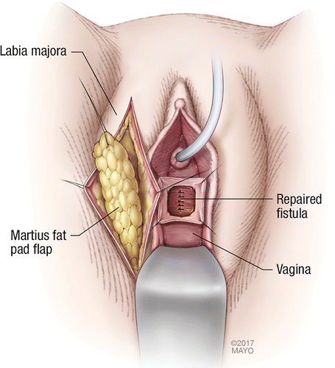

A: An incision is made on the labium minus pudendi to expose the fat pad underneath.

B: An incision is made on the labium majus pudendi to expose the fat pad underneath.

C: A tunnel connecting the pedicle of the fat pad to the rectal opening is formed.

D: The fistula is left open, and a flap is created without ligation.

E: The bulbocavernosus muscle is harvested for the creation of the flap.

# Answer:

B: An incision is made on the labium majus pudendi to expose the fat pad underneath. This step is the initial part of the procedure for creating a Martius flap, as shown in the illustration. This flap is typically used in the treatment of rectovaginal fistulas, especially in cases where previous attempts at closure have been unsuccessful. The labium majus pudendi is chosen for the incision because it contains a substantial amount of fat tissue, which is necessary for the creation of the flap. The incision allows the surgeon to access this fat pad and create the flap. The other options do not accurately represent the initial steps in the creation of a Martius flap.

---Source:

Imaging and Surgical Management of Anorectal Vaginal Fistulas

---Original Figure Caption:

Figure 16a.Drawings illustrate the creation of a Martius modified labial fat pad flap, or Martius flap.(a)After the fistula is ligated, a Martius flap is created by making an incision on the labium majus pudendi to expose the fat pad underneath. Gentle dissection to free the fat pad is performed while staying lateral to the bulbocavernosus and ischiocavernosus muscles.(b)A tunnel connecting the pedicle of the fat pad to the vaginal opening is formed with blunt dissection, and the flap is gently transferred through. A catheter is present in the urethra. (Reprinted, with permission, from Mayo Foundation for Medical Education and Research.)

# Question 9:

A 53-year-old woman presents with a gallbladder abnormality shown in the figure. Based on the T1-weighted image, which of the following is the most likely diagnosis?

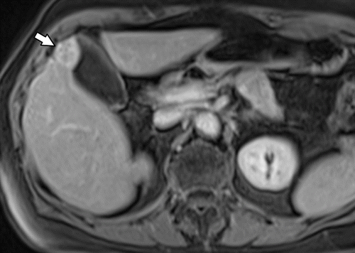

A: Gallbladder carcinoma

B: Gallbladder adenomyoma

C: Primary lymphoma of the gallbladder

D: Secondary lymphoma of the gallbladder

E: Gallbladder polyp

# Answer:

B: Gallbladder adenomyoma. Based on the figure, the mass has fairly homogeneous enhancement, which is characteristic of gallbladder adenomyoma. Gallbladder carcinoma, option A, is less likely as it commonly shows early invasion of adjacent structures and heterogeneous enhancement, features not seen in the figure. Primary and secondary lymphoma of the gallbladder, options C and D, are very rare and imaging characteristics can be difficult to distinguish from those of gallbladder adenocarcinoma, but they typically involve the submucosa and can manifest as a solid lesion within the gallbladder or irregular wall thickening, features not seen in the figure. Gallbladder polyp, option E, is less likely as polyps are typically smaller and do not present as a mass with homogeneous enhancement as seen in the figure. Hence, given the imaging findings and the patient's clinical context, gallbladder adenomyoma is the most likely diagnosis.

---Source:

Gallbladder Carcinoma and Its Differential Diagnosis at MRI_ What Radiologists Should Know

---Original Figure Caption:

Figure 11c.Gallbladder adenomyoma mimicking gallbladder cancer in a 53-year-old woman.(a)Axial T2-weighted image shows a focal mass (arrow) in the fundus that is hypointense with areas of high signal intensity from dilated Rokitansky-Aschoff sinuses.(b)Axial fat-suppressed T1-weighted image shows that the mass (arrow) has a focus of higher signal intensity.(c)Axial contrast-enhanced fat-suppressed T1-weighted image shows that the mass (arrow) has fairly homogeneous enhancement, from hypervascular focal fundal adenomyomatosis mimicking gallbladder cancer.(d)Image from MR cholangiopancreatography shows the characteristic outpouchings from dilated Rokitansky-Aschoff sinuses (arrow), which distinguish the lesion from cancer.

# Question 10:

A 45-year-old woman presents with recurrent episodes of fecal incontinence and vaginal discharge. Based on the provided figure and the text context, which of the following statements about the surgical repair technique shown is most accurate?

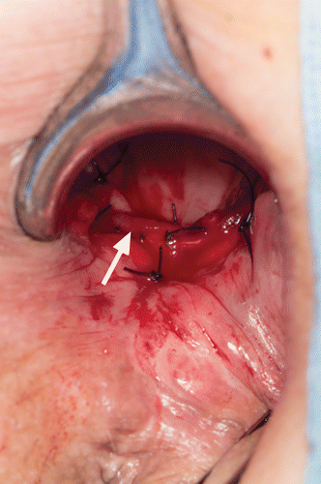

A: The muscle graft is harvested from the right thigh and interposed between two organs.

B: The muscle graft is advanced by way of a transabdominal approach.

C: The muscle graft is sutured in place with use of an incision at a specific septum.

D: The muscle graft is passed through a subcutaneous tunnel between the abdominal and thigh incisions.

E: The harvested muscle graft is not recommended for large defects.

# Answer:

The correct answer is C. The figure shows a gracilis flap repair technique, where the gracilis muscle is used as a graft. The muscle is advanced by way of a transperineal approach, interposed between the rectum and vagina, and then sutured in place with use of an incision at the rectovaginal septum. This approach is designed to place tissue or prosthetic material between the rectal and vaginal openings, which is a common treatment for conditions like rectovaginal fistula. Therefore, option C is the most accurate statement about the technique shown in the figure.

---Source:

Imaging and Surgical Management of Anorectal Vaginal Fistulas

---Original Figure Caption:

Figure 18b.Gracilis flap repair.(a)Photograph shows the left thigh of a patient in the modified lithotomy position, with mobilization of the gracilis muscle (☆).(b)The muscle is advanced by way of a transperineal approach, interposed between the rectum and vagina, and sutured in place with use of an incision at the rectovaginal septum (arrow). All steps are performed through the vagina.

# Question 11:

A 43-year-old man presents with acute abdominal pain. A coronal contrast-enhanced CT image is provided. Based on the imaging findings, which of the following is the most likely diagnosis?

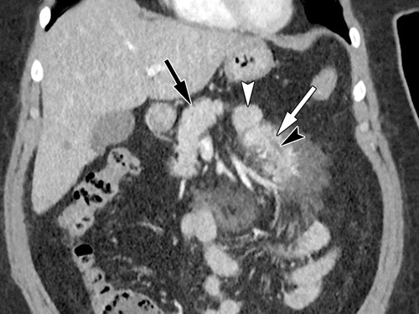

A: Mesenteric lymphoma

B: Mesenteric lipoma

C: Mesenteric heterotopic pancreas

D: Mesenteric adenitis

E: Mesenteric cyst

# Answer:

The correct answer is C, Mesenteric heterotopic pancreas. The imaging findings, as described in the figure caption, show an elongated mass in the jejunal mesentery with surrounding fat stranding. The mass has a broad base intimately associated with a jejunal loop and tapers as it extends into the mesentery. A ductlike structure is seen paralleling the long axis of the mass. These findings are consistent with mesenteric heterotopic pancreas, a congenital anomaly in which pancreatic tissue is anatomically separate from the main gland. This condition can present with acute abdominal pain, as in the case of this patient. The other options, such as mesenteric lymphoma, mesenteric lipoma, mesenteric adenitis, and mesenteric cyst, do not typically present with these specific imaging findings.

---Source:

Heterotopic Pancreas_ Histopathologic Features, Imaging Findings, and Complications

---Original Figure Caption:

Figure 7.Mesenteric heterotopic pancreas complicated by acute pancreatitis in a 43-year-old man. Coronal contrast-enhanced CT image shows an elongated mass (white arrow) in the jejunal mesentery with surrounding fat stranding. The mass has a broad base intimately associated with a jejunal loop (white arrowhead) and tapers as it extends into the mesentery. Although the heterotopic tissue is anatomically separate from the orthotopic pancreas (black arrow), it has similar morphology and enhancement. A ductlike structure (black arrowhead) is seen paralleling the long axis of the mass. (Image courtesy of Aarti Sekhar, MD, Emory University, Atlanta, Ga.)

# Question 12:

A 38-year-old woman presents with abdominal discomfort. A CT scan of the abdomen is provided. Based on the imaging findings, which of the following is the most likely diagnosis?

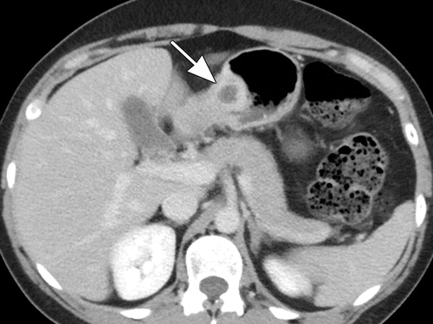

A: Gastric adenocarcinoma

B: Gastrointestinal stromal tumor (GIST)

C: Gastric lymphoma

D: Gastric pancreatic heterotopia

E: Gastric leiomyoma

# Answer:

The correct answer is D. Gastric pancreatic heterotopia. The CT scan shows an intensely enhancing intramural mass with multiple small internal cystic areas, which is consistent with the appearance of normal pancreatic tissue. This, along with the location of the mass along the greater curvature of the gastric antrum, is indicative of gastric pancreatic heterotopia, a congenital anomaly where pancreatic tissue is anatomically separate from the main gland. The other options, such as gastric adenocarcinoma, GIST, gastric lymphoma, and gastric leiomyoma, would exhibit different imaging characteristics and are therefore less likely.

---Source:

Heterotopic Pancreas_ Histopathologic Features, Imaging Findings, and Complications

---Original Figure Caption:

Figure 11a.Gastric pancreatic heterotopia complicated by pseudocyst formation in a 38-year-old woman. Axial(a)and coronal(b)contrast-enhanced CT images show an intramural mass (arrow) along the greater curvature of the gastric antrum. Similar to the normal pancreatic tissue, the mass is intensely enhancing and contains multiple small internal cystic areas. Also note the hyperenhancement of the overlying gastric mucosa (arrowhead inb) and the endoluminal growth pattern of the lesion.

# Question 13:

A 64-year-old man with follicular lymphoma presented with multiple hepatic masses and had a partial response to chemotherapy. A follow-up axial portal phase CT image is provided. Based on the context and the figure, which of the following is the most likely diagnosis?

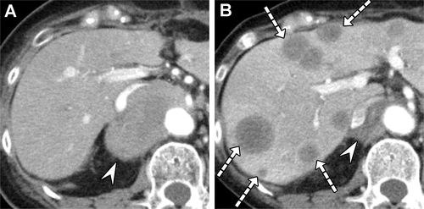

A: Metastatic adenocarcinomas from lung, breast, or colorectal origin

B: Primary hepatic lymphoma

C: Metastatic sarcomatoid carcinoma of the small intestine

D: Secondary liver involvement from non-Hodgkin lymphoma

E: Hepatic metastases from gastric cancer

# Answer:

The correct diagnosis is Metastatic sarcomatoid carcinoma of the small intestine (option C). The figure caption mentions that the new hepatic masses lack the vessel-penetrating sign, which is often observed in primary and secondary lymphomas. This suggests a new primary malignancy rather than hepatic lymphoma. The context further supports this, explaining that the transformation of a primary cancer into a different histopathologic tumor type has been reported as a resistance process in response to targeted therapies. Therefore, the new hepatic masses are likely from a new primary malignancy, which was proven to be metastatic sarcomatoid carcinoma of the small intestine.

---Source:

Liver Metastases_ Correlation between Imaging Features and Pathomolecular Environments

---Original Figure Caption:

Figure 16.Multiple hepatic masses in a 64-year-old man with follicular lymphoma who had a partial response to chemotherapy.(A)Pretreatment axial arterial phase CT image shows a well-circumscribed hypovascular mass (arrowhead) in the aortocaval space.(B)Follow-up axial portal phase CT image shows multiple new low-attenuation hepatic masses (arrows), which lack the vessel-penetrating sign, and an interval decrease in the size of the lymphoma (arrowhead) after chemotherapy. This finding suggested a new primary malignancy rather than hepatic lymphoma and was proven to be metastatic sarcomatoid carcinoma of the small intestine (not shown).

# Question 14:

A 52-year-old man with a history of mucinous adenocarcinoma of the sigmoid colon presents with new liver lesions noted on imaging. Based on the T2-weighted image provided, which of the following best describes the typical imaging findings of liver metastases from this type of primary tumor?

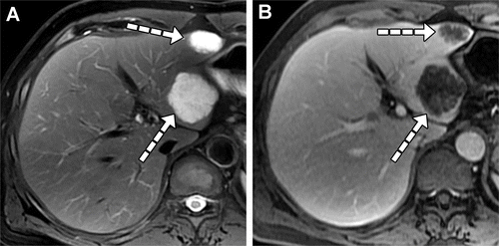

A: Hypointensity on T2-weighted images due to abundant mucin.

B: Hypoattenuation on noncontrast CT images, clear hyperintensity on T2-weighted images, and hypointensity on T1-weighted images, accompanied by no enhancement.

C: Marked hyperintensity on T2-weighted images due to abundant mucin.

D: Multifocal hypovascular nodular lesions with hypoattenuation on noncontrast CT images, hypointensity on T1-weighted images, and moderate hyperintensity on T2-weighted images.

E: Hyperintensity on T2-weighted images and hypoattenuating areas on CT images due to severe degeneration or necrosis.

# Answer:

The correct answer is C. Marked hyperintensity on T2-weighted images due to abundant mucin. This is consistent with the figure caption that describes liver metastases in a patient with mucinous adenocarcinoma of the sigmoid colon showing marked hyperintensity on T2-weighted images due to abundant mucin. The context also supports this, noting that liver metastases of mucinous adenocarcinoma show marked hyperintensity on T2-weighted images owing to abundant mucin.

---Source:

Liver Metastases_ Correlation between Imaging Features and Pathomolecular Environments

---Original Figure Caption:

Figure 12.Liver metastases in a 52-year-old man with mucinous adenocarcinoma of the sigmoid colon.(A)Axial fat-suppressed T2-weighted image shows liver metastases (arrows) with marked hyperintensity due to abundant mucin.(B)Axial portal phase MR image shows liver metastases (arrows) with poor but reticular enhancement.

# Question 15:

A 71-year-old woman presents with abdominal discomfort. Based on the axial contrast-enhanced T1-weighted image provided, which of the following is the most likely diagnosis?

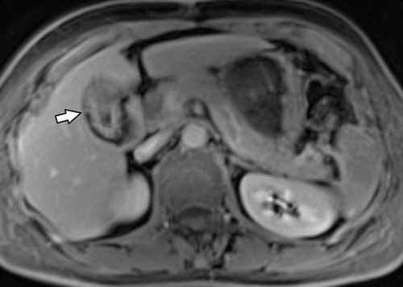

A: Gangrenous acute cholecystitis

B: Gallbladder carcinoma

C: Xanthogranulomatous cholecystitis

D: Hyalinizing cholecystitis

E: Gallbladder adenomyomatosis

# Answer:

The correct answer is E. Gallbladder adenomyomatosis. This condition is a common acquired benign disease, found in up to 5%–8% of cholecystectomy specimens. It is characterized by hyperplastic changes of the gallbladder wall with mucosal overgrowth, thickening of the muscular wall, and presence of intramural diverticula or sinus tracts. Given the patient's age and symptoms, this is the most likely diagnosis. The other options like Gangrenous acute cholecystitis, Gallbladder carcinoma, Xanthogranulomatous cholecystitis, and Hyalinizing cholecystitis are less likely based on the provided context and the imaging findings.

---Source:

Gallbladder Carcinoma and Its Differential Diagnosis at MRI_ What Radiologists Should Know

---Original Figure Caption:

Figure 12a.Adenomyomatosis in a 71-year-old woman.(a)Axial contrast-enhanced T1-weighted image shows apparent gallbladder wall thickening (arrow).(b)Image from MR cholangiopancreatography shows the “pearl necklace” sign (arrows), which refers to the characteristically curvilinear arrangement of multiple round hyperintense outpouchings.

# Question 16:

A 49-year-old man presents with abdominal cramps and blood in the stool. Based on the provided CT image and the patient's symptoms, which of the following is the most likely diagnosis?

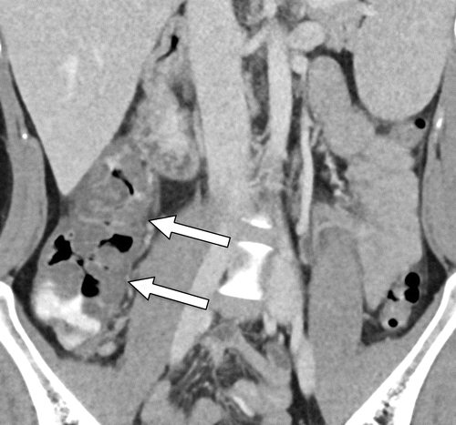

A: Colonic ischemia

B: Diverticular bleeding

C: Hemorrhoids

D: Hemorrhagic Escherichia coli colitis

E: Colonic angioectasia

# Answer:

The correct answer is D, Hemorrhagic Escherichia coli colitis. The CT image in the figure shows marked cecal and ascending colonic wall thickening, with associated pericolonic fat stranding. These findings, along with the clinical presentation of the patient, suggest a diagnosis of Hemorrhagic Escherichia coli colitis. Colonic ischemia (Option A) typically results in hypoattenuation and abnormal mural enhancement, which are not evident in the image. Diverticular bleeding (Option B) is characterized by contrast extravasation into a colonic diverticulum, which is not seen here. Hemorrhoids (Option C) would be best defined on portal images and would appear as enlarged serpiginous veins within the anus and lower rectum. Colonic angioectasia (Option E) would appear as punctate or discoid foci of enhancement in the colon wall, which is not the case in this image.

---Source:

Gastrointestinal Bleeding at CT Angiography and CT Enterography_ Imaging Atlas and Glossary of Terms

---Original Figure Caption:

Figure 26.HemorrhagicEscherichia colicolitis in a 49-year-old man who presented with abdominal cramps and blood in the stool. Coronal dual-energy mixed (blended) CT image shows marked cecal and ascending colonic wall thickening, with associated pericolonic fat stranding (arrows). High-attenuation intraluminal fluid in the colon was likely ingested material, given its presence on virtual noncontrast images (not shown). Clinically, the patient was found to have hemorrhagicE colicolitis.

# Question 17:

A 40-year-old man presents with a well-defined focal mass in the pancreas. An MR image is provided. Based on the imaging findings and the provided context, which of the following is the most likely diagnosis?

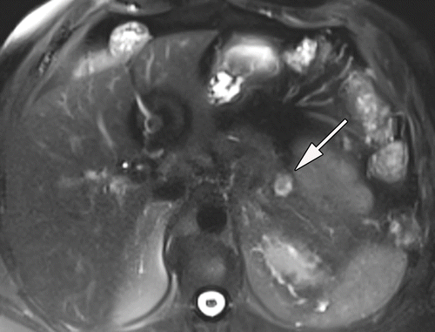

A: Poorly differentiated pancreatic neuroendocrine carcinoma

B: Well-differentiated, high-grade panNET

C: Well-differentiated grade 1 panNET

D: Peripancreatic gastrointestinal stromal tumor

E: Peripancreatic paraganglioma

# Answer:

The correct answer is C, Well-differentiated grade 1 panNET. The MR image shows a well-defined heterogeneously enhancing focal mass in the pancreas. This, along with the age of the patient and the characteristics of the tumor cells as described in the figure caption (uniform characteristic organoid and trabecular growth pattern of small relatively uniform tumor cells, strong positivity for chromogranin, and Ki-67 proliferation indices of less than 3) is consistent with a well-differentiated grade 1 panNET. The other options are less likely: A poorly differentiated pancreatic neuroendocrine carcinoma (Option A) typically presents as a large hypoenhancing mass with heterogeneous enhancement and ill-defined margins. A well-differentiated, high-grade panNET (Option B) is a distinct entity with different pathogenesis, clinical features, imaging findings, treatment options, and prognoses. Peripancreatic gastrointestinal stromal tumors (Option D) and peripancreatic paragangliomas (Option E) may mimic panNENs at imaging, but the imaging findings and the patient's clinical scenario do not match these diagnoses.

---Source:

Pancreatic Neuroendocrine Neoplasms_ 2020 Update on Pathologic and Imaging Findings and Classification

---Original Figure Caption:

Figure 1a.Well-differentiated panNET in a 40-year-old man.(a, b)Axial T2-weighted(a)and gadolinium-enhanced T1-weighted(b)MR images show a well-defined heterogeneously enhancing focal mass (arrow) in the pancreas.(c)Photograph of the sectioned gross specimen shows a well-defined intrapancreatic tumor with a few foci of hemorrhage (arrow).(d)Photomicrograph shows the uniform characteristic organoid and trabecular growth pattern of small relatively uniform tumor cells, which is consistent with a low-grade tumor. The tumor cells were strongly positive for chromogranin and had Ki-67 proliferation indices of less than 3 (not shown), which is consistent with a well-differentiated grade 1 panNET. (Hematoxylin-eosin stain; original magnification, ×40.)

# Question 18:

A 41-year-old man presents with duodenal outlet obstruction. An axial fat-suppressed T2-weighted MR image is provided. Based on the image and the patient's symptoms, what is the most likely diagnosis?

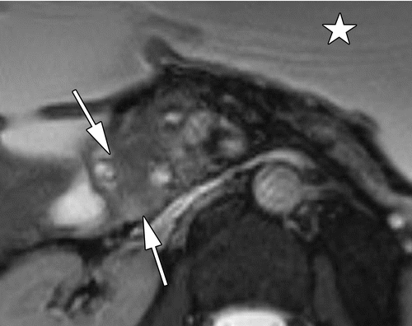

A: Peripapillary cancer

B: Type 1 solid Paraduodenal pancreatitis (PDP)

C: Type 2 cystic PDP

D: Type 3 ill-defined PDP

E: Pancreaticoduodenal carcinoma

# Answer:

The correct diagnosis is Type 1 solid Paraduodenal pancreatitis (PDP). Paraduodenal pancreatitis (PDP) is a unique form of focal chronic pancreatitis that selectively involves the duodenum and adjacent pancreatic head. The Type 1 solid form of PDP is often associated with symptoms of duodenal outlet obstruction, as in this patient. The other options are less likely given the patient's symptoms. For instance, Peripapillary cancer and Pancreaticoduodenal carcinoma are less likely as they usually present with a different set of symptoms and clinical manifestations. Similarly, Type 2 cystic PDP and Type 3 ill-defined PDP have different clinical and imaging characteristics that do not match with the provided patient's presentation.

---Source:

Chronic Pancreatitis or Pancreatic Tumor_ A Problem-solving Approach

---Original Figure Caption:

Figure 12a.Type 1 solid PDP (groove pancreatitis) in a 41-year-old man.(a)Axial fat-suppressed T2-weighted MR image shows an ill-defined masslike thickening of the medial duodenal wall, with intermediate signal intensity (arrows). At presentation, the patient was found to have duodenal outlet obstruction. Note the dilated stomach (☆).(b)Axial fat-suppressed T2-weighted MR image shows a predominantly solid masslike area in the pancreatic head and microcystic changes along the duodenal wall (arrow).

# Question 19:

A 55-year-old male presents with symptoms of duodenal obstruction. An axial fat-saturated T1-weighted MR image of the abdomen is provided. Based on the imaging findings, which of the following is the most likely diagnosis?

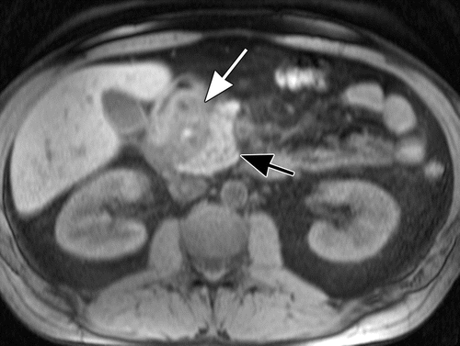

A: Acute pancreatitis

B: Paraduodenal pancreatitis

C: Pancreatic adenocarcinoma

D: Chronic pancreatitis

E: Pancreatic pseudocyst

# Answer:

B: The correct answer is Paraduodenal pancreatitis. The axial fat-saturated T1-weighted MR image enables the best differentiation of the sheetlike mass from the normal pancreatic head. This mass is characteristic of paraduodenal pancreatitis, which presents as a hypovascular sheetlike mass in the pancreaticoduodenal groove, as described in the figure caption and context. This mass narrows the duodenum and displaces the pancreatic head, which can lead to symptoms of duodenal obstruction as presented by the patient. The other options are less likely given the specific imaging findings and patient's symptoms. Acute pancreatitis would typically present with more diffuse inflammation of the pancreas, which is not seen in the image. Pancreatic adenocarcinoma would typically present as a hypervascular mass, not a hypovascular sheetlike mass. Chronic pancreatitis would usually show pancreatic parenchymal atrophy and upstream ductal dilatation, which is not seen in the image. A pancreatic pseudocyst would present as a well-defined fluid-filled structure, which is not described in the figure caption or context.

---Source:

Heterotopic Pancreas_ Histopathologic Features, Imaging Findings, and Complications

---Original Figure Caption:

Figure 15c.Paraduodenal pancreatitis.(a)Axial contrast-enhanced CT image shows soft-tissue and cystic change in the pancreaticoduodenal groove (arrow), as well as wall thickening of the adjacent duodenum (arrowhead).(b)Axial T2-weighted MR image best shows the cysts (arrowhead) in the groove.(c)Axial fat-saturated T1-weighted MR image enables the best differentiation of the sheetlike mass (white arrow) in the groove from the normal pancreatic head (black arrow).(d)Axial contrast-enhanced fat-saturated T1-weighted arterial phase MR image best demonstrates the hyperenhancement and thickening of the duodenal wall (arrowhead) and shows the hypovascular nature of the fibrous mass (arrow) in the groove.

# Question 20:

A 73-year-old man presents with a history of occult GI bleeding. Based on the CTE images provided in the figure, which of the following is the most likely diagnosis?

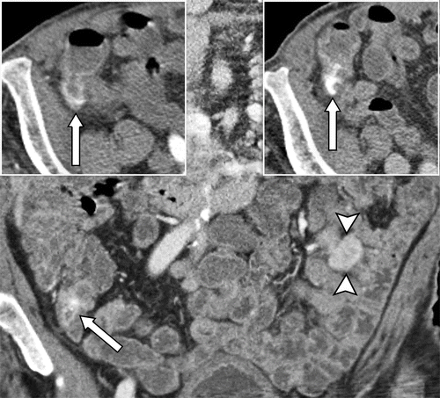

A: Infectious colitis

B: Cecal angioectasia with active bleeding and jejunal GIST

C: Small bowel vascular lesions

D: Colonic arteriovenous malformations

E: Jejunal varices

# Answer:

B: Cecal angioectasia with active bleeding and jejunal GIST. The CTE images show active extravasation in the cecum that appears in the arterial phase and changes in size, attenuation, and shape in the portal venous phase, indicative of cecal angioectasia. Additionally, there is a hyperenhancing exophytic mass in the jejunum consistent with a GIST. While infectious colitis, small bowel vascular lesions, colonic arteriovenous malformations, and jejunal varices can also present with GI bleeding, the specific findings in the CTE images provided are most consistent with cecal angioectasia and jejunal GIST.

---Source:

Gastrointestinal Bleeding at CT Angiography and CT Enterography_ Imaging Atlas and Glossary of Terms

---Original Figure Caption:

Figure 25.Cecal angioectasia with active bleeding and jejunal GIST in a 73-year-old man with a history of occult GI bleeding. Coronal (main image) and axial (right inset) portal venous phase and axial arterial phase (left inset) CTE images show active extravasation in the cecum that appears in the arterial phase and changes in size, attenuation, and shape in the portal venous phase (arrow in all images) caused by cecal angioectasia, which was confirmed at colonoscopy. There is also a hyperenhancing exophytic mass in the jejunum (arrowheads in main image) that is consistent with a GIST, which was confirmed at surgical resection.

# Question 21:

A 50-year-old man presents with an abnormality in the pancreatic tail on an axial T2-weighted image. Based on the imaging findings, which of the following is the most likely diagnosis?

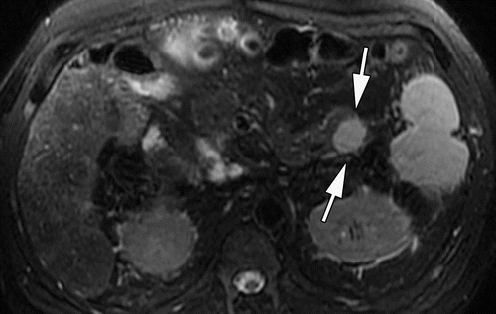

A: Pancreatic ductal adenocarcinoma

B: Pancreatic neuroendocrine neoplasm (panNEN)

C: Intraductal papillary mucinous neoplasm

D: Intrapancreatic splenule

E: Peripancreatic gastrointestinal stromal tumor

# Answer:

D. Intrapancreatic splenule is the most likely diagnosis. The image shows a well-defined round lesion in the pancreatic tail that appears similar to the spleen. This lesion demonstrates serpiginous enhancement in the arterial phase and homogeneous enhancement in the portal venous phase, similar to the adjacent splenic parenchyma. These imaging findings are consistent with an intrapancreatic splenule, not with pancreatic ductal adenocarcinoma, pancreatic neuroendocrine neoplasm (panNEN), intraductal papillary mucinous neoplasm, or peripancreatic gastrointestinal stromal tumor.

---Source:

Pancreatic Neuroendocrine Neoplasms_ 2020 Update on Pathologic and Imaging Findings and Classification

---Original Figure Caption:

Figure 19a.Intrapancreatic splenule mimicking a panNET in a 50-year-old man. Axial T2-weighted image(a)and gadolinium-enhanced T1-weighted MR images of the pancreas in the arterial(b)and portal venous(c)phases show a mildly T2-hyperintense well-defined round lesion (arrows ina) in the pancreatic tail that appears similar to the spleen. This lesion demonstrates serpiginous enhancement in the arterial phase (arrow inb) and homogeneous enhancement in the portal venous phase (arrow inc), similar to the adjacent splenic parenchyma (arrowhead inbandc). These findings are consistent with an intrapancreatic splenule.

# Question 22:

A 55-year-old man with a history of chronic pancreatitis presents with worsening abdominal pain. A coronal CT image is provided. Based on the image, what does the imaging finding suggest?

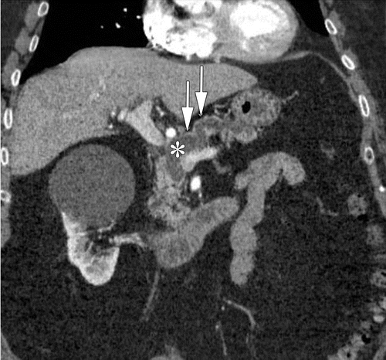

A: An inflammatory condition

B: Chronic pancreatitis

C: A neoplastic cause

D: A benign pancreatic lesion

E: Normal pancreatic anatomy

# Answer:

C: A neoplastic cause. This is suggested by the patient's history of chronic pancreatitis and worsening abdominal pain. In the context of these symptoms, certain imaging features such as the one expected in the provided image, favor the diagnosis of a neoplastic cause.

---Source:

Chronic Pancreatitis or Pancreatic Tumor_ A Problem-solving Approach

---Original Figure Caption:

Figure 2a.Imaging findings that favor diagnosis of a malignancy rather than an inflammatory condition.(a)Coronal CT image shows a duct-to-parenchyma ratio (maximum diameter of the diffusely dilated main pancreatic duct [*] and the overlying atrophic parenchyma [arrows]) of greater than 0.5).(b)Axial CT image shows diffuse calcifications in the background parenchyma and peripheral displacement of calcifications by a focal hypoattenuating lesion (dotted circle) in the pancreatic body.(c)MR cholangiopancreatogram shows the double duct sign, or dilatation of both the pancreatic duct (double arrows) and the common bile duct (single arrow).(d)Axial CT image shows the teardrop sign (arrows), a teardrop-shaped deformity of the SMV due to vascular encasement. Note the loss of fat in the perivascular space.(e)Axial CT image shows the SMA-to-SMV ratio, or the decreased caliber of the SMV (arrowhead) (almost the same size as the SMA [arrow]), of greater than or equal to 1.0. Note the loss of fat in the perivascular space.

# Question 23:

A 60-year-old woman presents with weight loss and jaundice. The axial early and delayed contrast-enhanced T1-weighted images are provided. Based on these findings, how would you stage the gallbladder carcinoma according to the TNM staging system?

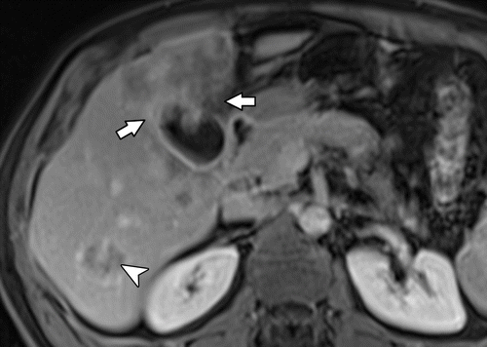

A: T1 - Tumor confined to the gallbladder

B: T2a - Tumor on the peritoneal side of the gallbladder

C: T2b - Tumor on the hepatic side of the gallbladder

D: T3 - Tumor perforates the gallbladder serosa or penetrates into the liver or one other adjacent organ

E: T4 - Tumor invades the hepatic artery, main portal vein, or two or more extrahepatic organs

# Answer:

The correct answer is D. T3 - Tumor perforates the gallbladder serosa or penetrates into the liver or one other adjacent organ. The other options are incorrect because they do not accurately describe the extent of tumor penetration as observed in the figure.

---Source:

Gallbladder Carcinoma and Its Differential Diagnosis at MRI_ What Radiologists Should Know

---Original Figure Caption:

Figure 7c.Metastatic gallbladder cancer in a 60-year-old woman.(a)Axial T2-weighted image shows a heterogeneous mass in the liver extending from the gallbladder (arrow).(b, c)Axial early(b)and delayed(c)contrast-enhanced T1-weighted images show the gallbladder lesion with heterogeneous progressive enhancement of the area of tumor infiltration into the adjacent liver (arrows) as well as in a metastatic hepatic lesion (arrowhead).

# Question 24:

A 60-year-old woman presents with weight loss and jaundice. An MRI scan of the abdomen is provided. Based on the imaging findings, which of the following would be the most likely stage of gallbladder carcinoma according to the TNM staging system?

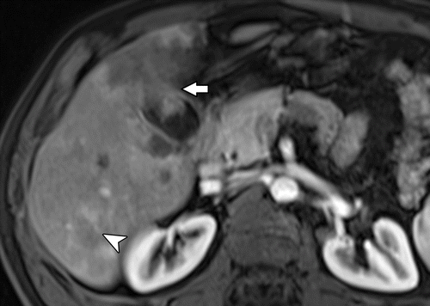

A: T1 - Tumor confined to the gallbladder

B: T2a - Tumor on the peritoneal side of the gallbladder

C: T2b - Tumor on the hepatic side of the gallbladder

D: T3 - Tumor perforating the gallbladder serosa or penetrating into the liver or one other adjacent organ

E: T4 - Tumor invading the hepatic artery, main portal vein, or two or more extrahepatic organs

# Answer:

D - T3 - Tumor perforating the gallbladder serosa or penetrating into the liver or one other adjacent organ. The image shows a heterogeneous mass in the liver extending from the gallbladder, which suggests that the tumor has penetrated into the liver, an adjacent organ. This is consistent with a T3 staging of gallbladder carcinoma according to the TNM staging system. T3 tumors perforate the gallbladder serosa or penetrate into the liver or one other adjacent organ.

---Source:

Gallbladder Carcinoma and Its Differential Diagnosis at MRI_ What Radiologists Should Know

---Original Figure Caption:

Figure 7b.Metastatic gallbladder cancer in a 60-year-old woman.(a)Axial T2-weighted image shows a heterogeneous mass in the liver extending from the gallbladder (arrow).(b, c)Axial early(b)and delayed(c)contrast-enhanced T1-weighted images show the gallbladder lesion with heterogeneous progressive enhancement of the area of tumor infiltration into the adjacent liver (arrows) as well as in a metastatic hepatic lesion (arrowhead).

# Question 25:

A 45-year-old male patient presents with recurrent perianal sepsis. An axial T2-weighted MR image of the male perineum is obtained. Based on the anal clock diagram, which location corresponds to the right lateral aspect of the anal canal?

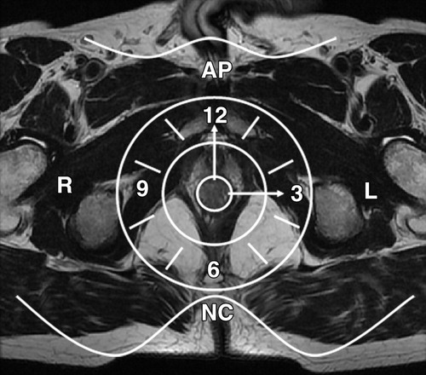

A: 12 o'clock

B: 3 o'clock

C: 6 o'clock

D: 9 o'clock

E: None of the above

# Answer:

The correct answer is D: 9 o'clock. The anal clock diagram is a method used to locate anal fistulas with respect to the anal canal. In this diagram, the anterior perineum is located at 12 o'clock, the natal cleft is at 6 o'clock, the left lateral aspect of the anal canal is at 3 o'clock, and the right lateral aspect is at 9 o'clock. Therefore, if the patient's axial T2-weighted MR image shows a fistula on the right lateral aspect of the anal canal, it would be located at 9 o'clock on the anal clock diagram.

---Source:

MR Imaging Evaluation of Perianal Fistulas_ Spectrum of Imaging Features

---Original Figure Caption:

Figure 6Anal clock. Axial T2-weighted MR image of the male perineum shows the anal clock diagram used to correctly locate anal fistulas with respect to the anal canal.AP= anterior perineum,L= left aspect of the anal canal,NC= natal cleft,R= right aspect of the anal canal.

# Question 26:

A 77-year-old woman presents with vague abdominal pain and right upper quadrant discomfort two years later. A noncontrast CT and a subsequent contrast-enhanced portal venous phase CT image of the abdomen are provided. Given the imaging findings and patient's clinical presentation, which of the following is the most likely diagnosis and appropriate management?

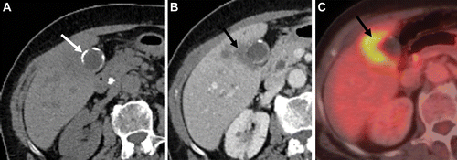

A: Chronic cholecystitis, recommend antibiotic therapy

B: Gallbladder adenoma, recommend regular follow-up

C: Gallbladder adenocarcinoma, recommend surgical resection

D: Biliary intraepithelial neoplasia, recommend endoscopic retrograde cholangiopancreatography

E: Choledocholithiasis, recommend endoscopic sphincterotomy

# Answer:

The correct answer is C. Gallbladder adenocarcinoma, recommend surgical resection. The figure shows circumferential calcification of the gallbladder wall, which is a characteristic finding of porcelain gallbladder. The presence of an ill-defined hypoenhancing mass arising from the gallbladder and extending into the adjacent hepatic parenchyma is concerning for gallbladder adenocarcinoma. The patient's clinical presentation of vague abdominal pain and right upper quadrant discomfort is also consistent with this diagnosis. Given these findings, surgical resection would be the most appropriate management. The other options are incorrect as they do not align with the imaging findings and clinical presentation.

---Source:

Imaging Features of Premalignant Biliary Lesions and Predisposing Conditions with Pathologic Correlation

---Original Figure Caption:

Figure 9.Porcelain gallbladder in a 77-year-old woman.(A)Axial image from noncontrast CT performed for vague abdominal pain shows circumferential calcification (arrow) of the gallbladder wall. Two years later, the patient presented with right upper quadrant discomfort.(B)Axial contrast-enhanced portal venous phase CT image shows an ill-defined hypoenhancing mass (arrow) arising from the gallbladder, with discontinuity of the wall calcifications and extension of the mass into the adjacent hepatic parenchyma.(C)Fluorine 18–fluorodeoxyglucose (FDG) PET/CT image shows that the mass (arrow) is FDG avid, representing adenocarcinoma, which was surgically resected.

# Question 27:

A 63-year-old man who underwent resection of sigmoid colon adenocarcinoma 6 years earlier is provided. Based on the axial arterial phase CT image provided, which histopathological feature does the peripheral and peritumor enhancement on the CT image correspond to?

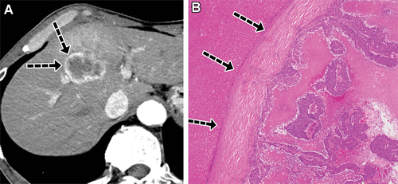

A: Cancer-associated fibroblasts

B: Desmoplastic reaction

C: Peritumor hyperplasia

D: Arterioportal shunts

E: Pseudocirrhosis

# Answer:

The correct answer is B. Desmoplastic reaction. The figure caption mentions that the peripheral and peritumor enhancement shown on the axial arterial phase CT image corresponds to the mainly desmoplastic reaction in the peritumor area seen on the histologic specimen. Desmoplastic reaction is a process in which dense fibrous tissue forms in response to injury or neoplasia. In this case, it is associated with the liver metastasis from sigmoid colon adenocarcinoma. The other options do not correctly correspond to the imaging findings. Cancer-associated fibroblasts (Option A) are indeed involved in the formation of the desmoplastic reaction but they are not the reaction itself. Peritumor hyperplasia (Option C) is a rim of hyperplastic hepatocytes surrounding the tumor, which is not mentioned in the figure caption. Arterioportal shunts (Option D) and pseudocirrhosis (Option E) are other phenomena that can be seen in liver diseases but are not related to the imaging findings in this figure.

---Source:

Liver Metastases_ Correlation between Imaging Features and Pathomolecular Environments

---Original Figure Caption:

Figure 3.Peripheral and peritumor enhancement of liver metastasis in a 63-year-old man who underwent resection of sigmoid colon adenocarcinoma 6 years earlier. Axial arterial phase CT image(A)shows a hypovascular metastasis with peripheral and peritumor enhancement (arrows inA), which corresponds to the mainly desmoplastic reaction (arrows inB) in the peritumor area seen on the histologic specimen(B).(Hematoxylin-eosin stain; original magnification, ×10.)

# Question 28:

A 28-year-old woman who underwent sphincteroplasty for a fourth-degree vaginal tear is suspected to have a fistula. Based on the provided coronal T2-weighted MR image, which of the following statements is most likely true?

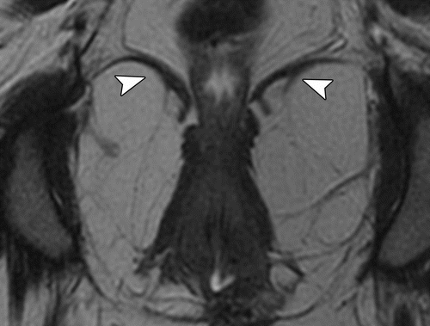

A: There is inflammation in the area of surgery

B: There is a persistent anovaginal fistula from the middle and upper regions of the anus to the middle region of the vagina

C: The puborectalis muscles are damaged

D: The puborectalis muscles are intact

E: There is an artifact in the area of attempted surgical repair

# Answer:

Option D) The puborectalis muscles are intact. The coronal T2-weighted MR image shows intact puborectalis muscles, which are an important finding in this case. The puborectalis muscles are part of the sphincteric complex, and their integrity is crucial in maintaining continence. Damage to these muscles, such as from an obstetric injury, can lead to incontinence and fistula formation. In this patient, the intact puborectalis muscles indicate that the sphincteroplasty was successful in preserving these muscles. This is important in the patient's prognosis and future management.

---Source:

Imaging and Surgical Management of Anorectal Vaginal Fistulas

---Original Figure Caption:

Figure 12c.Fistula formation in a 28-year-old woman who underwent sphincteroplasty for a fourth-degree vaginal tear.(a)Sagittal T2-weighted MR image obtained with use of vaginal and rectal gel shows a persistent anovaginal fistula (arrow) from the middle and upper regions of the anus to the middle region of the vagina, in the area of surgery.(b)Axial fat-suppressed T2-weighted MR image shows no inflammation (dashed oval).(c)Coronal T2-weighted MR image shows intact puborectalis muscles (arrowheads), which are an important finding.(d)Axial gradient-echo MR image is useful for depicting artifact (arrow) in the area of attempted surgical repair, which is sphincteroplasty in this case.

# Question 29:

A 60-year-old woman with known lung and bone NET metastases presents with symptoms of bowel obstruction. Her previous abdominal MRI showed mesenteric lymphadenopathy suspicious for a small bowel origin of metastatic NET. Her current enteric phase CTE images are shown in Figure 34. Based on the figure and her clinical history, which of the following is the most likely diagnosis?

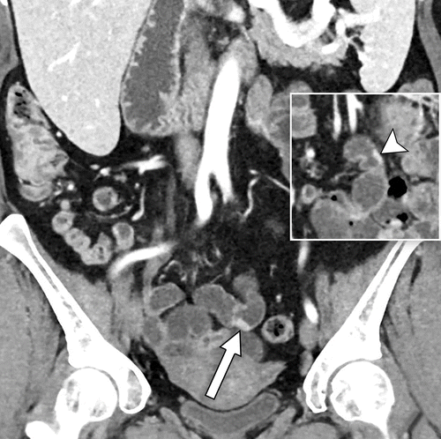

A: Adenomatous polyps

B: Hemangiomas

C: Neuroendocrine tumors (NETs)

D: Adenocarcinoma

E: Hematogenous metastasis from lung cancer

# Answer:

Neuroendocrine tumors (NETs). Given the patient's history of lung and bone NET metastases, and the presence of mesenteric lymphadenopathy suspicious for a small bowel origin of metastatic NET on her previous abdominal MRI, the most likely diagnosis is Neuroendocrine tumors (NETs). The figure supports this diagnosis without disclosing specific imaging findings.

---Source:

Gastrointestinal Bleeding at CT Angiography and CT Enterography_ Imaging Atlas and Glossary of Terms

---Original Figure Caption:

Figure 34.Multiple plaque-like NETs in a 60-year-old woman with known lung and bone NET metastases. Prior abdominal MRI examination (not shown) showed mesenteric lymphadenopathy that was suspicious for a small bowel origin of metastatic NET. Enteric phase CTE images show two of numerous hyperenhancing plaque-like lesions in the mid small bowel (arrow in main image, arrowhead in inset), which are consistent with NETs. There was associated mesenteric lymphadenopathy (not shown). NETs were subsequently confirmed at surgery.

# Question 30:

A 74-year-old man with a history of weight loss and jaundice presents for evaluation. An axial fat-saturated T2-weighted image of the gallbladder is provided. Based on the imaging findings and the patient's clinical presentation, what is the most likely diagnosis?

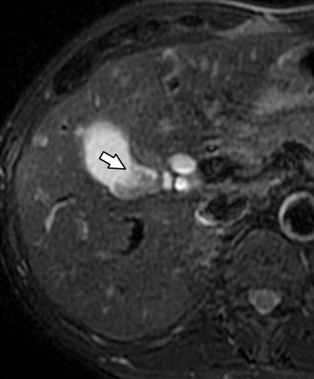

A: Gallbladder polyp

B: Gallbladder carcinoma

C: Tumefactive biliary sludge

D: Gallbladder metastases

E: Gallbladder adenoma

# Answer:

The correct diagnosis is Gallbladder carcinoma (Option B). The patient's clinical presentation of weight loss and jaundice, along with the imaging findings, are indicative of gallbladder cancer. The axial fat-saturated T2-weighted image is particularly helpful in detecting invasion of adjacent liver parenchyma which is commonly seen in gallbladder cancer. Furthermore, gallbladder cancer is the most common manifestation of a mass that arises from the gallbladder wall or replaces the gallbladder lumen or fossa, as seen in this case. The other options are less likely. Gallbladder polyps (Option A) would show enhancement favoring a benign or malignant polyp over a large gallstone or sludge. Tumefactive biliary sludge (Option C) would appear as a well-defined masslike lesion with high signal intensity on T1-weighted images, lack of enhancement on postcontrast images, variable signal intensity on T2-weighted images, and lack of diffusion restriction. Gallbladder metastases (Option D) typically grow as serosal implants with progression to polypoid lesions. Gallbladder adenoma (Option E) is a benign tumor and would not typically present with the patient's symptoms of weight loss and jaundice.

---Source:

Gallbladder Carcinoma and Its Differential Diagnosis at MRI_ What Radiologists Should Know

---Original Figure Caption:

Figure 14e.Gallbladder cancer in a 74-year-old man.(a)Axial nonenhanced CT image does not show a gallbladder mass.(b)Axial portal venous phase contrast-enhanced CT image shows an enhancing gallbladder mass (arrow).(c)Axial nonenhanced T1-weighted image does not show the gallbladder mass.(d)Axial portal venous phase contrast-enhanced T1-weighted image shows the enhancing gallbladder mass (arrow) without liver invasion.(e)Axial fat-saturated T2-weighted image shows a low-signal-intensity mass (arrow) in the gallbladder without liver invasion. At pathologic analysis, no tumor extension into the liver was found.

# Question 31:

A 41-year-old woman presents with an incidental finding on a contrast-enhanced CT scan. Based on the figure and the context provided, what is the most likely diagnosis?

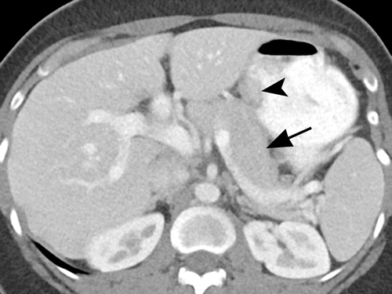

A: Gastric adenocarcinoma

B: Gastric lymphoma

C: Gastric leiomyoma

D: Gastric heterotopic pancreas

E: Gastric GIST (Gastrointestinal stromal tumor)

# Answer:

The most likely diagnosis is a Gastric heterotopic pancreas. The homogeneous enhancement of the mass similar to the normal pancreas, its flat profile, oval shape, and long to short diameter ratio higher than 1.4 are typical of heterotopic pancreatic lesions. Heterotopic pancreas is a congenital anomaly in which pancreatic tissue is anatomically separate from the main gland. This condition is typically asymptomatic and is often discovered incidentally during unrelated surgery or imaging examination.

---Source:

Heterotopic Pancreas_ Histopathologic Features, Imaging Findings, and Complications

---Original Figure Caption:

Figure 4a.Gastric heterotopic pancreas in a 41-year-old woman. Axial(a)and coronal(b)contrast material–enhanced CT images show an oval intramural gastric mass (arrowhead) with homogeneous enhancement—similar to the enhancement of the normal pancreas (arrow ina). The mass is flat and has a long diameter–to–short diameter ratio higher than 1.4. It has an oval shape and endoluminal growth pattern, which are typical of heterotopic pancreatic lesions.

# Question 32:

A 74-year-old man undergoes a nonenhanced CT scan which does not show a gallbladder mass. Based on Figure 14a and the provided context, which of the following statements is most likely true?

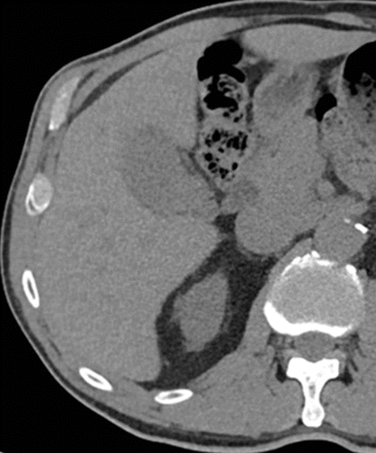

A: The patient is unlikely to have gallbladder cancer as it is not visible on the nonenhanced CT scan

B: The patient may have a T4 stage gallbladder cancer that has invaded the hepatic artery, main portal vein, or two or more extrahepatic organs

C: The patient may have a T3 stage gallbladder cancer that has perforated the gallbladder serosa or penetrated into the liver or one other adjacent organ

D: The patient may still have gallbladder cancer which could be detected on an axial portal venous phase contrast-enhanced CT image

E: The patient may have gallbladder cancer that has already spread to four or more lymph nodes

# Answer:

D. The patient may still have gallbladder cancer which could be detected on an axial portal venous phase contrast-enhanced CT image. Despite the nonenhanced CT scan not showing a gallbladder mass, the figure caption mentions that an axial portal venous phase contrast-enhanced CT image shows an enhancing gallbladder mass. This suggests that gallbladder cancer may not always be visible on nonenhanced CT scans, but can be detected using other imaging techniques such as contrast-enhanced CT scans. Therefore, the absence of a gallbladder mass on the nonenhanced CT scan does not rule out the possibility of gallbladder cancer.

---Source:

Gallbladder Carcinoma and Its Differential Diagnosis at MRI_ What Radiologists Should Know

---Original Figure Caption:

Figure 14a.Gallbladder cancer in a 74-year-old man.(a)Axial nonenhanced CT image does not show a gallbladder mass.(b)Axial portal venous phase contrast-enhanced CT image shows an enhancing gallbladder mass (arrow).(c)Axial nonenhanced T1-weighted image does not show the gallbladder mass.(d)Axial portal venous phase contrast-enhanced T1-weighted image shows the enhancing gallbladder mass (arrow) without liver invasion.(e)Axial fat-saturated T2-weighted image shows a low-signal-intensity mass (arrow) in the gallbladder without liver invasion. At pathologic analysis, no tumor extension into the liver was found.

# Question 33:

A 44-year-old woman with a history of stomach cancer presents with suspected tumor recurrence. Based on the imaging findings, which of the following is the most likely diagnosis?

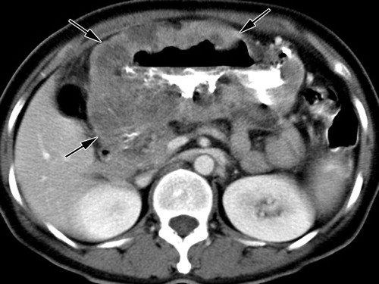

A: Residual tumor causing obstruction of a pyloric stent

B: Improperly distended bowel loops

C: Bowel adhesion

D: Reflux gastritis

E: Surgical plication

# Answer:

The correct answer is A. The axial contrast-enhanced CT scan shows prominent diffuse gastric wall thickening, which is indicative of a residual tumor causing obstruction of a pyloric stent. This is further supported by the fact that the patient had undergone chemotherapy and a subsequent follow-up PET scan showed markedly decreased FDG uptake in the stomach, suggesting a response to treatment. However, the presence of an obstruction in the pyloric stent is suggestive of residual tumor. The other options (B-E) are potential sources of erroneous interpretation in the context of gastric cancer and its treatment, but they do not align with the imaging findings in this case.

---Source:

CT and PET in Stomach Cancer_ Preoperative Staging and Monitoring of Response to Therapy

---Original Figure Caption:

Figure 16a.Suspected tumor recurrence in a 44-year-old woman with stomach cancer.(a, b)Axial contrast-enhanced CT scan(a)and PET scan(b)obtained prior to chemotherapy show prominent diffuse gastric wall thickening (arrows ina) with prominent FDG uptake (arrow inb).(c)Follow-up PET scan obtained approximately 5 months after chemotherapy shows markedly decreased FDG uptake in the stomach (arrow).(d)Follow-up CT scan obtained 3 months later demonstrates obstruction of a pyloric stent (arrow), a finding that suggests residual tumor. A radical subtotal gastrectomy was performed for palliation, but no residual tumor was detected in the resected specimen.

# Question 34:

A patient presented with gastrointestinal bleeding. A contrast-enhanced fat-saturated T1-weighted MR image of the patient is provided. Based on the imaging findings, which of the following complications is most likely associated with this patient's condition?

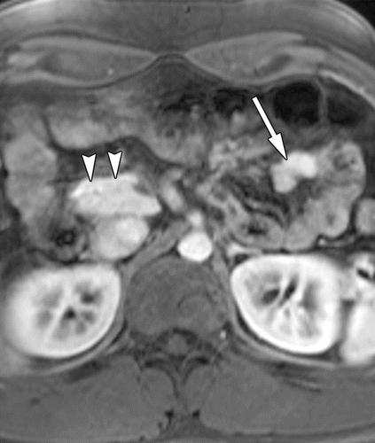

A: Paraduodenal pancreatitis

B: Bowel obstruction

C: Malignant degeneration

D: Pancreatitis

E: Pseudocyst formation

# Answer:

The correct answer is B: Bowel obstruction. In the figure, a solid mass is observed in the proximal jejunum, which is isointense to the normal pancreas. This is indicative of a heterotopic pancreas, a condition where pancreatic tissue is found outside of its normal location with no vascular or ductal connection to the main pancreas. One of the potential complications of heterotopic pancreas is bowel obstruction, which can occur when the mass grows large enough to block the passage of material through the intestines. This is likely the cause of the patient's gastrointestinal bleeding. Other complications such as pancreatitis, pseudocyst formation, malignant degeneration, and paraduodenal pancreatitis can occur with a heterotopic pancreas, but the imaging findings and the patient's symptoms point towards a bowel obstruction.

---Source:

Heterotopic Pancreas_ Histopathologic Features, Imaging Findings, and Complications

---Original Figure Caption:

Figure 6c.Jejunal heterotopic pancreas. Axial T2-weighted(a), fat-saturated T1-weighted(b), and contrast-enhanced fat-saturated T1-weighted(c)MR images show a solid mass (arrow) in the proximal jejunum. The mass is isointense to the normal pancreas (arrowheads) with all MR imaging sequences, with characteristic high signal intensity on the nonenhanced T1-weighted MR image and intense early enhancement.

# Question 35:

A 53-year-old man presents with abdominal pain. An MRI of the abdomen is provided. Based on the imaging findings, which of the following is the most likely additional feature of this condition?

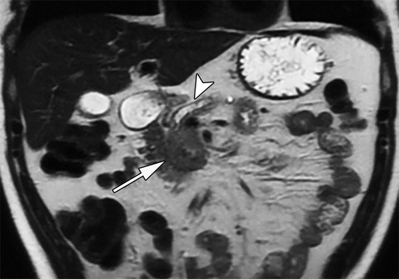

A: The mass shows high signal intensity at T1-weighted MRI

B: The mass does not show diffusion restriction

C: The mass is diffusely hyperenhancing after administration of contrast material

D: The mass is associated with higher ADCs at diffusion-weighted MRI

E: The mass is associated with substantial pancreatic parenchymal atrophy and main pancreatic ductal dilatation

# Answer:

E: The mass is associated with substantial pancreatic parenchymal atrophy and main pancreatic ductal dilatation. As per the figure caption, the mass is ill-defined with mild T2 signal hyperintensity involving the head and uncinate of the pancreas, showing substantial diffusion restriction. The mass is diffusely hypoenhancing after administration of contrast material, not hyperenhancing. Moreover, there is evidence of substantial pancreatic parenchymal atrophy and main pancreatic ductal dilatation, which is a common feature in such cases. Therefore, option E is the correct answer.

---Source:

Pancreatic Neuroendocrine Neoplasms_ 2020 Update on Pathologic and Imaging Findings and Classification

---Original Figure Caption:

Figure 15a.Poorly differentiated high-grade panNEC in a 53-year-old man. Coronal T2-weighted(a)and axial diffusion-weighted (b= 800 sec/mm2)(b)MR images,corresponding ADC map(c),and axial gadolinium-enhanced T1-weighted MR images(d, e)show an ill-defined mass (arrow ina–d) with mild T2 signal hyperintensity (arrow ina) involving the head and uncinate of the pancreas, which also show substantial diffusion restriction (arrow inb). The mass is diffusely hypoenhancing (arrow ind) after administration of contrast material, and there are multiple liver metastases (arrowheads ine). Also note the substantial pancreatic parenchymal atrophy and the main pancreatic ductal dilatation (arrowhead ina), which mimic pancreatic ductal adenocarcinoma. The patient underwent Whipple surgery (pancreatoduodenectomy), and the mass was proven to be a poorly differentiated grade 3 panNEC with Ki-67 proliferation of 70%.

# Question 36:

A 61-year-old male patient with a history of gallbladder cancer who had undergone cholecystectomy presents with weight loss and jaundice. Based on the provided T2-weighted image, which of the following is the most likely diagnosis?

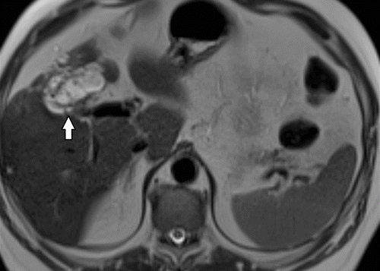

A: Gallstones

B: Cholecystitis

C: Hepatic cyst

D: Tumor recurrence in the gallbladder fossa

E: Hepatocellular carcinoma

# Answer:

The most likely diagnosis is tumor recurrence in the gallbladder fossa (Option D). The T2-weighted image shows a hyperintense lesion in the gallbladder fossa, which is a common site for gallbladder cancer recurrence. The patient's history of gallbladder cancer and cholecystectomy, along with the presence of weight loss and jaundice, further support this diagnosis. The other options are less likely because they do not align with the imaging findings and the patient's clinical history. Gallstones (Option A) and cholecystitis (Option B) would not typically present as a hyperintense lesion in the gallbladder fossa. A hepatic cyst (Option C) could potentially appear as a hyperintense lesion on T2-weighted images, but it would be located in the liver parenchyma, not the gallbladder fossa. Hepatocellular carcinoma (Option E) is a primary liver malignancy and would not typically present in the gallbladder fossa.

---Source:

Gallbladder Carcinoma and Its Differential Diagnosis at MRI_ What Radiologists Should Know

---Original Figure Caption:

Figure 16a.Tumor recurrence in a 61-year-old man with a history of gallbladder cancer who had undergone cholecystectomy.(a)Axial T2-weighted image shows a hyperintense lesion in the gallbladder fossa (arrow).(b)Axial contrast-enhanced T1-weighted image shows heterogeneous enhancement of the lesion (arrow), compatible with local tumor recurrence.

# Question 37:

A woman 8 months postpartum with a grade 4 episiotomy injury is presented. Based on the axial T2-weighted MR image obtained with endorectal coil placement provided in the figure, what is the most likely finding?

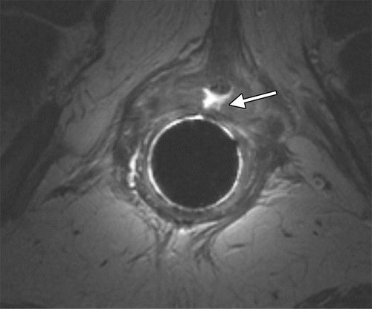

A: A rectovaginal fistula extending to the upper part of the vagina

B: A full-thickness tear in the internal anal sphincter

C: A perianal abscess

D: Bilateral puborectalis atrophy

E: Signs of diverticulitis, such as intramural edema and pericolonic inflammation

# Answer:

B: A full-thickness tear in the internal anal sphincter. The axial T2-weighted MR image obtained with endorectal coil placement in the figure shows a full-thickness tear, which is consistent with a severe episiotomy injury. This finding is in line with the patient's clinical presentation of being 8 months postpartum with a grade 4 episiotomy injury. The other options are less likely based on the provided figure and the patient's clinical context.

---Source:

Imaging and Surgical Management of Anorectal Vaginal Fistulas

---Original Figure Caption:

Figure 6a.Findings in a woman 8 months postpartum with a grade 4 episiotomy injury.(a)Axial T2-weighted MR image obtained with endorectal coil placement shows a full-thickness tear (arrow) in the internal anal sphincter at the 12-o’clock position.(b)Sagittal proctographic MR image shows two fistulas (arrowheads) to the vagina, which became widely patent during simulated defecation at MR proctography.(c)Axial fat-suppressed T2-weighted MR image shows how narrow even the upper anovaginal fistula lumen (arrow) is at rest. The patient underwent overlapping sphincteroplasty and ileostomy.

# Question 38:

A 55-year-old male patient presents with a history of recurrent perianal abscesses. An axial MR imaging is provided. According to the Parks classification, how would you classify the fistula observed in the image?

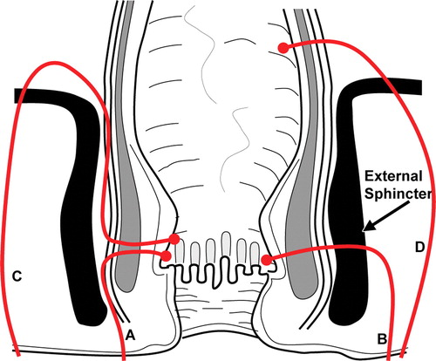

A: Intersphincteric

B: Transsphincteric

C: Suprasphincteric

D: Extrasphincteric

E: Not classifiable

# Answer:

The correct answer is C: Suprasphincteric. According to the Parks classification, a suprasphincteric fistula is characterized by a track that progresses upward into the intersphincteric space, passes over the top of the puborectalis muscle, then descends through the levator plate to the ischiorectal fossa. This classification is based on the course of the fistula and its relationships to the internal and external sphincters. The image should demonstrate these characteristics to classify the fistula as suprasphincteric.

---Source:

MR Imaging Evaluation of Perianal Fistulas_ Spectrum of Imaging Features

---Original Figure Caption:

Figure 7Parks classification. Drawing of the anal canal in the coronal plane shows the Parks classification of perianal fistulas.A= intersphincteric,B= transsphincteric,C= suprasphincteric,D= extrasphincteric. The external sphincter is the keystone of the Parks classification.

# Question 39:

A 40-year-old man presents with symptoms of hypoglycemia. An intraoperative ultrasound is provided in the figure above. What is the most likely diagnosis based on the patient's symptoms?

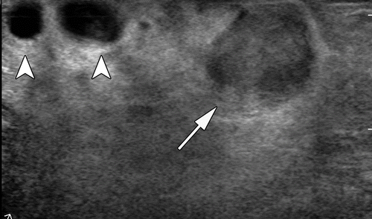

A: Ductal adenocarcinoma of the pancreas

B: Hepatic metastasis from panNEC

C: Intrapancreatic splenule

D: Insulinoma

E: Gastrinoma

# Answer:

The correct answer is D: Insulinoma. Insulinomas are neuroendocrine tumors of the pancreas that produce insulin, leading to symptoms of hypoglycemia like the ones this patient is experiencing. The figure provides an intraoperative ultrasound image from a 40-year-old man with an insulinoma. The clear relationship of the mass to the adjacent vessels, which is a crucial factor in surgical planning, can be deduced from the figure. Other options like ductal adenocarcinoma of the pancreas, hepatic metastasis from panNEC, intrapancreatic splenule, and gastrinoma are less likely based on the patient's symptoms.

---Source:

Pancreatic Neuroendocrine Neoplasms_ 2020 Update on Pathologic and Imaging Findings and Classification

---Original Figure Caption:

Figure 3a.Intraoperative US in management of panNEN.(a)Intraoperative US image in a 40-year-old man with an insulinoma shows a well-defined hypoechoic mass (arrow) in the pancreas and its clear relationship to the adjacent vessels (arrowheads).(b)Intraoperative US image in a 55-year-old man with hepatic metastasis from panNEC shows a targetoid lesion in the liver with a central hyperechoic area and a peripheral hypoechoic halo (arrow).

# Question 40:

A 25-year-old man with VHL syndrome presents with abdominal pain. An axial gadolinium-enhanced T1-weighted MR image of the abdomen is provided. What is the most likely diagnosis for this patient?

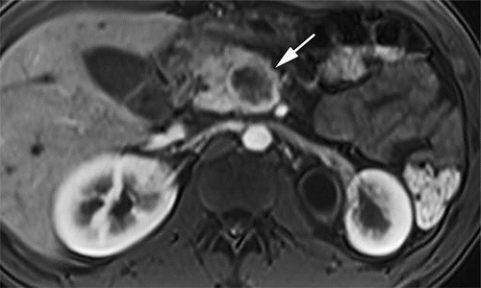

A: Gastrinoma

B: Serous cystadenoma

C: High-grade panNEC

D: Renal cell carcinoma

E: Hemangioblastoma of the central nervous system

# Answer:

The correct answer is C, High-grade panNEC. Although VHL syndrome can present with various pancreatic manifestations including multiple simple pancreatic cysts, serous cystadenomas, and panNETs, the presence of a heterogeneously enhancing mass in the pancreas is suggestive of a panNEC. Gastrinoma (Option A) is associated with MEN1 syndrome, not VHL. Serous cystadenoma (Option B) is a possibility in VHL, but the provided figure does not show a cystic lesion. Renal cell carcinoma (Option D) and hemangioblastoma of the central nervous system (Option E) are other manifestations of VHL, but they are not related to the pancreas.

---Source:

Pancreatic Neuroendocrine Neoplasms_ 2020 Update on Pathologic and Imaging Findings and Classification

---Original Figure Caption:

Figure 11b.PanNENs in two patients with VHL syndrome.(a)Axial gadolinium-enhanced T1-weighted MR image in a 34-year-old man with VHL syndrome shows multiple hyperenhancing masses (arrows) that are suggestive of panNETs. A few cysts (arrowhead) are also seen in the right kidney.(b)Axial gadolinium-enhanced T1-weighted MR image in a 25-year-old man with VHL syndrome shows a heterogeneously enhancing mass (arrow) in the pancreas. This mass was proven to be a high-grade panNEC at surgical resection.

# Question 41:

A 44-year-old woman presents with a history of Crohn's disease and a vaginal discharge, which was initially interpreted as a perianal fistula on MRI. An MRI of the area is provided in Figure 5b. Based on the imaging findings, what is the most likely diagnosis?

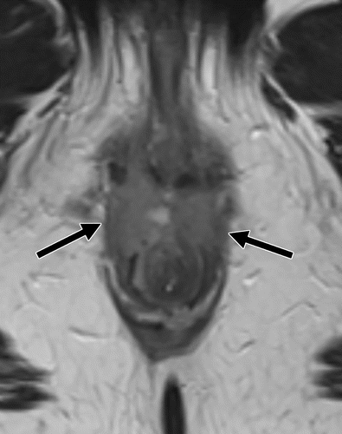

A: Crohn's disease–related anorectal-vaginal fistula

B: Crohn's disease–related postoperative pouch-vaginal fistula

C: Squamous cell carcinoma

D: Rectal cancer

E: Uterine cancer

# Answer:

The correct answer is C. Squamous cell carcinoma. The MRI shows an intermediate-signal-intensity soft-tissue mass involving the anterior portions of the internal and external sphincters and extending inferiorly into the perianal fat, with internal enhancement and associated restricted diffusion at diffusion-weighted imaging. These findings were initially interpreted as a perianal fistula but were later revealed to represent malignancy with a tumor fistula. A biopsy confirmed the diagnosis of squamous cell carcinoma. The patient subsequently underwent chemoradiation with proctectomy, which led to a complete disease response. While Crohn's disease can lead to various types of fistulas (options A and B), the imaging findings in this case were indicative of a malignancy rather than a fistula. Rectal and uterine cancers (options D and E) could also present with similar symptoms, but the specific imaging findings in this case were more consistent with squamous cell carcinoma.

---Source:

Imaging and Surgical Management of Anorectal Vaginal Fistulas

---Original Figure Caption:

Figure 5b.Crohn colitis in a 44-year-old woman who was presumed to also have perianal disease owing to a vaginal discharge, which was initially and erroneously interpreted at MRI to indicate a perianal fistula.(a)Sagittal fat-saturated T2-weighted fast spin-echo MR image shows a fluid-filled fistula (arrows) posterior to the lower region of the vagina and introitus (arrowhead).(b, c)Axial fast spin-echo T2-weighted MR images show an intermediate-signal-intensity soft-tissue mass (arrows inb) involving the anterior portions of the internal and external sphincters and extending inferiorly into the perianal fat, with internal enhancement (arrows inc), as well as increased signal intensity atb= 400 sec/mm2(top inset inc) and associated restricted diffusion (bottom inset inc) at diffusion-weighted imaging. These findings were believed to represent malignancy with a tumor fistula. Biopsy revealed squamous cell carcinoma. The patient subsequently underwent chemoradiation with proctectomy, which led to a complete disease response.

# Question 42:

A 45-year-old female patient presents with a history of urinary incontinence. Based on the axial illustration of normal pelvic floor anatomy presented in the provided figure, which of the following structures separates the lower part of the vagina from the anal sphincters?

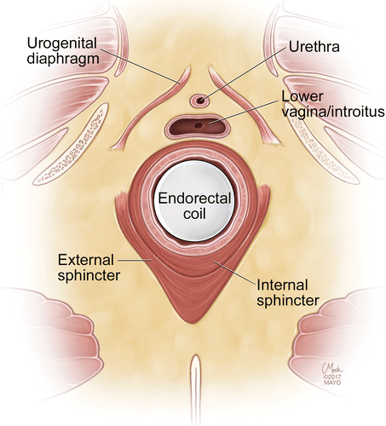

A: Urogenital diaphragm

B: Perineal body

C: External sphincter

D: Internal sphincter

E: Puborectalis muscle

# Answer:

Option B, the Perineal body, is the correct answer. The perineal body is a fibromuscular mass located in the midline perineum at the junction of the anal and urogenital triangles, as described in the context. This structure separates the lower part of the vagina from the anal sphincters, playing a crucial role in urinary continence. The other options, such as the urogenital diaphragm, external sphincter, internal sphincter, and puborectalis muscle, are also important components of the pelvic floor anatomy but do not serve the specific function of separating the lower part of the vagina from the anal sphincters.

---Source:

Imaging and Surgical Management of Anorectal Vaginal Fistulas

---Original Figure Caption:

Figure 1c.Normal pelvic floor anatomy.(a)Sagittal illustration shows the normal anatomy. (Reprinted, with permission, from Mayo Foundation for Medical Education and Research.)(b)Sagittal T2-weighted MR image shows gel distending the rectum(R)and vagina(V). DL= dentate line,ES= external sphincter,IS= internal sphincter,U= urethra.(c)Axial illustration shows the normal anatomy. (Reprinted with permission, from Mayo Foundation for Medical Education and Research.)(d, e)Axial T2-weighted MR images obtained with an endorectal coil.ES= external sphincter,ICL= ileococcygeal component of levator plate,IS= internal sphincter,LV/I= lower region of vagina at the introitus,PR= puborectalis muscle,U= urethra,UGD= urogenital diaphragm,V= vagina.

# Question 43:

A 68-year-old woman presents with a history of recurrent right upper quadrant pain. Based on the MRI findings provided in the figure, what is the most likely diagnosis?

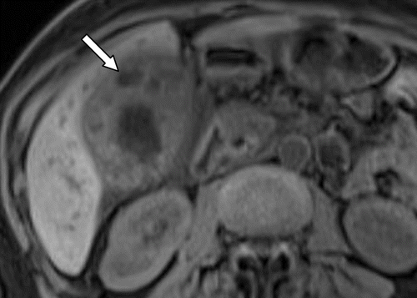

A: Acute cholecystitis

B: Gallbladder carcinoma

C: Xanthogranulomatous cholecystitis

D: Chronic cholecystitis

E: Hyalinizing cholecystitis

# Answer:

The correct answer is C: Xanthogranulomatous cholecystitis. This is a rare form of chronic cholecystitis characterized by intramural nodules. The context describes the MRI findings for this condition as having intermediate to mild high signal intensity on T2-weighted images, with areas of slight enhancement on early-phase images and persistent enhancement on late-phase images, corresponding to areas with fibrosis related to the xanthogranulomas. The figure shows a heterogeneously thickened gallbladder wall with multiple intramural lesions (arrows) and hypointense cystic foci (arrow), which are characteristics of Xanthogranulomatous cholecystitis.

---Source:

Gallbladder Carcinoma and Its Differential Diagnosis at MRI_ What Radiologists Should Know

---Original Figure Caption:

Figure 9b.Xanthogranulomatous cholecystitis in a 68-year-old woman.(a)Axial T2-weighted image shows a heterogeneously thickened gallbladder wall with multiple intramural lesions (arrows), which are iso- or hyperintense.(b)Axial T1-weighted image shows hypointense cystic foci (arrow).(c, d)Axial early(c)and delayed(d)contrast-enhanced T1-weighted images show mild arterial and marked delayed enhancement surrounding the cystic foci (long arrow). There is mild surrounding hepatic parenchymal enhancement (short arrow), which is likely reactive.

# Question 44:

A 67-year-old woman presents with a splenic mass. Based on the imaging characteristics provided in the figure, which of the following is the most likely diagnosis?

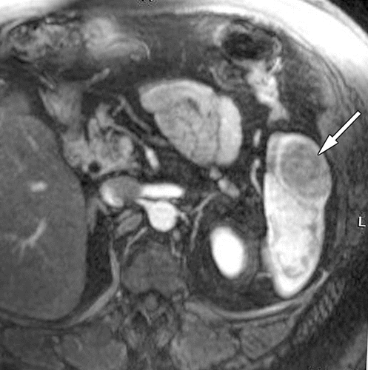

A: Mucinous cystadenocarcinoma

B: Heterotopic pancreas

C: Insulinoma with lymph node metastasis

D: Mucinous cystadenoma

E: Ectopic intestinal tissue

# Answer:

B: Heterotopic pancreas. The figure shows a hypoattenuating mass in the spleen, which is hypointense on the T2-weighted image, slightly hyperintense on the nonenhanced T1-weighted image, and hypovascular relative to the spleen in the arterial phase, with progressive contrast material retention, in the equilibrium phase. These characteristics match those of a heterotopic pancreas. While other options could theoretically present as splenic masses, the specific imaging characteristics depicted in the figure are most consistent with a heterotopic pancreas. For example, mucinous cystadenocarcinomas and mucinous cystadenomas usually manifest as complex masses containing cystic mucin-filled compartments and solid components, which is not consistent with the imaging findings in the figure. An insulinoma would typically show up as a hyperenhancing lesion, which is also inconsistent with the figure. Ectopic intestinal tissue, while a possibility, is less likely given the imaging findings and the rarity of this condition.

---Source:

Heterotopic Pancreas_ Histopathologic Features, Imaging Findings, and Complications

---Original Figure Caption:

Figure 8d.Splenic heterotopic pancreas in a 67-year-old woman.(a)Axial contrast-enhanced CT image shows a hypoattenuating mass (arrow) in the spleen.(b–e)Axial T2-weighted(b)and T1-weighted(c)fat-saturated MR images and contrast-enhanced fat-saturated T1-weighted MR images in the arterial(d)and equilibrium(e)phases show a solid, round, subcapsular splenic mass (arrow). The mass is hypointense on the T2-weighted image, slightly hyperintense on the nonenhanced T1-weighted image, and hypovascular relative to the spleen in the arterial phase, with progressive contrast material retention, in the equilibrium phase.

# Question 45:

An 80-year-old woman with a history of chronic atrial fibrillation, aortic valve replacement, and recent spinal fusion surgery, who is on enoxaparin and warfarin, presents with overt upper GI bleeding. Axial and coronal portal venous phase CT images are provided. What is the most likely cause of the bleeding in this patient?

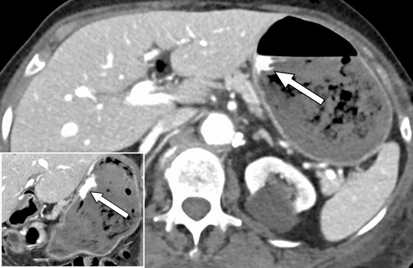

A: Gastroesophageal varices due to portal hypertension

B: Mallory-Weiss tears in the distal esophagus

C: Bleeding from a Dieulafoy lesion

D: Bleeding from a gastric ulcer

E: Bleeding from a marginal ulceration near the gastrojejunostomy site

# Answer:

The most likely cause of the bleeding in this patient is a gastric ulcer (Option D). The patient's history and the provided CT images should guide the examinee to this conclusion. The patient is elderly and has multiple risk factors for gastric ulcers, including the use of anticoagulants and recent surgery. Furthermore, the figure caption indicates contrast extravasation along the lesser curvature of the stomach, which is a common location for gastric ulcers. While the other options could theoretically cause GI bleeding, they are less likely in this clinical context. For example, gastroesophageal varices (Option A) are usually associated with cirrhosis and portal hypertension, which the patient does not have. Mallory-Weiss tears (Option B) are typically associated with vomiting or retching, not mentioned in the patient's history. Dieulafoy lesions (Option C) are rare and would not be as well seen on portal venous phase images. Finally, the patient has not undergone a gastric bypass surgery, which makes marginal ulceration (Option E) an unlikely cause of bleeding.

---Source:

Gastrointestinal Bleeding at CT Angiography and CT Enterography_ Imaging Atlas and Glossary of Terms

---Original Figure Caption:

Figure 9.Gastric ulcer causing active bleeding in an 80-year-old woman receiving enoxaparin and warfarin for chronic atrial fibrillation and aortic valve replacement who underwent recent spinal fusion surgery. Axial (main image) and coronal (inset) portal venous phase CT images show contrast extravasation along the lesser curvature of the stomach (arrow in both images).Figure E1is an upper endoscopic image in this patient that shows an actively bleeding ulcer in the lesser curvature of the stomach.

# Question 46:

A 63-year-old man underwent a subtotal gastrectomy and a follow-up axial contrast-enhanced CT scan is provided. What could be a possible reason for the misinterpretation of the postoperative changes?

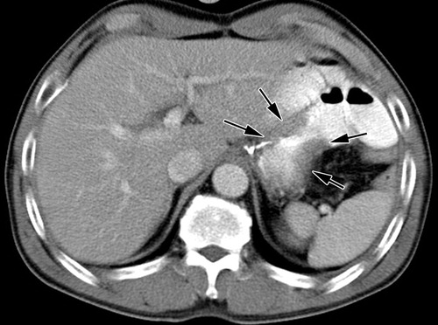

A: Improperly distended bowel loops

B: Surgical plication

C: Bowel adhesion

D: Reflux gastritis

E: Presence of benign gastric ulcer

# Answer:

The correct answer is B: 'Surgical plication'. In the context of postoperative changes following a subtotal gastrectomy, surgical plication could lead to the appearance of gastric wall thickening in a CT scan, potentially leading to misinterpretation. Improperly distended bowel loops (Option A), bowel adhesion (Option C), and reflux gastritis (Option D) are also potential sources of erroneous interpretation in the postoperative setting, but they are less likely to cause misinterpretation of postoperative changes as surgical plication. Presence of benign gastric ulcer (Option E) is not typically associated with postoperative changes following gastrectomy.

---Source:

CT and PET in Stomach Cancer_ Preoperative Staging and Monitoring of Response to Therapy

---Original Figure Caption:

Figure 15a.Local tumor recurrence following subtotal gastrectomy in a 63-year-old man.(a)Axial contrast-enhanced CT scan shows mild gastric wall thickening (arrows) at an anastomotic site. This finding was misinterpreted as a postoperative change (possibly plication-induced fibrotic change or reflux gastritis).(b)Axial PET scan shows prominent increased FDG uptake (arrows) in the anastomotic site. Cancer recurrence was proved at histologic analysis of tissue obtained at endoscopic biopsy.

# Question 47:

A 63-year-old man with irritable bowel syndrome and arthritis, on chronic NSAID treatment, presents with occult GI bleeding and inconclusive findings at endoscopy. Coronal CTE images of the patient are provided. Based on the imaging findings, which of the following is the most likely diagnosis?

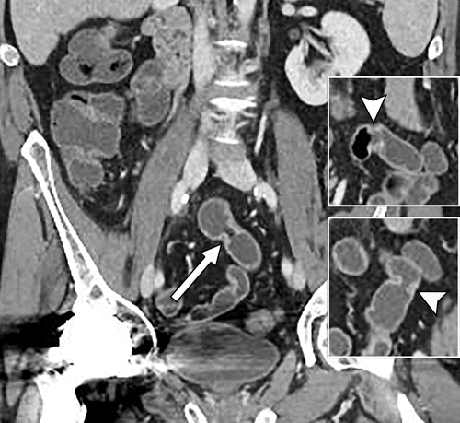

A: Crohn's disease

B: Radiation-induced strictures

C: Cryptogenic multifocal ulcerous stenosing enteritis

D: NSAID Enteropathy

E: Small bowel neoplasm

# Answer:

The correct diagnosis is D, NSAID Enteropathy. NSAID Enteropathy is characterized by multiple short-segment, or diaphragm-like strictures that tend to be clustered within the same region or segment of the bowel, usually in the ileum. The wall associated with the strictures is typically thickened and hyperenhancing. This is consistent with the patient's history of chronic NSAID treatment and the imaging findings in the CTE images. The other options, such as Crohn's disease, radiation-induced strictures, cryptogenic multifocal ulcerous stenosing enteritis, and small bowel neoplasm, are less likely due to the specific presentation and imaging findings associated with NSAID Enteropathy.

---Source:

Gastrointestinal Bleeding at CT Angiography and CT Enterography_ Imaging Atlas and Glossary of Terms

---Original Figure Caption:

Figure 29.NSAID enteropathy in a 63-year-old man with irritable bowel syndrome and arthritis and chronic NSAID treatment who presented with occult GI bleeding and inconclusive findings at endoscopy (not shown). Coronal CTE images show three of the multiple diaphragm-like strictures that were present in the mid small bowel (arrow in main image, arrowhead in top and bottom inset), which are consistent with stricturing related to NSAID enteropathy.

# Question 48:

A patient presents with bright red blood in the rectum. A CT image is provided. Based on the imaging findings, which of the following is the most likely diagnosis?

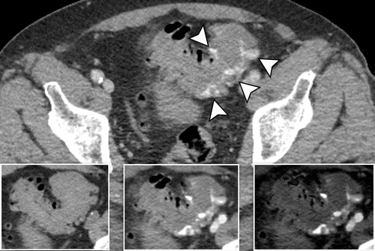

A: Colonic Ischemia

B: Anorectal Disease

C: Acute Diverticular Bleed in the Sigmoid Colon

D: GI or Suspected Small Bowel Bleeding

E: Mesenteric Venous Thrombosis

# Answer:

The correct answer is C: Acute Diverticular Bleed in the Sigmoid Colon. The figure shows multiple foci of contrast extravasation in the sigmoid colon and diffuse sigmoid diverticulosis, some containing extravasated contrast material. This is indicative of an acute diverticular bleed in the sigmoid colon. The other options are less likely based on the provided image and the patient's presentation. Colonic Ischemia (Option A) typically results in bowel wall thickening and pericolonic fat stranding, which is not evident in the image. Anorectal Disease (Option B) usually presents with enlarged serpiginous veins within the anus and lower rectum, which is not the case here. GI or Suspected Small Bowel Bleeding (Option D) and Mesenteric Venous Thrombosis (Option E) would not present with the specific contrast extravasation in the sigmoid colon as seen in the figure.

---Source:

Gastrointestinal Bleeding at CT Angiography and CT Enterography_ Imaging Atlas and Glossary of Terms

---Original Figure Caption:

Figure 8.Acute diverticular bleed in the sigmoid colon on dual-energy CT images in a 72-year-old man who presented with bright red blood in the rectum. Axial portal venous phase mixed (blended) CT image (main image) shows multiple foci of contrast extravasation in the sigmoid colon (arrowheads) and diffuse sigmoid diverticulosis, some containing extravasated contrast material. Axial noncontrast CT image (left inset) shows hyperattenuating bowel contents in the sigmoid colon. Axial postprocessed monoenergetic 50-keV image (middle inset) and iodine map image (right inset) show contrast extravasation that is more conspicuous at the lower kiloelectron voltage setting and on the iodine map than on the mixed (blended) image.

# Question 49:

A 38-year-old woman presents with abdominal pain and discomfort. A contrast-enhanced CT scan of the abdomen is provided. Based on the imaging findings, what is the most likely diagnosis?

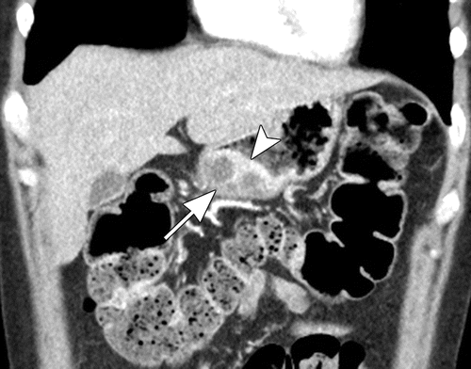

A: Gastric carcinoma

B: Gastric pancreatic heterotopia complicated by pseudocyst formation

C: Gastric lymphoma

D: Gastric peptic ulcer disease

E: Gastric diverticulum

# Answer:

The correct diagnosis is B, Gastric pancreatic heterotopia complicated by pseudocyst formation. Gastric pancreatic heterotopia is a congenital anomaly where pancreatic tissue is found separate from the main gland. The CT scan shows an intramural mass along the greater curvature of the gastric antrum, which is a common location for this condition. The mass is intensely enhancing and contains multiple small internal cystic areas, a characteristic of this condition. The hyperenhancement of the overlying gastric mucosa further supports this diagnosis. The other options are less likely because they do not typically present with these specific imaging findings.

---Source:

Heterotopic Pancreas_ Histopathologic Features, Imaging Findings, and Complications

---Original Figure Caption:

Figure 11b.Gastric pancreatic heterotopia complicated by pseudocyst formation in a 38-year-old woman. Axial(a)and coronal(b)contrast-enhanced CT images show an intramural mass (arrow) along the greater curvature of the gastric antrum. Similar to the normal pancreatic tissue, the mass is intensely enhancing and contains multiple small internal cystic areas. Also note the hyperenhancement of the overlying gastric mucosa (arrowhead inb) and the endoluminal growth pattern of the lesion.

# Question 50:

A 57-year-old woman underwent treatment for rectal adenocarcinoma that had invaded the vagina. Post-treatment axial T2-weighted MR images are provided. What is the most likely outcome based on these images?

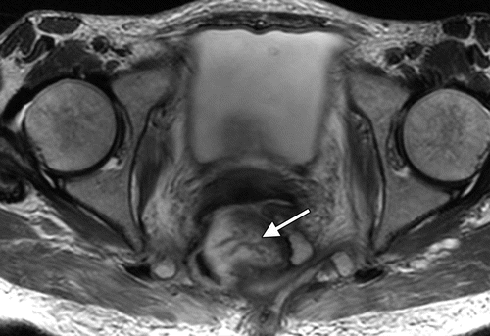

A: Complete resolution of the fistula and rectal mass

B: Persistence of the fistula with substantial loss of the right lateral and anterior rectal walls

C: Development of an anovaginal fistula

D: Complete recovery with no loss of rectal and vaginal tissue

E: Development of a colovaginal fistula due to diverticulitis

# Answer:

The correct answer is B, 'Persistence of the fistula with substantial loss of the right lateral and anterior rectal walls'. The figure shows a marked treatment response in the tumor, however, the fistula persists, resulting in a loss of substantial portions of the right lateral and anterior rectal walls, with destruction of the vagina and right piriformis muscle. This is indicative of the aggressive nature of the disease and the extensive damage it has caused. The other options do not accurately reflect the post-treatment condition shown in the figure. Complete resolution of the fistula and rectal mass (Option A) and complete recovery with no loss of rectal and vaginal tissue (Option D) are not observed in the figure. Development of an anovaginal fistula (Option C) and a colovaginal fistula due to diverticulitis (Option E) are not mentioned in the figure caption or the context, and are therefore not relevant to the question.

---Source:

Imaging and Surgical Management of Anorectal Vaginal Fistulas

---Original Figure Caption:

Figure 9c.Rectal adenocarcinoma invading the vagina in a 57-year-old woman.(a, b)Sagittal(a)and axial(b)T2-weighted MR images show a heterogeneous predominantly T2-hyperintense rectal mass invading the middle to upper region of the vagina and thus causing an enormous fistula (☆). The patient underwent radiation therapy.(c)Subsequently obtained axial T2-weighted MR image shows a marked treatment response in the tumor (arrow). Persistence of the fistula resulted in a loss of substantial portions of the right lateral and anterior rectal walls, with destruction of the vagina and right piriformis muscle. Permanent diverting colostomy was recommended; however, the patient selected incontinence rather than diversion.