**AI-Generated Short Answer Questions from  
RadioGraphics Top 10 Reading List  
(Gastrointestinal Imaging - R4)**

# Question 1:

A 65-year-old man presents with right upper quadrant pain and weight loss. An axial T2-weighted image and early contrast-enhanced T1-weighted image are provided. Based on the imaging findings, what is the likely N category of his condition according to the AJCC Manual?

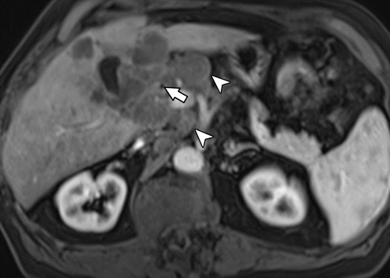

# Answer:

N2

---Source:

Gallbladder Carcinoma and Its Differential Diagnosis at MRI_ What Radiologists Should Know

---Original Figure Caption:

Figure 6b.Suspicious lymph nodes in a 65-year-old man with right upper quadrant pain and weight loss.(a, b)Axial T2-weighted image(a)and early contrast-enhanced T1-weighted image(b)show a gallbladder mass (arrow) invading the liver with extensive lymphadenopathy, including paraceliac nodes (arrowheads).(c)Axial contrast-enhanced T1-weighted image shows a ring-enhancing liver lesion (arrow) from metastasis.

# Question 2:

A 55-year-old patient presents with weight loss and abdominal pain. Based on the CT scan provided in the figure, which adjacent organ is being invaded by the stage T4 gastric tumor?

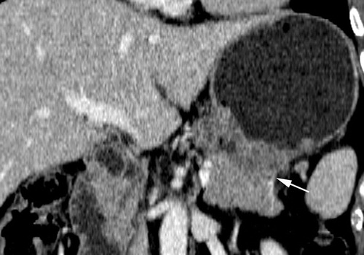

# Answer:

Distal pancreatic body

---Source:

CT and PET in Stomach Cancer_ Preoperative Staging and Monitoring of Response to Therapy

---Original Figure Caption:

Figure 1e.Stage T1–T4 gastric tumors.(a)Coronal reformatted image shows a stage T1 tumor (arrows) with focal nontransmural enhancement in the upper body.(b)Axial CT scan shows a stage T2 tumor (arrow), a localized, transmurally enhancing ulcerative mass without perigastric extension, in the lower body.(c)Coronal reformatted image shows a stage T3 tumor (arrows), with gross infiltration of the perigastric fat tissue in the antrum.(d)Axial CT scan shows a stage T4 tumor with invasion of the colon. The tumor represents an advanced cancer of the antrum and is accompanied by obliteration of the fat plane and thickening of the colonic wall (arrows).(e)Coronal reformatted image shows a stage T4 tumor (arrow) infiltrating the distal pancreatic body.(f)Axial CT scan shows a stage T4 tumor (arrows), an advanced cancer with gross infiltration of the lateral segment of the liver.

# Question 3:

A 49-year-old woman presents with abdominal pain. A coronal CT image of her abdomen is provided. What is the likely diagnosis?

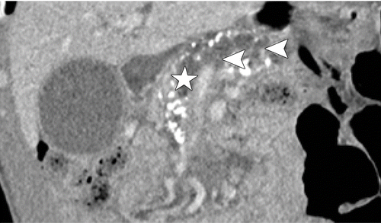

# Answer:

PDAC (Pancreatic Ductal Adenocarcinoma)

---Source:

Chronic Pancreatitis or Pancreatic Tumor_ A Problem-solving Approach

---Original Figure Caption:

Figure 6b.PDAC and chronic pancreatitis in a 49-year-old woman.(a)Axial CT image shows an ill-defined and slightly hypoattenuating mass in the pancreatic head (circle), peripheral displacement of calcifications (yellow arrow), an SMA-to-SMV (red and blue arrows, respectively) ratio of almost 1, and a teardrop sign in the SMV. The perivascular fat planes are invaded by the mass (white arrow).(b)Coronal CT image shows the dilated pancreatic duct (☆) and side branches (arrowheads).(c)Axial CT image shows the dilated common bile duct (double arrows).

# Question 4:

A 63-year-old woman undergoes an axial T2-weighted imaging. What characteristic of a lesion would suggest it is gallbladder carcinoma rather than a gallstone?

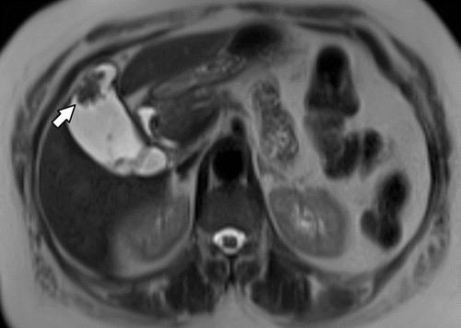

# Answer:

Enhancement after contrast material administration

---Source:

Gallbladder Carcinoma and Its Differential Diagnosis at MRI_ What Radiologists Should Know

---Original Figure Caption:

Figure 5a.Gallbladder carcinoma in a 63-year-old woman with an incidentally found polypoid gallbladder lesion.(a)Axial T2-weighted image shows a 2.3-cm hypointense polypoid gallbladder lesion (arrow).(b)Axial contrast-enhanced T1-weighted image shows enhancement of the polypoid mass (arrow). The mass was surgically proved to be gallbladder carcinoma (T2NXM0).

# Question 5:

A 64-year-old woman with a history of mucinous adenocarcinoma of the ovary presents for a follow-up CT scan. Based on the imaging findings, what has this been clinically diagnosed as?

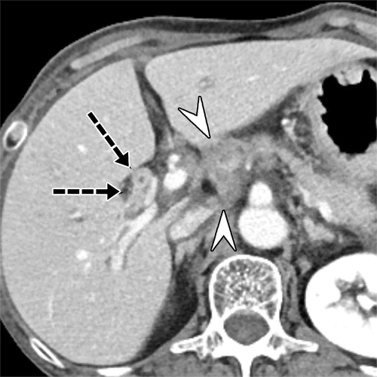

# Answer:

Biliary epithelium metastasis

---Source:

Liver Metastases_ Correlation between Imaging Features and Pathomolecular Environments

---Original Figure Caption:

Figure 21.Biliary epithelium metastasis in a 64-year-old woman with a history of mucinous adenocarcinoma of the ovary 5 years previously. Axial portal phase CT image shows an intrahepatic bile duct (arrows) with diffuse thickening; this was clinically diagnosed as biliary epithelium metastasis. Multiple lymph node metastases (arrowheads) in the hepatoduodenal ligament also are depicted.

# Question 6:

In the context of the normal anatomy of the anal canal, where do the anal glands open into?

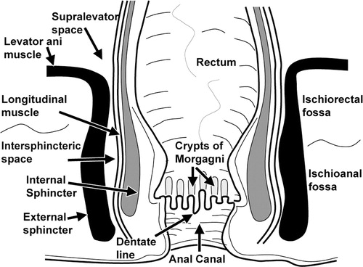

# Answer:

The base of the crypts of Morgagni

---Source:

MR Imaging Evaluation of Perianal Fistulas_ Spectrum of Imaging Features

---Original Figure Caption:

Figure 3Drawing shows the normal anatomy of the anal canal in the coronal plane.

# Question 7:

In the context of tumor metastasis progression as depicted in the provided figure, which cells transform into cancer-associated fibroblasts and induce liver fibrosis after fusing with organ-specific exosomes effused by the primary tumor?

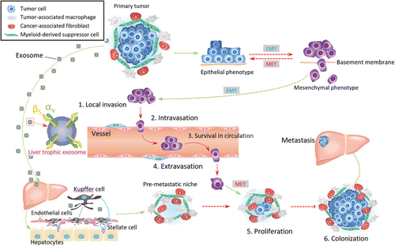

# Answer:

Kupffer cells

---Source:

Liver Metastases_ Correlation between Imaging Features and Pathomolecular Environments

---Original Figure Caption:

Figure 1.Tumor microenvironment and premetastatic niche formed by means of tumor exosome effusion during metastasis progression. The tumor microenvironment is composed of tumor-associated macrophages, cancer-associated fibroblasts, and myeloid-derived suppressor cells in addition to tumor cells. Tumor exosomes derived from the primary cancer are seen as small gray circles. A magnification of one exosome is shown together with integrins αv and β5 (left side of figure). The primary tumor antecedently consolidates the microenvironment of the metastatic site by effusing organ-specific exosomes that preferentially fuse with Kupffer cells, which transform hepatic stellate cells into cancer-associated fibroblasts and induce liver fibrosis; this process is formation of a premetastatic niche. Metastatic tumor progression is divided into six major steps:1.Invasion of the basement membrane and cell migration.2.Intravasation into the surrounding vasculature or lymphatic system.3.Survival in the circulation.4.Extravasation from the vasculature to secondary tissues.5.Proliferation at the distant location.6.Colonization at secondary tumor sites.EMT= epithelial-to-mesenchymal transition,MET= mesenchymal-to-epithelial transition.

# Question 8:

In the procedure illustrated in the figure, after the fistula is ligated and the Martius flap is created, what anatomical structure is the flap gently transferred through?

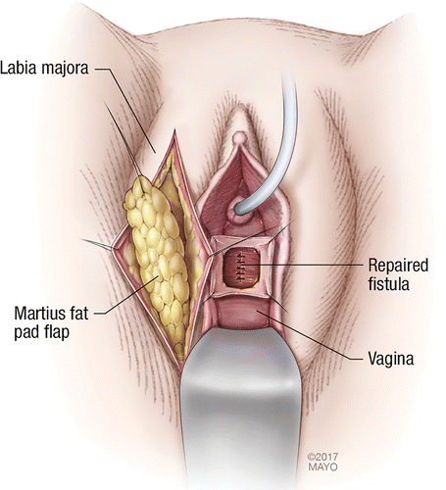

# Answer:

Vaginal opening

---Source:

Imaging and Surgical Management of Anorectal Vaginal Fistulas

---Original Figure Caption:

Figure 16a.Drawings illustrate the creation of a Martius modified labial fat pad flap, or Martius flap.(a)After the fistula is ligated, a Martius flap is created by making an incision on the labium majus pudendi to expose the fat pad underneath. Gentle dissection to free the fat pad is performed while staying lateral to the bulbocavernosus and ischiocavernosus muscles.(b)A tunnel connecting the pedicle of the fat pad to the vaginal opening is formed with blunt dissection, and the flap is gently transferred through. A catheter is present in the urethra. (Reprinted, with permission, from Mayo Foundation for Medical Education and Research.)

# Question 9:

A 53-year-old woman presents with abdominal discomfort. An axial contrast-enhanced fat-suppressed T1-weighted image of the gallbladder is provided in the figure. What characteristic of the mass's enhancement can help distinguish it from gallbladder cancer?

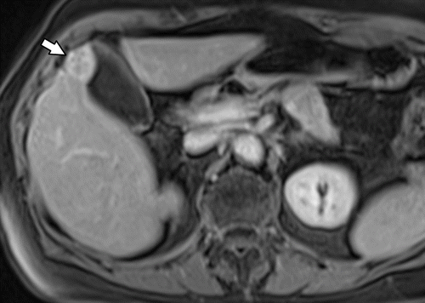

# Answer:

Homogeneous enhancement

---Source:

Gallbladder Carcinoma and Its Differential Diagnosis at MRI_ What Radiologists Should Know

---Original Figure Caption:

Figure 11c.Gallbladder adenomyoma mimicking gallbladder cancer in a 53-year-old woman.(a)Axial T2-weighted image shows a focal mass (arrow) in the fundus that is hypointense with areas of high signal intensity from dilated Rokitansky-Aschoff sinuses.(b)Axial fat-suppressed T1-weighted image shows that the mass (arrow) has a focus of higher signal intensity.(c)Axial contrast-enhanced fat-suppressed T1-weighted image shows that the mass (arrow) has fairly homogeneous enhancement, from hypervascular focal fundal adenomyomatosis mimicking gallbladder cancer.(d)Image from MR cholangiopancreatography shows the characteristic outpouchings from dilated Rokitansky-Aschoff sinuses (arrow), which distinguish the lesion from cancer.

# Question 10:

In the context of a gracilis flap repair for a rectovaginal fistula, what is the role of the harvested gracilis muscle as seen in the provided figure?

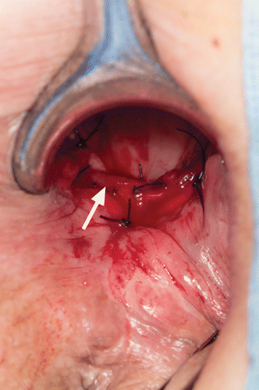

# Answer:

It is interposed between the rectum and vagina and sutured in place

---Source:

Imaging and Surgical Management of Anorectal Vaginal Fistulas

---Original Figure Caption:

Figure 18b.Gracilis flap repair.(a)Photograph shows the left thigh of a patient in the modified lithotomy position, with mobilization of the gracilis muscle (☆).(b)The muscle is advanced by way of a transperineal approach, interposed between the rectum and vagina, and sutured in place with use of an incision at the rectovaginal septum (arrow). All steps are performed through the vagina.

# Question 11:

In the context of the provided figure, a 43-year-old man presents with a heterotopic pancreas complicated by acute pancreatitis. What is the common computed tomographic appearance of heterotopic pancreas?

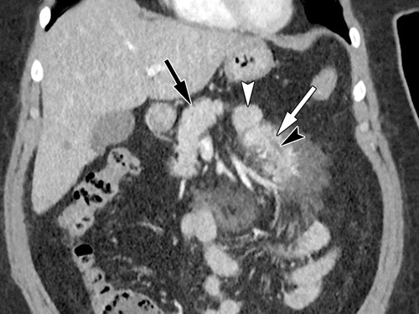

# Answer:

Small oval intramural mass with microlobulated margins and an endoluminal growth pattern

---Source:

Heterotopic Pancreas_ Histopathologic Features, Imaging Findings, and Complications

---Original Figure Caption:

Figure 7.Mesenteric heterotopic pancreas complicated by acute pancreatitis in a 43-year-old man. Coronal contrast-enhanced CT image shows an elongated mass (white arrow) in the jejunal mesentery with surrounding fat stranding. The mass has a broad base intimately associated with a jejunal loop (white arrowhead) and tapers as it extends into the mesentery. Although the heterotopic tissue is anatomically separate from the orthotopic pancreas (black arrow), it has similar morphology and enhancement. A ductlike structure (black arrowhead) is seen paralleling the long axis of the mass. (Image courtesy of Aarti Sekhar, MD, Emory University, Atlanta, Ga.)

# Question 12:

A 38-year-old woman presents with abdominal discomfort. A contrast-enhanced CT image of the abdomen is provided. Based on the imaging findings, what is the most likely diagnosis?

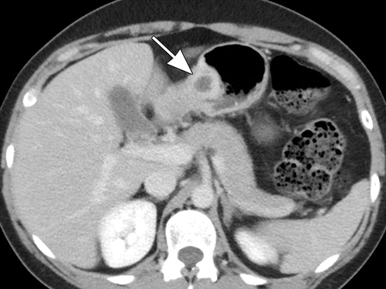

# Answer:

Gastric pancreatic heterotopia

---Source:

Heterotopic Pancreas_ Histopathologic Features, Imaging Findings, and Complications

---Original Figure Caption:

Figure 11a.Gastric pancreatic heterotopia complicated by pseudocyst formation in a 38-year-old woman. Axial(a)and coronal(b)contrast-enhanced CT images show an intramural mass (arrow) along the greater curvature of the gastric antrum. Similar to the normal pancreatic tissue, the mass is intensely enhancing and contains multiple small internal cystic areas. Also note the hyperenhancement of the overlying gastric mucosa (arrowhead inb) and the endoluminal growth pattern of the lesion.

# Question 13:

A 64-year-old man with follicular lymphoma, who had a partial response to chemotherapy, is presented. The follow-up axial portal phase CT image is provided in the figure. What is the likely diagnosis given the absence of the vessel-penetrating sign?

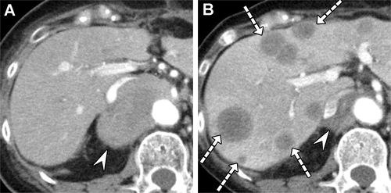

# Answer:

Metastatic sarcomatoid carcinoma of the small intestine

---Source:

Liver Metastases_ Correlation between Imaging Features and Pathomolecular Environments

---Original Figure Caption:

Figure 16.Multiple hepatic masses in a 64-year-old man with follicular lymphoma who had a partial response to chemotherapy.(A)Pretreatment axial arterial phase CT image shows a well-circumscribed hypovascular mass (arrowhead) in the aortocaval space.(B)Follow-up axial portal phase CT image shows multiple new low-attenuation hepatic masses (arrows), which lack the vessel-penetrating sign, and an interval decrease in the size of the lymphoma (arrowhead) after chemotherapy. This finding suggested a new primary malignancy rather than hepatic lymphoma and was proven to be metastatic sarcomatoid carcinoma of the small intestine (not shown).

# Question 14:

A 52-year-old man with a history of mucinous adenocarcinoma of the sigmoid colon presents with new onset abdominal pain. Based on the imaging findings in the provided figure, what type of liver lesions are most likely present?

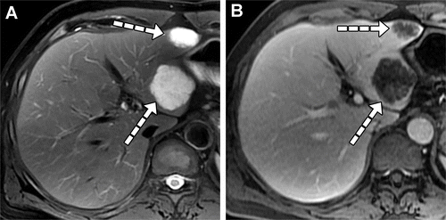

# Answer:

Liver metastases

---Source:

Liver Metastases_ Correlation between Imaging Features and Pathomolecular Environments

---Original Figure Caption:

Figure 12.Liver metastases in a 52-year-old man with mucinous adenocarcinoma of the sigmoid colon.(A)Axial fat-suppressed T2-weighted image shows liver metastases (arrows) with marked hyperintensity due to abundant mucin.(B)Axial portal phase MR image shows liver metastases (arrows) with poor but reticular enhancement.

# Question 15:

A 71-year-old woman presents with abdominal pain. Based on the axial contrast-enhanced T1-weighted image provided in the figure, what characteristic sign, relating to the gallbladder, might you expect to see on T2-weighted images?

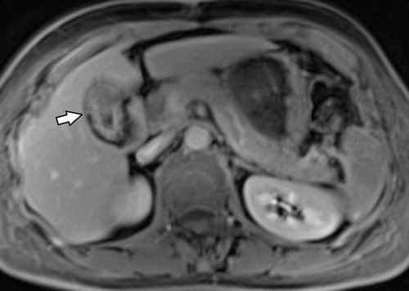

# Answer:

Pearl necklace sign

---Source:

Gallbladder Carcinoma and Its Differential Diagnosis at MRI_ What Radiologists Should Know

---Original Figure Caption:

Figure 12a.Adenomyomatosis in a 71-year-old woman.(a)Axial contrast-enhanced T1-weighted image shows apparent gallbladder wall thickening (arrow).(b)Image from MR cholangiopancreatography shows the “pearl necklace” sign (arrows), which refers to the characteristically curvilinear arrangement of multiple round hyperintense outpouchings.

# Question 16:

A 49-year-old man presents with abdominal cramps and blood in the stool. A coronal dual-energy mixed CT image is provided. Based on the imaging findings, what is the most likely diagnosis?

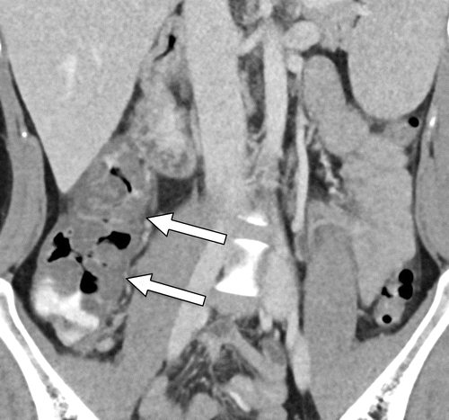

# Answer:

Hemorrhagic Escherichia coli colitis

---Source:

Gastrointestinal Bleeding at CT Angiography and CT Enterography_ Imaging Atlas and Glossary of Terms

---Original Figure Caption:

Figure 26.HemorrhagicEscherichia colicolitis in a 49-year-old man who presented with abdominal cramps and blood in the stool. Coronal dual-energy mixed (blended) CT image shows marked cecal and ascending colonic wall thickening, with associated pericolonic fat stranding (arrows). High-attenuation intraluminal fluid in the colon was likely ingested material, given its presence on virtual noncontrast images (not shown). Clinically, the patient was found to have hemorrhagicE colicolitis.

# Question 17:

A 40-year-old man undergoes an Axial T2-weighted MRI of the pancreas. Based on the imaging findings, what is the most likely diagnosis?

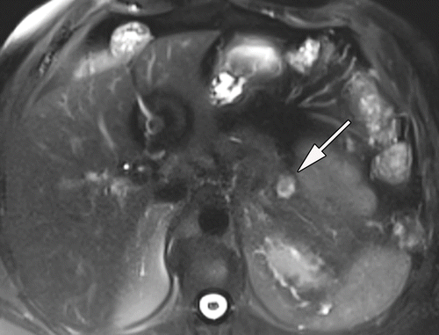

# Answer:

Well-differentiated panNET

---Source:

Pancreatic Neuroendocrine Neoplasms_ 2020 Update on Pathologic and Imaging Findings and Classification

---Original Figure Caption:

Figure 1a.Well-differentiated panNET in a 40-year-old man.(a, b)Axial T2-weighted(a)and gadolinium-enhanced T1-weighted(b)MR images show a well-defined heterogeneously enhancing focal mass (arrow) in the pancreas.(c)Photograph of the sectioned gross specimen shows a well-defined intrapancreatic tumor with a few foci of hemorrhage (arrow).(d)Photomicrograph shows the uniform characteristic organoid and trabecular growth pattern of small relatively uniform tumor cells, which is consistent with a low-grade tumor. The tumor cells were strongly positive for chromogranin and had Ki-67 proliferation indices of less than 3 (not shown), which is consistent with a well-differentiated grade 1 panNET. (Hematoxylin-eosin stain; original magnification, ×40.)

# Question 18:

A 41-year-old man presents with duodenal outlet obstruction. Based on the axial fat-suppressed T2-weighted MR image provided in the figure, what specific imaging finding can be observed?

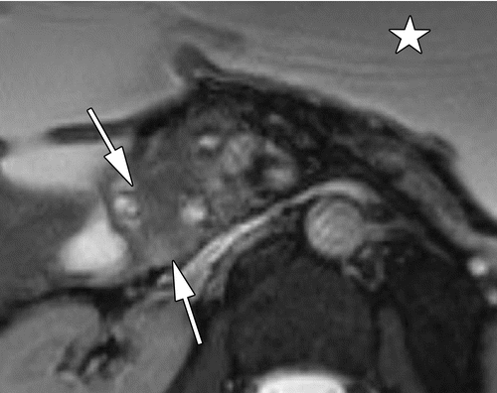

# Answer:

Ill-defined masslike thickening with intermediate signal intensity

---Source:

Chronic Pancreatitis or Pancreatic Tumor_ A Problem-solving Approach

---Original Figure Caption:

Figure 12a.Type 1 solid PDP (groove pancreatitis) in a 41-year-old man.(a)Axial fat-suppressed T2-weighted MR image shows an ill-defined masslike thickening of the medial duodenal wall, with intermediate signal intensity (arrows). At presentation, the patient was found to have duodenal outlet obstruction. Note the dilated stomach (☆).(b)Axial fat-suppressed T2-weighted MR image shows a predominantly solid masslike area in the pancreatic head and microcystic changes along the duodenal wall (arrow).

# Question 19:

In the context of paraduodenal pancreatitis, what imaging feature can be best differentiated on an axial fat-saturated T1-weighted MR image according to Figure 15c?

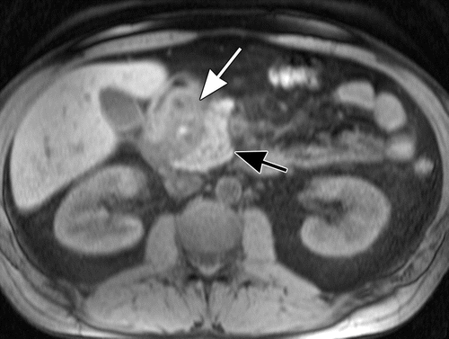

# Answer:

The sheetlike mass in the groove from the normal pancreatic head

---Source:

Heterotopic Pancreas_ Histopathologic Features, Imaging Findings, and Complications

---Original Figure Caption:

Figure 15c.Paraduodenal pancreatitis.(a)Axial contrast-enhanced CT image shows soft-tissue and cystic change in the pancreaticoduodenal groove (arrow), as well as wall thickening of the adjacent duodenum (arrowhead).(b)Axial T2-weighted MR image best shows the cysts (arrowhead) in the groove.(c)Axial fat-saturated T1-weighted MR image enables the best differentiation of the sheetlike mass (white arrow) in the groove from the normal pancreatic head (black arrow).(d)Axial contrast-enhanced fat-saturated T1-weighted arterial phase MR image best demonstrates the hyperenhancement and thickening of the duodenal wall (arrowhead) and shows the hypovascular nature of the fibrous mass (arrow) in the groove.

# Question 20:

A 73-year-old man with a history of occult GI bleeding presents with active bleeding. Based on the imaging findings provided in the figure, what are the two significant findings that could explain his clinical condition?

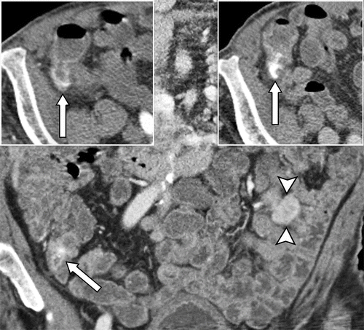

# Answer:

Cecal angioectasia with active bleeding and jejunal GIST

---Source:

Gastrointestinal Bleeding at CT Angiography and CT Enterography_ Imaging Atlas and Glossary of Terms

---Original Figure Caption:

Figure 25.Cecal angioectasia with active bleeding and jejunal GIST in a 73-year-old man with a history of occult GI bleeding. Coronal (main image) and axial (right inset) portal venous phase and axial arterial phase (left inset) CTE images show active extravasation in the cecum that appears in the arterial phase and changes in size, attenuation, and shape in the portal venous phase (arrow in all images) caused by cecal angioectasia, which was confirmed at colonoscopy. There is also a hyperenhancing exophytic mass in the jejunum (arrowheads in main image) that is consistent with a GIST, which was confirmed at surgical resection.

# Question 21:

A 50-year-old man presents with a lesion in the pancreatic tail that appears similar to the spleen on imaging. What could be a possible diagnosis based on the serpiginous enhancement in the arterial phase and homogeneous enhancement in the portal venous phase?

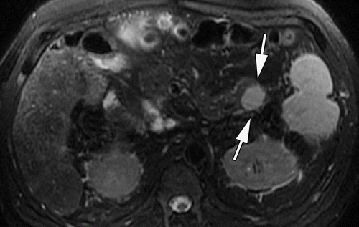

# Answer:

Intrapancreatic splenule

---Source:

Pancreatic Neuroendocrine Neoplasms_ 2020 Update on Pathologic and Imaging Findings and Classification

---Original Figure Caption:

Figure 19a.Intrapancreatic splenule mimicking a panNET in a 50-year-old man. Axial T2-weighted image(a)and gadolinium-enhanced T1-weighted MR images of the pancreas in the arterial(b)and portal venous(c)phases show a mildly T2-hyperintense well-defined round lesion (arrows ina) in the pancreatic tail that appears similar to the spleen. This lesion demonstrates serpiginous enhancement in the arterial phase (arrow inb) and homogeneous enhancement in the portal venous phase (arrow inc), similar to the adjacent splenic parenchyma (arrowhead inbandc). These findings are consistent with an intrapancreatic splenule.

# Question 22:

In the context of the image provided, if a patient presents with a pancreatic duct-to-parenchyma ratio of greater than 0.5, what condition does this finding strongly favor?

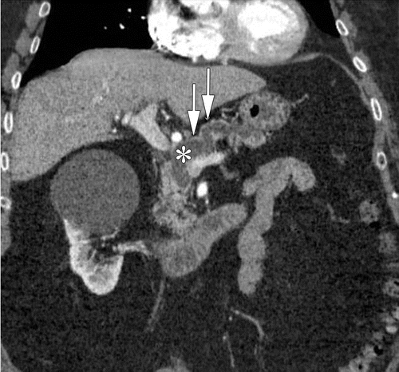

# Answer:

PDAC (Pancreatic Ductal Adenocarcinoma)

---Source:

Chronic Pancreatitis or Pancreatic Tumor_ A Problem-solving Approach

---Original Figure Caption:

Figure 2a.Imaging findings that favor diagnosis of a malignancy rather than an inflammatory condition.(a)Coronal CT image shows a duct-to-parenchyma ratio (maximum diameter of the diffusely dilated main pancreatic duct [*] and the overlying atrophic parenchyma [arrows]) of greater than 0.5).(b)Axial CT image shows diffuse calcifications in the background parenchyma and peripheral displacement of calcifications by a focal hypoattenuating lesion (dotted circle) in the pancreatic body.(c)MR cholangiopancreatogram shows the double duct sign, or dilatation of both the pancreatic duct (double arrows) and the common bile duct (single arrow).(d)Axial CT image shows the teardrop sign (arrows), a teardrop-shaped deformity of the SMV due to vascular encasement. Note the loss of fat in the perivascular space.(e)Axial CT image shows the SMA-to-SMV ratio, or the decreased caliber of the SMV (arrowhead) (almost the same size as the SMA [arrow]), of greater than or equal to 1.0. Note the loss of fat in the perivascular space.

# Question 23:

A 60-year-old woman presents with weight loss and jaundice. A contrast-enhanced T1-weighted image is provided in the figure. Based on the imaging findings, what is the most likely diagnosis?

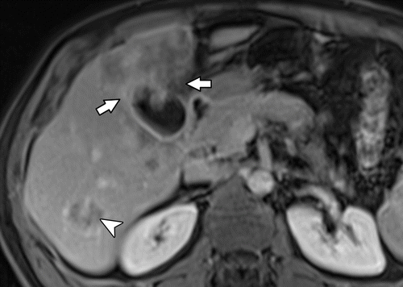

# Answer:

Gallbladder cancer

---Source:

Gallbladder Carcinoma and Its Differential Diagnosis at MRI_ What Radiologists Should Know

---Original Figure Caption:

Figure 7c.Metastatic gallbladder cancer in a 60-year-old woman.(a)Axial T2-weighted image shows a heterogeneous mass in the liver extending from the gallbladder (arrow).(b, c)Axial early(b)and delayed(c)contrast-enhanced T1-weighted images show the gallbladder lesion with heterogeneous progressive enhancement of the area of tumor infiltration into the adjacent liver (arrows) as well as in a metastatic hepatic lesion (arrowhead).

# Question 24:

A 60-year-old woman presents with weight loss and jaundice. An MRI of the abdomen is provided in the figure. Based on the imaging findings, which cancer should be suspected?

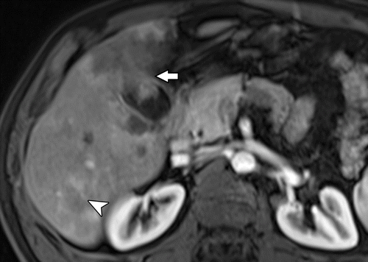

# Answer:

Metastatic gallbladder cancer

---Source:

Gallbladder Carcinoma and Its Differential Diagnosis at MRI_ What Radiologists Should Know

---Original Figure Caption:

Figure 7b.Metastatic gallbladder cancer in a 60-year-old woman.(a)Axial T2-weighted image shows a heterogeneous mass in the liver extending from the gallbladder (arrow).(b, c)Axial early(b)and delayed(c)contrast-enhanced T1-weighted images show the gallbladder lesion with heterogeneous progressive enhancement of the area of tumor infiltration into the adjacent liver (arrows) as well as in a metastatic hepatic lesion (arrowhead).

# Question 25:

Considering the axial T2-weighted MR image of the male perineum provided in the figure, if a patient is in the lithotomy position, where would you locate the anterior perineum on the anal clock diagram?

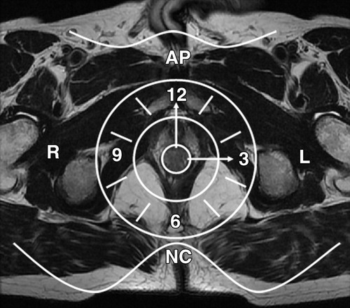

# Answer:

At 12 o'clock

---Source:

MR Imaging Evaluation of Perianal Fistulas_ Spectrum of Imaging Features

---Original Figure Caption:

Figure 6Anal clock. Axial T2-weighted MR image of the male perineum shows the anal clock diagram used to correctly locate anal fistulas with respect to the anal canal.AP= anterior perineum,L= left aspect of the anal canal,NC= natal cleft,R= right aspect of the anal canal.

# Question 26:

A 77-year-old woman with a history of vague abdominal pain presents with right upper quadrant discomfort. Based on the findings in the provided figure, what is the most likely diagnosis?

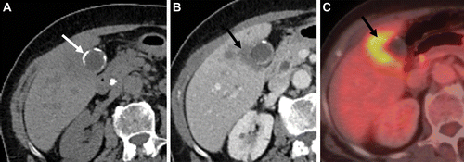

# Answer:

Adenocarcinoma of the gallbladder

---Source:

Imaging Features of Premalignant Biliary Lesions and Predisposing Conditions with Pathologic Correlation

---Original Figure Caption:

Figure 9.Porcelain gallbladder in a 77-year-old woman.(A)Axial image from noncontrast CT performed for vague abdominal pain shows circumferential calcification (arrow) of the gallbladder wall. Two years later, the patient presented with right upper quadrant discomfort.(B)Axial contrast-enhanced portal venous phase CT image shows an ill-defined hypoenhancing mass (arrow) arising from the gallbladder, with discontinuity of the wall calcifications and extension of the mass into the adjacent hepatic parenchyma.(C)Fluorine 18–fluorodeoxyglucose (FDG) PET/CT image shows that the mass (arrow) is FDG avid, representing adenocarcinoma, which was surgically resected.

# Question 27:

A 63-year-old man who underwent resection of sigmoid colon adenocarcinoma 6 years earlier presents with liver metastasis. Based on the axial arterial phase CT image provided, what type of reaction is seen in the peritumor area?

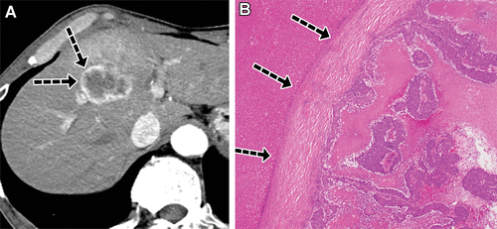

# Answer:

Desmoplastic reaction

---Source:

Liver Metastases_ Correlation between Imaging Features and Pathomolecular Environments

---Original Figure Caption:

Figure 3.Peripheral and peritumor enhancement of liver metastasis in a 63-year-old man who underwent resection of sigmoid colon adenocarcinoma 6 years earlier. Axial arterial phase CT image(A)shows a hypovascular metastasis with peripheral and peritumor enhancement (arrows inA), which corresponds to the mainly desmoplastic reaction (arrows inB) in the peritumor area seen on the histologic specimen(B).(Hematoxylin-eosin stain; original magnification, ×10.)

# Question 28:

In the context of a patient who underwent sphincteroplasty for a fourth-degree vaginal tear, what finding on a coronal T2-weighted MR image, as provided in the figure, would be considered important?

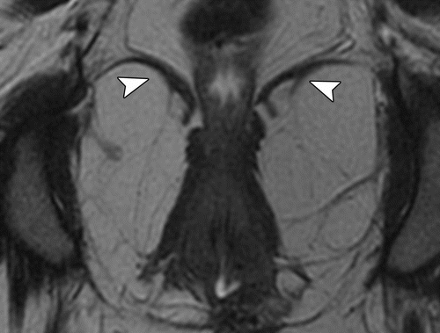

# Answer:

Intact puborectalis muscles

---Source:

Imaging and Surgical Management of Anorectal Vaginal Fistulas

---Original Figure Caption:

Figure 12c.Fistula formation in a 28-year-old woman who underwent sphincteroplasty for a fourth-degree vaginal tear.(a)Sagittal T2-weighted MR image obtained with use of vaginal and rectal gel shows a persistent anovaginal fistula (arrow) from the middle and upper regions of the anus to the middle region of the vagina, in the area of surgery.(b)Axial fat-suppressed T2-weighted MR image shows no inflammation (dashed oval).(c)Coronal T2-weighted MR image shows intact puborectalis muscles (arrowheads), which are an important finding.(d)Axial gradient-echo MR image is useful for depicting artifact (arrow) in the area of attempted surgical repair, which is sphincteroplasty in this case.

# Question 29:

In the context of a 60-year-old woman with known lung and bone NET metastases, what is the characteristic appearance of small bowel NETs on cross-sectional imaging as observed in the provided figure?

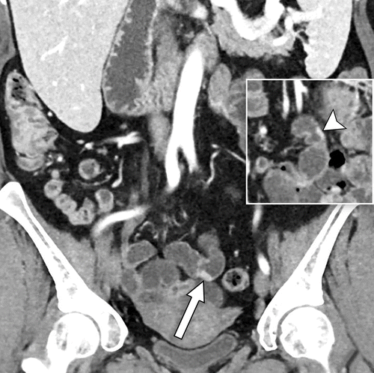

# Answer:

Flat or plaque-like

---Source:

Gastrointestinal Bleeding at CT Angiography and CT Enterography_ Imaging Atlas and Glossary of Terms

---Original Figure Caption:

Figure 34.Multiple plaque-like NETs in a 60-year-old woman with known lung and bone NET metastases. Prior abdominal MRI examination (not shown) showed mesenteric lymphadenopathy that was suspicious for a small bowel origin of metastatic NET. Enteric phase CTE images show two of numerous hyperenhancing plaque-like lesions in the mid small bowel (arrow in main image, arrowhead in inset), which are consistent with NETs. There was associated mesenteric lymphadenopathy (not shown). NETs were subsequently confirmed at surgery.

# Question 30:

In the context of a 74-year-old man with gallbladder cancer, an axial fat-saturated T2-weighted image is provided. Based on the imaging findings, what is the most likely T category in the TNM staging system for this patient's cancer?

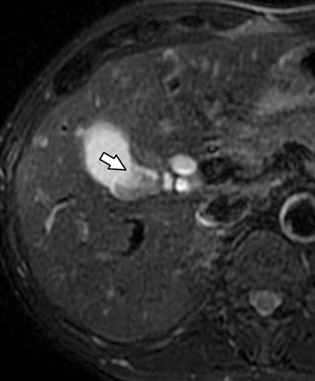

# Answer:

T2

---Source:

Gallbladder Carcinoma and Its Differential Diagnosis at MRI_ What Radiologists Should Know

---Original Figure Caption:

Figure 14e.Gallbladder cancer in a 74-year-old man.(a)Axial nonenhanced CT image does not show a gallbladder mass.(b)Axial portal venous phase contrast-enhanced CT image shows an enhancing gallbladder mass (arrow).(c)Axial nonenhanced T1-weighted image does not show the gallbladder mass.(d)Axial portal venous phase contrast-enhanced T1-weighted image shows the enhancing gallbladder mass (arrow) without liver invasion.(e)Axial fat-saturated T2-weighted image shows a low-signal-intensity mass (arrow) in the gallbladder without liver invasion. At pathologic analysis, no tumor extension into the liver was found.

# Question 31:

A 41-year-old woman presents with an asymptomatic gastric mass discovered during an unrelated surgery. Axial and coronal contrast material-enhanced CT images are provided. Based on the imaging findings, what is the most likely diagnosis for this lesion?

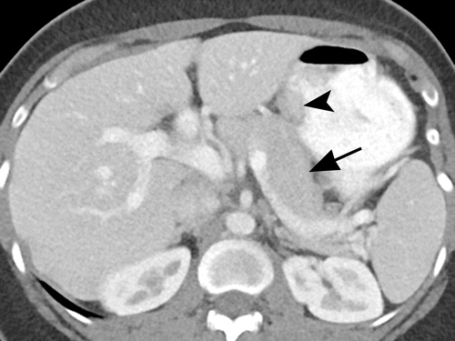

# Answer:

Gastric heterotopic pancreas

---Source:

Heterotopic Pancreas_ Histopathologic Features, Imaging Findings, and Complications

---Original Figure Caption:

Figure 4a.Gastric heterotopic pancreas in a 41-year-old woman. Axial(a)and coronal(b)contrast material–enhanced CT images show an oval intramural gastric mass (arrowhead) with homogeneous enhancement—similar to the enhancement of the normal pancreas (arrow ina). The mass is flat and has a long diameter–to–short diameter ratio higher than 1.4. It has an oval shape and endoluminal growth pattern, which are typical of heterotopic pancreatic lesions.

# Question 32:

A 74-year-old man presents with weight loss and jaundice. Based on the axial nonenhanced CT image provided in the figure, what would be your initial diagnosis?

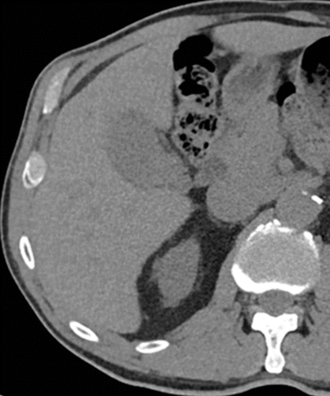

# Answer:

No gallbladder mass is visible

---Source:

Gallbladder Carcinoma and Its Differential Diagnosis at MRI_ What Radiologists Should Know

---Original Figure Caption:

Figure 14a.Gallbladder cancer in a 74-year-old man.(a)Axial nonenhanced CT image does not show a gallbladder mass.(b)Axial portal venous phase contrast-enhanced CT image shows an enhancing gallbladder mass (arrow).(c)Axial nonenhanced T1-weighted image does not show the gallbladder mass.(d)Axial portal venous phase contrast-enhanced T1-weighted image shows the enhancing gallbladder mass (arrow) without liver invasion.(e)Axial fat-saturated T2-weighted image shows a low-signal-intensity mass (arrow) in the gallbladder without liver invasion. At pathologic analysis, no tumor extension into the liver was found.

# Question 33:

In the context of a 44-year-old woman with stomach cancer and suspected tumor recurrence, what imaging finding on a follow-up CT scan might suggest residual tumor?

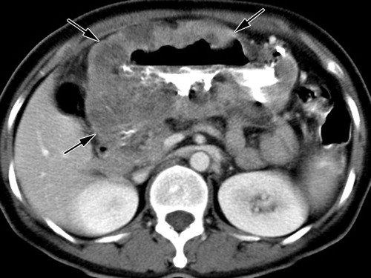

# Answer:

Obstruction of a pyloric stent

---Source:

CT and PET in Stomach Cancer_ Preoperative Staging and Monitoring of Response to Therapy

---Original Figure Caption:

Figure 16a.Suspected tumor recurrence in a 44-year-old woman with stomach cancer.(a, b)Axial contrast-enhanced CT scan(a)and PET scan(b)obtained prior to chemotherapy show prominent diffuse gastric wall thickening (arrows ina) with prominent FDG uptake (arrow inb).(c)Follow-up PET scan obtained approximately 5 months after chemotherapy shows markedly decreased FDG uptake in the stomach (arrow).(d)Follow-up CT scan obtained 3 months later demonstrates obstruction of a pyloric stent (arrow), a finding that suggests residual tumor. A radical subtotal gastrectomy was performed for palliation, but no residual tumor was detected in the resected specimen.

# Question 34:

A patient presents with a solid mass in the proximal jejunum. MR images are provided in the figure. What is the likely diagnosis based on these imaging characteristics?

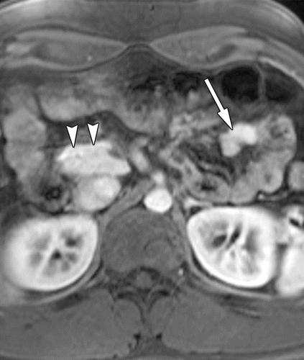

# Answer:

Jejunal heterotopic pancreas

---Source:

Heterotopic Pancreas_ Histopathologic Features, Imaging Findings, and Complications

---Original Figure Caption:

Figure 6c.Jejunal heterotopic pancreas. Axial T2-weighted(a), fat-saturated T1-weighted(b), and contrast-enhanced fat-saturated T1-weighted(c)MR images show a solid mass (arrow) in the proximal jejunum. The mass is isointense to the normal pancreas (arrowheads) with all MR imaging sequences, with characteristic high signal intensity on the nonenhanced T1-weighted MR image and intense early enhancement.

# Question 35:

A 53-year-old man presents with an ill-defined mass. An MR image of the pancreas is provided in the figure. Based on the imaging findings, what surgical procedure was performed?

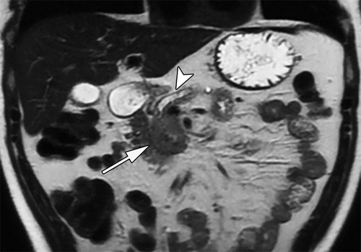

# Answer:

Whipple surgery (pancreatoduodenectomy)

---Source:

Pancreatic Neuroendocrine Neoplasms_ 2020 Update on Pathologic and Imaging Findings and Classification

---Original Figure Caption:

Figure 15a.Poorly differentiated high-grade panNEC in a 53-year-old man. Coronal T2-weighted(a)and axial diffusion-weighted (b= 800 sec/mm2)(b)MR images,corresponding ADC map(c),and axial gadolinium-enhanced T1-weighted MR images(d, e)show an ill-defined mass (arrow ina–d) with mild T2 signal hyperintensity (arrow ina) involving the head and uncinate of the pancreas, which also show substantial diffusion restriction (arrow inb). The mass is diffusely hypoenhancing (arrow ind) after administration of contrast material, and there are multiple liver metastases (arrowheads ine). Also note the substantial pancreatic parenchymal atrophy and the main pancreatic ductal dilatation (arrowhead ina), which mimic pancreatic ductal adenocarcinoma. The patient underwent Whipple surgery (pancreatoduodenectomy), and the mass was proven to be a poorly differentiated grade 3 panNEC with Ki-67 proliferation of 70%.

# Question 36:

A 61-year-old man with a history of gallbladder cancer who had undergone cholecystectomy is presented in the figure. Based on the axial T2-weighted image, what suggests a possible local tumor recurrence?

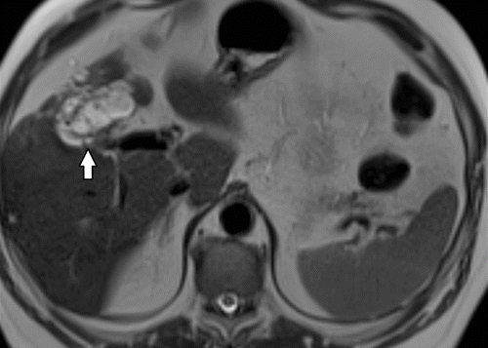

# Answer:

Hyperintense lesion in the gallbladder fossa

---Source:

Gallbladder Carcinoma and Its Differential Diagnosis at MRI_ What Radiologists Should Know

---Original Figure Caption:

Figure 16a.Tumor recurrence in a 61-year-old man with a history of gallbladder cancer who had undergone cholecystectomy.(a)Axial T2-weighted image shows a hyperintense lesion in the gallbladder fossa (arrow).(b)Axial contrast-enhanced T1-weighted image shows heterogeneous enhancement of the lesion (arrow), compatible with local tumor recurrence.

# Question 37:

In the context of a postpartum woman with a grade 4 episiotomy injury, what specific injury is demonstrated in the provided axial T2-weighted MR image?

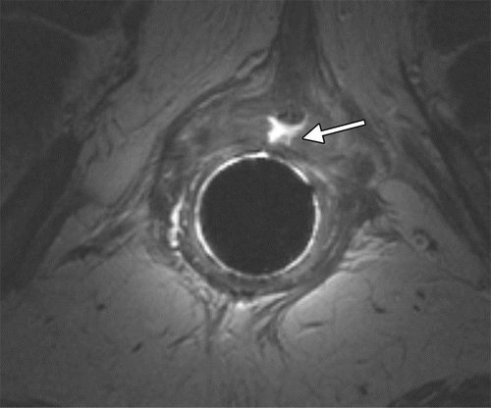

# Answer:

Full-thickness tear in the internal anal sphincter

---Source:

Imaging and Surgical Management of Anorectal Vaginal Fistulas

---Original Figure Caption:

Figure 6a.Findings in a woman 8 months postpartum with a grade 4 episiotomy injury.(a)Axial T2-weighted MR image obtained with endorectal coil placement shows a full-thickness tear (arrow) in the internal anal sphincter at the 12-o’clock position.(b)Sagittal proctographic MR image shows two fistulas (arrowheads) to the vagina, which became widely patent during simulated defecation at MR proctography.(c)Axial fat-suppressed T2-weighted MR image shows how narrow even the upper anovaginal fistula lumen (arrow) is at rest. The patient underwent overlapping sphincteroplasty and ileostomy.

# Question 38:

In the Parks classification of perianal fistulas, which type of fistula is most common and what percentage of cases does it represent according to the study by Parks et al?

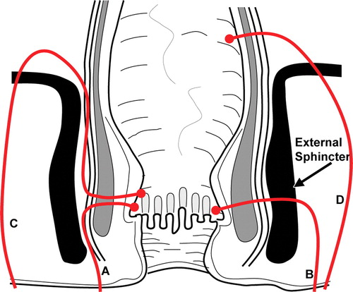

# Answer:

Intersphincteric fistulas, 45%

---Source:

MR Imaging Evaluation of Perianal Fistulas_ Spectrum of Imaging Features

---Original Figure Caption:

Figure 7Parks classification. Drawing of the anal canal in the coronal plane shows the Parks classification of perianal fistulas.A= intersphincteric,B= transsphincteric,C= suprasphincteric,D= extrasphincteric. The external sphincter is the keystone of the Parks classification.

# Question 39:

In the context of a 40-year-old man with an insulinoma, what does the intraoperative US image in the provided figure reveal about the relationship of the hypoechoic mass to the adjacent structures?

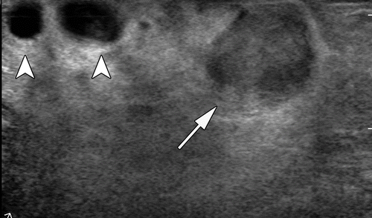

# Answer:

The mass has a clear relationship to the adjacent vessels

---Source:

Pancreatic Neuroendocrine Neoplasms_ 2020 Update on Pathologic and Imaging Findings and Classification

---Original Figure Caption:

Figure 3a.Intraoperative US in management of panNEN.(a)Intraoperative US image in a 40-year-old man with an insulinoma shows a well-defined hypoechoic mass (arrow) in the pancreas and its clear relationship to the adjacent vessels (arrowheads).(b)Intraoperative US image in a 55-year-old man with hepatic metastasis from panNEC shows a targetoid lesion in the liver with a central hyperechoic area and a peripheral hypoechoic halo (arrow).

# Question 40:

In a 25-year-old man with VHL syndrome, an axial gadolinium-enhanced T1-weighted MR image of the pancreas is provided. What was the mass in the pancreas proven to be at surgical resection?

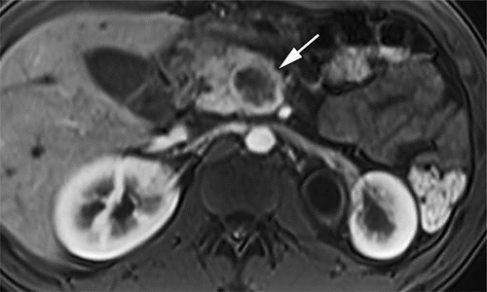

# Answer:

High-grade panNEC

---Source:

Pancreatic Neuroendocrine Neoplasms_ 2020 Update on Pathologic and Imaging Findings and Classification

---Original Figure Caption:

Figure 11b.PanNENs in two patients with VHL syndrome.(a)Axial gadolinium-enhanced T1-weighted MR image in a 34-year-old man with VHL syndrome shows multiple hyperenhancing masses (arrows) that are suggestive of panNETs. A few cysts (arrowhead) are also seen in the right kidney.(b)Axial gadolinium-enhanced T1-weighted MR image in a 25-year-old man with VHL syndrome shows a heterogeneously enhancing mass (arrow) in the pancreas. This mass was proven to be a high-grade panNEC at surgical resection.

# Question 41:

In the context of a 44-year-old woman with Crohn colitis and a vaginal discharge, what might be a possible diagnosis based on the MRI findings provided in the figure?

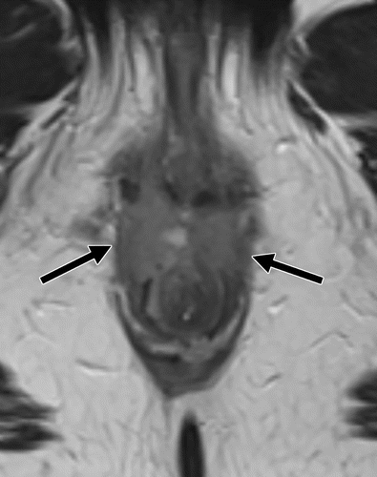

# Answer:

Squamous cell carcinoma

---Source:

Imaging and Surgical Management of Anorectal Vaginal Fistulas

---Original Figure Caption:

Figure 5b.Crohn colitis in a 44-year-old woman who was presumed to also have perianal disease owing to a vaginal discharge, which was initially and erroneously interpreted at MRI to indicate a perianal fistula.(a)Sagittal fat-saturated T2-weighted fast spin-echo MR image shows a fluid-filled fistula (arrows) posterior to the lower region of the vagina and introitus (arrowhead).(b, c)Axial fast spin-echo T2-weighted MR images show an intermediate-signal-intensity soft-tissue mass (arrows inb) involving the anterior portions of the internal and external sphincters and extending inferiorly into the perianal fat, with internal enhancement (arrows inc), as well as increased signal intensity atb= 400 sec/mm2(top inset inc) and associated restricted diffusion (bottom inset inc) at diffusion-weighted imaging. These findings were believed to represent malignancy with a tumor fistula. Biopsy revealed squamous cell carcinoma. The patient subsequently underwent chemoradiation with proctectomy, which led to a complete disease response.

# Question 42:

In the axial illustration of normal pelvic floor anatomy depicted in the figure, which structure separates the lower part of the vagina from the anal sphincters?

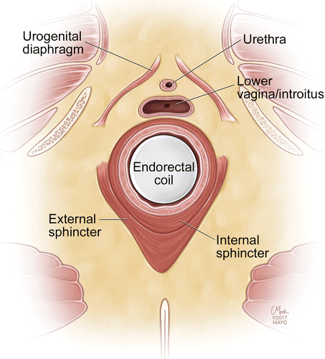

# Answer:

Perineal body

---Source:

Imaging and Surgical Management of Anorectal Vaginal Fistulas

---Original Figure Caption:

Figure 1c.Normal pelvic floor anatomy.(a)Sagittal illustration shows the normal anatomy. (Reprinted, with permission, from Mayo Foundation for Medical Education and Research.)(b)Sagittal T2-weighted MR image shows gel distending the rectum(R)and vagina(V). DL= dentate line,ES= external sphincter,IS= internal sphincter,U= urethra.(c)Axial illustration shows the normal anatomy. (Reprinted with permission, from Mayo Foundation for Medical Education and Research.)(d, e)Axial T2-weighted MR images obtained with an endorectal coil.ES= external sphincter,ICL= ileococcygeal component of levator plate,IS= internal sphincter,LV/I= lower region of vagina at the introitus,PR= puborectalis muscle,U= urethra,UGD= urogenital diaphragm,V= vagina.

# Question 43:

A 68-year-old woman presents with a history of recurrent right upper quadrant pain. Based on the T1-weighted image provided in the figure, what is a possible radiological finding that could suggest the diagnosis of Xanthogranulomatous cholecystitis?

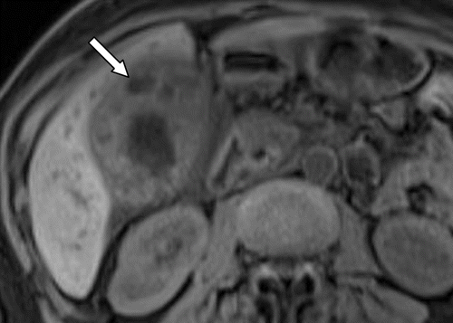

# Answer:

Hypointense cystic foci

---Source:

Gallbladder Carcinoma and Its Differential Diagnosis at MRI_ What Radiologists Should Know

---Original Figure Caption:

Figure 9b.Xanthogranulomatous cholecystitis in a 68-year-old woman.(a)Axial T2-weighted image shows a heterogeneously thickened gallbladder wall with multiple intramural lesions (arrows), which are iso- or hyperintense.(b)Axial T1-weighted image shows hypointense cystic foci (arrow).(c, d)Axial early(c)and delayed(d)contrast-enhanced T1-weighted images show mild arterial and marked delayed enhancement surrounding the cystic foci (long arrow). There is mild surrounding hepatic parenchymal enhancement (short arrow), which is likely reactive.

# Question 44:

A 67-year-old woman presents with abdominal discomfort. An imaging study is provided in the figure. Based on the imaging findings, what is the most likely diagnosis?

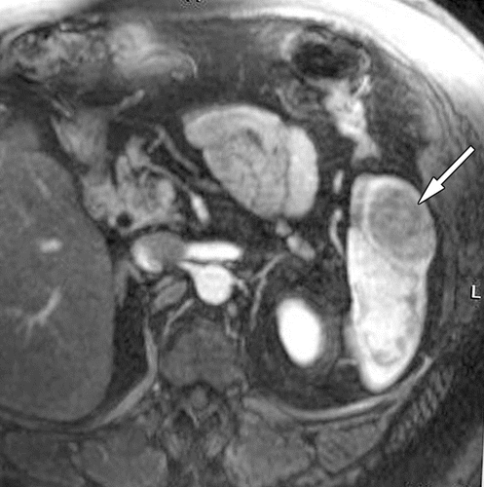

# Answer:

Splenic heterotopic pancreas

---Source:

Heterotopic Pancreas_ Histopathologic Features, Imaging Findings, and Complications

---Original Figure Caption:

Figure 8d.Splenic heterotopic pancreas in a 67-year-old woman.(a)Axial contrast-enhanced CT image shows a hypoattenuating mass (arrow) in the spleen.(b–e)Axial T2-weighted(b)and T1-weighted(c)fat-saturated MR images and contrast-enhanced fat-saturated T1-weighted MR images in the arterial(d)and equilibrium(e)phases show a solid, round, subcapsular splenic mass (arrow). The mass is hypointense on the T2-weighted image, slightly hyperintense on the nonenhanced T1-weighted image, and hypovascular relative to the spleen in the arterial phase, with progressive contrast material retention, in the equilibrium phase.

# Question 45:

An 80-year-old woman on anticoagulants for chronic atrial fibrillation and aortic valve replacement, who recently underwent spinal fusion surgery, presents with overt upper GI bleeding. Based on the findings in the provided figure, what is the most likely cause of the bleeding?

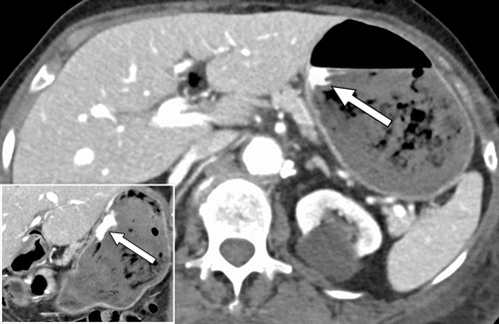

# Answer:

Gastric ulcer

---Source:

Gastrointestinal Bleeding at CT Angiography and CT Enterography_ Imaging Atlas and Glossary of Terms

---Original Figure Caption:

Figure 9.Gastric ulcer causing active bleeding in an 80-year-old woman receiving enoxaparin and warfarin for chronic atrial fibrillation and aortic valve replacement who underwent recent spinal fusion surgery. Axial (main image) and coronal (inset) portal venous phase CT images show contrast extravasation along the lesser curvature of the stomach (arrow in both images).Figure E1is an upper endoscopic image in this patient that shows an actively bleeding ulcer in the lesser curvature of the stomach.

# Question 46:

A 63-year-old man has undergone a subtotal gastrectomy. An axial contrast-enhanced CT scan is provided in the figure. This finding was initially misinterpreted as a postoperative change. What imaging modality could be used to accurately characterize this finding and differentiate it from a postoperative change?

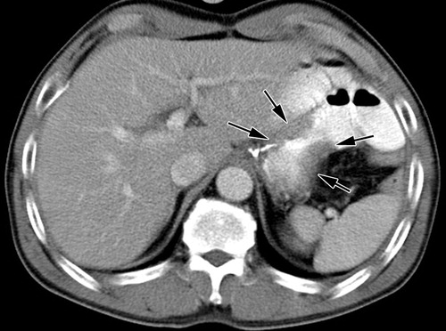

# Answer:

FDG PET

---Source:

CT and PET in Stomach Cancer_ Preoperative Staging and Monitoring of Response to Therapy

---Original Figure Caption:

Figure 15a.Local tumor recurrence following subtotal gastrectomy in a 63-year-old man.(a)Axial contrast-enhanced CT scan shows mild gastric wall thickening (arrows) at an anastomotic site. This finding was misinterpreted as a postoperative change (possibly plication-induced fibrotic change or reflux gastritis).(b)Axial PET scan shows prominent increased FDG uptake (arrows) in the anastomotic site. Cancer recurrence was proved at histologic analysis of tissue obtained at endoscopic biopsy.

# Question 47:

A 63-year-old man with irritable bowel syndrome, arthritis, and chronic NSAID treatment presents with occult GI bleeding and inconclusive findings at endoscopy. Based on the coronal CTE images provided in the figure, what is the most likely diagnosis?

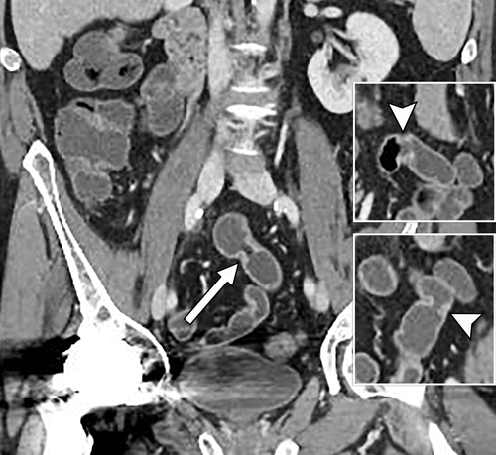

# Answer:

NSAID enteropathy

---Source:

Gastrointestinal Bleeding at CT Angiography and CT Enterography_ Imaging Atlas and Glossary of Terms

---Original Figure Caption:

Figure 29.NSAID enteropathy in a 63-year-old man with irritable bowel syndrome and arthritis and chronic NSAID treatment who presented with occult GI bleeding and inconclusive findings at endoscopy (not shown). Coronal CTE images show three of the multiple diaphragm-like strictures that were present in the mid small bowel (arrow in main image, arrowhead in top and bottom inset), which are consistent with stricturing related to NSAID enteropathy.

# Question 48:

A 72-year-old man presents with bright red blood in the rectum. Based on the CT images provided in the figure, what is the most likely diagnosis?

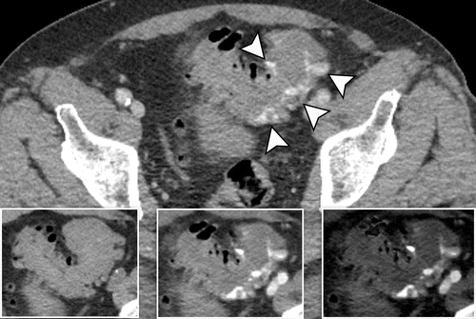

# Answer:

Acute diverticular bleed in the sigmoid colon

---Source:

Gastrointestinal Bleeding at CT Angiography and CT Enterography_ Imaging Atlas and Glossary of Terms

---Original Figure Caption:

Figure 8.Acute diverticular bleed in the sigmoid colon on dual-energy CT images in a 72-year-old man who presented with bright red blood in the rectum. Axial portal venous phase mixed (blended) CT image (main image) shows multiple foci of contrast extravasation in the sigmoid colon (arrowheads) and diffuse sigmoid diverticulosis, some containing extravasated contrast material. Axial noncontrast CT image (left inset) shows hyperattenuating bowel contents in the sigmoid colon. Axial postprocessed monoenergetic 50-keV image (middle inset) and iodine map image (right inset) show contrast extravasation that is more conspicuous at the lower kiloelectron voltage setting and on the iodine map than on the mixed (blended) image.

# Question 49:

In the context of a 38-year-old woman, the provided figure shows an intramural mass. What congenital anomaly is suggested by the imaging findings?

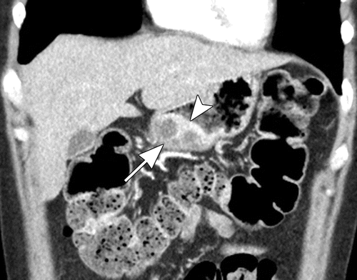

# Answer:

Heterotopic pancreas

---Source:

Heterotopic Pancreas_ Histopathologic Features, Imaging Findings, and Complications

---Original Figure Caption:

Figure 11b.Gastric pancreatic heterotopia complicated by pseudocyst formation in a 38-year-old woman. Axial(a)and coronal(b)contrast-enhanced CT images show an intramural mass (arrow) along the greater curvature of the gastric antrum. Similar to the normal pancreatic tissue, the mass is intensely enhancing and contains multiple small internal cystic areas. Also note the hyperenhancement of the overlying gastric mucosa (arrowhead inb) and the endoluminal growth pattern of the lesion.

# Question 50:

In the context of the provided figure, what was the treatment outcome of the rectal adenocarcinoma invading the vagina?

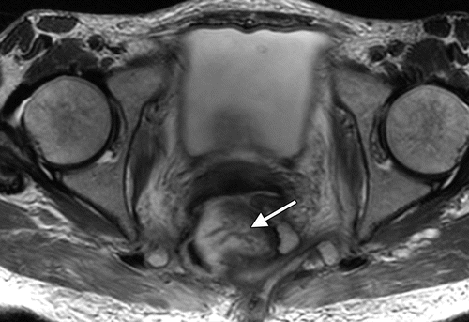

# Answer:

Marked treatment response

---Source:

Imaging and Surgical Management of Anorectal Vaginal Fistulas

---Original Figure Caption:

Figure 9c.Rectal adenocarcinoma invading the vagina in a 57-year-old woman.(a, b)Sagittal(a)and axial(b)T2-weighted MR images show a heterogeneous predominantly T2-hyperintense rectal mass invading the middle to upper region of the vagina and thus causing an enormous fistula (☆). The patient underwent radiation therapy.(c)Subsequently obtained axial T2-weighted MR image shows a marked treatment response in the tumor (arrow). Persistence of the fistula resulted in a loss of substantial portions of the right lateral and anterior rectal walls, with destruction of the vagina and right piriformis muscle. Permanent diverting colostomy was recommended; however, the patient selected incontinence rather than diversion.