**31st WERC Environmental Design Contest Open Task Test Plan & Preliminary Report**

**Economic Feasibility of Commercial Mixed Plastic Waste Pyrolysis Process Using Twin Reactor System**

**University of Arkansas Pyrolypigs Team—Spring 2021**

**Members**

**Carol Rogers—Team Leader**

**Renato Gonzalez, Patricia Means, Kaida Sheets, and Hayden Townsend**

**Mentors/Advisors**

**Drs. Michael Ackerson and W. Roy Penney**

1. **Problem Statement**

* An estimated 53,000 tons of mixed plastic waste was produced by the general population of Northwest Arkansas (NWA) in 2016[1] [2].
* In NWA, only polyethylene terephthalate (PET/PETE) and high-density polyethylene (HDPE) plastic bottles are recycled.
* In 2014 plastics composed approximately 17.22% of the municipal solid waste stream in Fayetteville[3]. These plastics are destined to landfills.
* Despite the indication of recyclability through markers listed at the bottom of #1-7 plastic containers, packaging, plastic cups/plates, etc., these materials are scarcely recycled[4].
* These “mixed plastics” are most abundantly composed of PET/PETE (#1), HDPE (#2), low-density polyethylene (LDPE; #4), polypropylene (PP; #5), and/or polystyrene (PS; #6).
* The Pyrolypigs team will design a commercial process to pyrolyze mixed plastics into a product that can be sold as a fuel or fuel precursor (e.g. synthetic crude oil).

1. **Approach**

The Pyrolypigs team will adapt a pilot scale pyrolysis unit, tested primarily to pyrolyze sawdust, to the application of mixed plastic pyrolysis in Huntsville, AR and design and determine the economic feasibility of a commercial scale mixed plastic pyrolysis plant in NWA. Key points of focus include expanding the collection of mixed plastic waste in NWA; developing a procedure to prepare the plastic for feeding into the unit; determining the optimal operating conditions for pyrolysis; analysis of the product; evaluation of economic and environmental benefits of the entire process (starting at plastics collection and ending at sale of oil product to a refinery).

1. **Chemicals/Materials Used**

Chemicals/Materials:

1. Mixed Plastics
   1. PET shred
   2. HDPE pellets
   3. LDPE pellets
   4. PP pellets
   5. PS plastic
      1. Crystalline polystyrene cups
      2. Expanded polystyrene (EPS) beads
2. Dry ice for use as an aid in shredding brittle plastic
3. Nitrogen gas
   1. Purging nitrogen for feed hopper and pyrolysis reactor
4. Stainless steel gas cylinders for gas sample collection
5. 250 mL to 500 mL amber glass sample bottles for storing and transferring solid and liquid product for analysis

Equipment:

1. Pilot Scale Pyrolysis Unit

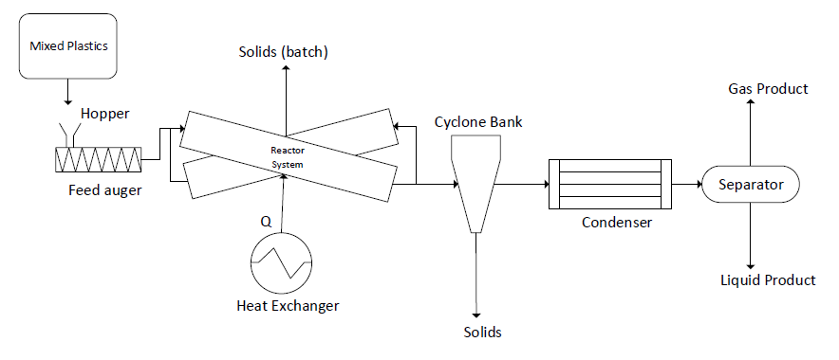

1. **Synthetic Solutions Needed: N/A**
2. **Testing Methods**
3. Liquid Oil Product- Tests for the oil product will determine the worth and viability of the oil as a fuel.
   1. Flash point- ASTM D93
   2. Kinematic Viscosity @ 25 C- ASTM D445
   3. Boiling Range- ASTM 2887
   4. Lower Heating Value- ASTM D240
   5. Cloud Point- ASTM D2500
   6. PONA analysis- ASTM D8071
   7. Density @ 25 C- ASTM D4052
   8. Sulfur Content- ASTM D2622-16
   9. Water and Sediment Content- ASTM D4007-11
   10. Ash, %- ASTM D482-19
   11. Cetane Index- ASTM D613
4. Gas Product- Tests for the gas product will determine the composition of fuel gases to determine their worth as an energy recovery source for the pyrolysis reactor.
   1. Gas Chromatography-Mass Spectrometry (GC-MS)
5. Solid Product- Tests for the solid will determine viability of its use as either a raw material for producing carbon black or use as a fuel for combustion and gasification.
   1. Volatile Matter-ASTM D 3175
   2. Calorific Value- ASTM D 5865, using bomb calorimeter
   3. Elemental composition- using an elemental analyzer

* The Pyrolypigs team will send our products to Saybolt Laboratories to perform the desired analyses.
* The purposes of analyzing the gas, liquid, and solid products are to determine whether:
  + 1) The liquid oil product is viable as a fuel, which ensures an accurate comparison to crude oil
  + 2) The gas, oil, and solid compositions match predictions based on literature review
* While confirming the viability of the oil product as a fuel is dependent on analytical tests, the overall success of the project is determining economic viability of a commercial scale pyrolysis unit and does not solely depend on the results of product analysis.

1. **Additional Information**

* Estimated time requirement for bench-scale demo: 10-minute video
* Estimated time requirement for analytical results: Undetermined/Variable
  + The Pyrolypigs team will send the results of analyses performed by outside labs to NMSU WERC associates when they become available.

1. “Municipal Solid Waste Generation, Recycling, and Disposal in the United States: Facts and Figures for 2012” United States Environmental Protection Agency, 2013.
2. Bernet, Brenda; Bowden, Bill. “Northwest Arkansas clocks in at No. 22 for fast-growing U.S. metro areas.” Arkansas Democratic Gazette, 2017.
3. Mitchell, Robin. “Technical Memorandum No. 1.” 2015. Kessler Consulting inc.
4. “Advancing Sustainable Materials Management: Facts and Figures 2018.” United States Environmental Protection Agency, 2020.