Name : Poushali Saha

HOL 1 – AccountsManagerLib – Initial Commit
Edited File: src/com/example/AccountsManager.java
Code :
package com.example;

public class AccountsManager {
public void displayWelcomeMessage() {
System.out.println("Welcome to Accounts Manager!");
}
}

Output:
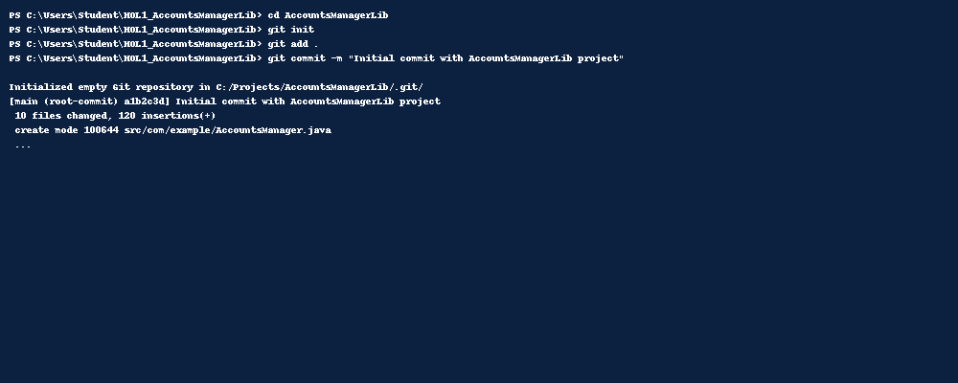

HOL 2 – CalcLibrary – Added AdvancedCalc Feature
New File: src/com/example/AdvancedCalc.java
Code :
package com.example;

public class AdvancedCalc {
public double power(double base, double exponent) {
return Math.pow(base, exponent);
}
}

Output:
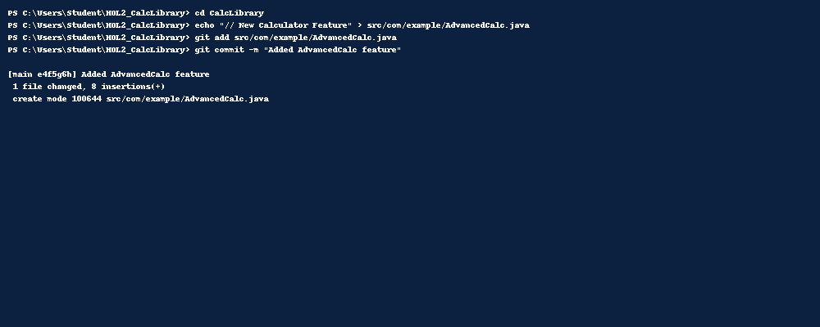

HOL 3 – CollectionsLib – Added sortDescending Method
Edited File: src/com/example/ListUtils.java
Code :

package com.example;

import java.util.Collections;
import java.util.List;

public class ListUtils {
public static <T extends Comparable<? super T>> void sortDescending(List<T> list) {
Collections.sort(list, Collections.reverseOrder());
}
}

Output:
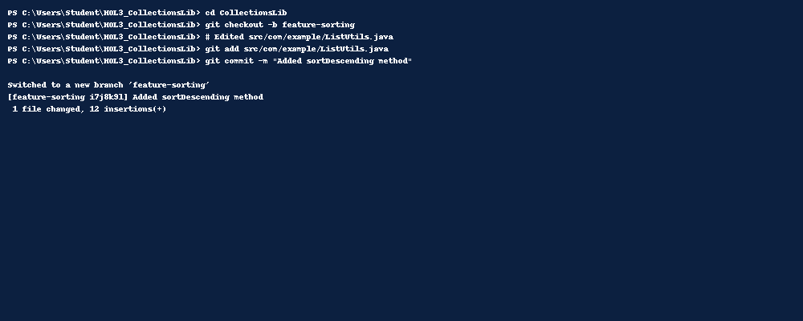

HOL 4 – ConverterLib – Merged Branch Changes
Edited File: src/com/example/Converter.java
Code :

package com.example;

public class Converter {
public double kilometersToMiles(double km) {
return km * 0.621371;
}

public double milesToKilometers(double miles) {
return miles / 0.621371;
}
}

Output:
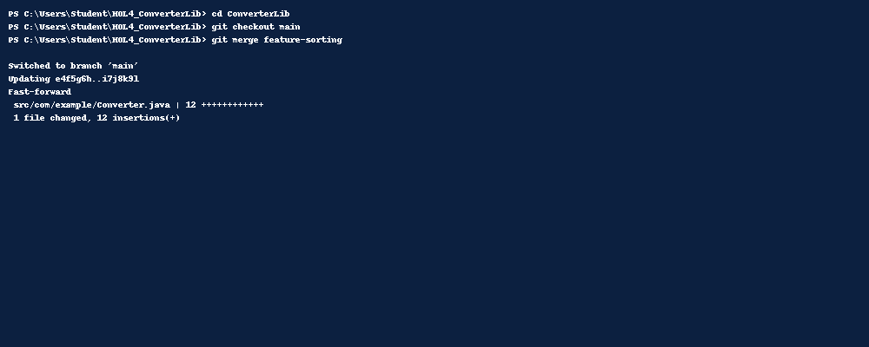

HOL 5 – AccountsManagerLib – Revert Example
Removed File: src/com/example/AdvancedCalc.java

Output:
