# Screenshot01_2016-02-25-18-40-38.pngTourCount 1.0.2

## 1. Introduction

TourCount is an Android App (Fig. 1) that supports you when recording butterflies. It allows a species-specific counting when walking in nature. It can substitute your field book and pencil, and with a modern smartphone you carry a camera for pictures of interesting species anyway.

The integrated database is related to tours and can be individually created and adapted regarding expected butterfly species. The recorded data (meta data, counts and remarks) may either be read on the smartphone for transfer into the butterfly registration system or transferred to a PC for your own processing.

The app is open source (published under https://github.com/wistein/ TourCount), has no tracking or advertising functions, demands only for permits which are needed for recording the data.

It needs access rights to storage media and uses GPS to register positions while counting.

Fig. 1: Starting page

2. Set up

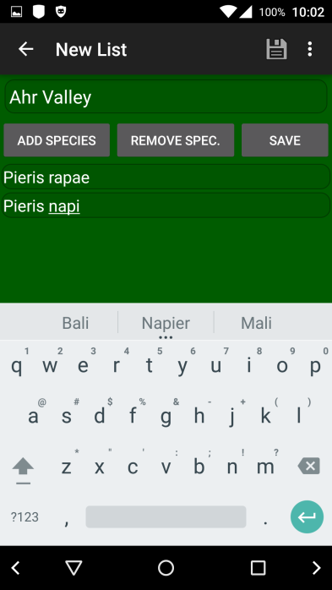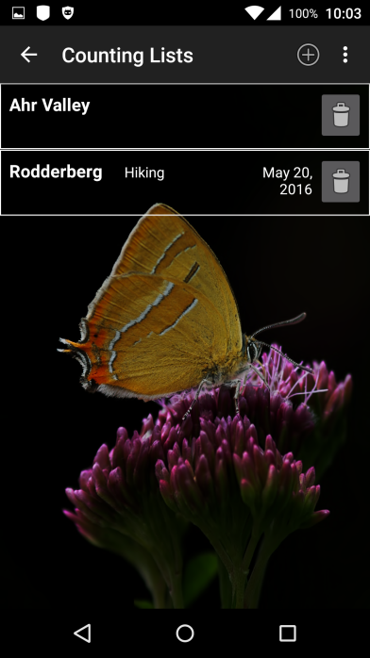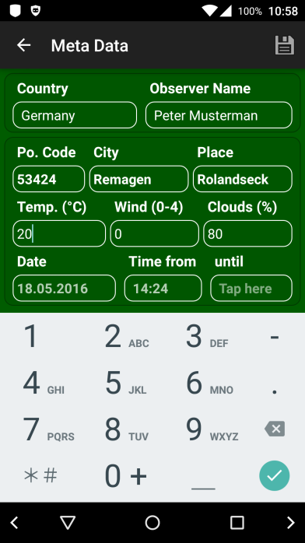Before initial use you must set up an empty basic database (Basic DB). Therefore, you first enter the meta data of the planned tour. Tap on “Prepare Re-cording” (Fig. 2) and finish this by tapping on the saving symbol. The meta data may be modified anytime later. Then create a regional species Fig. 2: Edit Meta Data Fig. 3: Counting Lists page Fig. 4: New List page  
list on "Counting   
Lists". Use the (+)-Button or the function "New Counting List" for that (Fig. 3).

The “New List” page opens (Fig. 4). Then this list gets a name (e.g.: Ahr Valley) and subsequently an entry for each expected species, e.g.:

Ahr Valley

--------------------

Pieris rapae

Pieris napi

Pieris na./ra.-compl.

...

This list can be changed or supplemented anytime afterwards. With "Save List" you get it stored into the database.

Once this list is complete, you can copy it for other regions or travellings (counting page menu: "Duplicate Counting List", Fig. 5) and name each accordingly (e.g.: “France”, “Italy”,...).

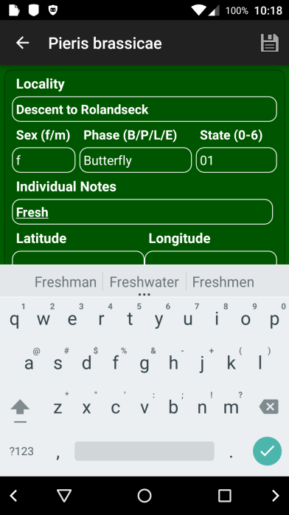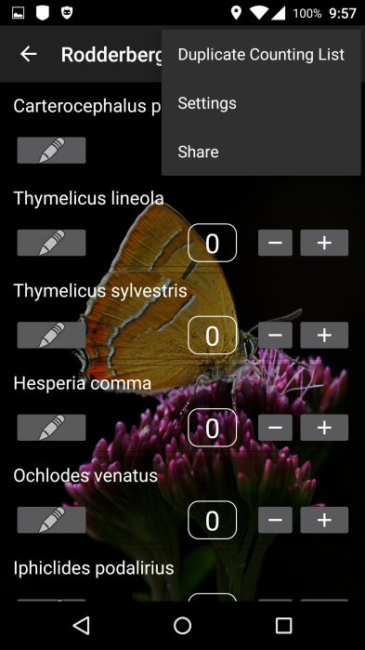

When you have created the counting lists for all expected regions, the database is ready for export as the "Basic Database". To do this, you can use the function "Export as Basic DB" in the menu of the starting page. After that you have a copy of the empty database saved as "Basic Database" (tourcount0.db) within the home directory /sdcard (or /sdcard0, or /storage/emulated/0, it differs between smartphone models).

The "Basic Database" will be used as a template for further tour recordings. You may export the Basic DB anytime later, e.g. when you modified its structure or inserted new species.

3. Usage

Fig. 5: Section list Fig. 6: Counting page

Start with “Counting Lists” (Fig. 3).

Select the relevant regional species list. Its counting page appears (Fig. 5).

To count just tap on the "+"-Button of the corresponding species. The "-"-Buttons allows for corrections. Mind that the "-"-Button reduces the individuals list for the last entry of an species.

While storing the counting results the current date and time of the registration will be stored either for this list. The date and a possible list remark will then be shown in the page of counting lists.

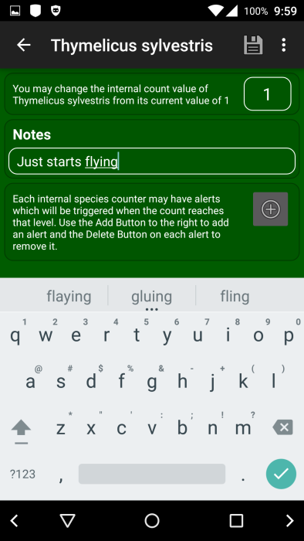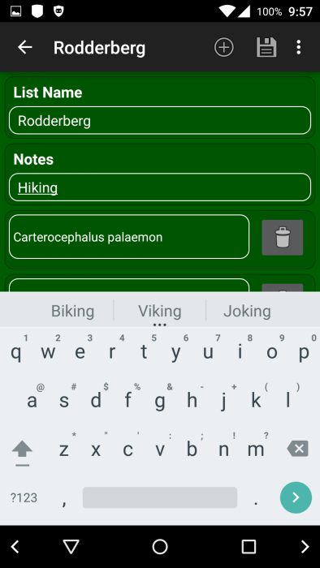The Pencil-Button in the app bar of the counting page opens the counting list editing page (Fig. 7) for adding remarks for the list and editing the names of the list and species. The list-related remarks will be shown at the end of the list and within the “Counting Lists” page.

The Pencil-Button in each species row of the counting page opens the species editing page (Fig. 8) that lets you add remarks for each species and set its counters to any value. Here you may also set pop-up alarms which show up while reaching a set value on the corresponding internal counter (e.g. to realize already on site if a certain species is more abundant than on a previous tour).

If you enter a species related remark this will be shown on the counting page in an extra line beneath the species row.

Fig. 7: Edit counting list Fig. 8: Edit species

To move back one page you can use the arrow in the left upper corner. You should leave TourCount always from its starting page, as in this state the database is safely closed and GPS no longer used.

Some app pages have a specific context menu. You can activate it with the 3-point-symbol in the upper right corner.

When you have large lists or have collected big amounts of data the app may delay the start of pages, especially when entering a transect section list (the counting page) or the result page, as those need heavy calculations.

Finally, there is a page showing your results (Fig. 9). Here you see beneath the meta data of the inspection the species which got counts. You open this page from the Starting page with the "Show Result"-Button or the Eye-symbol in the app-bar. It may take a few seconds to show up.

4. Further functions

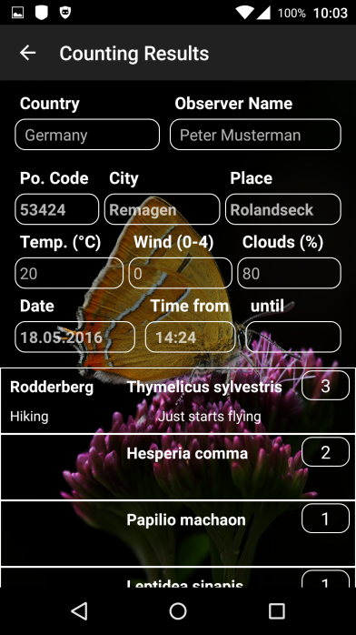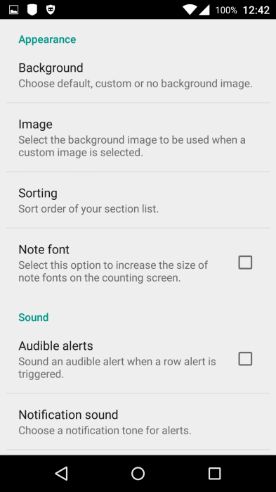

The "Settings" page (Fig. 10) can be reached from most pages of the app. Here you may adapt the look an feel in some aspects to your wishes, e.g. sounds and alerts.

Selecting an own background picture can be achieved by the Gallery App, accessible in the left side menu of the background option (if applicable wipe from the left edge)..

The menu on the starting page (Fig. 11) has Settings, Reset, Import, Export, Info and Help functions.

For preparing a new tour you may use “Reset Data” to reset the tour-specific meta data and count data. Alternatively you may import the Basic DB from /sdcard/tourcount0.db

Fig. 9: Counting Result Fig. 10: Settings

By “Export Basic DB” you may export the

DB as empty "Basic DB" which is reasonable, when lasting changes of a counting list have been made (e.g. new species added).

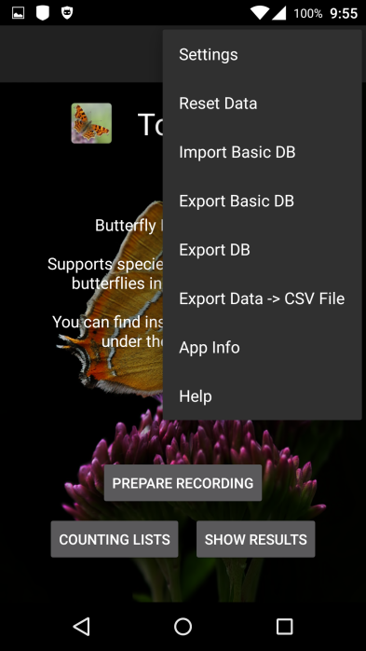Exporting the current database (Export DB) writes a copy of the complete DB to /sdcard/tourcount\_YYYY-MM-DD\_hhmmss.db.

The function “Export Data -> CSV File” writes the counting results into a MS Excel readable .csv-file to

/sdcard/tourcount\_YYYY-MM-DD\_hhmmss.csv.

Under "App Info" you find the email address of the author, the history of the app and the license note.

The menu of the “Counting Lists” page allows you to create new counting lists. This function will be used only while creating the Basic DB or creating a counting list with different species.

The counting page provides the "Duplicate Counting List" function. This function is used while creating a Basic DB, as described under "2. Set up“. Remark: This version of the app supports only the initially created counting list completely.

The menu of this page provides a "Share" function for sending notes using a standard app like SMS or email.

Fig. 11: Starting page menu

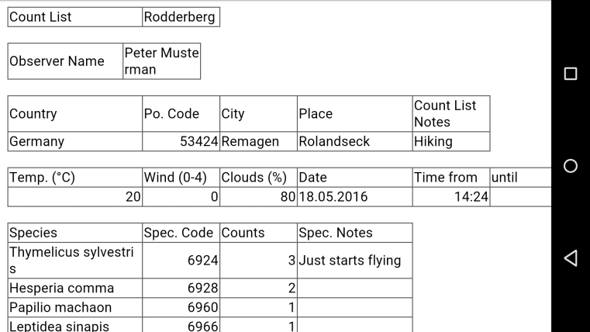IT-affine users may transfer the exported "tourcount\_YYYY-MM-DD\_hhmmss.db" or “.csv” files to a PC. With a free tool like "SqliteBrowser" (sqlitebrowser.org) you may examine the db-file. The .csv file may be imported as a text file (with file origin “Unicode UTF-8”) to an Excel sheet for further processing.

Fig. 11 shows the exported .csv-table in an Android Office Suite

Fig. 12: CSV import in Smartphone Office Suite