# Screenshot01_2016-02-25-18-40-38.pngTourCount 2.0.4

## 1. Introduction

TourCount is an Android App (Fig. 1) that supports you when recording butterflies. It allows a species-specific counting when walking in nature. It can substitute your field book and pencil, and with a modern smartphone you carry a camera for pictures of interesting species anyway.

The integrated database is related to tours/walks and can be individually created and adapted regarding expected butterfly species. The recorded data (meta data, counts and remarks) may either be read on the smartphone for transfer into the butterfly registration system (e.g. on www.science4you.org) or transferred to a PC for your own processing.

The app is open source (published under https://github.com/wistein/ TourCount), has no tracking or advertiing functions, demands only for permits which are needed for recording the data.

It needs access rights to storage media and uses GPS to register positions while counting.

Fig. 1: Starting page

2. Set up

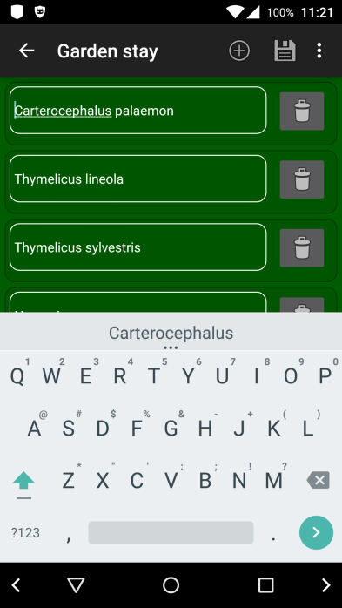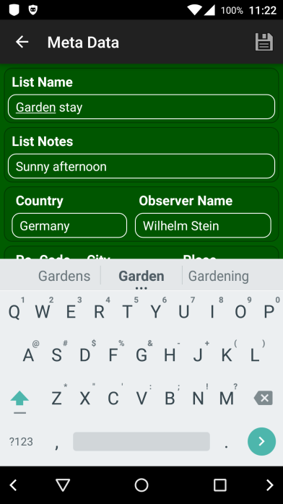Before initial use you must set up an empty basic database (Basic DB). Therefore, you first enter the meta data of the planned tour (Fig. 2). Tap on “Prepare Recording” and finish this by tapping on the saving symbol. The meta data may be modified anytime later.

Then open the “Counting List” and create the species list. Use the pencil button or the function "Edit List" for that.

The species list page opens (Fig. 3). Then this list gets an entry for each expected species by the (+)-Button, e.g.:

Carterocephalus palaemon

Thymelicus lineola

Thymelicus sylvestris

...

Fig. 2: Edit Meta Data Fig. 3: Edit List page

This list can be changed or supplemented anytime afterwards. With "Save List" you get it stored into the database.

When you have entered the meta data and created the counting list for all expected species, the database is ready for export as the "Basic Database". To do this, you can use the function "Export as Basic DB" in the menu of the starting page (Fig. 9). After that you have a copy of the empty database saved as "Basic Database" (tourcount0.db) within the home directory /sdcard (or /sdcard0, or /storage/emulated/0, it differs between smartphone models).

The "Basic Database" will be used as a template for further tour recordings. You may export the Basic DB anytime later, e.g. when you modified its structure or inserted new species.

3. Usage

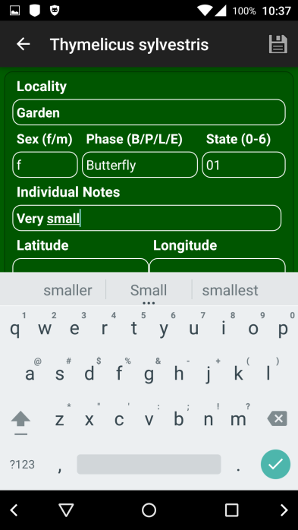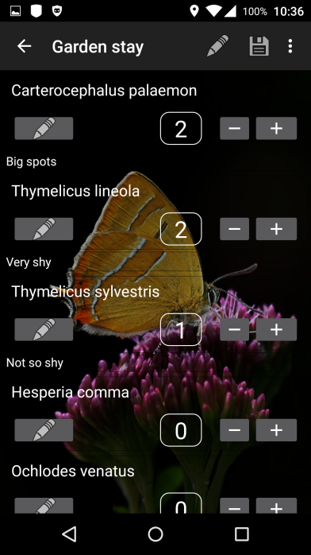Start with “Counting List” (Fig. 4).

To count just tap on the (+)-Button of the corresponding species. The counter increases and the page to edit the individual data opens (Fig. 5). Date and time as well as coordinates are entered automatically. Tapping on the Save Button gets back to the counting page.

The (-)-Buttons allows for corrections. Mind that the (-)-Button reduces the individuals list for the last entry of a species.

The Pencil-Button in each species row of the counting page opens the species editing page (Fig. 6) that lets you add remarks for each species and set its counters to any value. But this generates inconsistency between the individuals table and count number in the DB.

If you enter a species related remark this will be shown on the counting page in an extra line beneath the species row. Fig. 4: Counting List Fig. 5: Edit individual

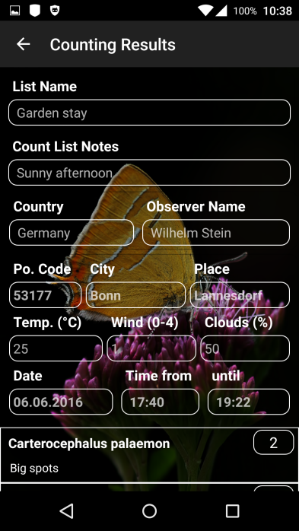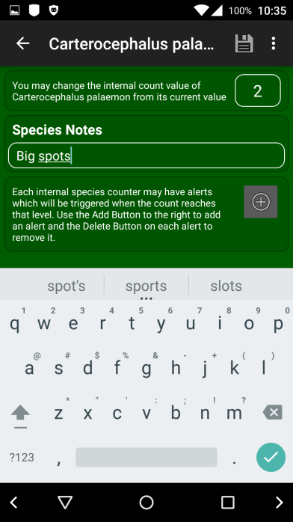To move back one page you can use the back-button or the arrow in the left upper corner. To make sure to save edited content you should go back by tapping the Save-Button.

You should leave TourCount always from its starting page, as in this state the database is safely closed and GPS no longer used by the app.

Some app pages have a specific context menu. You can activate it with the 3-point-symbol in the upper right corner.

When you have large lists or have collected big amounts of data the app may delay the start of pages, especially when entering a transect section list (the counting page) or the result page, as those need heavy calculations.

Fig. 6: Edit species Fig. 7: Results page

Finally, there is a page showing your results (Fig. 7). Here you see beneath the meta data of the tour the species which got counts. You open this page from the Starting page with the "Show Result"-Button or the Eye-symbol in the app-bar. It may take a few seconds to show up.

4. Further functions

The "Settings" page (Fig. 8) can be reached from most pages of the app. Here you may adapt the look an feel in some aspects to your wishes, e.g. sounds and background.

Selecting an own background picture can be achieved by the Gallery App, accessible in the left side menu of the background option (if applicable wipe from the left edge)..

The menu on the starting page (Fig. 9) has Settings, Reset, Import, Export, Info and Help functions.

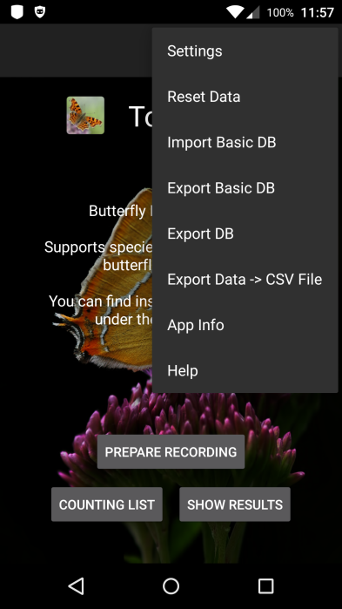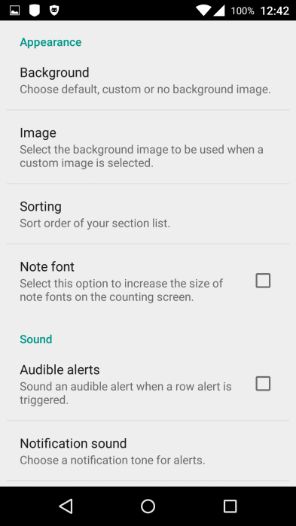For preparing a new tour you may use “Reset Data” to reset the tour-specific meta data and count data. Alternatively you may import the Basic DB from /sdcard/tourcount0.db

By “Export Basic DB” you may export the DB as empty "Basic DB" which is reasonable, when lasting changes of a counting list have been made (e.g. new species added).

Exporting the current database (Export DB) writes a copy of the complete DB to /sdcard/tourcount\_YYYY-MM-DD\_hhmmss.db.

The function “Export Data -> CSV File” writes the counting results into a MS Excel readable .csv-file to   
/sdcard/tourcount\_YYYY-MM-DD\_hhmmss.csv.

Fig. 8: Settings Fig. 9: Starting page menu

Under "App Info" you find the email address of the author, the history of the app and the license note.

The menu of the counting page provides a "Share" function for sending notes using a standard app like SMS or email.

IT-affine users may transfer the exported "tourcount\_YYYY-MM-DD\_hhmmss.db" or “.csv” files to a PC. With a free tool like "SqliteBrowser" (sqlitebrowser.org) you may examine the db-file. The .csv file may be imported as a text file (with file origin “Unicode UTF-8”) to an Excel sheet for further processing.

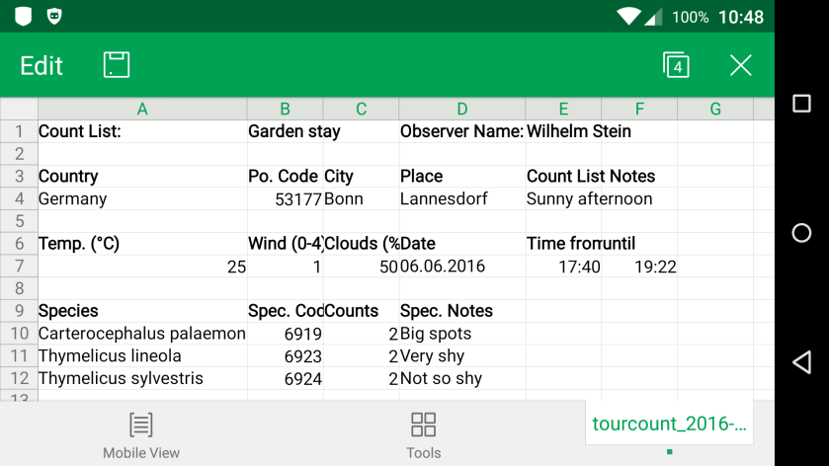Fig. 10 shows the exported .csv-table in

an Android Office Suite

Fig. 10: CSV import in Smartphone Office Suite