Do CLASH reliability and complexity ratings justify data exclusion? A residual-based audit and counterfactual assessment of wave-overtopping prediction policies
[Author names and affiliations]
Revised manuscript prepared for Ocean Engineering
Generated from verified outputs of the analysis repository (revision/). Items in square brackets, the RF/CF category wording and references marked 'to verify' must be completed by the authors before submission.

Highlights
- All 10 532 CLASH tests are audited. The models use 10 389 tests (occurrence) and 9 333 tests (discharge), with every RF and CF category kept.
- RF = 4 tests have 2.3 times the residual variance of RF = 1 tests, consistently across learners and validation schemes. RF 1–3 show no ordered trend.
- The complexity factor shows no ordered relation to geometry-level error. CF = 3 is the difficult class, and much of its error comes from a few series.
- Excluding category-4 tests changes the other predictions by at most 0.007 (fixed learner) or 0.014 (re-tuned, not significant) but degrades category-4 predictions by about 0.25 log10 units.
- Quality-aware conformal intervals with all tests retained raise RF = 4 coverage from 77 % to 89 %. CF = 3 remains under-covered.

Abstract
Each test in the CLASH wave-overtopping database carries a Reliability Factor (RF) and a Complexity Factor (CF), both ordinal from 1 to 4. These ratings are used to weight or exclude tests when data-driven predictors are developed, but their validity for that decision has not been tested. We audited all 10 532 tests: 9 333 positive-discharge tests enter the regression and 10 389 enter an occurrence (wet/dry) model. The ratings were evaluated against out-of-fold residuals of nested, geometry-grouped cross-validated learners. Tests with RF = 4 show 2.34 [1.41, 3.81] times the residual variance of RF = 1 tests. The result holds for every learner and validation scheme, but RF 1–3 show no ordered trend and near-replicate repeatability does not rise systematically with RF. CF shows no ordered relation to geometry-level error. A nested decomposition attributes 58 % of the residual variance to within-geometry variation, 29 % to geometries and 13 % to test series. Near-replicate variance accounts for 56 % [31, 93 %] of the within-geometry part, so that part is not pure measurement error. On identical held-out tests, excluding or zero-weighting category-4 tests changes the error of the remaining tests by at most 0.007 log10 units. With a learner re-tuned for each policy the retained tests gain at most 0.014 (not significant). Both ways, the error of RF = 4 tests increases by +0.27 to +0.31. Retaining all tests and scaling group-weighted split-conformal intervals by RF, CF and the physical inputs raises RF = 4 coverage of 90 % intervals from 77 % to 89 % and gives the best interval score. CF = 3 tests remain under-covered (82 %). Exclusion also changes engineering decisions: it raises the share of missed exceedances of allowable discharges for RF = 4 tests and removes almost all depth-limited tests. The ratings should be evaluated empirically before they are used to discard data, and are better used to manage predictive uncertainty than to exclude tests.
Keywords: wave overtopping; CLASH database; data quality; reliability factor; complexity factor; data selection; conformal prediction; EurOtop

1. Introduction
Data-driven prediction of mean wave-overtopping discharge rests on the CLASH database and its successors (Steendam et al., 2004; Van der Meer et al., 2009; EurOtop, 2018). Every test carries two ordinal ratings. The Reliability Factor (RF) describes how reliable the measurement and its documentation are. The Complexity Factor (CF) describes how well the standard CLASH parameters represent the tested cross-section. Both run from 1 (very reliable / simple) to 4 (unreliable / very complex).
The ratings are used to select training data. The CLASH neural network weighted each test by (4 − RF)(4 − CF), which gives zero weight to every test with RF = 4 or CF = 4, and removed tests remarked "do not use for neural network" (Van Gent et al., 2007). Later neural-network and gradient-boosting predictors excluded or resampled tests by their ratings (Zanuttigh et al., 2016; den Bieman et al., 2021). In these studies the validity of the ratings for the data-selection decision is assumed, not tested. Category-4 tests are not a random sample: they include depth-limited conditions and unusual sections that the other tests cover poorly. Removing them may therefore discard information without reducing noise.
This paper evaluates the ratings empirically and measures the consequences of rating-based data curation. Out-of-fold residuals of tuned learners are the instrument; the learners themselves are not the contribution. No physical causal effect of a hydraulic or structural parameter is estimated. Geometry-grouped validation and conformal prediction are used as tools; their development is the subject of companion work [Paper 1], and causal analysis of physical drivers is treated in [Paper 2]. The research questions are:
- RQ1. Does RF distinguish tests with different predictive residual dispersion and near-replicate repeatability?
- RQ2. Does CF identify geometries with higher predictive difficulty or poorer generalisation?
- RQ3. How is the prediction error distributed over identifiable test-series, geometry and within-geometry levels, and do RF and CF map onto these levels? (Laboratory effects are not identifiable.)
- RQ4. How do retaining, excluding or re-weighting tests by RF and CF change accuracy, calibration and engineering decisions on identical held-out tests, with fixed and with re-tuned learners?
- RQ5. Do concept-based explanations of a regression-adapted Causal Concept Wrapper Network (CCW-Net) faithfully describe the learned representations, and do they depend on data quality?
- RQ6. Is there a defensible alternative to automatic exclusion of category-4 tests?

2. CLASH data and quality ratings

2.1 Record accounting
The workbook holds 10 532 tests from 163 test series. Of these, 9 442 report positive discharge, 1 069 zero discharge and 21 a missing marker or a negative value. 123 records lack a usable toe wave height, spectral period, toe depth or freeboard; one of them also has an invalid response (Table 1). The occurrence (wet/dry) model therefore uses 10 389 tests and the discharge regression 9 333 tests. All 143 records outside the wet/dry set have RF = 4. No observation was modified and no epsilon was added to zero discharges.
Table 1. Mutually exclusive record accounting of the CLASH database.
Category | Records | Series | RF = 4 | CF = 4 | Wet/dry | Regression
invalid response AND unusable inputs | 1 | 1 | 1 | 0 | 0 | 0
invalid response only (missing marker or negative q) | 20 | 7 | 20 | 0 | 0 | 0
positive discharge, unusable inputs | 109 | 9 | 109 | 17 | 0 | 0
positive discharge, usable (wet/dry + regression) | 9 333 | 162 | 637 | 212 | 9 333 | 9 333
zero discharge, unusable inputs | 13 | 4 | 13 | 4 | 0 | 0
zero discharge, usable (wet/dry only) | 1 056 | 83 | 126 | 21 | 1 056 | 0
TOTAL | 10 532 | 163 | 906 | 254 | 10 389 | 9 333
Overlapping exclusion reasons are given in the supplementary material (Table S1).
Input unusability is confined to RF = 4: 13.8 % of valid-response RF = 4 tests have unusable inputs, against none in RF 1–3. The affected tests are not representative of the RF = 4 tests that enter the models. They have a median toe depth of 0.00 m against 0.26 m, mostly vertical lower slopes, and 67 % come from one series. They are dominantly emergent-toe conditions, where a toe wave height is not defined. Because q* requires the toe wave height, these tests cannot be scaled without imputing part of the response, which was not done in the primary analysis. A sensitivity analysis that substitutes deep-water wave conditions (100 tests) changes the RF = 4 variance ratio from 2.34 to 3.66 [1.85, 5.77]. The RF = 4 results therefore describe RF = 4 tests with complete toe conditions.
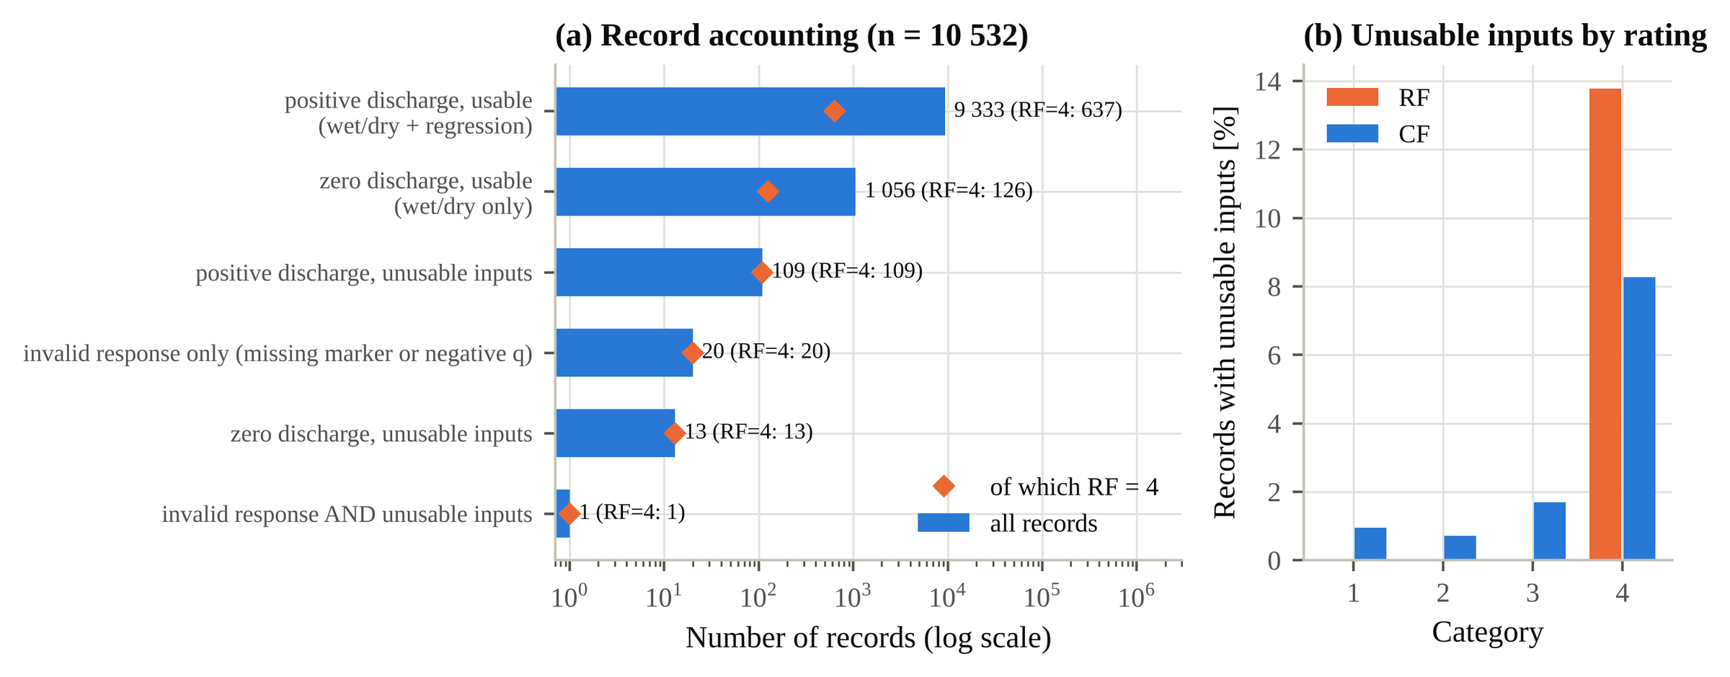
Fig. 1. Record accounting: (a) mutually exclusive categories of the 10 532 records and the number of RF = 4 records in each; (b) share of valid-response records with unusable inputs by RF and CF.

2.2 Ratings, identifiers and reconstructed geometries
Table 2. Distribution of RF and CF over all 10 532 tests.
Factor | 1 | 2 | 3 | 4
RF | 3386 (32.1 %) | 3598 (34.2 %) | 2642 (25.1 %) | 906 (8.6 %)
CF | 7989 (75.9 %) | 1405 (13.3 %) | 884 (8.4 %) | 254 (2.4 %)
RF: 1 very reliable … 4 not reliable. CF: 1 simple … 4 very complex (category wording to be verified against the CLASH WP2 documentation).
CF = 4 comprises 254 tests from 9 series (212 regression tests from 7 series), dominated by one investigation of chute structures. The test-series number (162 series in the regression set) and the literature reference are genuine identifiers. No structure or laboratory identifier exists. Geometries were therefore reconstructed within each series from water-level-invariant descriptors, giving 2 046 geometries in the regression set. A laboratory could be inferred from the reference for 70 % of tests only, so a laboratory effect is not identifiable.
CF is nominally a property of the cross-section, but it varies within 32 reconstructed geometries (311 tests; 27 geometries in the regression set). Within these geometries the lowest- and highest-CF tests differ in water level or freeboard in 0 geometries, in wave conditions in 30 and in wave obliquity in 17, which suggests that CF was sometimes assigned per test condition rather than per cross-section. In 2 they differ in no documented variable. The inconsistencies were retained, and CF is aggregated by its maximum where a geometry-level value is needed. This variation limits the use of CF as a geometry-level quality indicator.

3. Methodology

3.1 Response and predictors
The response is Y = log₁₀ q*, with q* = q / (g H_{m0}³)^{1/2}, q the mean discharge per metre (m³/s/m) and H_{m0} the spectral wave height at the toe. Fifteen dimensionless predictors use Froude scaling at the toe: R_{c}/H_{m0}, A_{c}/H_{m0}, G_{c}/L₀, H_{m0}/L₀, h/L₀, h_{t}/H_{m0}, B_{t}/L₀, B/L₀, h_{b}/H_{m0}, tan α_{B}, cot α_{d}, cot α_{u}, γ_{f}, β and the foreshore slope 1/m, with L₀ = gT_{m−1,0}²/2π. All transformations were recomputed independently, with relative differences below 10⁻¹² (supplementary Table S2). RF and CF never enter a mean model.

3.2 Validation and model optimisation
All learners share five pre-specified outer folds in which every reconstructed geometry is held out once. Hyper-parameters are selected by Optuna (TPE; Akiba et al., 2019) on grouped inner three-fold cross-validation of the outer-training partition. Boosted trees use early stopping on inner folds. Imputation and scaling are fitted on training rows only, and outer test rows are never used for any choice. The original configuration (Random Forest, XGBoost, CatBoost and MLP with 12, 30, 15 and 8 trials) was reproduced exactly. A revised configuration widens the search spaces and raises the budgets to 30–100 trials with median pruning. It adds LightGBM, histogram gradient boosting, ExtraTrees and an XGBoost variant with physically derived features (Iribarren number and roughness- and obliquity-scaled freeboards), and refits every configuration with three seeds. Learners are compared by paired geometry-cluster bootstrap differences on identical records. XGBoost remains the pre-specified reference learner for the RF/CF analyses. Series-held-out and random-record validation are reported; the latter is a leakage-sensitive reference only.

3.3 Two-stage occurrence and discharge model
Overtopping occurrence and discharge magnitude are modelled separately. Stage A is an XGBoost classifier for P(wet | X), tuned by Optuna on log loss over grouped inner folds. Its decision threshold is the maximiser of balanced accuracy on grouped inner out-of-fold probabilities. Stage B is the regression of Y on positive tests. Stage C combines both: E(q | X) = P(wet | X) E(q | wet, X), with E(q | wet, X) = 10^{μ(X)} S (g H_{m0}³)^{1/2}, where S is the Duan smearing factor from grouped inner out-of-fold residuals. All 10 389 tests are assigned the outer fold of their geometry, so positive tests keep their regression fold.

3.4 Validity of RF and CF
RF and CF are treated as ordinal. The analyses comprise:
- residual strata with test-series cluster-bootstrap intervals;
- rank trends with Holm correction;
- proportional-odds models;
- a Gamma GLM of squared residuals on the RF and CF categories, with and without an RF × CF term, repeated for every learner and validation scheme;
- contrasts between RF categories;
- geometry-level CF analyses (maximum CF within a geometry), with leave-one-series-out sensitivity for CF = 3 and CF = 4;
- minimum detectable variance ratios;
- near-replicate repeatability, repeat SD = (mean d²/2)^{1/2}, with matching tolerances of 0.5–5 % and a disjoint-pair estimator.
No laboratory reports or second ratings exist. The analyses therefore establish predictive validity and internal consistency, not the correctness of individual ratings.

3.5 Hierarchical error decomposition
Out-of-fold residuals are decomposed by exact restricted maximum likelihood into nested random intercepts for test series and geometry and a within-geometry residual. Intervals come from a series-cluster bootstrap. The stability of the shares is checked under geometry keys with 2 and 4 significant digits and a coarse key. The within-geometry component is compared with near-replicate variance and is not called measurement error.

3.6 Counterfactual data-selection policies
A policy decides which training tests are kept and how they are weighted (Table 3). Within each outer fold only the policy changes; folds, test records, seeds and calibration geometries stay fixed. The counterfactual concerns training data, not a physical input. Two experiments are reported:
- fixed hyper-parameters, tuned once on the full training partition, which isolates the effect of the data;
- policy-specific nested tuning, with Optuna applied separately for each policy on its own inner folds, which gives each policy its best achievable learner.
Accuracy is evaluated on identical held-out tests, split into common tests (RF < 4 and CF < 4, 8 494 tests), RF = 4, CF = 4 and CF = 3 tests, with paired geometry-cluster bootstrap differences to retaining all tests (P1). The empirical variance model σ²(RF, CF) used by P6 is fitted on grouped inner out-of-fold residuals of the proper-training geometries only. This corrects an earlier version that also used calibration geometries.
Table 3. Data-selection policies.
Policy | Training tests | Weights | Interval width
P1 retain all | all | equal | constant
P2 | excl. RF = 4 | equal | constant
P3 | excl. CF = 4 | equal | constant
P4 | excl. RF = 4 or CF = 4 | equal | constant
P5 conventional | RF < 4 and CF < 4 | (4 − RF)(4 − CF) | constant
P5b conventional | as P5, 'do not use' tests removed | (4 − RF)(4 − CF) | constant
P6a empirical weights | all | 1/σ²(RF, CF) | constant
P6b quality-aware intervals | all | equal | ∝ σ(RF, CF)
P6b′ shrunk cells | all | equal | ∝ σ(RF × CF), partially pooled
P6c | all | 1/σ²(RF, CF) | ∝ σ(RF, CF)

3.7 Quality-aware conformal intervals
Intervals use group-weighted split conformal prediction: each calibration geometry carries weight 1/(K + 1), and a mass of 1/(K + 1) sits at infinity (Lee et al., 2023, preprint). The mean model is fitted on proper-training geometries, and every scale function on their inner out-of-fold residuals. Scores are therefore independent of the calibration and test outcomes. Six scale functions represent different availabilities of quality information:
- none;
- RF and CF main effects (retrospective audit);
- partially pooled RF × CF cells;
- CF only (known geometry, no RF);
- physical predictors only (new structure, no rating);
- physical predictors with RF and CF.
Calibration fractions of 0.15, 0.25 and 0.35 with five calibration seeds test the stability of the results. The guarantee is marginal over new geometries; coverage within categories is empirical, not guaranteed.

3.8 Engineering decision analysis
EurOtop (2018) mean-value formulae are applied only within stated domains:
- single-slope structures without berm or crest wall, 1 ≤ cot α ≤ 7, 0.1 < R_{c}/H_{m0} < 3.5 and ξ_{m−1,0} < 5 (slope equations with roughness, obliquity and crest-width factors);
- plain vertical walls without a toe mound and without foreshore influence (h/H_{m0} ≥ 4).
The formulae were partly calibrated on CLASH data, so this comparison is not independent. Allowable discharges depend on use and wave height (EurOtop, 2018), and no universal limit exists. A sensitivity grid of prototype limits q_{allow} ∈ {0.1, 1, 10, 50} l/s/m at H_{m0} ∈ {1, 2, 3} m is therefore converted to q* by Froude similarity. Under each policy we record false-safe and false-alarm classifications, changes of safety class and the shift in risk ranking.

3.9 Concept-based explanations (CCW-Net)
A regression adaptation of the Causal Concept Wrapper Network (Rountree et al., 2026) wraps a frozen tabular backbone with ten concept slots and trains them with necessity, sufficiency and independence criteria. The implementation was checked line by line against the authors' reference code (supplementary Section S8). Its effects are properties of the network's representations, not physical causal effects. Full details are in the supplementary material.

4. Predictive model diagnostics
Table 4. Out-of-fold accuracy on held-out geometries (n = 9 333, all RF and CF retained; Y = log₁₀ q*).
Model | RMSE (per seed) | RMSE seed ensemble [95 % CI] | R² | Bias | F10 | ΔRMSE vs baseline XGBoost [95 % CI]
Random Forest (baseline) | 0.539 | 0.539 [0.489, 0.590] | 0.787 | +0.002 | 3.46 | +0.038 [0.024, 0.052]
XGBoost (baseline) | 0.501 | 0.501 [0.458, 0.547] | 0.816 | −0.010 | 3.17 | 0
CatBoost (baseline) | 0.513 | 0.513 [0.462, 0.567] | 0.808 | −0.011 | 3.26 | +0.011 [−0.002, 0.024]
MLP (baseline) | 0.576 ± 0.021 | 0.550 [0.493, 0.612] | 0.757 | −0.003 | 3.77 | +0.048 [0.024, 0.075]
CCW-Net (baseline) | 0.601 ± 0.006 | 0.564 [0.504, 0.631] | 0.736 | −0.020 | 3.99 | +0.063 [0.033, 0.095]
XGBoost v2 | 0.494 ± 0.002 | 0.491 [0.445, 0.540] | 0.821 | −0.014 | 3.12 | −0.010 [−0.017, −0.003]
XGBoost v2 + physical features | 0.503 ± 0.001 | 0.500 [0.456, 0.546] | 0.815 | −0.024 | 3.18 | −0.001 [−0.012, 0.011]
LightGBM v2 | 0.499 ± 0.001 | 0.497 [0.452, 0.545] | 0.818 | −0.019 | 3.15 | −0.004 [−0.012, 0.003]
RMSE is the pooled out-of-fold RMSE (the definition used throughout; the fold-mean values of the original Table 2 are in the SI). Bias = predicted − measured. F10 = 10^RMSE. ΔRMSE: paired geometry-cluster bootstrap on identical records.
The reproduced baseline XGBoost gives RMSE 0.501 (Table 4). The best optimised learner, XGBoost v2, reaches 0.491 as a seed ensemble, a paired difference of −0.010 [−0.017, −0.003]. 1 optimised learner(s) improve significantly on the baseline, by at most 0.010 log10 units (a factor 1.023 in discharge). This is small against the 0.50 residual SD and does not alter any RF/CF conclusion (Section 5). For XGBoost the outer RMSE changes from 0.511 after 10 trials to 0.493 after 100, so larger budgets bring little.
The validation unit dominates: the reference model reaches RMSE 0.354 with random records, 0.501 with held-out geometries and 0.749 with held-out test series. Geometry-grouped validation is therefore not equivalent to generalisation to a new laboratory or test series.
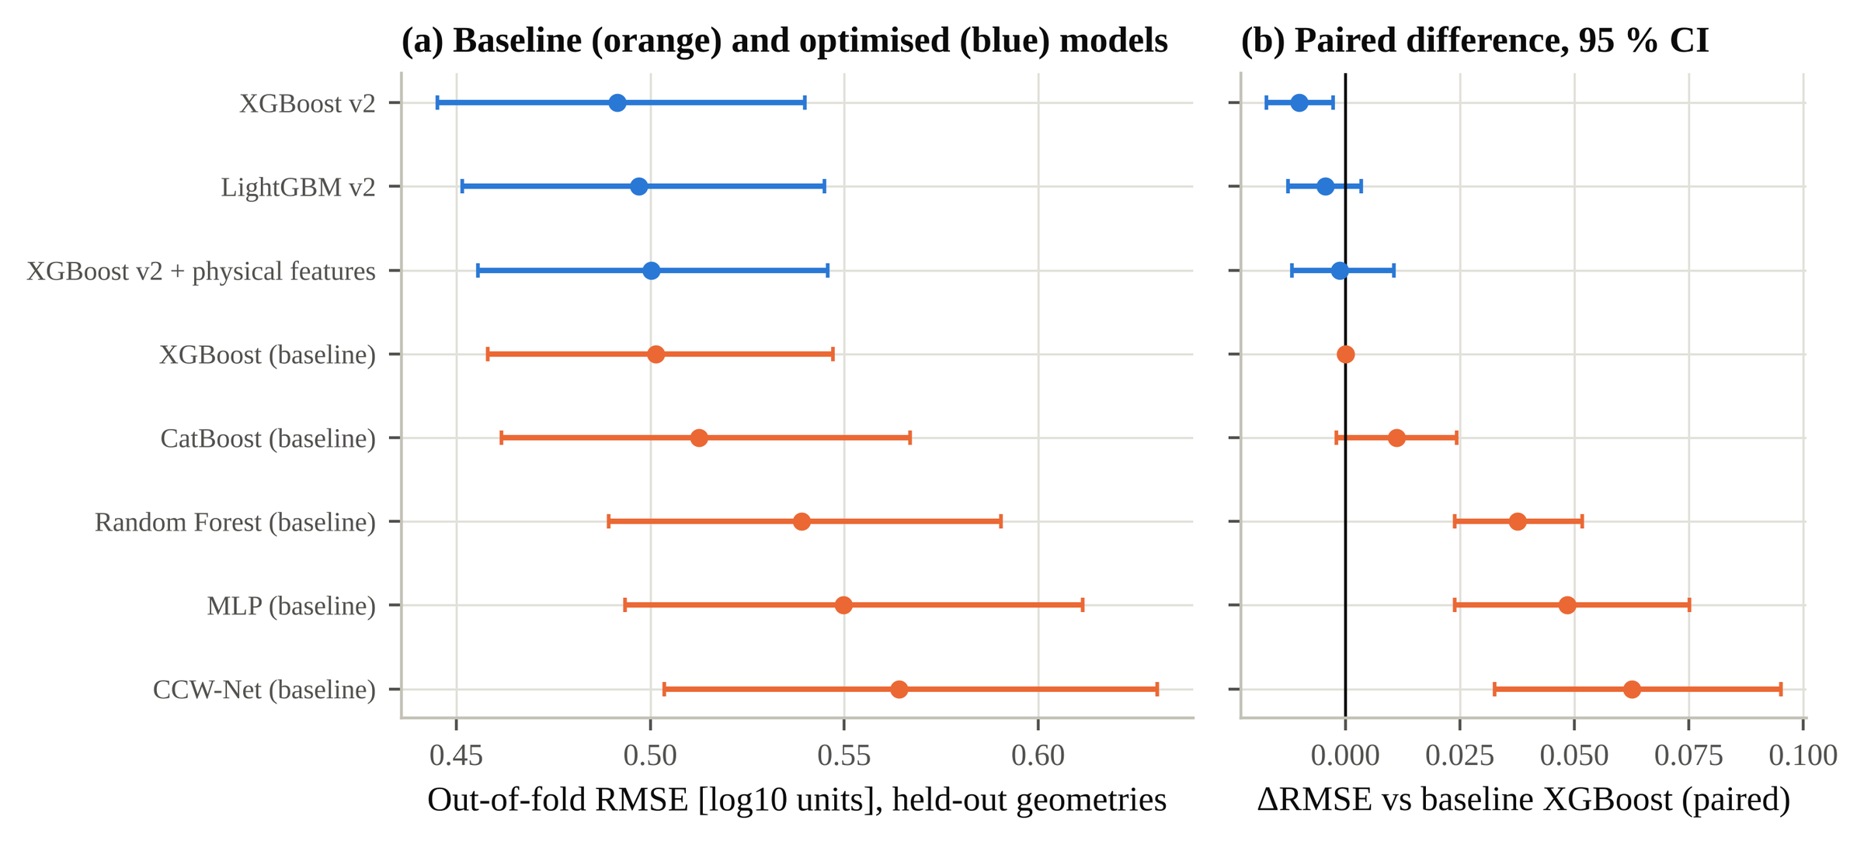
Fig. 2. Baseline and optimised learners on identical held-out geometries: (a) seed-ensemble RMSE with geometry-cluster bootstrap 95 % intervals; (b) paired difference to the baseline XGBoost.

4.1 Occurrence and combined prediction
The occurrence model separates wet from dry tests with ROC AUC 0.929 [0.908, 0.945], Brier score 0.049 and balanced accuracy 0.849 at the inner-CV threshold (Fig. 3). Discrimination is weaker for RF = 4 (AUC 0.80 [0.69, 0.89] against 0.92 for RF = 1) and for CF = 4 (0.83). It is computed on the same geometry folds as the regression; the original wet/dry figures (0.81 and 0.92) came from a fixed-parameter classifier with separate folds and agree with these. The stage-B predictions reproduce the original out-of-fold predictions exactly. For positive tests the combined expected discharge is +0.39 log10 units above the conditional median, as expected for a mean of a log-normal quantity. For zero-discharge tests the median predicted expected discharge is 0.0010 l/s/m (model scale).
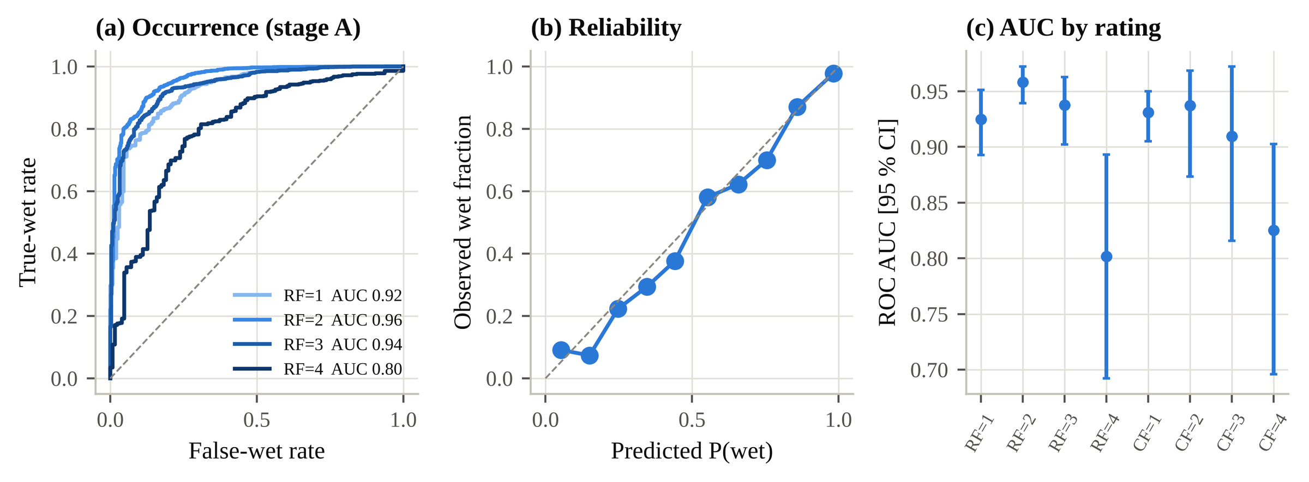
Fig. 3. Overtopping occurrence (stage A) on held-out geometries: (a) ROC curves by RF; (b) reliability diagram; (c) ROC AUC by RF and CF with geometry-cluster bootstrap intervals.

5. Validity of the reliability and complexity factors

5.1 Reliability factor
Table 5. Residuals, repeatability and variance ratios by RF (reference XGBoost, held-out geometries).
RF | n | Series | MAE [95 % CI] | Within-geometry SD | Repeat SD (pairs) | Variance ratio vs RF 1
1 | 3 189 | 54 | 0.306 [0.262, 0.357] | 0.340 [0.298, 0.384] | 0.19 (130) | 1
2 | 3 174 | 71 | 0.363 [0.298, 0.455] | 0.395 [0.318, 0.492] | 0.23 (483) | 1.38 [0.90, 2.15]
3 | 2 333 | 76 | 0.357 [0.294, 0.442] | 0.350 [0.309, 0.394] | 0.36 (457) | 1.49 [0.86, 2.34]
4 | 637 | 41 | 0.451 [0.373, 0.545] | 0.470 [0.378, 0.570] | 0.22 (66) | 2.34 [1.41, 3.81]
Repeat SD from near-replicate pairs (1 % tolerance) by the larger RF of the pair. Variance ratios from a Gamma GLM with RF and CF categories; test-series cluster bootstrap.
Tests with RF = 4 have a residual variance 2.34 [1.41, 3.81] times that of RF = 1 tests, adjusted for CF (Table 5). Across all learners and validation schemes the ratio lies between 2.13 and 3.14, and every interval excludes one (Fig. 4). The effect is specific to the top category. RF = 4 differs from RF = 2 (1.70 [1.02, 2.83]) but not clearly from RF = 3 (1.56 [0.93, 2.71]), and there is no trend among RF 1–3 (Spearman 0.047 [−0.042, 0.131]). The scale therefore behaves as a flag for an elevated-dispersion group rather than as a graded measure. Equal spacing of the categories is not supported.
Near-replicate repeatability does not reproduce the RF = 4 effect at the primary 1 % tolerance: the repeat SD is 0.19 for pairs with RF ≤ 1 and 0.22 with RF = 4, from only 66 RF = 4 pairs in 15 series. With a 5 % tolerance the RF = 4 value rises to 0.39 [0.23, 0.50]. Wider tolerances, however, admit genuine hydraulic differences. Repeatability evidence on RF is therefore inconclusive, and the elevated residual dispersion of RF = 4 cannot be attributed to measurement uncertainty alone. RF rises with indicators of estimated parameters, so RF partly records documentation completeness.

5.2 Complexity factor
Table 6. Geometry-level errors by CF (maximum CF within the geometry; geometries are the units).
CF | Geometries | Series | Tests | |Mean residual| | Mean geometry RMSE | Grouped − random RMSE
1 | 1 367 | 120 | 6 931 | 0.259 [0.232, 0.297] | 0.316 [0.279, 0.377] | 0.046 [0.033, 0.066]
2 | 363 | 48 | 1 248 | 0.239 [0.201, 0.282] | 0.303 [0.250, 0.372] | 0.043 [0.023, 0.065]
3 | 263 | 27 | 935 | 0.319 [0.261, 0.399] | 0.391 [0.323, 0.489] | 0.024 [0.003, 0.055]
4 | 53 | 7 | 219 | 0.255 [0.147, 0.380] | 0.326 [0.238, 0.533] | 0.087 [0.041, 0.189]
Mean geometry RMSE is the unweighted mean over geometries of the per-geometry RMSE. It differs from the record-level RMSE pooled over all tests of a category (Section 5.2).
No geometry-level quantity is rank-correlated with CF (Table 6). The absolute geometry mean residual gives 0.03 [−0.06, 0.10] and the generalisation gap −0.00 [−0.07, 0.06]. The non-significant trend does not demonstrate absence of an effect. The minimum detectable variance ratio for CF = 4 is 3.0, so moderate effects could go undetected. CF = 3 is the difficult class: its residual variance is 2.18 [1.01, 3.87] times that of CF = 1. Its record-level RMSE (0.71) and its mean geometry RMSE (0.391) differ because the former pools 825 tests and is dominated by a few series with large over-predictions. Series 506 alone contributes 41 % of the CF = 3 squared error. Leaving out single CF = 3 series moves the CF = 3 variance ratio between 1.46 and 2.72; without series 506 it is 1.46 [0.77, 2.74], so the CF = 3 effect rests largely on one investigation. CF = 4 tests are predicted well (variance ratio 0.66; leave-one-series-out range 0.59–0.98), which reflects the internal consistency of a few series, not easy representation of complex sections. When whole series are held out, a weak positive CF trend appears (0.11 [0.01, 0.22]). It is reported but does not survive multiple-comparison correction. RF and CF do not interact (RF × CF term 1.06 [0.83, 1.29]).
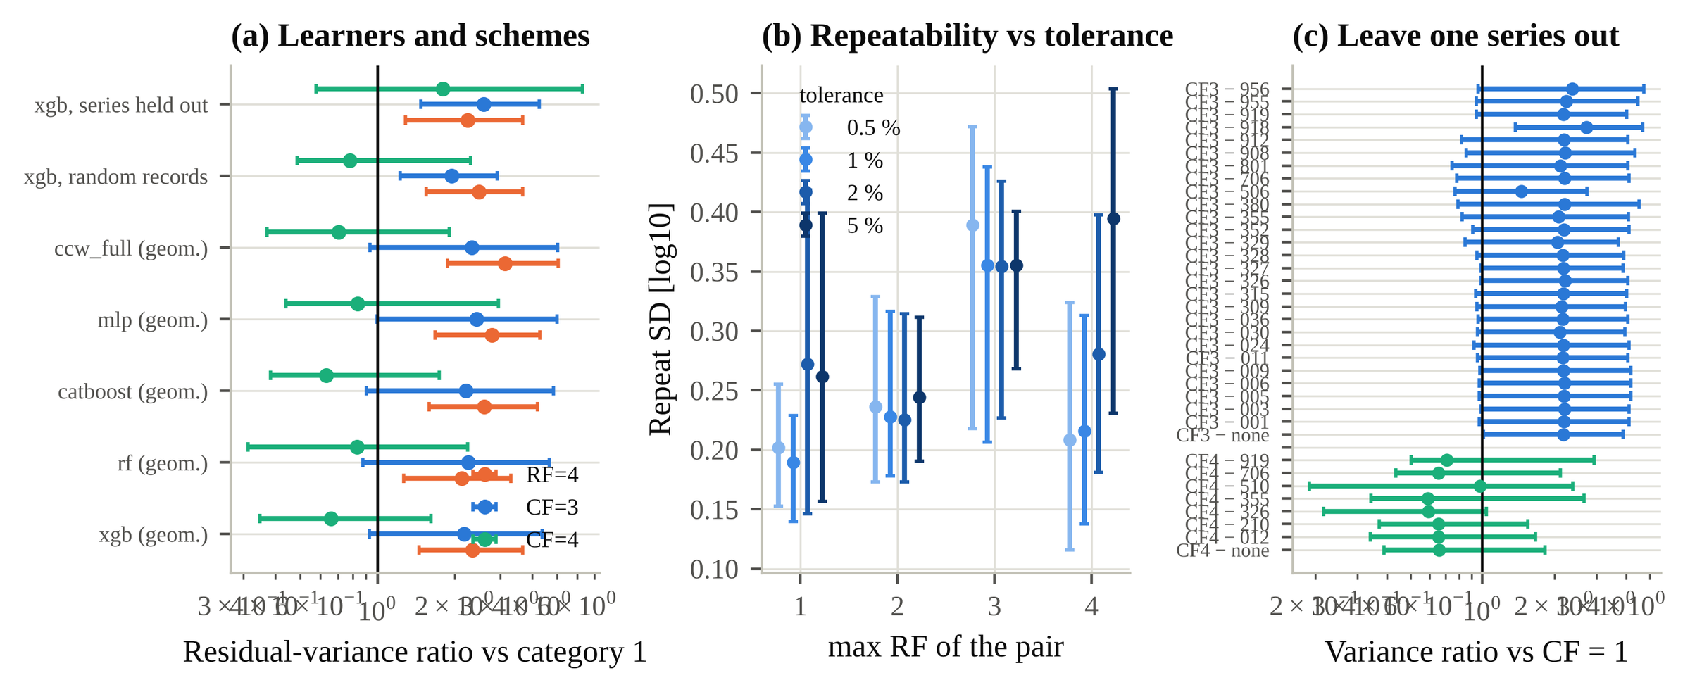
Fig. 4. Robustness of the RF and CF findings: (a) residual-variance ratios (RF = 4, CF = 3, CF = 4 vs category 1) for every learner and validation scheme; (b) near-replicate repeat SD by RF for matching tolerances of 0.5–5 %; (c) leave-one-series-out variance ratios for CF = 4 and CF = 3. Test-series cluster bootstrap 95 % intervals.
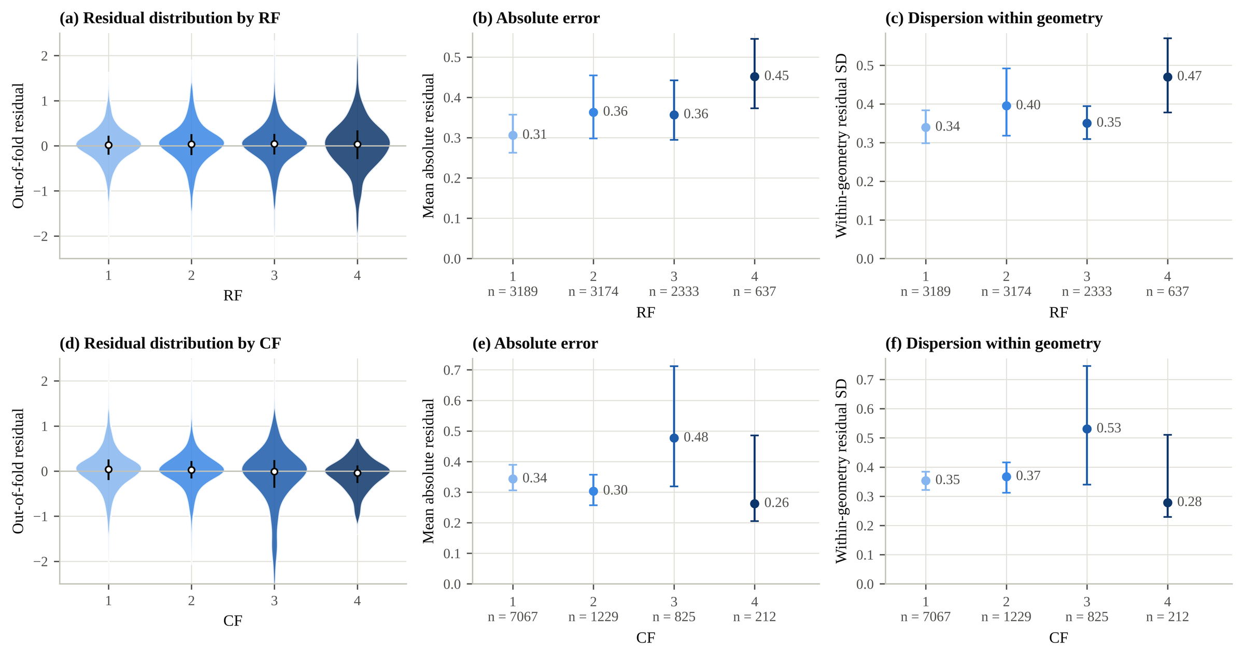
Fig. 5. Out-of-fold residuals by RF (top) and CF (bottom): distributions, mean absolute residual and within-geometry SD with test-series cluster-bootstrap 95 % intervals.

6. Hierarchical error decomposition
Table 7. REML decomposition of out-of-fold residuals (reference XGBoost, held-out geometries).
Component | Units | SD | Share of variance [95 % CI]
series | 162 | 0.177 | 13 % [2 %, 29 %]
geometry | 2 046 | 0.262 | 29 % [19 %, 40 %]
within-geometry residual | 9 333 | 0.372 | 58 % [48 %, 63 %]

Within-geometry variation accounts for 58 % of the residual variance, the geometry level for 29 % and the test series for 13 % (Table 7, Fig. 6). Rebuilding the geometry key with 2 or 4 significant digits or a coarse key changes the number of geometries from 554 to 2 074 (adjusted Rand index ≥ 0.73). The within-geometry share stays between 47 % and 58 %, and the RF = 4 variance ratio between 2.34 and 2.84. The near-replicate variance is 56 % [31 %, 93 %] of the within-geometry variance. The within-geometry residual therefore contains model and unrecorded-condition components besides repeatability, and is not pure measurement error. A laboratory component is not identifiable: laboratories are inferred for only part of the tests and coincide largely with series. RF and CF do not map onto the levels as their definitions imply. RF = 4 is elevated at the within-geometry and at the geometry level, and the geometry-level SD is similar in every CF class.
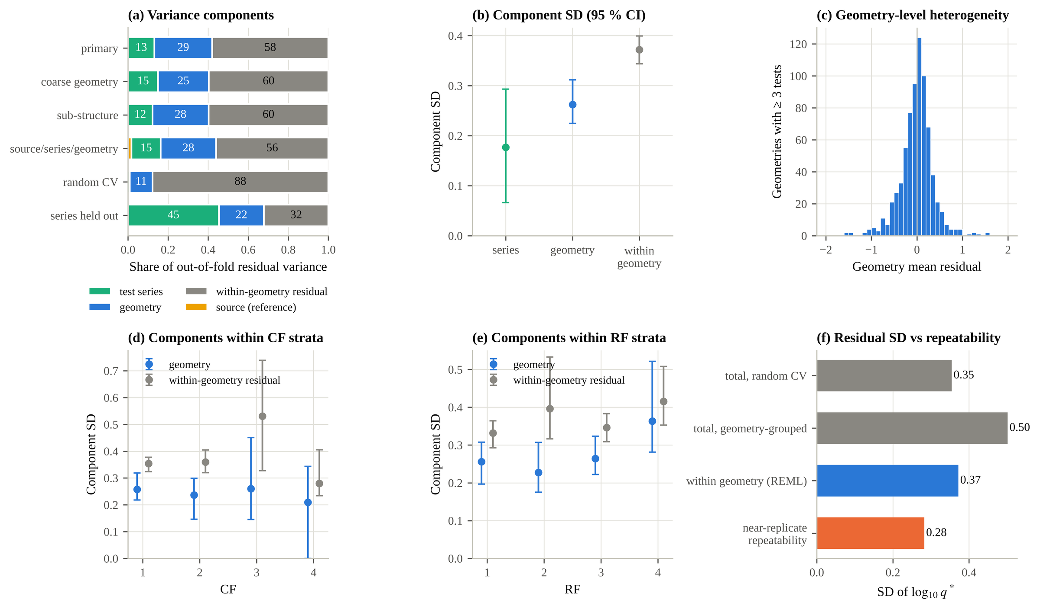
Fig. 6. Hierarchical decomposition of out-of-fold residuals: (a) variance shares under alternative groupings and validation units; (b) component SDs; (c) geometry mean residuals; (d, e) components within CF and RF strata; (f) residual SD compared with near-replicate repeatability.

7. Counterfactual data-selection policies
Table 8. Effect of the training-data policy on identical held-out tests (XGBoost). ΔRMSE relative to P1 of the same experiment, with paired geometry-cluster bootstrap 95 % intervals.
Policy | Training tests / fold | ESS | ΔRMSE common | ΔRMSE RF = 4 | ΔRMSE CF = 4 | Tuned: Δ common | Tuned: Δ RF = 4 | Tuned: Δ CF = 4
P1 retain all | 7 466 | 7 466 | 0 | 0 | 0 | 0 | 0 | 0
P2 excl. RF = 4 | 6 957 | 6 957 | +0.001 [−0.007, 0.009] | +0.282 [0.185, 0.395] | −0.016 [−0.040, 0.006] | −0.008 | +0.266 | −0.012
P3 excl. CF = 4 | 7 297 | 7 297 | −0.000 [−0.006, 0.006] | −0.011 [−0.026, 0.006] | +0.225 [0.171, 0.295] | +0.001 | +0.001 | +0.260
P4 excl. RF/CF = 4 | 6 795 | 6 795 | −0.005 [−0.012, 0.002] | +0.266 [0.160, 0.388] | +0.222 [0.163, 0.294] | −0.008 | +0.243 | +0.224
P5 (4−RF)(4−CF) | 6 795 | 5 576 | −0.003 [−0.013, 0.008] | +0.297 [0.189, 0.416] | +0.266 [0.205, 0.357] | −0.010 | +0.266 | +0.257
P5b P5 + remarks | 6 556 | 5 381 | −0.007 [−0.028, 0.011] | +0.310 [0.200, 0.430] | +0.262 [0.208, 0.331] | −0.014 | +0.309 | +0.243
P6a 1/σ² weights | 7 466 | 7 070 | −0.009 [−0.021, 0.003] | +0.021 [−0.012, 0.054] | +0.016 [0.003, 0.031] | −0.004 | +0.011 | −0.007
P6c P6a + P6b | 7 466 | 7 070 | −0.009 [−0.021, 0.003] | +0.021 [−0.012, 0.054] | +0.016 [0.003, 0.031] | −0.004 | +0.011 | −0.007
Fixed hyper-parameters unless marked 'tuned' (policy-specific nested Optuna). ESS: effective sample size (Σw)²/Σw². P1 RMSE (fixed): common 0.499, RF = 4 0.641, CF = 4 0.360. The original fixed-parameter results (Table S9) agree.
No exclusion or conventional weighting policy improves prediction of the tests it keeps (Table 8, Fig. 7). With fixed hyper-parameters the common-test differences lie between −0.007 and +0.001. With policy-specific tuning they lie between −0.014 and +0.001. The largest gain (P5b P5 + remarks: −0.014 [−0.029, 0.001], 2.8 % of the common-test RMSE) is not significant at the 95 % level. Re-tuning on curated data thus yields at most a small gain on the retained tests. Part of it reflects a different selected model (shallower, faster-learning trees) rather than cleaner data: the inner objective is computed on the retained tests only and is therefore lower (0.506 against 0.544). Every policy that removes or zero-weights a category degrades that category: RF = 4 tests gain +0.27 to +0.31 RMSE and CF = 4 tests +0.22 to +0.27 (+0.24 to +0.31 and +0.22 to +0.26 when tuned). The same policies move 26–41 % of category-4 predictions by more than a factor 2. Excluding RF = 4 changes CF = 4 errors by −0.016, and excluding CF = 4 changes RF = 4 errors by −0.011, so each loss is largely specific to the removed category. Empirical down-weighting (P6a, effective sample size 7 070 of 7 466; weights 0.26–1.79) changes the common-test RMSE by −0.009. Neutrality on common tests is not evidence that exclusion is harmless: it is harmless only to the tests that are kept.
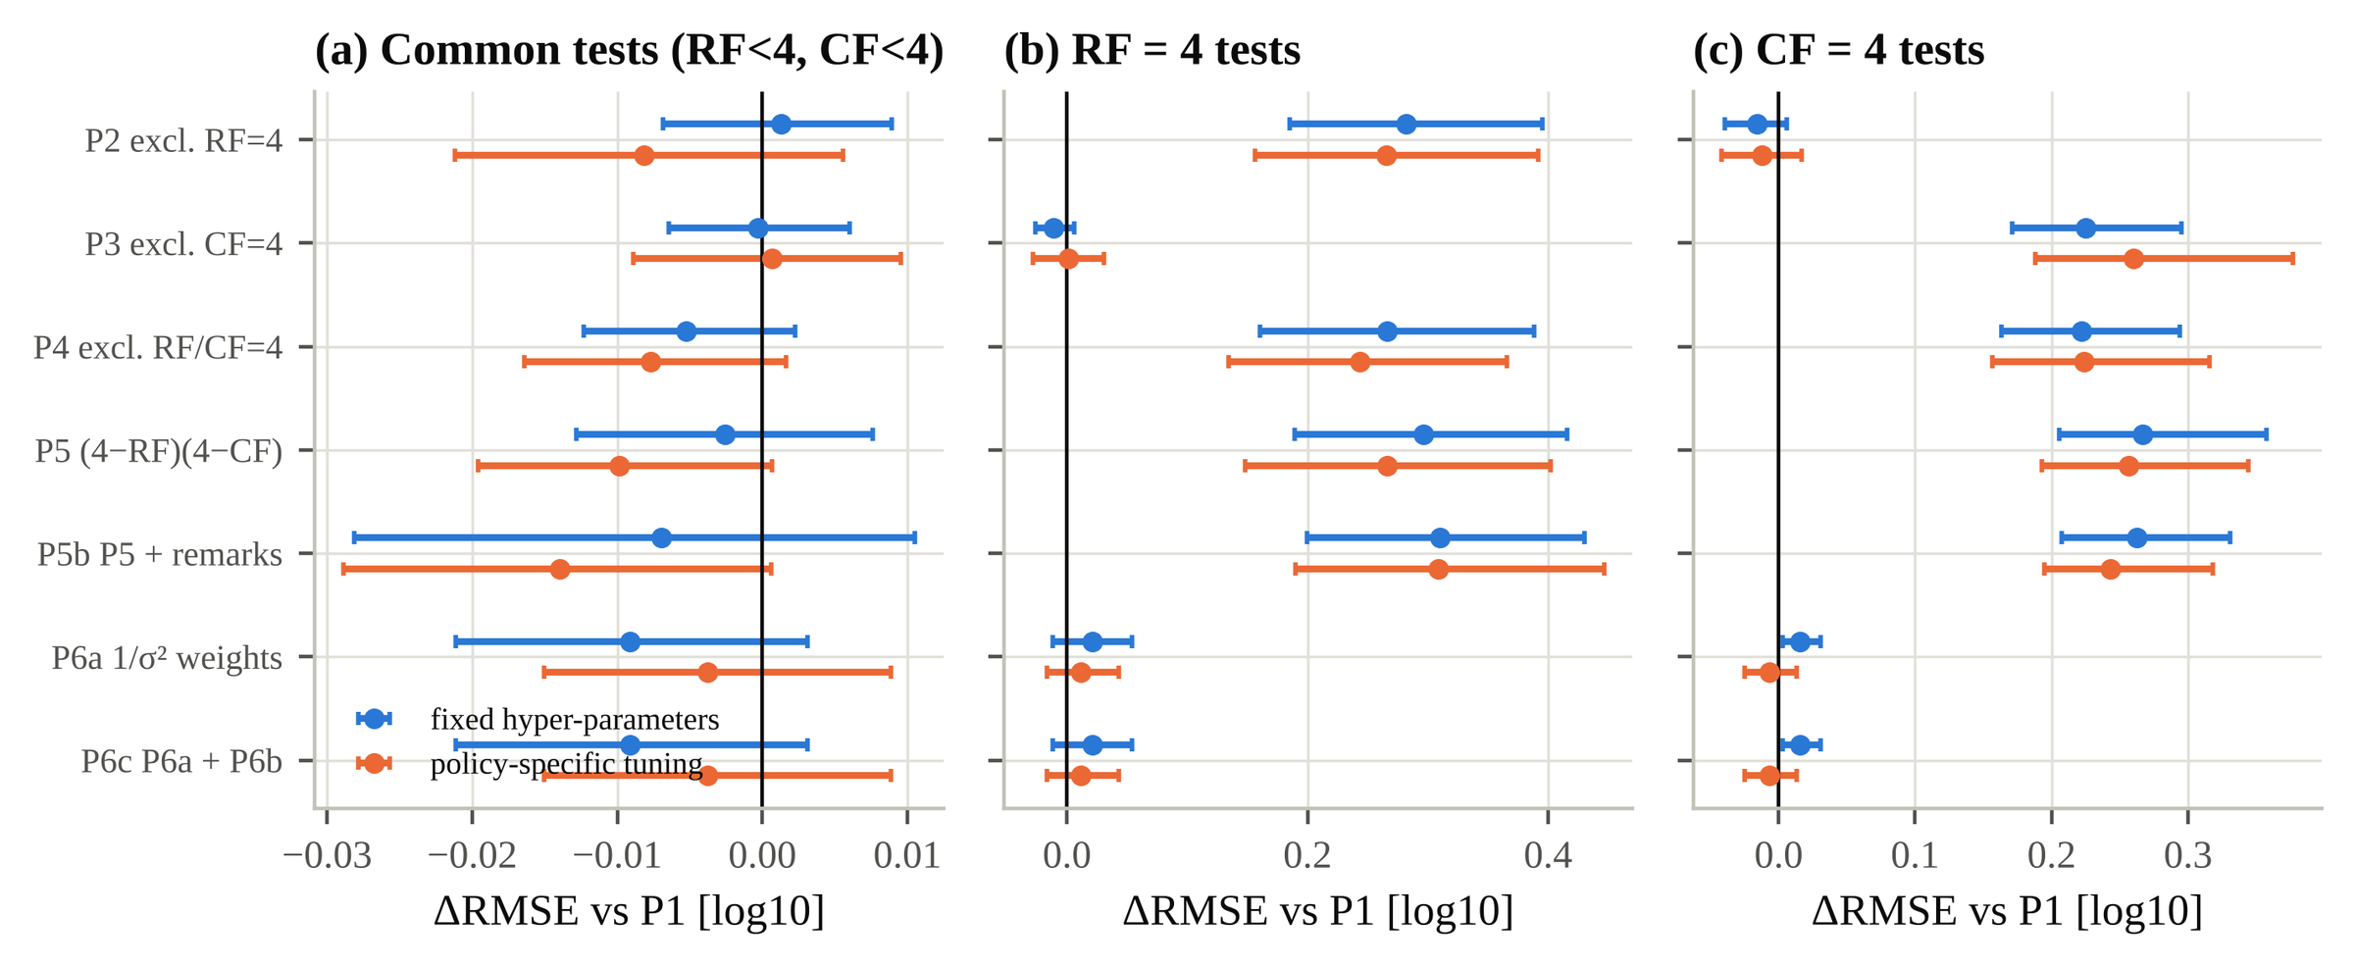
Fig. 7. Counterfactual policies with fixed and with policy-specific tuned XGBoost: ΔRMSE relative to retaining all tests for (a) common, (b) RF = 4 and (c) CF = 4 tests, with paired geometry-cluster bootstrap 95 % intervals.
Exclusion also affects the occurrence model. Excluding RF = 4 tests lowers the AUC on held-out RF = 4 tests from 0.80 to 0.74, and excluding CF = 4 lowers it on CF = 4 tests from 0.83 to 0.62. Common-test AUC is unchanged (0.948 against 0.943 under P4).

8. Quality-aware uncertainty quantification
Table 9. Split-conformal 90 % intervals by scale function (calibration fraction 0.25, five calibration seeds, all tests retained).
Scale | Geometry-mean coverage [95 % CI] | Record coverage | RF = 4 | CF = 3 | CF = 4 | Max dev. over RF (pts) | Mean width | Winkler | Series < 80 %
constant | 90.5 % [89.8 %, 91.1 %] | 85.4 % | 76.7 % | 78.7 % | 93.6 % | 13.3 | 1.48 | 2.74 | 31 %
RF+CF main effects | 90.2 % [89.6 %, 90.8 %] | 84.9 % | 85.9 % | 82.2 % | 86.8 % | 5.7 | 1.48 | 2.74 | 31 %
RFxCF shrunk cells | 90.5 % [89.8 %, 91.0 %] | 85.1 % | 86.3 % | 82.7 % | 87.6 % | 5.7 | 1.51 | 2.75 | 32 %
CF only | 90.4 % [89.8 %, 91.0 %] | 85.0 % | 75.9 % | 82.4 % | 88.2 % | 14.1 | 1.47 | 2.75 | 31 %
physical only | 90.6 % [90.0 %, 91.1 %] | 88.8 % | 82.7 % | 79.4 % | 94.0 % | 7.3 | 1.72 | 2.52 | 19 %
physical+RF+CF | 90.7 % [90.1 %, 91.2 %] | 88.8 % | 88.8 % | 82.2 % | 92.0 % | 2.6 | 1.71 | 2.49 | 19 %
Width and Winkler (interval) score in log10 units; a width w corresponds to a factor 10^{w/2} either side of the prediction. Coverage within categories is empirical; only the marginal coverage over new geometries is guaranteed.
Every scale attains the guaranteed quantity, the coverage averaged over held-out geometries (90.2 %–90.7 %; Table 9). Record-level coverage is lower (84.9 %–88.8 %), because geometries with many tests are harder to predict. The hierarchical guarantee does not extend to individual tests, and this must be considered when intervals are read per test. Constant intervals cover only 76.7 % of RF = 4 tests (Fig. 8). Scaling by the RF and CF main effects raises RF = 4 coverage to 85.9 % and reduces the largest coverage deviation across RF from 13.3 to 5.7 points, at a mean width of 1.48 against 1.48. The lowest interval (Winkler) score is obtained by the physical+RF+CF scale (2.49 against 2.74 for constant intervals), with RF = 4 coverage 88.8 % and a largest RF deviation of 2.6 points, at a mean width of 1.71. Partial pooling of the 16 RF × CF cells gives 86.3 % for RF = 4 and 82.7 % for CF = 3, with no unstable widths. The results are stable across calibration fractions (RF = 4 coverage 85.6 %–87.2 %) and seeds. CF = 3 tests remain under-covered under every scale (78.7 %–82.7 %), because their error is concentrated in a few series (Section 5.2). Without series 506, CF = 3 coverage under the main-effects scale is 86.9 %. Coverage is therefore not equalised across all quality categories.
RF records how reliable a completed experiment was, so it is not available for a new structure. For a prospective prediction, CF may be assessable from the geometry but RF is not. A scale based on CF alone gives RF = 4 coverage 75.9 %. A scale based on physical predictors only gives 82.7 % at width 1.72, and the learned concepts recover RF = 4 only weakly from the inputs. The quality-aware intervals are therefore a tool for retrospective database auditing and for use of the database as training data, not a prospective uncertainty model for new structures.
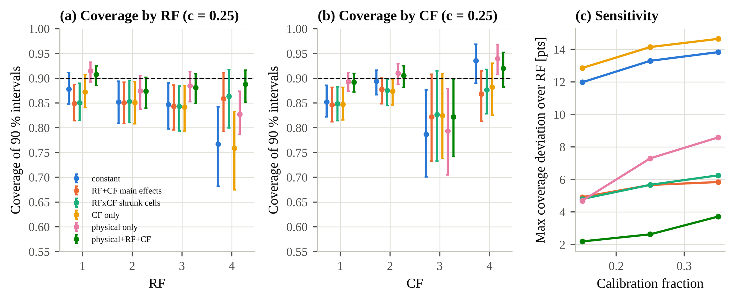
Fig. 8. Quality-aware conformal intervals with all tests retained: coverage of 90 % intervals by (a) RF and (b) CF for six scale functions (geometry-cluster bootstrap 95 % intervals); (c) largest coverage deviation across RF versus calibration fraction.

9. Engineering decision implications
Table 10. EurOtop (2018) mean-value formulae and data-driven predictions within the EurOtop validity domain: RMSE / bias in log₁₀ q*.
Domain | Tests | Series | EurOtop | XGBoost baseline | XGBoost v2
all applicable | 4 083 | 90 | 0.969 / +0.00 | 0.526 / −0.04 | 0.513 / −0.05
S rough single slope | 2 697 | 63 | 1.132 / +0.04 | 0.588 / −0.01 | 0.575 / −0.03
S smooth single slope | 1 278 | 26 | 0.430 / −0.02 | 0.371 / −0.10 | 0.363 / −0.09
V plain vertical wall | 108 | 5 | 1.128 / −0.65 | 0.429 / −0.09 | 0.407 / −0.09
EurOtop was partly calibrated on CLASH data, while the learners are evaluated on held-out geometries; the comparison is not independent. Outside the stated domains (5 250 tests) no formula was applied.
Within its validity domain (4 083 tests) EurOtop gives RMSE 0.969 against 0.526 for the held-out-geometry XGBoost (Table 10). For RF = 4 tests the EurOtop error rises to 1.492 with bias +0.60. These tests are poorly described by standard formulae as well as by data-driven models.
Data-selection policies change engineering decisions. With an allowable discharge of 1 l/s/m at H_{m0} = 2 m, the share of RF = 4 exceedances predicted as safe rises from 7.8 % when all tests are retained to 18.3 % when RF = 4 tests are excluded (16.2 % under P4). Excluding RF = 4 changes the exceed/not-exceed decision for 17.1 % of RF = 4 tests, against 4.0 % of common tests (Fig. 9). The pattern holds over the threshold grid (supplementary Table S14), and the safety class of 33 % of RF = 4 tests changes under P2. Retaining the tests and widening their intervals (P6b) leaves every point decision unchanged and lowers the probability that an exceedance is missed.
Category-4 tests are concentrated in particular regimes (Fig. 9). Of the depth-limited tests (H_{m0}/h > 1), 99 % would be removed by excluding category 4. So would 31 % of the low-freeboard tests, 21 % of the strongly oblique tests and all chute structures. Without them, the median distance from an RF = 4 test to the nearest retained test of another series grows from 1.38 to 1.52 (standardised units). Exclusion thus removes coverage of physically important regimes, which is where the unusual tests are most valuable.
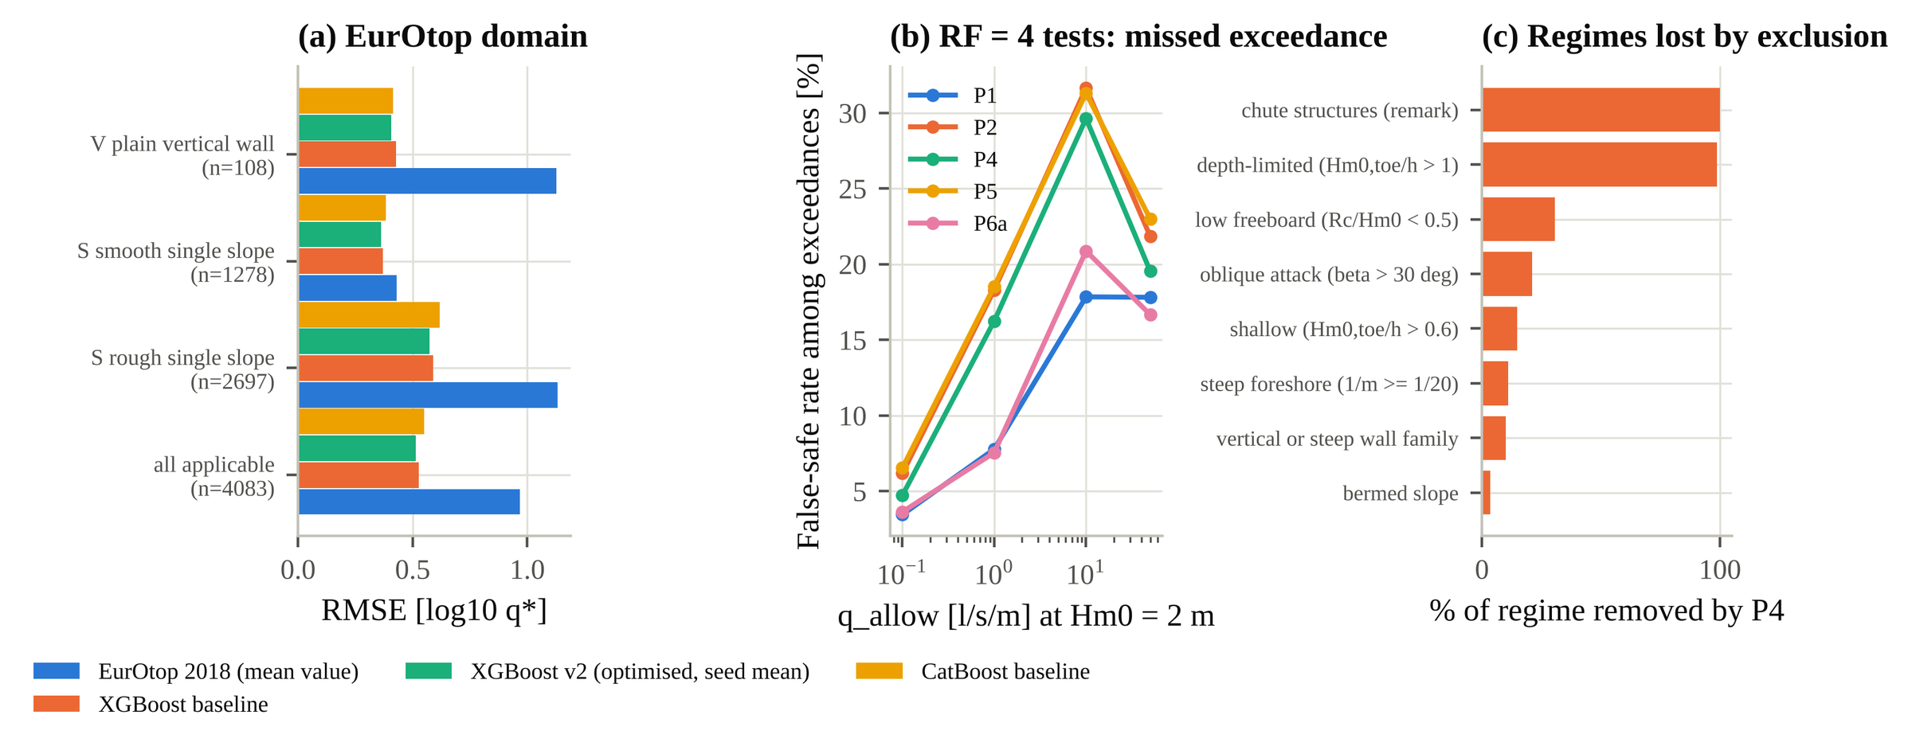
Fig. 9. Engineering consequences: (a) EurOtop and data-driven RMSE within the EurOtop validity domain; (b) share of RF = 4 exceedances predicted as safe under five policies, by allowable discharge at H_{m0} = 2 m; (c) share of each physical regime removed by excluding category-4 tests.

10. Concept-explanation assessment (CCW-Net)
CCW-Net is less accurate than gradient boosting (pooled RMSE 0.601 against 0.501). Causal alignment does what it is trained to do for necessity and sufficiency: relative to an unaligned wrapper the necessity effect falls from 0.055 to 0.038 and the sufficiency gap from 0.273 to 0.108. It does not improve additivity (0.062 against 0.049). It does not route a change in one concept through that concept's slot more often (matched share 0.171 against 0.169; 0.10 = indiscriminate). Concept importances disagree with grouped TreeSHAP (Spearman 0.07) and with established formulae, which rank freeboard and roughness first. Explanation quality does not vary with CF, and its weak relation to RF does not survive correction. These are negative methodological results. CCW-Net examines model-internal representations, not physical mechanisms. The complete analysis (ablations, attribution, interaction terms, implementation check) is in supplementary Section S8; it adds testable explanations but no engineering evidence about the ratings.

11. Discussion

11.1 What the data demonstrate
The policy experiments answer the engineering question on identical held-out tests, with fixed and with re-tuned learners. Conventional exclusion and weighting rules do not make the remaining predictions measurably more accurate; at best a re-tuned learner gains about 0.01 log10 units, within the uncertainty. They make predictions for the excluded tests much worse, intervals for those tests over-confident, and safety decisions for them less conservative. Category-4 tests occupy regimes the other tests do not cover, and their value lies in that coverage.

11.2 What is supported by predictive association only
The RF = 4 versus RF = 1 dispersion contrast is robust across learners, validation units, geometry definitions and missing-input scenarios. It describes how the ratings relate to model error. It does not establish that individual ratings are correct, and it does not separate measurement uncertainty from unrecorded conditions; near-replicate evidence is inconclusive. CF = 3, not CF = 4, marks the hardest tests, and much of that effect sits in a few series.

11.3 What concerns model-internal explanation
Causal alignment makes concept explanations testable but not physically credible. It does not disentangle concepts, and its importances disagree with feature attribution and engineering knowledge.

11.4 What cannot be identified
Several quantities cannot be identified from the database: the correctness of individual ratings, a pure measurement-error component, laboratory effects and the prospective availability of RF. Identifying them would require original laboratory reports, controlled repeat tests or a blinded multi-expert re-rating analysed with weighted kappa or Krippendorff's alpha.

12. Limitations
- Geometries are reconstructed, not recorded. Results are stable under alternative tolerances, but the reconstruction remains an approximation.
- The analyses use complete-case toe conditions. The RF = 4 tests with unusable inputs (mostly emergent toes) differ systematically from those analysed, and only a deep-water-substitution sensitivity was possible.
- CF = 4 rests on 7 series and RF = 4 repeatability on 66 near-replicate pairs, so power is limited.
- Allowable discharges are a sensitivity grid converted by Froude similarity at assumed prototype wave heights, not design criteria.
- Conformal guarantees are marginal over new geometries. Hyper-parameters were tuned on partitions that include the calibration geometries (the mean and scale models were not), which is a mild departure from strict split conformal.
- EurOtop was partly calibrated on CLASH, so the benchmark is not independent.
- Overlap with the authors' previous papers could be checked only conceptually (supplementary Section S10).

13. Conclusions
- RF = 4 identifies tests with about 2.3 times the residual dispersion of RF = 1 tests. RF 1–3 are not ordered, and repeatability evidence is inconclusive. RF is a coarse flag, not a graded uncertainty measure.
- CF shows no ordered relation to geometry-level error or generalisation, and varies within reconstructed geometries. CF = 3 is the hardest class, driven by a few series.
- Most residual variance lies within geometries (58 %), and only about half of it can be matched by near-replicate variance.
- Excluding or zero-weighting category-4 tests gives no significant benefit to the remaining predictions; with re-tuned learners a gain of about 1–3 % of the RMSE is possible but not significant. It degrades predictions, interval coverage and safety decisions for the excluded tests and removes depth-limited and low-freeboard regimes.
- Retaining all tests and using RF and CF to scale prediction intervals is the more defensible practice for using the database. CF = 3 under-coverage and the unavailability of RF for new structures remain open.
- Data-quality ratings should be evaluated empirically before they are used to discard experimental information.

Data and code availability
Code, configuration, out-of-fold predictions, audit files and all tables and figures are available in the project repository [link]. The CLASH database is available from its maintainers.

CRediT authorship contribution statement
[To be completed by the authors.]

Declaration of competing interest
[To be completed by the authors.]

References
Verification status of every reference is listed in revision/audit/reference_audit.csv; entries marked 'to verify' must be checked by the authors.
Akiba, T., Sano, S., Yanase, T., Ohta, T., Koyama, M., 2019. Optuna: a next-generation hyperparameter optimization framework. Proc. 25th ACM SIGKDD, 2623–2631. https://doi.org/10.1145/3292500.3330701 [to verify]
Chen, T., Guestrin, C., 2016. XGBoost: a scalable tree boosting system. Proc. 22nd ACM SIGKDD, 785–794. https://doi.org/10.1145/2939672.2939785 [to verify]
den Bieman, J.P., van Gent, M.R.A., van den Boogaard, H.F.P., 2021. Wave overtopping predictions using an advanced machine learning technique. Coastal Engineering 166, 103830. https://doi.org/10.1016/j.coastaleng.2020.103830
EurOtop, 2018. Manual on wave overtopping of sea defences and related structures. An overtopping manual largely based on European research, but for worldwide application, second ed. Van der Meer, J.W., Allsop, N.W.H., Bruce, T., De Rouck, J., Kortenhaus, A., Pullen, T., Schüttrumpf, H., Troch, P., Zanuttigh, B. www.overtopping-manual.com.
Koh, P.W., Nguyen, T., Tang, Y.S., Mussmann, S., Pierson, E., Kim, B., Liang, P., 2020. Concept bottleneck models. Proc. 37th ICML, PMLR 119. [to verify]
Lee, Y., Barber, R.F., Willett, R., 2023. Distribution-free inference with hierarchical data. Preprint, arXiv:2306.06342.
Lundberg, S.M., Erion, G., Chen, H., et al., 2020. From local explanations to global understanding with explainable AI for trees. Nature Machine Intelligence 2, 56–67. [to verify]
Prokhorenkova, L., Gusev, G., Vorobev, A., Dorogush, A.V., Gulin, A., 2018. CatBoost: unbiased boosting with categorical features. NeurIPS 31. [to verify]
Rountree, J., Verma, P., So, O., Fan, C., Shah, J.A., 2026. Causal concept explanations for deep neural models. Advances in Neural Information Processing Systems (NeurIPS 2026). [proceedings details to verify; the arXiv identifier used in the earlier draft could not be confirmed]
Steendam, G.J., Van der Meer, J.W., Verhaeghe, H., Besley, P., Franco, L., Van Gent, M.R.A., 2004. The international database on wave overtopping. Proc. 29th Int. Conf. Coastal Engineering, World Scientific, 4301–4313.
Van der Meer, J.W., Verhaeghe, H., Steendam, G.J., 2009. The new wave overtopping database for coastal structures. Coastal Engineering 56, 108–120. [pages and DOI to verify]
Van Gent, M.R.A., van den Boogaard, H.F.P., Pozueta, B., Medina, J.R., 2007. Neural network modelling of wave overtopping at coastal structures. Coastal Engineering 54, 586–593. https://doi.org/10.1016/j.coastaleng.2006.12.001
Zanuttigh, B., Formentin, S.M., Van der Meer, J.W., 2016. Prediction of extreme and tolerable wave overtopping discharges through an advanced neural network. Ocean Engineering 127, 7–22. https://doi.org/10.1016/j.oceaneng.2016.09.032
[Paper 1] Machine-learning prediction of wave overtopping at untested structures: geometry-grouped validation, freeboard monotonicity and conformal coverage. [authors, status]
[Paper 2] Quantum machine learning for wave overtopping estimation: integrating with causal inference and uncertainty quantification. Ocean Engineering [volume, article, year].
[CLASH WP2 report defining RF and CF — exact title and number to be supplied by the authors.]

